DSWD DROMIC Terminal Report on the
Fire in Incident in Brgy. Dumagoc, Pagadian City
25 August 2020, 4PM

SUMMARY

This is the final report on the fire incident that occurred in Purok Kahayag & Sweet Love in Barangay Dumagoc, Pagadian City on 30 August 2019 at around 11:11 AM.
Source: DSWD-FO IX

- Status of Affected Families / Persons
A total of 131 families or 560 persons were affected in Brgy. Dumagoc, Pagadian City (see Table 1).

Table 1. Number of Affected Families / Persons
REGION / PROVINCE / MUNICIPALITY |  | NUMBER OF AFFECTED
 |  | Barangays | Families | Persons
GRAND TOTAL |  | 1 | 131 | 560
REGION IX |  | 1 | 131 | 560
Zamboanga del Sur |  | 1 | 131 | 560
 | Pagadian City (capital) | 1 | 131 | 560
Source: DSWD-FO IX

- Status of Displaced Families / Persons
  - Inside Evacuation Center
A total of 56 families or 280 persons are currently staying inside at Balangasan Gymnasium (see Table 2).

Table 2. Number of Displaced Families / Persons Inside Evacuation Center
REGION / PROVINCE / MUNICIPALITY |  | NUMBER OF EVACUATION CENTERS (ECs) |  | INSIDE ECs
 |  |  |  | Families |  | Persons
 |  | CUM | NOW | CUM | NOW | CUM | NOW
GRAND TOTAL |  | 1 | - | 56 | - | 280 | -
REGION IX |  | 1 | - | 56 | - | 280 | -
Zamboanga del Sur |  | 1 | - | 56 | - | 280 | -
 | Pagadian City (capital) | 1 | - | 56 | - | 280 | -
Source: DSWD-FO IX

b. Outside Evacuation Center
There are 75 families or 280 persons who are currently taking temporary shelter with their friends and/or relatives (see Table 3).

Table 3. Number of Displaced Families / Persons Outside Evacuation Center
REGION / PROVINCE / MUNICIPALITY |  | OUTSIDE ECs
 |  | Families |  | Persons
 |  | CUM | NOW | CUM | NOW
GRAND TOTAL |  | 75 | 75 | 280 | 280
REGION IX |  | 75 | 75 | 280 | 280
Zamboanga del Sur |  | 75 | 75 | 280 | 280
 | Pagadian City (capital) | 75 | 75 | 280 | 280
Source: DSWD-FO IX

- Damaged Houses
There are 119 totally damaged houses (see Table 4).

Table 4. Number of Damaged Houses
REGION / PROVINCE / MUNICIPALITY |  | NO. OF DAMAGED HOUSES
 |  | Total | Totally | Partially
GRAND TOTAL |  | 119 | 119 | -
REGION IX |  | 119 | 119 | -
Zamboanga del Sur |  | 119 | 119 | -
 | Pagadian City (capital) | 119 | 119 | -
Source: DSWD-FO IX

- Assistance Provided
A total of ₱346,412.50 worth of assistance was provided to the affected families; of which, ₱146,412.50 was provided by DSWD and ₱200,000.00 from LGU. (see Table 5).
Table 5. Cost of Assistance Provided to Affected Families / Persons
REGION / PROVINCE / MUNICIPALITY |  | TOTAL COST OF ASSISTANCE
 |  | DSWD | LGU | NGOs | OTHERS | GRAND TOTAL
GRAND TOTAL |  | 146,412.50 | 200,000.00 | - | - | 346,412.50
REGION IX |  | 146,412.50 | 200,000.00 | - | - | 346,412.50
Zamboanga del Sur |  | 146,412.50 | 200,000.00 | - | - | 346,412.50
 | Pagadian City (capital) | 146,412.50 | 200,000.00 | - | - | 346,412.50
Source: DSWD-FO IX
SITUATIONAL REPORT

DSWD-FO IX
DATE | SITUATIONS / ACTIONS UNDERTAKEN
25 August 2020 | - DSWD FO-IX submitted their terminal report

*****
The Disaster Response Operations Monitoring and Information Center (DROMIC) of the DSWD-DRMB continues to closely coordinate with DSWD-FO IX for any request of Technical Assistance and Resource Augmentation (TARA).

Prepared by:

MARIEL B. FERRARIZ

JEM ERIC F. FAMORCAN
Releasing Officer

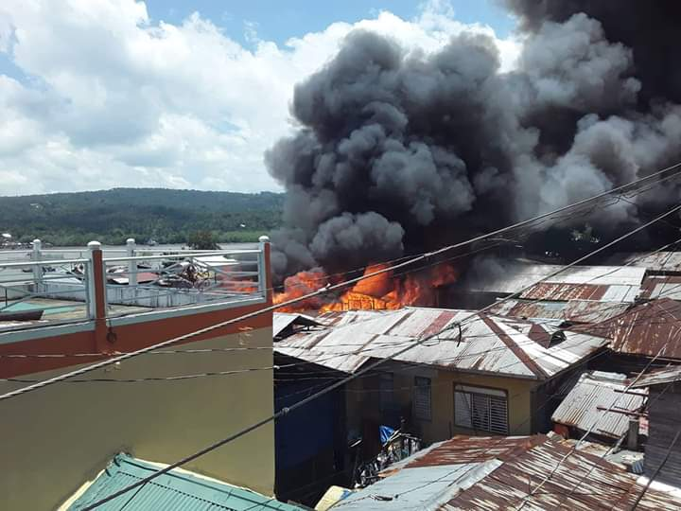
PHOTO DOCUMENTATION

