DSWD DROMIC Preparedness for Response Report #2
on the Observance of Undas 2019
as of 31 October 2019, 6PM

Situation Overview
Being a largely Christian-dominated nation in Asia, the Philippines joins the entire Christendom in its traditional yearly commemoration of the All Saints Day and All Souls Day every November 1 & 2. All Filipinos are on their way rushing to go back to their provinces and hometowns to celebrate with their families the traditional Undas, and this leads to increased volume of people on the roads and sacred grounds that may lead to human-induced disasters or possible occurrence of natural disasters.
Undas (also known as Todos los Santos, Araw ng mga Patay, or All Saints' Day) is a holiday honoring the dead, widely celebrated in the Philippines. Filipino families traditionally visit cemeteries on November 1 or 2, to hold gatherings around the graves of their departed loved ones and lay out flowers and candles. Often the occasion is treated as a reunion or banquet, with families bringing food and drink and camping out all day or even overnight. It is an official, state-recognized holiday, so people get leave from school or work on these days.

Source: Wikipilipinas.org
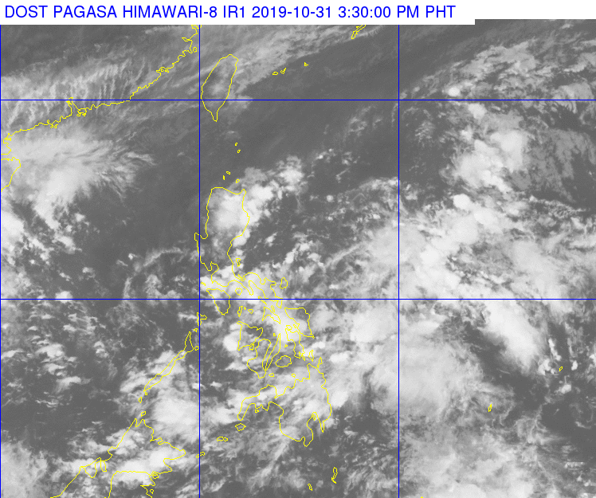
Weather Bulletin
At 3:00 PM today, the Low Pressure Area (LPA) was estimated based on all available data at 600 km East of Davao City (8.0 °N, 131.2 °E). Northeast Monsoon affecting Northern Luzon.

Source: DOST-PAGASA Severe Weather Bulletin

Status of Prepositioned Resources: Stockpile and Standby Funds

The DSWD Central Office (CO), Field Offices (FOs), and National Resource Operations Center (NROC) have stockpiles and standby funds amounting to ₱1,973,562,937.16 with breakdown as follows:

- Standby Funds
A total of ₱1,109,437,849.36 standby funds in the CO and FOs. Of the said amount, ₱1,076,221,717.34 is the available Quick Response Fund in the CO.

- Stockpiles
A total of 341,296 Family Food Packs (FFPs) amounting to ₱132,618,653.23, and available food and non-food items (FNIs) amounting to ₱732,181,061.45.

 | STANDBY FUNDS | FAMILY FOOD PACKS |  | Other Food Items | Non Food Items | SUB-TOTAL (Food and NFIs) | Total STANDBY FUNDS & STOCKPILE
 |  | Quantity | Total Cost | Total Cost | Total Cost
TOTAL | 1,109,437,849.36 | 341,296 | 132,618,653.23 | 187,235,081.83 | 544,945,979.62 | 732,181,061.45 | 1,974,237,564.04
Central Office | 1,076,221,717.34 | 0 | - | - | - | - | 1,076,221,717.34
NRLMB - NROC | - | 69,514 | 29,039,407.32 | 51,646,111.65 | 281,038,239.65 | 332,684,351.30 | 361,723,758.62
NRLMB - VDRC | - | 0 | - | 7,256,200.00 | 6,387,750.00 | 13,643,950.00 | 13,643,950.00
I | 2,379,275.00 | 16,182 | 7,579,674.78 | 299,455.20 | 37,645,525.20 | 37,944,980.40 | 47,903,930.18
II | 3,559,531.66 | 28,662 | 9,214,300.12 | 998,872.00 | 2,219,096.75 | 3,217,968.75 | 15,991,800.53
III | 3,068,057.00 | 13,073 | 5,221,262.84 | 2,420,969.70 | 7,080,011.65 | 9,500,981.35 | 17,790,301.19
CALABARZON | 1,772,325.00 | 6,405 | 2,264,433.70 | 3,187,954.80 | 6,205,173.91 | 9,393,128.71 | 13,429,887.41
MIMAROPA | 1,156,022.58 | 29,087 | 12,158,366.00 | 697,934.74 | 10,663,131.29 | 11,361,066.03 | 24,675,454.61
V | 1,464,000.00 | 25,443 | 9,922,770.00 | 5,829,520.72 | 39,733,790.47 | 45,563,311.19 | 56,950,081.19
VI | 3,000,000.00 | 20,328 | 7,318,080.00 | 3,840,805.72 | 6,133,853.25 | 9,974,658.97 | 20,292,738.97
VII | 2,300.00 | 16,373 | 5,894,280.00 | 7,962,633.21 | 19,738,281.27 | 27,700,914.48 | 33,597,494.48
VIII | 3,755,235.00 | 29,152 | 11,146,890.42 | 3,285,093.94 | 24,286,537.08 | 27,571,631.02 | 42,473,756.44
IX | 1,888.85 | 12,047 | 4,336,920.00 | 1,359,070.00 | 16,257,570.14 | 17,616,640.14 | 21,955,448.99
X | 3,000,000.00 | 27,570 | 10,078,187.39 | 83,193,669.56 | 39,526,952.54 | 122,720,622.10 | 135,798,809.49
XI | 3,028,750.00 | 6,681 | 2,414,513.40 | 2,630,400.00 | 8,201,218.31 | 10,831,618.31 | 16,274,881.71
XII | 3,000,701.68 | 5,860 | 2,349,860.00 | 7,342,356.00 | 746,876.16 | 8,089,232.16 | 13,439,793.84
CARAGA | 708,696.75 | 13,301 | 5,424,413.82 | 210,180.68 | 3,728,747.96 | 3,938,928.64 | 10,072,039.21
NCR | 3,292,543.50 | 6,346 | 2,378,666.64 | 982,611.51 | 10,538,332.60 | 11,520,944.11 | 17,192,154.25
CAR | 26,805.00 | 15,272 | 5,876,626.80 | 4,091,242.40 | 24,814,891.39 | 28,906,133.79 | 34,809,565.59
*Quick Response Fund (QRF) as of 11 October 2019
** Status of Standby Funds and Stockpile as of 31 October 2019

Situational Reports

DSWD-DRMB
DATE | SITUATIONS / ACTIONS UNDERTAKEN
October 31, 2019 | - The Disaster Response Operations Monitoring and Information Center (DROMIC) of the DSWD-DRMB is closely coordinating with the DSWD-Field Offices for significant updates on disaster preparedness for response with regard to the observation of Undas 2019.

DSWD-FO NCR
DATE | SITUATIONS / ACTIONS UNDERTAKEN
October 31, 2019 | - DSWD-NCR Quick Response Teams is ready for deployment at all times in the observance of All Saints and Souls Day.

DSWD-FO I
DATE | SITUATIONS / ACTIONS UNDERTAKEN
October 31, 2019 | - The Disaster Response Management Division (DRMD) staff and the Social Welfare and Development (SWAD) Team are on standby in observance of All Saints’ Day and All Souls’ Day on 01 and 02 November 2019.

DSWD-FO CALABARZON
DATE | SITUATIONS / ACTIONS UNDERTAKEN
October 31, 2019 | - Regional and Provincial Quick Response Team (QRT) members are on standby alert mode status and ready for mobilization if needed.  - The DRMD also advised the LSWDOs to closely monitor and oversee the overall conduct of the operations in every province in coordination with the respective Local Disaster Risk Reduction and Management Offices (LDRRMOs).  - Coordinated with SWAD Team Leaders and Provincial Action Team of the CALABARZON Provinces and advised them to monitor and coordinate with the LGUs to gather reports on the disaster events and emergencies that may occur during Undas 2019.  - Coordinated with LSWDOs and LDRRMOs and instructed them to be on standby alert and prepare their respective evacuation centers, and family food packs should need arises.  - Coordinate with RDRRMC IV-A OpCen for updates on the preparedness level of the members of the Response Cluster of the region.  - DSWD FO IV-A has informed member agencies of the response cluster to be on-stand-by alert status and ready for mobilization in case situation arises.

DSWD-FO MIMAROPA
DATE | SITUATIONS / ACTIONS UNDERTAKEN
October 31, 2019 | - DSWD-FO MIMAROPA activated Field Office Operation Center to monitor daily local weather condition and provide situational awareness.  - Alerted all Provincial/City/Municipal (P/C/M) Quick Response Teams (QRTs) in five (5) provinces of MIMAROPA to regularly monitor the situation in their areas.  - All members of R/P/C/M QRTs are on call-status and on standby duty ready for deployment if needed.  - Advised our P/MQRTs to coordinate with concerned LGUs to report any unusual eventualities in their respective areas and take appropriate actions.  - Information and Communication Technology Management Unit (ICTMU) is activated to ensure robust communication system.  - All members of Rapid Emergency Telecommunications Team are on-call and on standby status ready for deployment if needed.  - Standby logistical equipment and workforce through coordination with SWADT and concerned LGUs on management of stranded passengers if there will be reported in ports and terminals.  - Ensured that relief goods both food and non-food items are ready and available at any given time.  - DSWD-FO MIMAROPA is in close coordination with the Office of Civil Defense (OCD) and RDRRMC MIMAROPA for any warning signal updates for monitoring purposes and response mechanism for areas that will be affected.

DSWD-FO V
DATE | SITUATIONS / ACTIONS UNDERTAKEN
October 31, 2019 | - DSWD FO V QRTs were alerted and advised to be prepared for augmentation support needed from the field and/or 24/7 duty at the DRMD Operation Center.  - PAT and MAT members in the 6 provinces are on standby and were instructed to coordinate with the P/MDRRMOs for status reports and updates.

DSWD-FO VI
DATE | SITUATIONS / ACTIONS UNDERTAKEN
October 31, 2019 | - All Quick Response Team (QRT) members are on standby and ready in case of responsive action.  - DSWD-FO VI will closely monitor the situation in coordination with RDRRMC and other warning agencies.

DSWD-FO VII
DATE | SITUATIONS / ACTIONS UNDERTAKEN
October 31, 2019 | - Regional DRMD personnel is on standby and will render on-call duty to monitor and responds to any emergency situation during the  - DSWD-FO VII is in close coordination with the PNP, LGU through its LSWDOs and DRRM, and other concerned agencies.

DSWD-FO IX
DATE | SITUATIONS / ACTIONS UNDERTAKEN
October 31, 2019 | - The Disaster Response Management Division informed and disseminated to SWADT leader to monitor the situation in the respective area of responsibility.  - All Quick Response Team (QRT) members is on call and ready to response to any eventualities that may occur during the long weekend.

DSWD-FO X
DATE | SITUATIONS / ACTIONS UNDERTAKEN
October 31, 2019 | - DSWD-FO X through the Disaster Response Management Division (DRMD) submitted the Regional Implementation Plan in observance of the All Saints and All Souls Day.  - SWADTLs and P/C/MATs is on standby in coordination with the P/C/LDRRMOs.  - DSWD-FO X ensures enough level of standby foods and non-food items.

DSWD-FO XI
DATE | SITUATIONS / ACTIONS UNDERTAKEN
October 31, 2019 | - DSWD-FO XI staff and QRTs are ready and available for deployment to the affected municipalities any time.  - DSWD-FO XI deployed ten (10) staff to manage the camp in the Municipalities of Magsaysay, Matano, and Bansalan, Davao del Sur.

DSWD-FO CARAGA
DATE | SITUATIONS / ACTIONS UNDERTAKEN
October 31, 2019 | - The DRMD Staff and Quick Response Teams (QRT) are on standby and on-call basis throughout the observance of UNDAS 2019.

DSWD-FO CAR
DATE | SITUATIONS / ACTIONS UNDERTAKEN
October 31, 2019 | - The Provincial Social Welfare and Development Teams (PSWADT) Disaster Response Management Division (DRMD) Project Development Officer (PDO) IIs are alerted and members are on standby.  - Municipal Action Teams are on alert and on standby.  - Continuous coordination by the DRMD PDO IIs assigned in the PSWADTs with the Local Disaster Risk Reduction and Management Offices (LDRRMOs) for updates.  - Rapid Emergency Telecommunications Team (RETT) including the International Maritime/Marine Satellite (INMARSAT) equipment are on standby.  - The Operations Center is on BLUE alert in accordance to the alert level status of Cordillera Regional Disaster Risk Reduction and Management Council (CRDRRMC).

*****
The Disaster Response Operations Monitoring and Information Center (DROMIC) of the DSWD-DRMB is closely coordinating with the DSWD-Field Offices for any significant disaster preparedness for response updates.

Prepared by:

DIANE C. PELEGRINO

RODEL V. CABADDU
Releasing Officer

