DSWD DROMIC Report #12 on the
Ms 6.6 Earthquake Incident in Tulunan, North Cotabato
as of 04 November 2019, 6AM

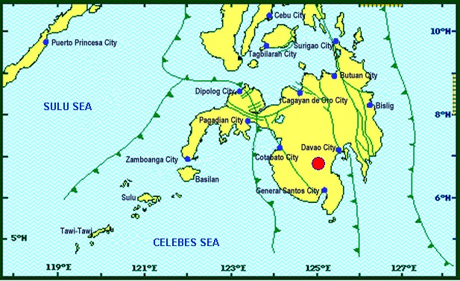
Situation Overview

On 29 October 2019 at 09:04 AM, a 6.6 magnitude earthquake jolted the municipality of Tulunan, North Cotabato (06.81°N, 125.03°E - 022 km S 79° E) with a tectonic origin and a depth of focus of 7 km. The earthquake was also felt in the neighboring municipalities of North Cotabato.

Date/Time: | 29 Oct 2019 - 09:04:43 AM
Reported Intensities: | Intensity VII – Tulunan and Makilala, Cotabato; Kidapawan City; Digos City, Bansalan,  Magsaysay, Davao del Sur and Malungon, Sarangani  Intensity VI – Koronadal City and Davao City  Intensity V – Cotabato City; Tampakan, Surallah, Banga and Tupi, South Cotabato; General Santos City; Magpet, Cotabato; Tacurong City, Kalamansig, Bagumbayan, Sultan Kudarat; Alabel, Sarangani; Kalilangan and Damulog, Bukidnon; Tagum City, Davao del Norte  Intensity IV – Cagayan De Oro City; Talakag, Manolo Fortich and Libona, Bukidnon; Glan, Maitum, Maasim and Kiamba, Sarangani; Butuan City; Iligan City; Tubod and Bacolod, Lanao del Norte  Intensity III – Molave, Zamboanga del Sur; Dipolog City, Sergio Osmeña Sr. and Polanco, Zamboanga del Norte; Zamboanga City; Gingoog City, Misamis Oriental and Bislig City  Intensity II – Kabasalan, Zamboanga Sibugay, Mambajao, Camiguin and Isabela City, Basilan  Instrumental Intensities:  Intensity VII – Malungon, Sarangani  Intensity V – Cotabato City; Alabel, Sarangani and Tupi, South Cotabato  Intensity IV – Gingoog City, Misamis Oriental; Kiamba, Sarangani; General Santos City;  Cagayan De Oro City  Intensity II – Zamboanga City and Tulunan, Cotabato  Intensity I – Palo, Leyte; Dipolog City and Bislig City
Expecting Damage: | YES
Expecting Aftershocks: | YES

Source: DOST-PHIVOLCS Earthquake Bulletin

- Status of Affected Families / Persons
A total of 37,706 families or 188,533 persons were affected by the earthquake incident in 238 barangays in Regions XI and XII (see Table 1).

Table 1. Number of Affected Families / Persons
REGION / PROVINCE / MUNICIPALITY |  | NUMBER OF AFFECTED
 |  | Barangays | Families | Persons
GRAND TOTAL |  | 238 | 37,706 | 188,533
REGION XI |  | 128 | 8,087 | 40,438
Davao del Sur |  | 123 | 8,066 | 40,333
 | Bansalan | 20 | 1,185 | 5,925
 | City of Digos (capital) | 14 | 1,501 | 7,508
 | Hagonoy | 21 | 596 | 2,980
 | Kiblawan | 1 | 1 | 5
 | Magsaysay | 21 | 3,215 | 16,075
 | Malalag | 3 | 229 | 1,145
 | Matanao | 31 | 1,309 | 6,545
 | Padada | 1 | 2 | 10
 | Santa Cruz | 11 | 28 | 140
Davao Occidental |  | 5 | 21 | 105
 | Malita | 1 | 1 | 5
 | Santa Maria | 4 | 20 | 100
REGION XII |  | 110 | 29,619 | 148,095
North Cotabato |  | 110 | 29,619 | 148,095
 | Arakan | 1 | 53 | 265
 | City of Kidapawan (capital) | 6 | 2,099 | 10,495
 | Magpet | 15 | 2,426 | 12,130
 | Makilala | 38 | 20,704 | 103,520
 | M'lang | 15 | 514 | 2,570
 | President Roxas | 6 | 164 | 820
 | Tulunan | 29 | 3,659 | 18,295
Note: Ongoing assessment and validation being conducted.
Source: DSWD-FOs XI and XII

- Status of Displaced Families / Persons
- Inside Evacuation Center
There are 4,800 families or 24,000 persons taking temporary shelter in thirty-four (34) evacuation centers in Regions XI and XII (see Table 2).

Table 2. Number of Displaced Families / Persons Inside Evacuation Centers
REGION / PROVINCE / MUNICIPALITY |  | NUMBER OF EVACUATION CENTERS (ECs) |  | INSIDE ECs
 |  |  |  | Families |  | Persons
 |  | CUM | NOW | CUM | NOW | CUM | NOW
GRAND TOTAL |  | 34 | 34 | 4,800 | 4,800 | 24,000 | 24,000
REGION XI |  | 25 | 25 | 2,771 | 2,771 | 13,855 | 13,855
Davao del Sur |  | 25 | 25 | 2,771 | 2,771 | 13,855 | 13,855
 | Bansalan | 9 | 9 | 561 | 561 | 2,805 | 2,805
 | City of Digos (capital) | 3 | 3 | 173 | 173 | 865 | 865
 | Hagonoy | 4 | 4 | 438 | 438 | 2,190 | 2,190
 | Magsaysay | 9 | 9 | 1,599 | 1,599 | 7,995 | 7,995
REGION XII |  | 9 | 9 | 2,029 | 2,029 | 10,145 | 10,145
North Cotabato |  | 9 | 9 | 2,029 | 2,029 | 10,145 | 10,145
 | City of Kidapawan (capital) | 9 | 9 | 2,029 | 2,029 | 10,145 | 10,145
Note: Ongoing assessment and validation being conducted.
Source: DSWD-FOs XI and XII
- Outside Evacuation Center
There are 1,493 families or 7,465 persons currently staying with their relatives and/or friends (see Table 3).

Table 3. Number of Displaced Families / Persons Outside Evacuation Centers
REGION / PROVINCE / MUNICIPALITY |  | OUTSIDE ECs
 |  | Families |  | Persons
 |  | CUM | NOW | CUM | NOW
GRAND TOTAL |  | 1,493 | 1,493 | 7,465 | 7,465
REGION XI |  | 390 | 390 | 1,950 | 1,950
Davao del Sur |  | 390 | 390 | 1,950 | 1,950
 | Bansalan | 126 | 126 | 630 | 630
 | Magsaysay | 236 | 236 | 1,180 | 1,180
 | Santa Cruz | 28 | 28 | 140 | 140
REGION XII |  | 1,103 | 1,103 | 5,515 | 5,515
North Cotabato |  | 1,103 | 1,103 | 5,515 | 5,515
 | Arakan | 53 | 53 | 265 | 265
 | City of Kidapawan (capital) | 70 | 70 | 350 | 350
 | M'lang | 50 | 50 | 250 | 250
 | Tulunan | 930 | 930 | 4,650 | 4,650
Note: Ongoing assessment and validation being conducted.
Source: DSWD-FOs XI and XII

- Damaged Houses
There are 29,377 damaged houses; of which, 21,064 are totally damaged and 8,313 are partially damaged (see Table 4).

Table 4. Number of Damaged Houses
REGION / PROVINCE / MUNICIPALITY |  | NO. OF DAMAGED HOUSES
 |  | Total | Totally | Partially
GRAND TOTAL |  | 29,377 | 21,064 | 8,313
REGION XI |  | 3,229 | 506 | 2,723
Davao del Sur |  | 3,208 | 505 | 2,703
 | Bansalan | 858 | 174 | 684
 | Hagonoy | 334 | 41 | 293
 | Kiblawan | 1 | 1 | -
 | Magsaysay | 1,951 | 286 | 1,665
 | Matanao | 51 | 1 | 50
 | Padada | 2 | - | 2
 | Santa Cruz | 11 | 2 | 9
Davao Occidental |  | 21 | 1 | 20
 | Malita | 1 | 1 | -
 | Santa Maria | 20 | - | 20
REGION XII |  | 26,148 | 20,558 | 5,590
North Cotabato |  | 26,148 | 20,558 | 5,590
 | Arakan | 25 | 1 | 24
 | City of Kidapawan (capital) | 1,366 | 38 | 1,328
 | Makilala | 20,704 | 18,997 | 1,707
 | M'lang | 230 | 73 | 157
 | President Roxas | 164 | 74 | 90
 | Tulunan | 3,659 | 1,375 | 2,284
Note: Ongoing assessment and validation being conducted
Source: DSWD-FOs XI and XII

- Assistance Provided
A total of ₱11,843,306.00 worth of assistance was provided by DSWD to the affected families (see Table 5).

Table 5. Cost of Assistance Provided to Affected Families / Persons
REGION / PROVINCE / MUNICIPALITY |  | TOTAL COST OF ASSISTANCE
 |  | DSWD | LGU | NGOs | OTHERS | GRAND TOTAL
GRAND TOTAL |  | 11,843,306.00 | - | - | - | 11,843,306.00
REGION XI |  | 5,139,437.00 | - | - | - | 5,139,437.00
Davao del Sur |  | 5,139,437.00 | - | - | - | 5,139,437.00
 | Bansalan | 1,470,767.00 | - | - | - | 1,470,767.00
 | City of Digos (capital) | 525,700.00 | - | - | - | 525,700.00
 | Magsaysay | 2,295,630.00 | - | - | - | 2,295,630.00
 | Malalag | 318,700.00 | - | - | - | 318,700.00
 | Matanao | 528,640.00 | - | - | - | 528,640.00
REGION XII |  | 6,703,869.00 | - | - | - | 6,703,869.00
North Cotabato |  | 6,703,869.00 | - | - | - | 6,703,869.00
 | Arakan | 44,856.00 | - | - | - | 44,856.00
 | City of Kidapawan (capital) | 1,049,928.00 | - | - | - | 1,049,928.00
 | Magpet | 319,300.00 | - | - | - | 319,300.00
 | Makilala | 1,540,727.00 | - | - | - | 1,540,727.00
 | M'lang | 123,508.00 | - | - | - | 123,508.00
 | Tulunan | 3,625,550.00 | - | - | - | 3,625,550.00
Note: Ongoing assessment and validation being conducted
Source: DSWD-FOs XI and XII

DSWD DISASTER RESPONSE INFORMATION
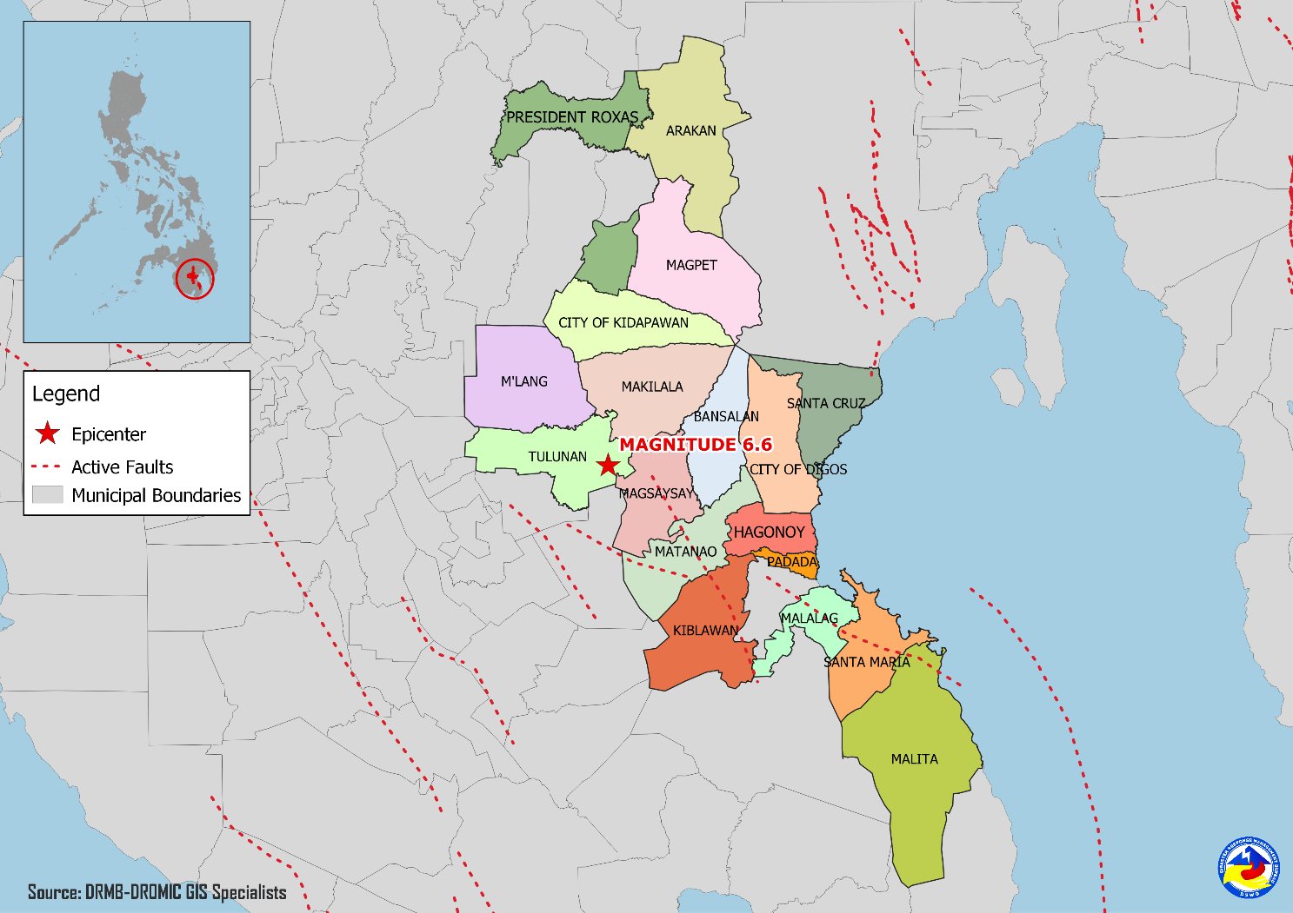

Situational Reports

DSWD-DRMB
DATE | SITUATIONS / ACTIONS UNDERTAKEN
04 November 2019 | - The Disaster Response Management Bureau (DRMB) is on BLUE alert level status and is closely coordinating with the concerned field offices for significant disaster response updates.  - All QRT members and emergency equipment are on standby and ready for deployment.  - The four (4) technical staff from DSWD-DRMB deployed on 03 November 2019 are currently providing technical assistance and resource augmentation for the affected families in Region XI.
03 November 2019 | - The response team from Central Office brought ten (10) information boards to be used in the evacuation centers in Region XI.  - Provision for Child Friendly Space (CFS) and Women Friendly Space (WFS) kits based on the Camp Managers assessment where it will be established.  - Coordinated with the Department of Health for the provision of psycho-social support for the affected individuals in the evacuation centers.

DSWD-NRLMB
DATE | SITUATIONS / ACTIONS UNDERTAKEN
04 November 2019 | - The remaining 623 sleeping kits out of 1,333 sleeping kits are for pick-up by DSWD-FO XII at the General Santos Airport.
03 November 2019 | - A total of 9,600 pieces of laminated sacks, 4,513 pieces of kitchen kits and 2,800 pieces of sleeping kits were loaded at NROC for delivery to DSWD-FO XII via 5x10 wheeler wing van.
02 November 2019 | - A total of 25 pieces of family tents and 250 laminated sacks will be delivered to DSWD-FO XI via Air Asia Airlines.  - A total of 4,500 family food packs, 1,500 sleeping kits and 1,500 laminated sacks were in transit to DSWD-FO XI via Philippine Coast Guard.  - A total of 125 family tents were in transit to DSWD-FO XI via 10-wheeler wing van and currently in Gandara, Samar.  - A total of 7,500 family food packs were in transit to DSWD-FO XII via Philippine Coast Guard XI.  - A total of 2,815 sleeping kits, 2,160 kitchen kits, 4,800 pre-cut laminated sacks and 125 family tents were in transit to DSWD-FO XII via 4x10-wheeler wing van.  - a total of 1,060 pieces of laminated sacks, 267 pieces of sleeping kits and 1,200 pieces of kitchen kits were scheduled to be airlifted via Cebu Pacific on November 3 and 4.  - A total of 2,140 laminated sacks for DSWD-FO XII were received via Cebu Pacific as of November 02, 2019.  - A total of 710 out of 1,333 sleeping kits were received in DSWD-FO XII via Cebu Pacific as of November 01, 2019.
01 November 2019 | - 187 Sleeping kits transported via Air Asia Airlines have arrived at Davao International Airport.  - A total of 4,500 family food packs, 1,500 pieces sleeping kits and 1,500 pieces laminated sacks were in transit to DSWD-FO XI via Philippine Cost Guard which departed at 9:00AM at Ubusan Port, Allen, Northern Samar.  - A total of 7,500 Family Food Packs were in transit to DSWD-FO XII via Philippine Cost Guard which departed at 9:00AM at Ubusan Port, Allen, Northern Samar.  - DSWD-NRLMB delivered 75 family tents to DSWD-FO XI via C130 and was received on November 1, 2019 at 11AM.
31 October 2019 | - A total of 500 family food packs, 500 sleeping kits and 500 pre-cut laminated sacks were loaded at NAIA Terminal 4 via Air Asia Airlines.
30 October 2019 | - DSWD-NRLMB augmented 50 family tents, 500 sleeping kits, 500 pre-cut laminated sacks and 166 family food packs to DSWD-FO XII and were transported through C130 that arrived in General Santos City.

DSWD-FO X
DATE | ACTION(S) TAKEN
01 November 2019 | - DSWD-FO X deployed 11 Regional QRT members as augmentation support to DSWD-FO XI.
30 October 2019 | - DSWD-FO X was in close coordination with the concerned City Disaster Risk Reduction Management Offices (CDRRMOs) and Municipal Disaster Risk Reduction Management Offices (MDRRMOs) for any significant updates.

DSWD-FO XI
DATE | ACTION(S) TAKEN
- November 2019 | - DSWD-FO XI coordinated with SWADT/PAT/MAT/QRT/ Camp Managers assigned in different evacuation centers to capture the needs of IDPs.  - Ongoing repacking of goods at DSWD Warehouse.  - Briefing of 10 Camp Managers (3rd Batch) to be deployed in Magsaysay, Davao del Sur.
03 November 2019 | - The remaining non-food items augmentation support of DSWD-FO Caraga of which; 168 hygiene kits, 678 mosquito kits, 678 blanket, 2,003 malong, 120 plastic mat and 1,128 laminated sacks were already received at DSWD-FO XI.  - Augmentation assistance of 3,000 sleeping kits, 5,000 drinking kits and 100 bundles of trapal from DSWD-FO X were already received by DSWD-FO XI.  - DSWD-FO IX augmented a total of 500 hygiene kits, 500 mosquito nets, 150 blankets, 250 towels and 70 cases of sardines were also received by DSWD-FO XI.
02 November 2019 | - DSWD-FO XI transported 1,000 FFPs, 1,000 sleeping kits, 1,000 drinking kits, and 50 tents to the affected families and individuals in Magsaysay, Davao del Sur.  - DSWD-FO XI transported 1,500 FFPs, 500 sleeping kits, 500 drinking kits, and 500 laminated sacks and 168 hygiene kits to the affected families and individuals in Bansalan, Davao del Sur.  - DSWD-FO XI transported 628 laminated sacks to the affected families and individuals in Matanao, Davao del Sur.  - DSWD-FO XI transported 500 family food packs to the affected families and individuals of Digos City.  - SWADT, P/MAT, and QRT assess the need of the affected families inside and outside evacuation centers and areas affected.  - DSWD-FO XI is still on RED alert level status.  - DSWD-FO XI is in close coordination with the Local Government Units (LGUs) through the Municipal Social Welfare and Development Offices (MSWDOs) particularly in the municipalities of Davao del Sur for any significant updates.
01 November 2019 | - Augmentation assistance of 3,000 family food packs from DSWD-FO Caraga were received at DSWD-FO XI.  - DSWD-FO XI provided 500 family food packs and 300 sleeping kits to the affected families in Magsaysay, Davao del Sur.
31 October 2019 | - DSWD-FO XI deployed 10 camp managers to the affected municipalities of Davao del Sur.  - DSWD-FO XI distributed family food packs to affected families in the municipality of Matanao, Davao del Sur.
30 October 2019 | - DSWD-FO XI distributed family food packs and 10 family tents in Magsaysay, Davao del Sur.

DSWD-FO XII
DATE | ACTION(S) TAKEN
- November 2019 | - DSWD-FO XII distributed 345 family food packs in Makilala, North Cotabato.  - DSWD-FO XII distributed 428 family food packs and 320 sleeping kits in Kidapawan, North Cotabato.  - DSWD-FO XII distributed 500 family food packs, 100 sleeping kits, and 100 pieces of laminated sacks (10 meters) to the affected families.  - DSWD-FO XII distributed 4,000 family food packs in Tulunan, North Cotabato.  - DSWD-FO XII staff attended the PDRRMC meeting.  - DSWD QRT members administered the profiling of the IDPs using DAFAC in Brgy. Bulakanon, Makilala, North Cotabato.  - Installation of Mobile Storage Unit (MSU) in Amas, Kidapawan Provincial Capitol.
02 November 2019 | - DSWD-FO XII delivered 350 FFPs and 350 sleeping kits for the prepositioning of food and non-food items at the CIU Office Satellite Office in Kidapawan City.  - DSWD-FO XII deployed QRT team in Makilala, Kidapawan City, M’lang, and Tulunan, North Cotabato in coordination with concerned LGUs, SWADT, and P/C/MAT leaders.  - DSWD-FO XII coordinated with DICT in Cotabato Province through DRMB-DROMIC for the installation of internet connectivity.  - Relief goods for the affected families in Magpet and Makilala, North Cotabato were currently being loaded to transport vehicles.  - DSWD-FO XII delivered 110 laminated sacks, 460 sleeping kits and 60 pieces of water jags in Makilala, North Cotabato.  - DSWD-FO XII is still on RED alert status.
01 November 2019 | - DSWD-FO XII delivered 1,200 family food packs and 100 rolls of pre-cut laminated sacks in Tulunan, North Cotabato.
31 October 2019 | - DSW-FO XII activated the Quick Response Team.  - DSW-FO XII deployed Group 1 of the Quick Response Team for possible technical assistance and resource augmentation.
30 October 2019 | - DSWD-FO XII provided 350 family food packs and 10 rolls of laminated sacks to the affected families in Tulunan, North Cotabato.  - DSWD-FO XII provided 1,500 family food packs and 20 rolls of laminated sacks to the affected families in Kidapawan City, North Cotabato.  - DSWD-FO XII provided 308 family food packs to the affected families in M’lang, North Cotabato.  - DSWD-FO XII through the Disaster Response Management Division (DRMD) staff conducted an actual validation in all affected areas in North Cotabato.  - DSWD-FO XII through the Crisis Intervention Unit (CIU) provided ₱5,000.00 each to fifteen (15) injured individuals in Brgy. Daig, Tulunan, North Cotabato.  - DSWD-FO XII through the CIU provided ₱10,000.00 to the bereaved family of Narciso Nestor in Koronadal City.
29 October 2019 | - All QRT members were on standby and ready for activation if there is a need for deployment.  - 4 vehicles were ready for utilization in case of response activation.  - Employees except for QRT and DRMD staff were advised to vacate the building and go home.  - Tents were provided to Reception and Study Center for Children (RSCC) for the use of clients and staff as evacuation area while the safety of the building was being assessed.  - DSWD-FO XII requested laminated sacks and sleeping kits from NROC.  - All municipal and provincial-based DSWD staff were directed to conduct rapid assessment to their respective areas of assignment.

***
The Disaster Response Operations Monitoring and Information Center (DROMIC) of the DSWD-DRMB is closely coordinating with concerned DSWD Field Offices for any significant disaster response updates.

MARIE JOYCE G. RAFANAN
Releasing Officer

PHOTO DOCUMENTATION

Loading of Goods at NROC (October 30, 2019)
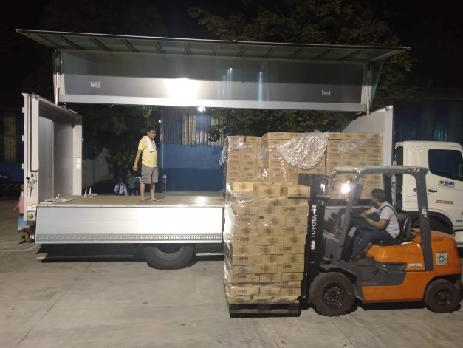
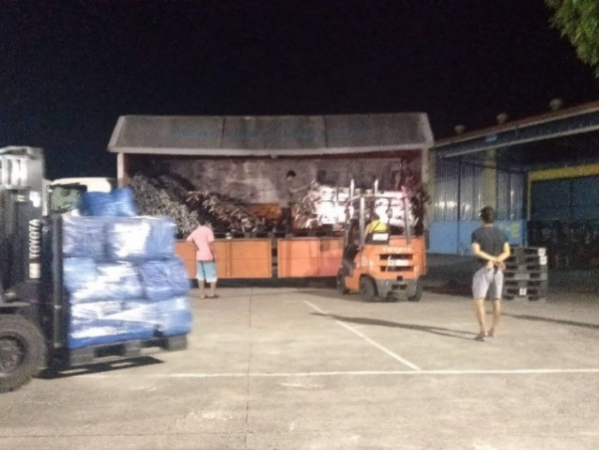

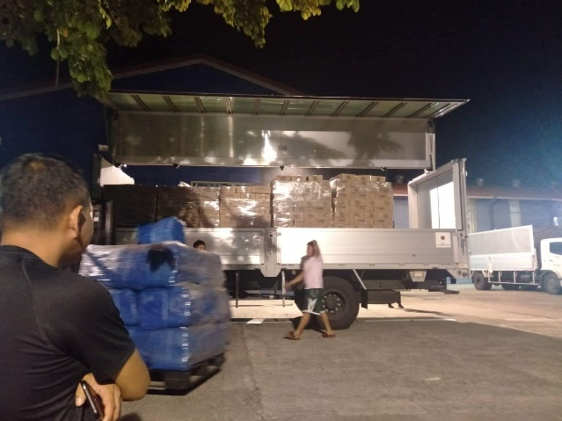
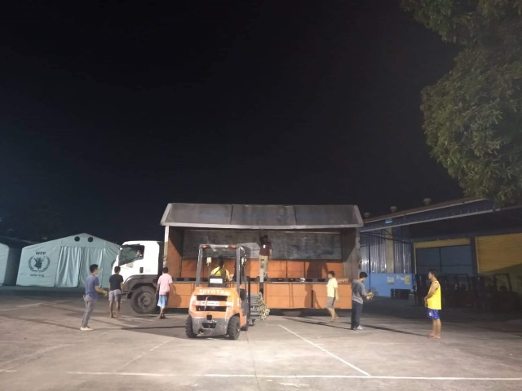

Loading of Goods at Villamor Airbase (October 30, 2019)
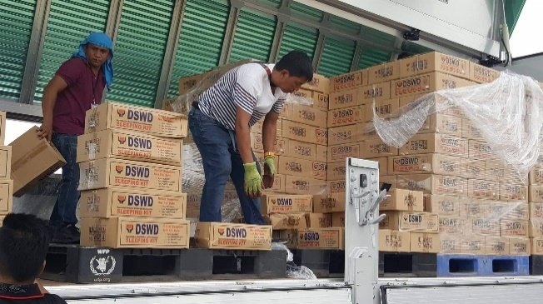
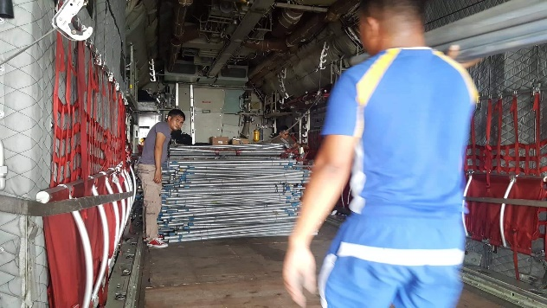

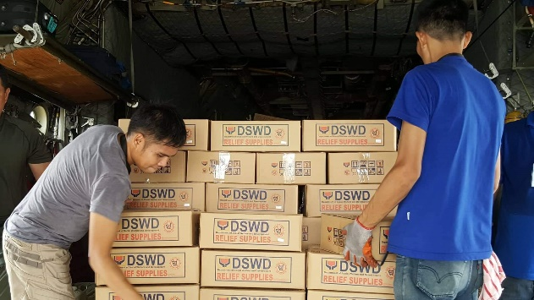
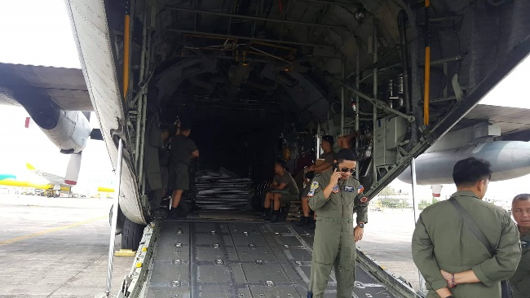

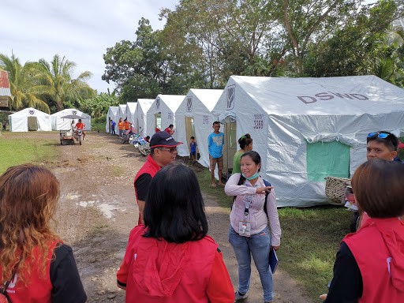
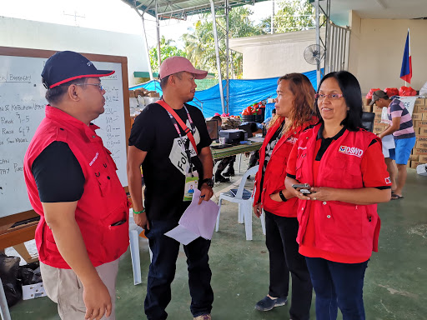
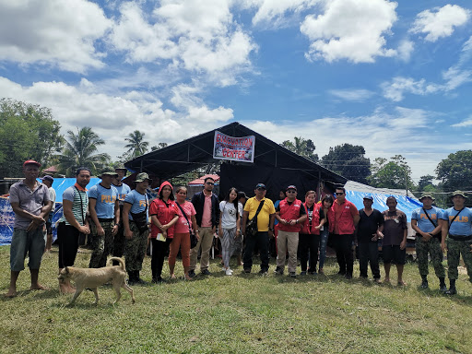
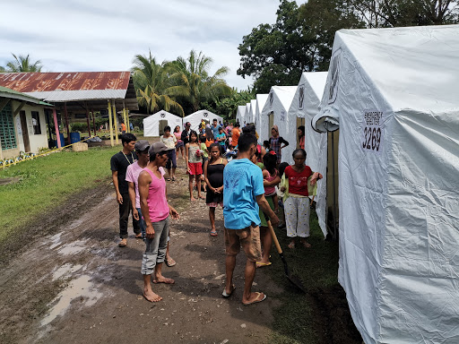
Evacuation Site Visit at Magsaysay, Davao del Sur (October 31, 2019)

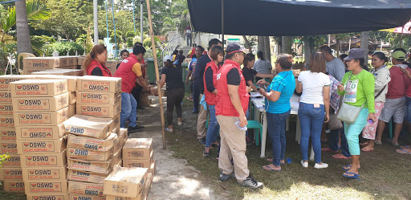
Relief distribution in coordination with LGU Matanao in Davao del Sur (October 31, 2019)
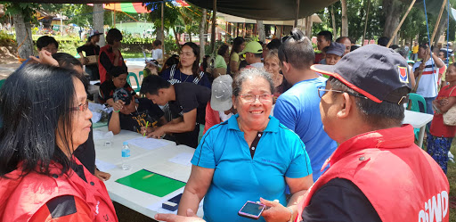

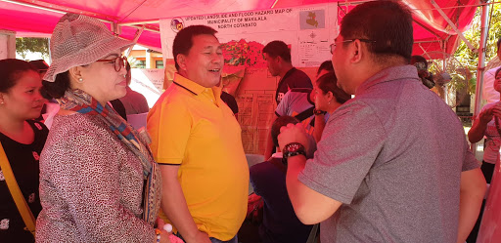
Meeting with Mayor Armando M. Quibod (middle) of Makilala, North Cotabato during the field monitoring of DSWD-DRMB headed by Dir. Rodolfo M. Encabo (right) (November 1, 2019)

Relief distribution in New Bulatukan, Makilala North Cotabato (November 02, 2019)
