DSWD DROMIC Report #13 on the
Ms 6.6 Earthquake Incident in Tulunan, North Cotabato
as of 04 November 2019, 6PM

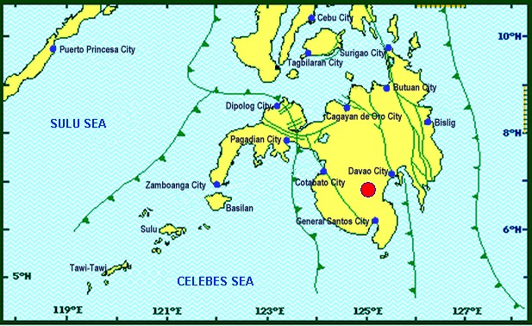
Situation Overview

On 29 October 2019 at 09:04 AM, a 6.6 magnitude earthquake jolted the municipality of Tulunan, North Cotabato (06.81°N, 125.03°E - 022 km S 79° E) with a tectonic origin and a depth of focus of 7 km. The earthquake was also felt in the neighboring municipalities of North Cotabato.

Date/Time: | 29 Oct 2019 - 09:04:43 AM
Reported Intensities: | Intensity VII – Tulunan and Makilala, Cotabato; Kidapawan City; Digos City, Bansalan,  Magsaysay, Davao del Sur and Malungon, Sarangani  Intensity VI – Koronadal City and Davao City  Intensity V – Cotabato City; Tampakan, Surallah, Banga and Tupi, South Cotabato; General Santos City; Magpet, Cotabato; Tacurong City, Kalamansig, Bagumbayan, Sultan Kudarat; Alabel, Sarangani; Kalilangan and Damulog, Bukidnon; Tagum City, Davao del Norte  Intensity IV – Cagayan De Oro City; Talakag, Manolo Fortich and Libona, Bukidnon; Glan, Maitum, Maasim and Kiamba, Sarangani; Butuan City; Iligan City; Tubod and Bacolod, Lanao del Norte  Intensity III – Molave, Zamboanga del Sur; Dipolog City, Sergio Osmeña Sr. and Polanco, Zamboanga del Norte; Zamboanga City; Gingoog City, Misamis Oriental and Bislig City  Intensity II – Kabasalan, Zamboanga Sibugay, Mambajao, Camiguin and Isabela City, Basilan  Instrumental Intensities:  Intensity VII – Malungon, Sarangani  Intensity V – Cotabato City; Alabel, Sarangani and Tupi, South Cotabato  Intensity IV – Gingoog City, Misamis Oriental; Kiamba, Sarangani; General Santos City;  Cagayan De Oro City  Intensity II – Zamboanga City and Tulunan, Cotabato  Intensity I – Palo, Leyte; Dipolog City and Bislig City
Expecting Damage: | YES
Expecting Aftershocks: | YES

Source: DOST-PHIVOLCS Earthquake Bulletin

- Status of Affected Families / Persons
A total of 37,716 families or 188,583 persons were affected by the earthquake incident in 246 barangays in Regions XI and XII (see Table 1).

Table 1. Number of Affected Families / Persons
REGION / PROVINCE / MUNICIPALITY |  | NUMBER OF AFFECTED
 |  | Barangays | Families | Persons
GRAND TOTAL |  | 246 | 37,716 | 188,583
REGION XI |  | 128 | 8,097 | 40,488
Davao del Sur |  | 123 | 8,076 | 40,383
 | Bansalan | 20 | 1,185 | 5,925
 | City of Digos (capital) | 14 | 1,501 | 7,508
 | Hagonoy | 21 | 596 | 2,980
 | Kiblawan | 1 | 1 | 5
 | Magsaysay | 21 | 3,215 | 16,075
 | Malalag | 3 | 229 | 1,145
 | Matanao | 31 | 1,309 | 6,545
 | Padada | 1 | 2 | 10
 | Santa Cruz | 11 | 38 | 190
Davao Occidental |  | 5 | 21 | 105
 | Malita | 1 | 1 | 5
 | Santa Maria | 4 | 20 | 100
REGION XII |  | 118 | 29,619 | 148,095
North Cotabato |  | 118 | 29,619 | 148,095
 | Arakan | 9 | 53 | 265
 | City of Kidapawan (capital) | 6 | 2,099 | 10,495
 | Magpet | 15 | 2,426 | 12,130
 | Makilala | 38 | 20,704 | 103,520
 | M'lang | 15 | 514 | 2,570
 | President Roxas | 6 | 164 | 820
 | Tulunan | 29 | 3,659 | 18,295
Note: Ongoing assessment and validation being conducted.
Source: DSWD-FOs XI and XII
- Status of Displaced Families / Persons
- Inside Evacuation Center
There are 5,614 families or 28,070 persons taking temporary shelter in thirty-two (32) evacuation centers in Regions XI and XII (see Table 2).

Table 2. Number of Displaced Families / Persons Inside Evacuation Centers
REGION / PROVINCE / MUNICIPALITY |  | NUMBER OF EVACUATION CENTERS (ECs) |  | INSIDE ECs
 |  |  |  | Families |  | Persons
 |  | CUM | NOW | CUM | NOW | CUM | NOW
GRAND TOTAL |  | 35 | 32 | 5,614 | 5,614 | 28,070 | 28,070
REGION XI |  | 26 | 23 | 3,585 | 3,585 | 17,925 | 17,925
Davao del Sur |  | 26 | 23 | 3,585 | 3,585 | 17,925 | 17,925
 | Bansalan | 9 | 6 | 1,375 | 1,375 | 6,875 | 6,875
 | City of Digos (capital) | 3 | 3 | 173 | 173 | 865 | 865
 | Hagonoy | 4 | 4 | 438 | 438 | 2,190 | 2,190
 | Magsaysay | 10 | 10 | 1,599 | 1,599 | 7,995 | 7,995
REGION XII |  | 9 | 9 | 2,029 | 2,029 | 10,145 | 10,145
North Cotabato |  | 9 | 9 | 2,029 | 2,029 | 10,145 | 10,145
 | City of Kidapawan (capital) | 9 | 9 | 2,029 | 2,029 | 10,145 | 10,145
Note: Ongoing assessment and validation being conducted.
Source: DSWD-FOs XI and XII
- Outside Evacuation Center
There are 1,493 families or 7,465 persons currently staying with their relatives and/or friends (see Table 3).

Table 3. Number of Displaced Families / Persons Outside Evacuation Centers
REGION / PROVINCE / MUNICIPALITY |  | OUTSIDE ECs
 |  | Families |  | Persons
 |  | CUM | NOW | CUM | NOW
GRAND TOTAL |  | 1,493 | 1,493 | 7,465 | 7,465
REGION XI |  | 390 | 390 | 1,950 | 1,950
Davao del Sur |  | 390 | 390 | 1,950 | 1,950
 | Bansalan | 126 | 126 | 630 | 630
 | Magsaysay | 236 | 236 | 1,180 | 1,180
 | Santa Cruz | 28 | 28 | 140 | 140
REGION XII |  | 1,103 | 1,103 | 5,515 | 5,515
North Cotabato |  | 1,103 | 1,103 | 5,515 | 5,515
 | Arakan | 53 | 53 | 265 | 265
 | City of Kidapawan (capital) | 70 | 70 | 350 | 350
 | M'lang | 50 | 50 | 250 | 250
 | Tulunan | 930 | 930 | 4,650 | 4,650
Note: Ongoing assessment and validation being conducted.
Source: DSWD-FOs XI and XII

- Damaged Houses
There are 29,377 damaged houses; of which, 21,064 are totally damaged and 8,313 are partially damaged (see Table 4).

Table 4. Number of Damaged Houses
REGION / PROVINCE / MUNICIPALITY |  | NO. OF DAMAGED HOUSES
 |  | Total | Totally | Partially
GRAND TOTAL |  | 29,377 | 21,064 | 8,313
REGION XI |  | 3,229 | 506 | 2,723
Davao del Sur |  | 3,208 | 505 | 2,703
 | Bansalan | 858 | 174 | 684
 | Hagonoy | 334 | 41 | 293
 | Kiblawan | 1 | 1 | -
 | Magsaysay | 1,951 | 286 | 1,665
 | Matanao | 51 | 1 | 50
 | Padada | 2 | - | 2
 | Santa Cruz | 11 | 2 | 9
Davao Occidental |  | 21 | 1 | 20
 | Malita | 1 | 1 | -
 | Santa Maria | 20 | - | 20
REGION XII |  | 26,148 | 20,558 | 5,590
North Cotabato |  | 26,148 | 20,558 | 5,590
 | Arakan | 25 | 1 | 24
 | City of Kidapawan (capital) | 1,366 | 38 | 1,328
 | Makilala | 20,704 | 18,997 | 1,707
 | M'lang | 230 | 73 | 157
 | President Roxas | 164 | 74 | 90
 | Tulunan | 3,659 | 1,375 | 2,284
Note: Ongoing assessment and validation being conducted
Source: DSWD-FOs XI and XII

- Assistance Provided
A total of ₱12,222,306.00 worth of assistance was provided by DSWD to the affected families (see Table 5).

Table 5. Cost of Assistance Provided to Affected Families / Persons
REGION / PROVINCE / MUNICIPALITY |  | TOTAL COST OF ASSISTANCE
 |  | DSWD | LGU | NGOs | OTHERS | GRAND TOTAL
GRAND TOTAL |  | 12,222,306.00 | - | - | - | 12,222,306.00
REGION XI |  | 5,139,437.00 | - | - | - | 5,139,437.00
Davao del Sur |  | 5,139,437.00 | - | - | - | 5,139,437.00
 | Bansalan | 1,470,767.00 | - | - | - | 1,470,767.00
 | City of Digos (capital) | 525,700.00 | - | - | - | 525,700.00
 | Magsaysay | 2,295,630.00 | - | - | - | 2,295,630.00
 | Malalag | 318,700.00 | - | - | - | 318,700.00
 | Matanao | 528,640.00 | - | - | - | 528,640.00
REGION XII |  | 7,082,869.00 | - | - | - | 7,082,869.00
North Cotabato |  | 7,082,869.00 | - | - | - | 7,082,869.00
 | Arakan | 44,856.00 | - | - | - | 44,856.00
 | City of Kidapawan (capital) | 1,049,928.00 | - | - | - | 1,049,928.00
 | Magpet | 319,300.00 | - | - | - | 319,300.00
 | Makilala | 1,919,727.00 | - | - | - | 1,919,727.00
 | M'lang | 123,508.00 | - | - | - | 123,508.00
 | Tulunan | 3,625,550.00 | - | - | - | 3,625,550.00
Note: Ongoing assessment and validation being conducted
Source: DSWD-FOs XI and XII
DSWD DISASTER RESPONSE INFORMATION
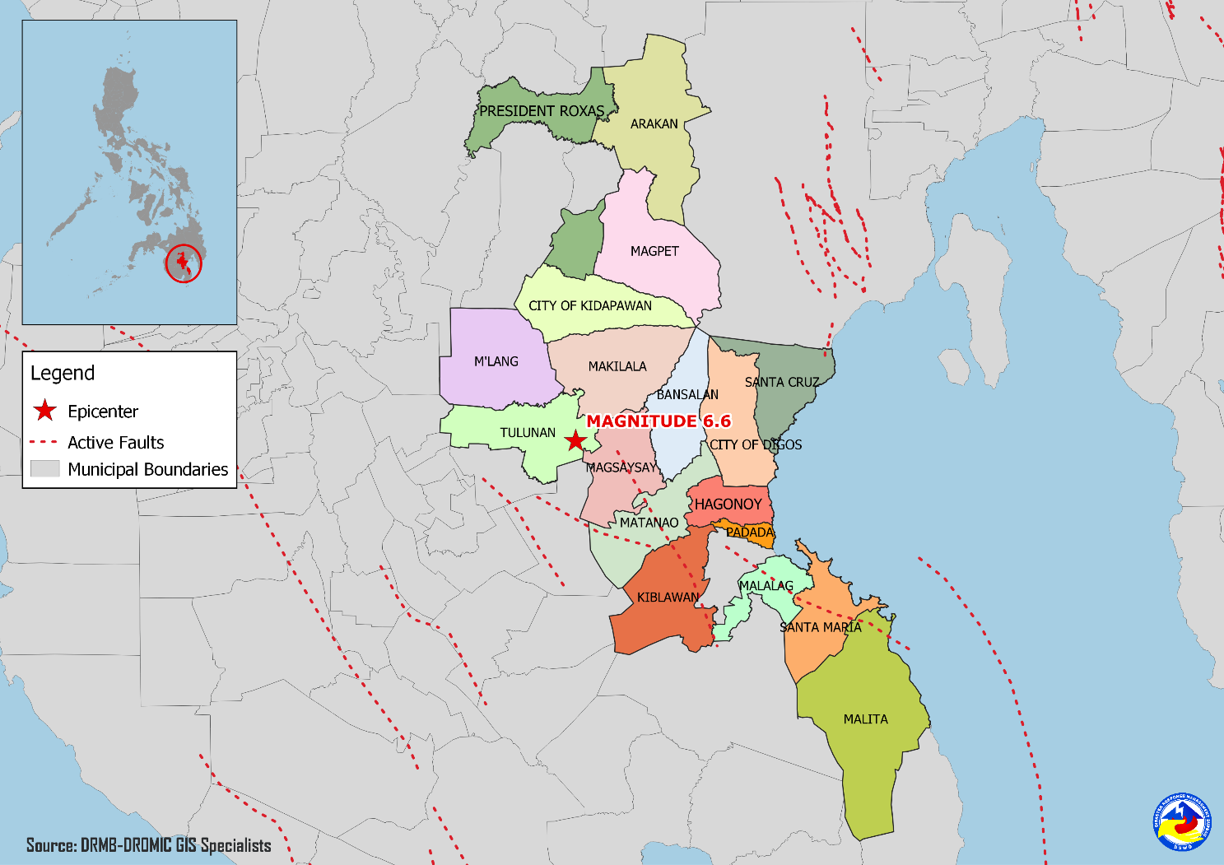

Situational Reports

DSWD-DRMB
DATE | SITUATIONS / ACTIONS UNDERTAKEN
04 November 2019 | - The Disaster Response Management Bureau (DRMB) is on BLUE alert level status and is closely coordinating with the concerned field offices for significant disaster response updates.  - All QRT members and emergency equipment are on standby and ready for deployment.  - The four (4) technical staff from DSWD-DRMB deployed on 03 November 2019 are currently providing technical assistance and resource augmentation for the affected families in Region XI.  - Prepared and released Sub-Allotment amounting to ₱20,160,000.00 intended for the purchase of family food packs and operational expenses for the ongoing relief operation due to 6.6 magnitude Earthquake in Region XI.  - Ongoing process of Sub-Allotment amounting to ₱26,732,500.00 intended for the purchase of family food packs, operational expenses and standby funds for the ongoing relief operation due to 6.6 magnitude Earthquake in Region XII.

DSWD-NRLMB
DATE | SITUATIONS / ACTIONS UNDERTAKEN
04 November 2019 | - The remaining 623 sleeping kits out of 1,333 sleeping kits are for pick-up by DSWD-FO XII at the General Santos Airport.  - A total of 4,500 family food packs, 1,500 pieces sleeping kits and 1,500 pieces laminated sacks were in transit to DSWD-FO XI via Philippine Cost Guard which departed on Nov.01, 2019 at 9:00AM at Ubusan Port, Allen, Northern Samar.  - A total of 7,500 Family Food Packs were in transit to DSWD-FO XII via Philippine Cost Guard which departed Nov.01, 2019 at 9:00AM at Ubusan Port, Allen, Northern Samar.
03 November 2019 | - A total of 9,600 pieces of laminated sacks, 4,513 pieces of kitchen kits and 2,800 pieces of sleeping kits were loaded at NROC for delivery to DSWD-FO XII via 5x10 wheeler wing van.
02 November 2019 | - A total of 25 pieces of family tents and 250 laminated sacks will be delivered to DSWD-FO XI via Air Asia Airlines.  - A total of 4,500 family food packs, 1,500 sleeping kits and 1,500 laminated sacks were in transit to DSWD-FO XI via Philippine Coast Guard.  - A total of 125 family tents were in transit to DSWD-FO XI via 10-wheeler wing van and currently in Gandara, Samar.  - A total of 7,500 family food packs were in transit to DSWD-FO XII via Philippine Coast Guard XI.  - A total of 2,815 sleeping kits, 2,160 kitchen kits, 4,800 pre-cut laminated sacks and 125 family tents were in transit to DSWD-FO XII via 4x10-wheeler wing van.  - a total of 1,060 pieces of laminated sacks, 267 pieces of sleeping kits and 1,200 pieces of kitchen kits were scheduled to be airlifted via Cebu Pacific on November 3 and 4.

DSWD-FO XI
DATE | ACTION(S) TAKEN
- November 2019 | - DSWD-FO XI is on RED alert level status.  - DSWD-FO XI coordinated with SWADT/PAT/MAT/QRT/ Camp Managers assigned in different evacuation centers to capture the needs of IDPs.  - Ongoing repacking of goods at DSWD Warehouse.  - Briefing of 10 Camp Managers (3rd Batch) to be deployed in Magsaysay, Davao del Sur.
02 November 2019 | - SWADT, P/MAT, and QRT assess the need of the affected families inside and outside evacuation centers and areas affected.  - DSWD-FO XI is in close coordination with the Local Government Units (LGUs) through the Municipal Social Welfare and Development Offices (MSWDOs) particularly in the municipalities of Davao del Sur for any significant updates.

DSWD-FO XII
DATE | ACTION(S) TAKEN
- November 2019 | - DSWD-FO XII is still on RED alert status.  - DSWD-FO XII distributed 345 family food packs in Makilala, North Cotabato.  - DSWD-FO XII distributed 428 family food packs and 320 sleeping kits in Kidapawan, North Cotabato.  - DSWD-FO XII distributed 500 family food packs, 100 sleeping kits, and 100 pieces of laminated sacks (10 meters) to the affected families.  - DSWD-FO XII distributed 4,000 family food packs in Tulunan, North Cotabato.  - DSWD-FO XII staff attended the PDRRMC meeting.  - DSWD QRT members administered the profiling of the IDPs using DAFAC in Brgy. Bulakanon, Makilala, North Cotabato.  - Installation of Mobile Storage Unit (MSU) in Amas, Kidapawan Provincial Capitol.  - DSWD-FO XII distributed 169 rolls of Laminated Sacks, 471 Sleeping Kits and 500 Kitchen Kits in Makilala, North Cotabato.  - DSWD-FO XII delivered 161 FFPs, 633 family kits and 50 rolls of Laminated Sacks for the prepositioning of food and non-food items at the CIU Satellite Office in Kidapawan City.

***
The Disaster Response Operations Monitoring and Information Center (DROMIC) of the DSWD-DRMB is closely coordinating with concerned DSWD Field Offices for any significant disaster response updates.

Prepared by:
MARIEL B. FERRARIZ
DIANE C. PELEGRINO

RODEL V. CABADDU
Releasing Officer

PHOTO DOCUMENTATION

Loading of Goods at NROC (October 30, 2019)
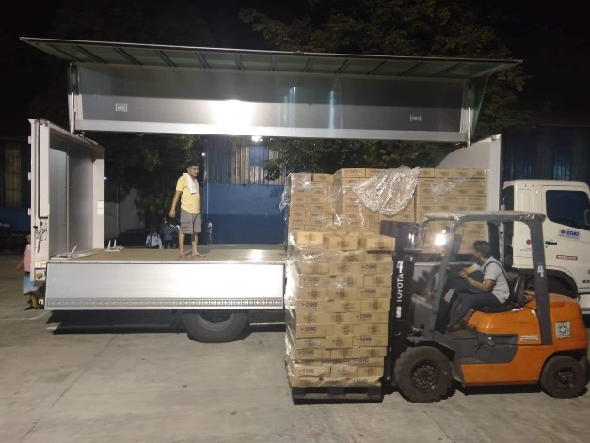
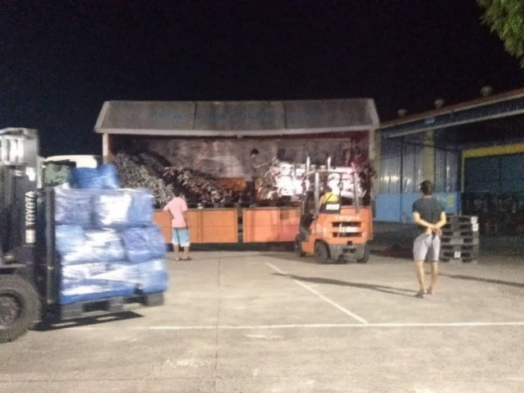

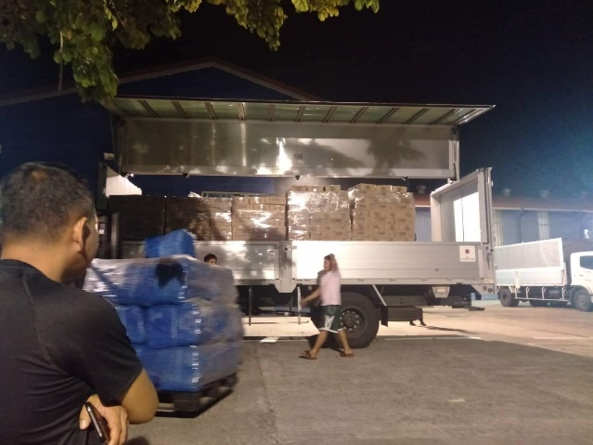
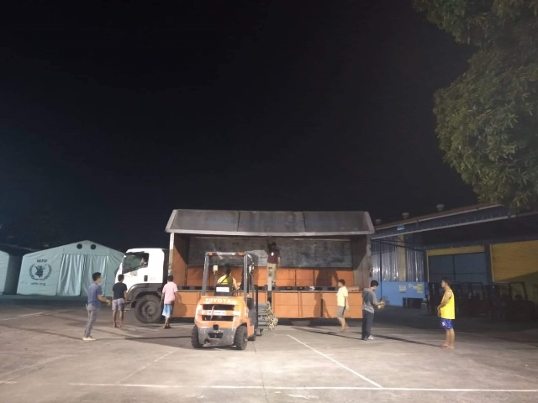

Loading of Goods at Villamor Airbase (October 30, 2019)
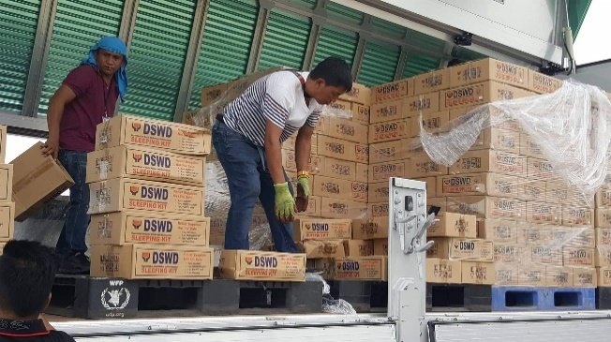
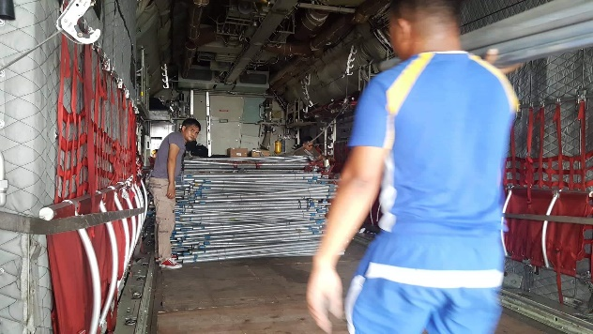

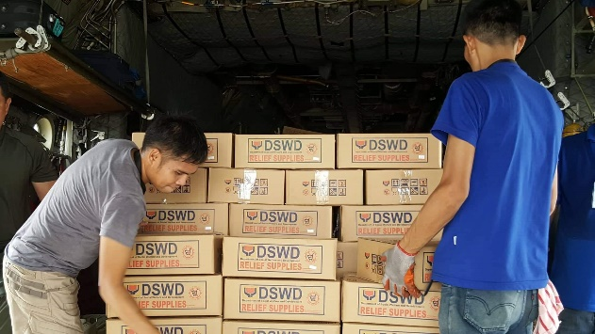
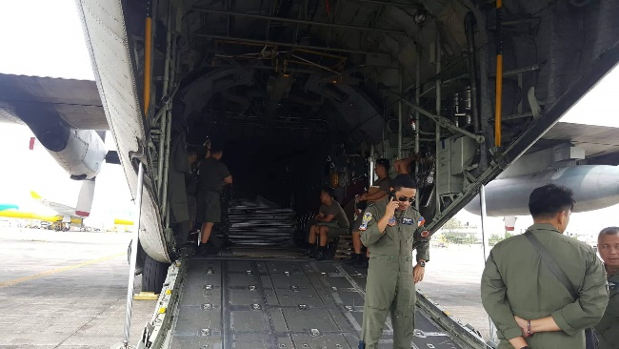

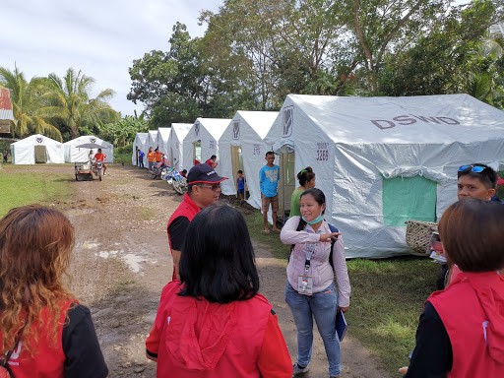
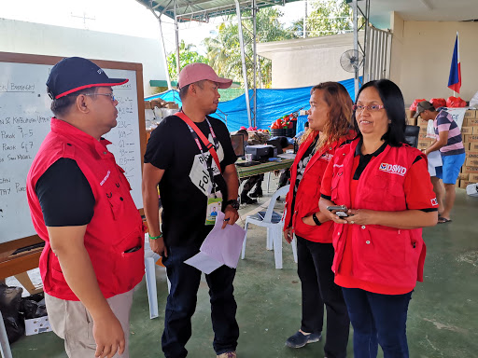
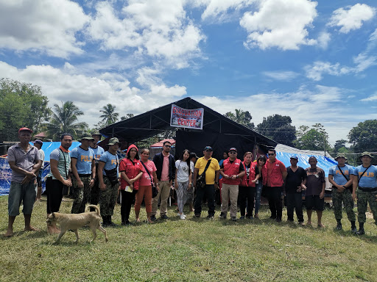
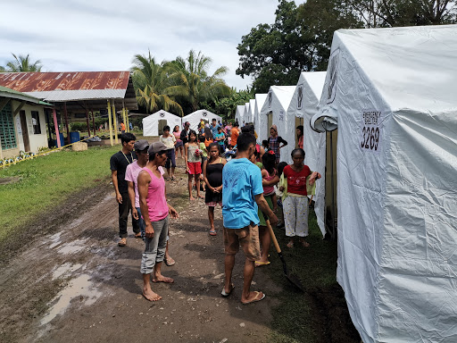
Evacuation Site Visit at Magsaysay, Davao del Sur (October 31, 2019)

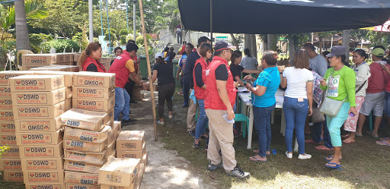
Relief distribution in coordination with LGU Matanao in Davao del Sur (October 31, 2019)
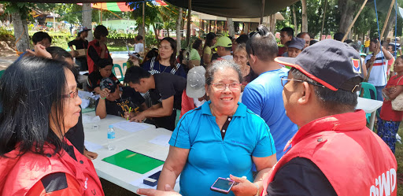

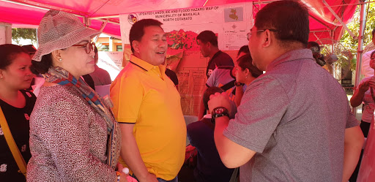
Meeting with Mayor Armando M. Quibod (middle) of Makilala, North Cotabato during the field monitoring of DSWD-DRMB headed by Dir. Rodolfo M. Encabo (right) (November 1, 2019)

Relief distribution in New Bulatukan, Makilala North Cotabato (November 02, 2019)
