DSWD DROMIC Report #15 on the
Ms 6.6 Earthquake Incident in Tulunan, North Cotabato
as of 05 November 2019, 6PM

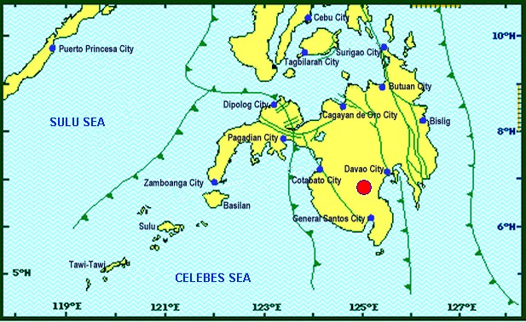
Situation Overview

On 29 October 2019 at 09:04 AM, a 6.6 magnitude earthquake jolted the municipality of Tulunan, North Cotabato (06.81°N, 125.03°E - 022 km S 79° E) with a tectonic origin and a depth of focus of 7 km. The earthquake was also felt in the neighboring municipalities of North Cotabato.

Date/Time: | 29 Oct 2019 - 09:04:43 AM
Reported Intensities: | Intensity VII – Tulunan and Makilala, Cotabato; Kidapawan City; Digos City, Bansalan,  Magsaysay, Davao del Sur and Malungon, Sarangani  Intensity VI – Koronadal City and Davao City  Intensity V – Cotabato City; Tampakan, Surallah, Banga and Tupi, South Cotabato; General Santos City; Magpet, Cotabato; Tacurong City, Kalamansig, Bagumbayan, Sultan Kudarat; Alabel, Sarangani; Kalilangan and Damulog, Bukidnon; Tagum City, Davao del Norte  Intensity IV – Cagayan De Oro City; Talakag, Manolo Fortich and Libona, Bukidnon; Glan, Maitum, Maasim and Kiamba, Sarangani; Butuan City; Iligan City; Tubod and Bacolod, Lanao del Norte  Intensity III – Molave, Zamboanga del Sur; Dipolog City, Sergio Osmeña Sr. and Polanco, Zamboanga del Norte; Zamboanga City; Gingoog City, Misamis Oriental and Bislig City  Intensity II – Kabasalan, Zamboanga Sibugay, Mambajao, Camiguin and Isabela City, Basilan  Instrumental Intensities:  Intensity VII – Malungon, Sarangani  Intensity V – Cotabato City; Alabel, Sarangani and Tupi, South Cotabato  Intensity IV – Gingoog City, Misamis Oriental; Kiamba, Sarangani; General Santos City;  Cagayan De Oro City  Intensity II – Zamboanga City and Tulunan, Cotabato  Intensity I – Palo, Leyte; Dipolog City and Bislig City
Expecting Damage: | YES
Expecting Aftershocks: | YES

Source: DOST-PHIVOLCS Earthquake Bulletin

- Status of Affected Families / Persons
A total of 49,681 families or 248,408 persons were affected by the earthquake incident in 251 barangays in Regions XI and XII (see Table 1).

Table 1. Number of Affected Families / Persons
REGION / PROVINCE / MUNICIPALITY |  | NUMBER OF AFFECTED
 |  | Barangays | Families | Persons
GRAND TOTAL |  | 251 | 49,681 | 248,408
REGION XI |  | 133 | 18,799 | 93,998
Davao del Sur |  | 128 | 18,778 | 93,893
 | Bansalan | 24 | 6,379 | 31,895
 | City of Digos (capital) | 14 | 1,501 | 7,508
 | Hagonoy | 21 | 596 | 2,980
 | Kiblawan | 1 | 1 | 5
 | Magsaysay | 22 | 8,723 | 43,615
 | Malalag | 3 | 229 | 1,145
 | Matanao | 31 | 1,309 | 6,545
 | Padada | 1 | 2 | 10
 | Santa Cruz | 11 | 38 | 190
Davao Occidental |  | 5 | 21 | 105
 | Malita | 1 | 1 | 5
 | Santa Maria | 4 | 20 | 100
REGION XII |  | 118 | 30,882 | 154,410
North Cotabato |  | 118 | 30,882 | 154,410
 | Arakan | 9 | 53 | 265
 | City of Kidapawan (capital) | 6 | 2,099 | 10,495
 | Magpet | 15 | 2,426 | 12,130
 | Makilala | 38 | 20,704 | 103,520
 | M'lang | 15 | 514 | 2,570
 | President Roxas | 6 | 164 | 820
 | Tulunan | 29 | 4,922 | 24,610
Note: Ongoing assessment and validation being conducted.
Source: DSWD-FOs XI and XII
- Status of Displaced Families / Persons
- Inside Evacuation Center
There are 10,224 families or 49,901 persons taking temporary shelter in forty-two (42) evacuation centers in Regions XI and XII (see Table 2).

Table 2. Number of Displaced Families / Persons Inside Evacuation Centers
REGION / PROVINCE / MUNICIPALITY |  | NUMBER OF EVACUATION CENTERS (ECs) |  | INSIDE ECs
 |  |  |  | Families |  | Persons
 |  | CUM | NOW | CUM | NOW | CUM | NOW
GRAND TOTAL |  | 45 | 42 | 10,576 | 10,224 | 52,395 | 49,901
REGION XI |  | 26 | 23 | 5,810 | 5,458 | 28,565 | 26,071
Davao del Sur |  | 26 | 23 | 5,810 | 5,458 | 28,565 | 26,071
 | Bansalan | 9 | 6 | 3,858 | 3,516 | 19,290 | 17,580
 | City of Digos (capital) | 3 | 3 | 173 | 173 | 865 | 865
 | Hagonoy | 4 | 4 | 438 | 438 | 2,190 | 2,190
 | Magsaysay | 10 | 10 | 1,341 | 1,331 | 6,220 | 5,436
REGION XII |  | 19 | 19 | 4,766 | 4,766 | 23,830 | 23,830
North Cotabato |  | 19 | 19 | 4,766 | 4,766 | 23,830 | 23,830
 | City of Kidapawan (capital) | 9 | 9 | 2,029 | 2,029 | 10,145 | 10,145
 | Makilala | 10 | 10 | 2,737 | 2,737 | 13,685 | 13,685
Note: Ongoing assessment and validation being conducted.
Source: DSWD-FOs XI and XII
- Outside Evacuation Center
There are 8,659 families or 43,295 persons currently staying with their relatives and/or friends (see Table 3).

Table 3. Number of Displaced Families / Persons Outside Evacuation Centers
REGION / PROVINCE / MUNICIPALITY |  | OUTSIDE ECs
 |  | Families |  | Persons
 |  | CUM | NOW | CUM | NOW
GRAND TOTAL |  | 8,659 | 8,659 | 43,295 | 43,295
REGION XI |  | 7,556 | 7,556 | 37,780 | 37,780
Davao del Sur |  | 7,556 | 7,556 | 37,780 | 37,780
 | Bansalan | 126 | 126 | 630 | 630
 | Magsaysay | 7,402 | 7,402 | 37,010 | 37,010
 | Santa Cruz | 28 | 28 | 140 | 140
REGION XII |  | 1,103 | 1,103 | 5,515 | 5,515
North Cotabato |  | 1,103 | 1,103 | 5,515 | 5,515
 | Arakan | 53 | 53 | 265 | 265
 | City of Kidapawan (capital) | 70 | 70 | 350 | 350
 | M'lang | 50 | 50 | 250 | 250
 | Tulunan | 930 | 930 | 4,650 | 4,650
Note: Ongoing assessment and validation being conducted.
Source: DSWD-FOs XI and XII

- Damaged Houses
There are 34,373 damaged houses; of which, 22,505 are totally damaged and 11,868 are partially damaged (see Table 4).

Table 4. Number of Damaged Houses
REGION / PROVINCE / MUNICIPALITY |  | NO. OF DAMAGED HOUSES
 |  | Total | Totally | Partially
GRAND TOTAL |  | 34,373 | 22,505 | 11,868
REGION XI |  | 6,962 | 1,721 | 5,241
Davao del Sur |  | 6,941 | 1,720 | 5,221
 | Bansalan | 858 | 174 | 684
 | Hagonoy | 334 | 41 | 293
 | Kiblawan | 1 | 1 | -
 | Magsaysay | 5,684 | 1,501 | 4,183
 | Matanao | 51 | 1 | 50
 | Padada | 2 | - | 2
 | Santa Cruz | 11 | 2 | 9
Davao Occidental |  | 21 | 1 | 20
 | Malita | 1 | 1 | -
 | Santa Maria | 20 | - | 20
REGION XII |  | 27,411 | 20,784 | 6,627
North Cotabato |  | 27,411 | 20,784 | 6,627
 | Arakan | 25 | 1 | 24
 | City of Kidapawan (capital) | 1,366 | 38 | 1,328
 | Makilala | 20,704 | 18,997 | 1,707
 | M'lang | 230 | 73 | 157
 | President Roxas | 164 | 74 | 90
 | Tulunan | 4,922 | 1,601 | 3,321
Note: Ongoing assessment and validation being conducted
Source: DSWD-FOs XI and XII

- Assistance Provided
A total of ₱18,665,988.20 worth of assistance was provided by DSWD to the affected families (see Table 5).

Table 5. Cost of Assistance Provided to Affected Families / Persons
REGION / PROVINCE / MUNICIPALITY |  | TOTAL COST OF ASSISTANCE
 |  | DSWD | LGU | NGOs | OTHERS | GRAND TOTAL
GRAND TOTAL |  | 18,665,988.20 | - | - | - | 18,665,988.20
REGION XI |  | 9,368,696.20 | - | - | - | 9,368,696.20
Davao del Sur |  | 9,368,696.20 | - | - | - | 9,368,696.20
 | Bansalan | 2,729,252.20 | - | - | - | 2,729,252.20
 | City of Digos (capital) | 1,454,100.00 | - | - | - | 1,454,100.00
 | Magsaysay | 3,498,630.00 | - | - | - | 3,498,630.00
 | Malalag | 527,330.00 | - | - | - | 527,330.00
 | Matanao | 1,159,384.00 | - | - | - | 1,159,384.00
REGION XII |  | 9,297,292.00 | - | - | - | 9,297,292.00
North Cotabato |  | 9,297,292.00 | - | - | - | 9,297,292.00
 | Arakan | 44,856.00 | - | - | - | 44,856.00
 | City of Kidapawan (capital) | 1,496,241.00 | - | - | - | 1,496,241.00
 | Magpet | 720,300.00 | - | - | - | 720,300.00
 | Makilala | 3,286,837.00 | - | - | - | 3,286,837.00
 | M'lang | 123,508.00 | - | - | - | 123,508.00
 | Tulunan | 3,625,550.00 | - | - | - | 3,625,550.00
Source: DSWD-FOs XI and XII

DSWD DISASTER RESPONSE INFORMATION
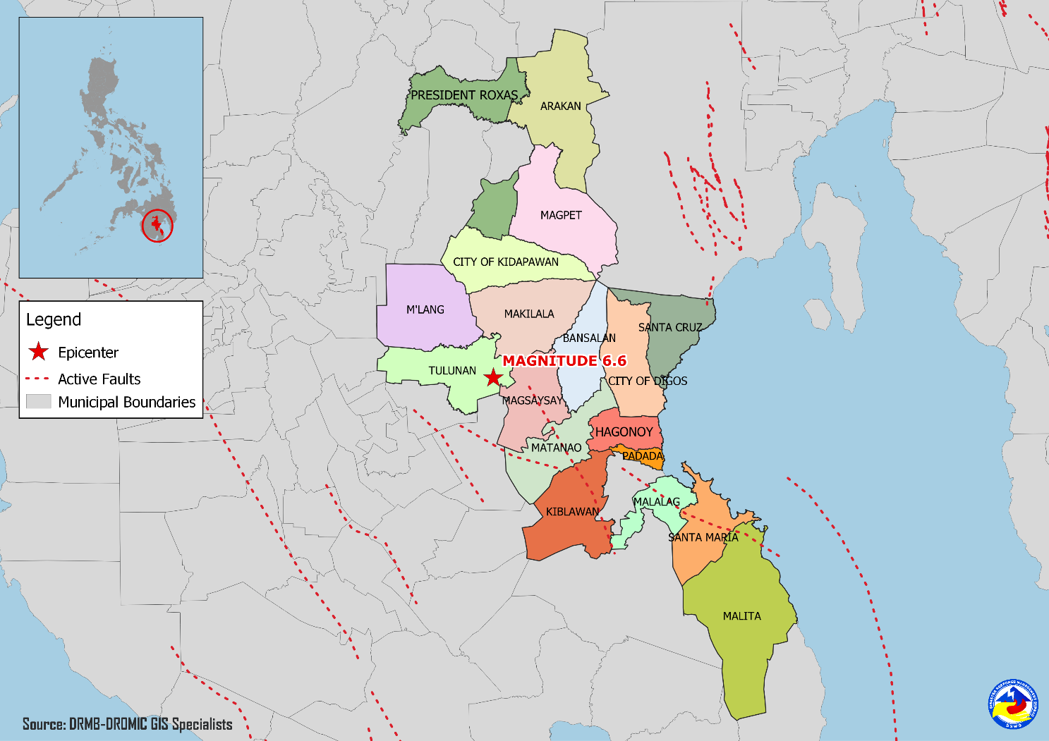

Situational Reports

DSWD-DRMB
DATE | SITUATIONS / ACTIONS UNDERTAKEN
05 November 2019 | - The Disaster Response Management Bureau (DRMB) is on BLUE alert level status and is closely coordinating with the concerned field offices for significant disaster response updates.  - All QRT members and emergency equipment are on standby and ready for deployment.  - Metropolitan Waterworks and Sewerage System (MWSS) committed to provide 400 bottles of 6 liters of water and 1,581 bottles of 1 liter of water for airlift to Davao via Air Asia on Tuesday, 05 November 2019.  - The four (4) technical staff from DSWD-DRMB deployed on 03 November 2019 are currently providing technical assistance and resource augmentation for the affected families in Region XI.
04 November 2019 | - Prepared and released Sub-Allotment amounting to ₱20,160,000.00 intended for the purchase of family food packs and operational expenses for the ongoing relief operation due to 6.6 magnitude Earthquake in Region XI.  - Ongoing process of Sub-Allotment amounting to ₱26,732,500.00 intended for the purchase of family food packs, operational expenses and standby funds for the ongoing relief operation due to 6.6 magnitude Earthquake in Region XII.

DSWD-NRLMB
DATE | SITUATIONS / ACTIONS UNDERTAKEN
05 November 2019 | - The 1,333 sleeping kits arrived in Region XII, transported thru Cebu Pacific Airlines.
04 November 2019 | - A total of 4,500 family food packs, 1,500 pieces sleeping kits and 1,500 pieces laminated sacks were in transit to DSWD-FO XI via Philippine Cost Guard which departed on Nov.01, 2019 at 9:00AM at Ubusan Port, Allen, Northern Samar.  - A total of 7,500 Family Food Packs were in transit to DSWD-FO XII via Philippine Cost Guard which departed Nov.01, 2019 at 9:00AM at Ubusan Port, Allen, Northern Samar.
03 November 2019 | - A total of 9,600 pieces of laminated sacks, 4,513 pieces of kitchen kits and 2,800 pieces of sleeping kits were loaded at NROC for delivery to DSWD-FO XII via 5x10 wheeler wing van.
02 November 2019 | - A total of 25 pieces of family tents and 250 laminated sacks will be delivered to DSWD-FO XI via Air Asia Airlines.  - A total of 4,500 family food packs, 1,500 sleeping kits and 1,500 laminated sacks were in transit to DSWD-FO XI via Philippine Coast Guard.  - A total of 125 family tents were in transit to DSWD-FO XI via 10-wheeler wing van and currently in Gandara, Samar.  - A total of 7,500 family food packs were in transit to DSWD-FO XII via Philippine Coast Guard XI.  - A total of 2,815 sleeping kits, 2,160 kitchen kits, 4,800 pre-cut laminated sacks and 125 family tents were in transit to DSWD-FO XII via 4x10-wheeler wing van.  - A total of 1,060 pieces of laminated sacks, 267 pieces of sleeping kits and 1,200 pieces of kitchen kits were scheduled to be airlifted via Cebu Pacific on November 3 and 4.

DSWD-FO XI
DATE | ACTION(S) TAKEN
- November 2019 | - DSWD-FO XI is still on RED alert level status.  - DSWD FO XI coordinated with SWADT/PAT/MAT/QRT/ Camp Mangers assigned in different evacuation centers to capture the needs of IDPs.  - Coordinated with assigned camp managers for the status of evacuation centers in municipalities of Bansalan, Magsaysay, and Digos, in Davao del Sur.  - DSWD- FO XI established Operations Center in the Province of Davao del Sur.  - Coordinated with NLRMB, DSWD-FOs IX and X, Field Office in Bicol, and Metropolitan Waterworks and Sewerage System (MWSS) for logistic status of augmentation.  - Coordinated with municipalities of Bansalan and Magsaysay for the validated number of affected families.  - DSWD-FO XI staff joined the RDANA Team in Bansalan Davao del Sur to conduct assessment and validate the needs of affected communities.  - DRMD Chief had a radio and t.v interview regarding disaster relief operations of DSWD.
04 November 2019 | - Ongoing repacking of goods at DSWD Warehouse.  - Briefing of 10 Camp Managers (3rd Batch) to be deployed in Magsaysay, Davao del Sur.
03 November 2019 | - DSWD-FO XI received augmentation support from DSWD-FO IX (500 hygiene kits, 500 mosquito nets, 150 Blankets, 250 towels, 70 cases sardines); DSWD-FO X (3,000 sleeping kits, 5,000 drinking kits, and 100 bundles of Trapal); and DSWD-FO CARAGA (3,000 family food packs, 168 hygiene kits, 678 mosquito kits, 678 blankets, 2,003 malong, 120 plastic mat and 1,128 laminated sacks).

DSWD-FO XII
DATE | ACTION(S) TAKEN
- November 2019 | - DSWD-FO XII is still on RED alert status.  - DSWD-FO XII distributed 345 family food packs in Makilala, North Cotabato.  - DSWD-FO XII distributed 428 family food packs and 320 sleeping kits in Kidapawan, North Cotabato.  - DSWD-FO XII distributed 500 family food packs, 100 sleeping kits, and 100 pieces of laminated sacks (10 meters) to the affected families.  - DSWD-FO XII distributed 4,000 family food packs in Tulunan, North Cotabato.  - DSWD-FO XII staff attended the PDRRMC meeting.  - DSWD QRT members administered the profiling of the IDPs using DAFAC in Brgy. Bulakanon, Makilala, North Cotabato.  - Installation of Mobile Storage Unit (MSU) in Amas, Kidapawan Provincial Capitol.  - DSWD-FO XII distributed 169 rolls of Laminated Sacks, 471 Sleeping Kits and 500 Kitchen Kits in Makilala, North Cotabato.  - DSWD-FO XII delivered 161 FFPs, 633 family kits and 50 rolls of Laminated Sacks for the prepositioning of food and non-food items at the CIU Satellite Office in Kidapawan City.

***
The Disaster Response Operations Monitoring and Information Center (DROMIC) of the DSWD-DRMB is closely coordinating with concerned DSWD Field Offices for any significant disaster response updates.

Prepared by:

MARIEL B. FERRARIZ
DIANE C. PELEGRINO

RODEL V. CABADDU
Releasing Officer

PHOTO DOCUMENTATION

Loading of Goods at NROC (October 30, 2019)
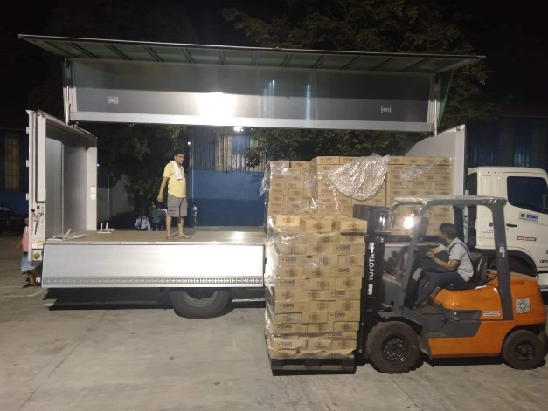
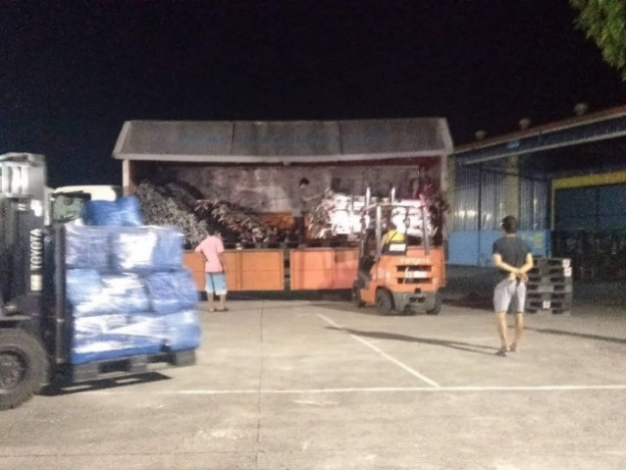

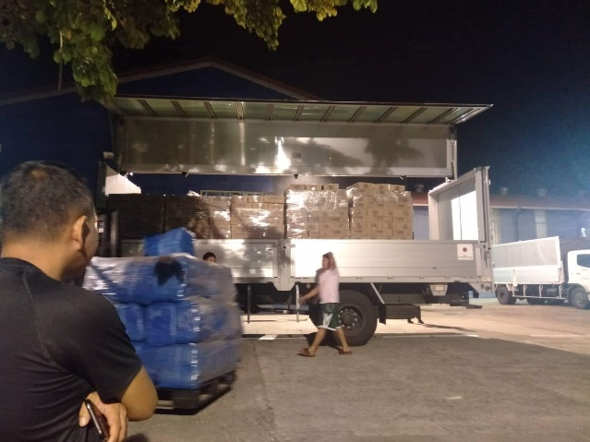
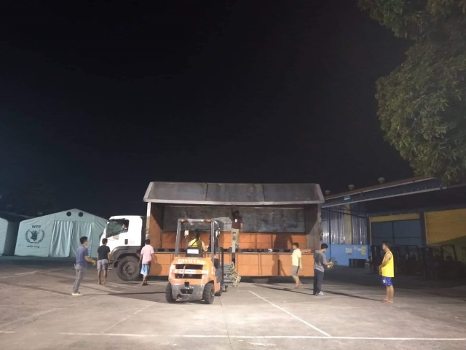

Loading of Goods at Villamor Airbase (October 30, 2019)
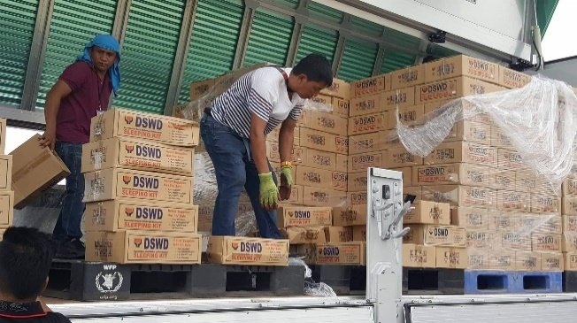
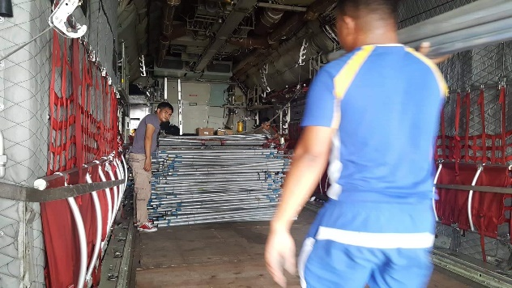

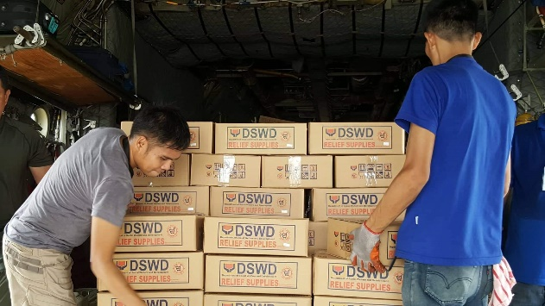
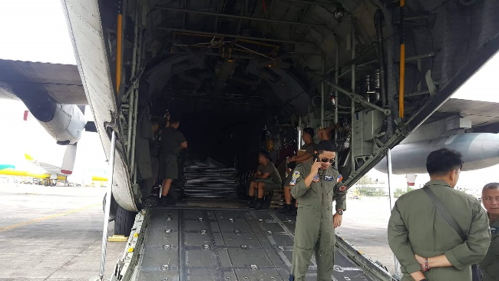

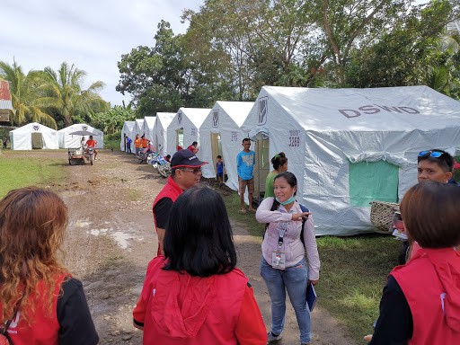
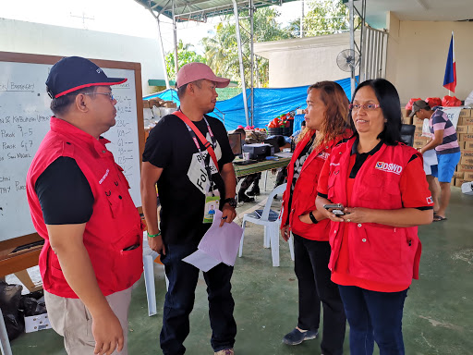
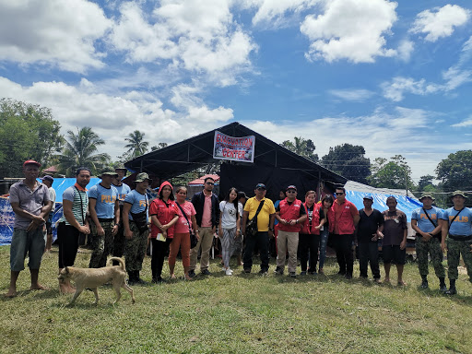
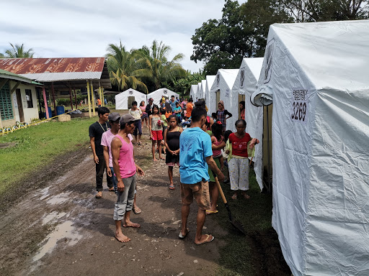
Evacuation Site Visit at Magsaysay, Davao del Sur (October 31, 2019)

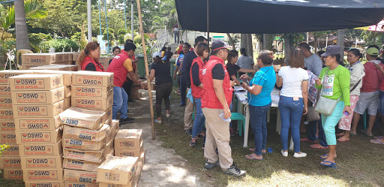
Relief distribution in coordination with LGU Matanao in Davao del Sur (October 31, 2019)
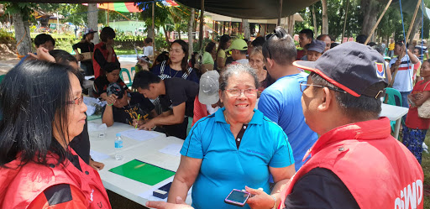

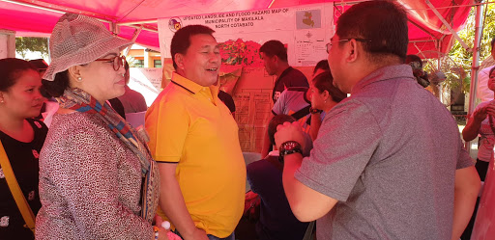
Meeting with Mayor Armando M. Quibod (middle) of Makilala, North Cotabato during the field monitoring of DSWD-DRMB headed by Dir. Rodolfo M. Encabo (right) (November 1, 2019)

Relief distribution in New Bulatukan, Makilala North Cotabato (November 02, 2019)
