DSWD DROMIC Report #19 on the
Ms 6.6 Earthquake Incident in Tulunan, North Cotabato
as of 08 November 2019, 6PM

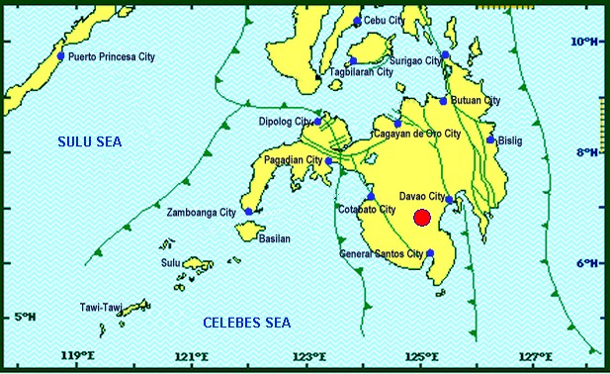
Situation Overview

On 29 October 2019 at 09:04 AM, a 6.6 magnitude earthquake jolted the municipality of Tulunan, North Cotabato (06.81°N, 125.03°E - 022 km S 79°E) with a tectonic origin and a depth of focus of 7 km. The earthquake was also felt in the neighboring municipalities of North Cotabato and Davao Region.

Source: DOST-PHIVOLCS Earthquake Bulletin

- Status of Affected Families / Persons

A total of 53,044 families or 264,531 persons were affected by the earthquake incident in 314 barangays in Regions XI and XII (see Table 1).

Table 1. Number of Affected Families / Persons
REGION / PROVINCE / MUNICIPALITY |  | NUMBER OF AFFECTED
 |  | Barangay | Families | Persons
GRAND TOTAL |  | 314 | 53,044 | 264,531
REGION XI |  | 148 | 20,651 | 102,566
Davao del Sur |  | 143 | 20,630 | 102,461
 | Bansalan | 24 | 7,171 | 35,855
 | City of Digos (capital) | 13 | 2,044 | 10,220
 | Hagonoy | 21 | 894 | 3,961
 | Kiblawan | 14 | 70 | 350
 | Magsaysay | 22 | 8,723 | 43,615
 | Malalag | 3 | 229 | 1,145
 | Matanao | 31 | 1,309 | 6,545
 | Padada | 1 | 2 | 10
 | Santa Cruz | 11 | 38 | 190
 | Sulop | 3 | 150 | 570
Davao Occidental |  | 5 | 21 | 105
 | Malita | 1 | 1 | 5
 | Santa Maria | 4 | 20 | 100
REGION XII |  | 166 | 32,393 | 161,965
North Cotabato |  | 164 | 32,337 | 161,685
 | Arakan | 11 | 108 | 540
 | Kabacan | 3 | 75 | 375
 | City of Kidapawan (capital) | 28 | 2,099 | 10,495
 | Magpet | 14 | 2,024 | 10,120
 | Makilala | 38 | 20,704 | 103,520
 | Matalam | 2 | 75 | 375
 | M'lang | 33 | 1,994 | 9,970
 | President Roxas | 6 | 164 | 820
 | Tulunan | 29 | 5,094 | 25,470
South Cotabato |  | 1 | 18 | 90
 | Tupi | 1 | 18 | 90
Sultan Kudarat |  | 1 | 38 | 190
 | Columbio | 1 | 38 | 190
Note: The decrease in the number of affected families and persons is due to ongoing assessment and validation being conducted.
Source: DSWD-FOs XI and XII

- Status of Displaced Families / Persons
- Inside Evacuation Center
There are 11,547 families or 55,462 persons taking temporary shelter in sixty-eight (68) evacuation centers in Regions XI and XII (see Table 2).

Table 2. Number of Displaced Families / Persons Inside Evacuation Centers
REGION / PROVINCE / MUNICIPALITY |  | NUMBER OF EVACUATION CENTERS (ECs) |  | NUMBER OF DISPLACED
 |  |  |  | INSIDE ECs
 |  |  |  | Families |  | Persons
 |  | CUM | NOW | CUM | NOW | CUM | NOW
GRAND TOTAL |  | 71 | 68 | 14,939 | 11,547 | 73,179 | 55,462
REGION XI |  | 42 | 39 | 8,162 | 4,770 | 39,294 | 21,577
Davao del Sur |  | 42 | 39 | 8,162 | 4,770 | 39,294 | 21,577
 | Bansalan | 9 | 6 | 3,999 | 680 | 19,789 | 2,622
 | City of Digos (capital) | 15 | 15 | 1,784 | 1,784 | 8,920 | 8,920
 | Hagonoy | 4 | 4 | 438 | 438 | 2,190 | 2,190
 | Magsaysay | 10 | 10 | 1,617 | 1,544 | 6,955 | 6,405
 | Matanao | 1 | 1 | 174 | 174 | 870 | 870
 | Sulop | 3 | 3 | 150 | 150 | 570 | 570
REGION XII |  | 29 | 29 | 6,777 | 6,777 | 33,885 | 33,885
North Cotabato |  | 29 | 29 | 6,777 | 6,777 | 33,885 | 33,885
 | City of Kidapawan (capital) | 9 | 9 | 2,029 | 2,029 | 10,145 | 10,145
 | Makilala | 20 | 20 | 4,748 | 4,748 | 23,740 | 23,740
Note: Ongoing assessment and validation being conducted.
Source: DSWD-FOs XI and XII

- Outside Evacuation Center
There are 9,110 families or 45,550 persons currently staying with their relatives and/or friends (see Table 3).

Table 3. Number of Displaced Families / Persons Outside Evacuation Centers
REGION / PROVINCE / MUNICIPALITY |  | NUMBER OF DISPLACED
 |  | OUTSIDE ECs
 |  | Families |  | Persons
 |  | CUM | NOW | CUM | NOW
GRAND TOTAL |  | 9,110 | 9,110 | 45,550 | 45,550
REGION XI |  | 7,877 | 7,877 | 39,385 | 39,385
Davao del Sur |  | 7,877 | 7,877 | 39,385 | 39,385
 | Bansalan | 447 | 447 | 2,235 | 2,235
 | Magsaysay | 7,402 | 7,402 | 37,010 | 37,010
 | Santa Cruz | 28 | 28 | 140 | 140
REGION XII |  | 1,233 | 1,233 | 6,165 | 6,165
North Cotabato |  | 1,233 | 1,233 | 6,165 | 6,165
 | Arakan | 108 | 108 | 540 | 540
 | Kabacan | 75 | 75 | 375 | 375
 | City of Kidapawan (capital) | 70 | 70 | 350 | 350
 | M'lang | 50 | 50 | 250 | 250
 | Tulunan | 930 | 930 | 4,650 | 4,650
Note: Ongoing assessment and validation being conducted.
Source: DSWD-FOs XI and XII
- Damaged Houses
There are 35,740 damaged houses; of which, 22,678 are totally damaged and 13,062 are partially damaged (see Table 4).

Table 4. Number of Damaged Houses
REGION / PROVINCE / MUNICIPALITY |  | NO. OF DAMAGED HOUSES
 |  | Total | Totally | Partially
GRAND TOTAL |  | 35,740 | 22,678 | 13,062
REGION XI |  | 7,112 | 1,775 | 5,337
Davao del Sur |  | 7,091 | 1,774 | 5,317
 | Bansalan | 858 | 174 | 684
 | Hagonoy | 334 | 41 | 293
 | Kiblawan | 1 | 1 | -
 | Magsaysay | 5,684 | 1,501 | 4,183
 | Matanao | 51 | 1 | 50
 | Padada | 2 | - | 2
 | Santa Cruz | 11 | 2 | 9
 | Sulop | 150 | 54 | 96
Davao Occidental |  | 21 | 1 | 20
 | Malita | 1 | 1 | -
 | Santa Maria | 20 | - | 20
REGION XII |  | 28,628 | 20,903 | 7,725
North Cotabato |  | 28,572 | 20,888 | 7,684
 | Arakan | 110 | 4 | 106
 | Kabacan | 58 | 2 | 56
 | City of Kidapawan (capital) | 1,366 | 38 | 1,328
 | Makilala | 20,704 | 18,997 | 1,707
 | Matalam | 121 | 1 | 120
 | M'lang | 955 | 89 | 866
 | President Roxas | 164 | 74 | 90
 | Tulunan | 5,094 | 1,683 | 3,411
South Cotabato |  | 18 | 1 | 17
 | Tupi | 18 | 1 | 17
Sultan Kudarat |  | 38 | 14 | 24
 | Columbio | 38 | 14 | 24
Note: Ongoing assessment and validation being conducted
Source: DSWD-FOs XI and XII

- Assistance Provided
A total of ₱34,481,656.92 worth of assistance was provided by DSWD to the affected families (see Table 5).

Table 5. Cost of Assistance Provided to Affected Families / Persons
REGION / PROVINCE / MUNICIPALITY |  | DSWD | LGU | NGOs | OTHERS | GRAND TOTAL
GRAND TOTAL |  | 34,481,656.92 | - | - | - | 34,481,656.92
REGION XI |  | 10,036,196.20 | - | - | - | 10,036,196.20
Davao del Sur |  | 10,036,196.20 | - | - | - | 10,036,196.20
 | Bansalan | 2,951,752.20 | - | - | - | 2,951,752.20
 | City of Digos (capital) | 1,454,100.00 | - | - | - | 1,454,100.00
 | Magsaysay | 3,943,630.00 | - | - | - | 3,943,630.00
 | Malalag | 527,330.00 | - | - | - | 527,330.00
 | Matanao | 1,159,384.00 | - | - | - | 1,159,384.00
REGION XII |  | 24,445,460.72 | - | - | - | 24,445,460.72
North Cotabato |  | 24,445,460.72 | - | - | - | 24,445,460.72
 | Arakan | 44,856.00 | - | - | - | 44,856.00
 | City of Kidapawan (capital) | 3,261,722.00 | - | - | - | 3,261,722.00
 | Magpet | 7,362,569.00 | - | - | - | 7,362,569.00
 | Makilala | 7,421,637.00 | - | - | - | 7,421,637.00
 | M'lang | 1,298,374.00 | - | - | - | 1,298,374.00
 | Tulunan | 5,056,302.72 | - | - | - | 5,056,302.72
Source: DSWD-FOs XI and XII

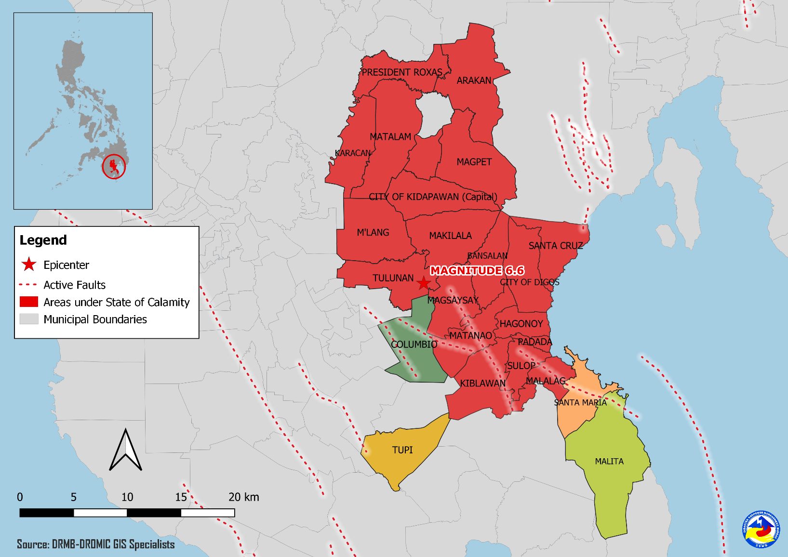
DSWD DISASTER RESPONSE INFORMATION
Source: DRMB-DROMIC GIS Specialists

Situational Reports

DSWD-DRMB
DATE | SITUATIONS / ACTIONS UNDERTAKEN
08 November 2019 | - The Disaster Response Management Bureau (DRMB) is on BLUE alert status and is closely coordinating with the concerned field offices for significant disaster response updates.  - All QRT members and emergency equipment are on standby and ready for deployment.  - The four (4) technical staff from DSWD-DRMB deployed on 03 November 2019 are currently providing technical assistance and resource augmentation to DSWD-FO XI.
04 November 2019 | - Prepared and released sub-allotment amounting to ₱20,160,000.00 intended for the purchase of family food packs and operational expenses for the ongoing relief operation due to 6.6 magnitude Earthquake in Region XI.  - Ongoing process of sub-allotment amounting to ₱26,732,500.00 intended for the purchase of family food packs, operational expenses and standby funds for the ongoing relief operation due to 6.6 magnitude Earthquake in Region XII.

DSWD-NRLMB
DATE | SITUATIONS / ACTIONS UNDERTAKEN
04 November 2019 | - A total of 4,500 family food packs, 1,500 pieces sleeping kits and 1,500 pieces laminated sacks were in transit to DSWD-FO XI via Philippine Cost Guard which departed on November 1, 2019 at 9AM at Ubusan Port, Allen, Northern Samar.  - A total of 7,500 family food packs were in transit to DSWD-FO XII via Philippine Cost Guard which departed November 1, 2019 at 9AM at Ubusan Port, Allen, Northern Samar.
03 November 2019 | - A total of 9,600 pieces of laminated sacks, 4,513 pieces of kitchen kits and 2,800 pieces of sleeping kits were loaded at NROC for delivery to DSWD-FO XII via 5x10 wheeler wing van.
02 November 2019 | - A total of 25 pieces of family tents and 250 laminated sacks would be delivered to DSWD-FO XI via Air Asia Airlines.  - A total of 4,500 family food packs, 1,500 sleeping kits and 1,500 laminated sacks were in transit to DSWD-FO XI via Philippine Coast Guard.  - A total of 125 family tents were in transit to DSWD-FO XI via 10-wheeler wing van.  - A total of 7,500 family food packs were in transit to DSWD-FO XII via Philippine Coast Guard XI.  - A total of 2,815 sleeping kits, 2,160 kitchen kits, 4,800 pre-cut laminated sacks and 125 family tents were in transit to DSWD-FO XII via 4x10-wheeler wing van.  - A total of 1,060 pieces of laminated sacks, 267 pieces of sleeping kits and 1,200 pieces of kitchen kits were scheduled to be airlifted via Cebu Pacific on November 3 and 4.

DSWD-FO XI
DATE | ACTION(S) TAKEN
08 November 2019 | - DSWD-FO XI is still on RED alert status.  - The Sangguniang Panlalawigan of Cotabato approved the SP Resolution No. 19-88 declaring the entire province of Davao del Sur under State of Calamity.
07 November 2019 | - Metropolitan Waterworks Sewerage System (MWSS) provided 1,581 bottles of 1 liter of water and 400 bottles of 6 liters of water to the affected families in Davao Region.  - DSWD-FO XI distributed 1,500 family food packs, 300 trapal/sakoline in Bansalan, Davao del Sur. Also, 44 family tents were provided to Dolo, Mt. Carmel and Altavista Evacuation Centers.  - DSWD-FO XI distributed 1,500 sleeping kits and 540 trapal/sakoline in Magsaysay, Davao del Sur.  - DSWD-FO XI distributed 50 family tents to BIR Evacuation Center in Digos City, Davao del Sur.  - DSWD-FO XI distributed 400 (6L) and 1,581 (1L) bottles of water from Maynilad to the affected families in BIR Evacuation Center in Digos City, Davao del Sur.  - DSWD-FO XI received the Mobile Storage Unit from World Food Program (WFP).  - DSWD-FO XI conducted meeting with the OIC-Regional Director, Division and Unit Heads for the status of disaster operations, and to resolve issues and concerns regarding financial status, stockpiles and manpower.  - DSWD-FO XI coordinated with SWADT/PAT/MAT/QRT/Camp Managers assigned in different evacuation centers to capture the needs of IDPs.
06 November 2019 | - DSWD-FO XI provided medical assistance and burial assistance to injured individuals and bereaved families amounting to a total of ₱2,090,535.00.

DSWD-FO XII
DATE | ACTION(S) TAKEN
08 November 2019 | - DSWD-FO XII is still on RED alert status.  - The Sangguniang Panlalawigan of Cotabato approved the SP Resolution No. 842 declaring the entire province of Cotabato under State of Calamity.
- November 2019 | - DSWD-FO XII distributed 345 family food packs in Makilala, North Cotabato.  - DSWD-FO XII distributed 428 family food packs and 320 sleeping kits in Kidapawan City, North Cotabato.  - DSWD-FO XII distributed 500 family food packs, 100 sleeping kits, and 100 pieces of laminated sacks (10 meters) to the affected families.  - DSWD-FO XII distributed 4,000 family food packs in Tulunan, North Cotabato.  - DSWD-FO XII distributed 169 rolls of laminated sacks, 471 sleeping kits and 500 kitchen kits in Makilala, North Cotabato.  - DSWD-FO XII delivered 161 FFPs, 633 family kits, and 50 rolls of laminated sacks for the prepositioning of food and non-food items at the CIU Satellite Office in Kidapawan City.

***
The Disaster Response Operations Monitoring and Information Center (DROMIC) of the DSWD-DRMB is closely coordinating with concerned DSWD Field Offices for any significant disaster response updates.

Prepared by:

DIANE C. PELEGRINO
MARIEL B. FERRARIZ

RODEL V. CABADDU
Releasing Officer

PHOTO DOCUMENTATION

Loading of Goods at NROC (October 30, 2019)
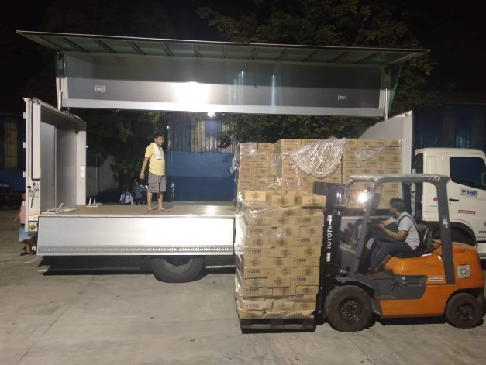
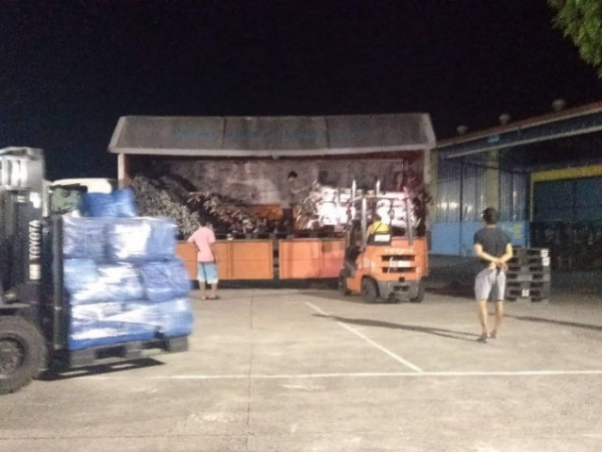

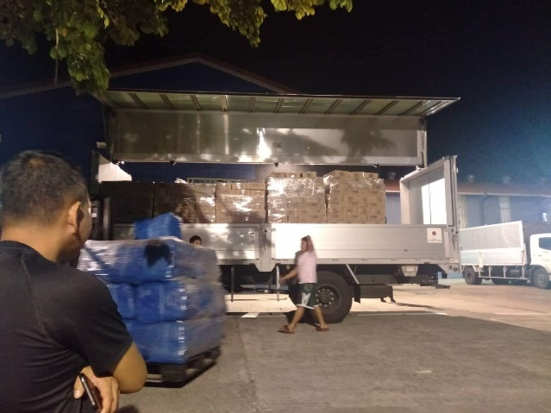
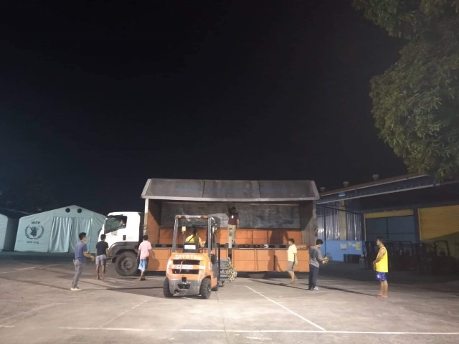

Loading of Goods at Villamor Airbase (October 30, 2019)
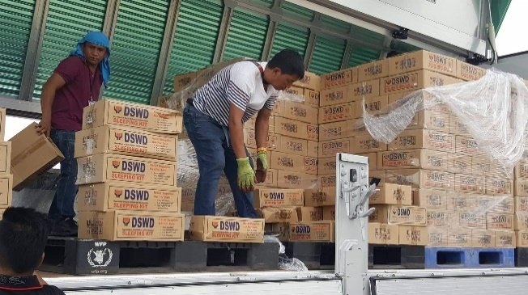
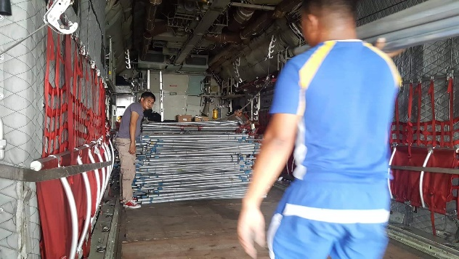

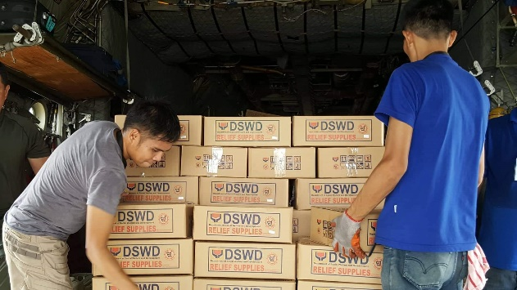
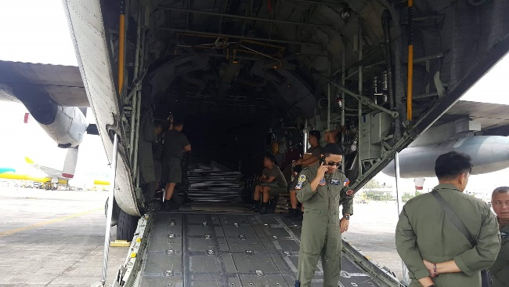

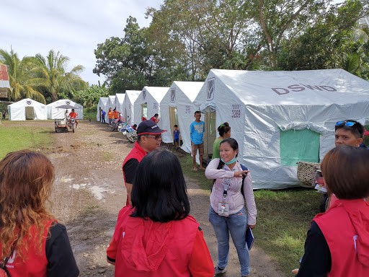
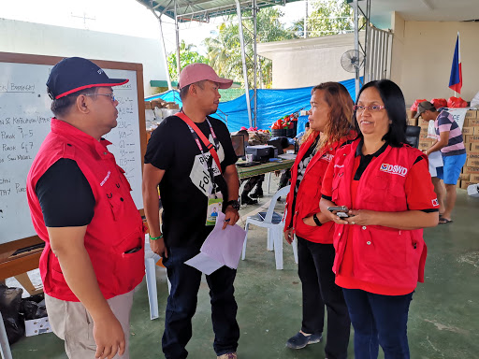
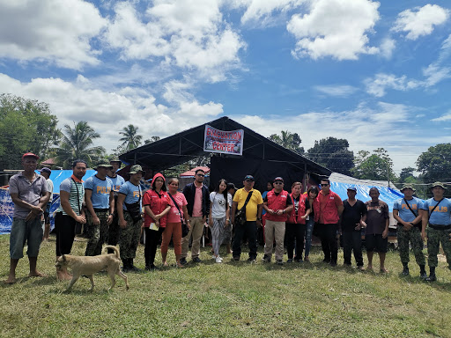
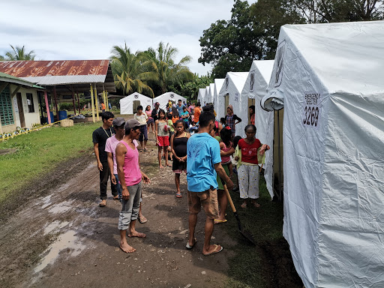
Evacuation Site Visit at Magsaysay, Davao del Sur (October 31, 2019)

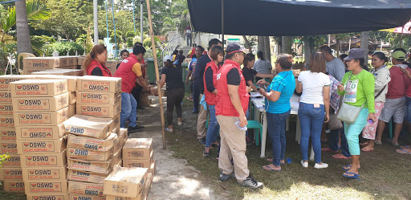
Relief distribution in coordination with LGU Matanao in Davao del Sur (October 31, 2019)
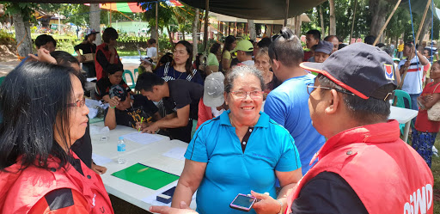

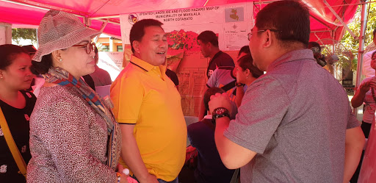
Meeting with Mayor Armando M. Quibod (middle) of Makilala, North Cotabato during the field monitoring of DSWD-DRMB headed by Dir. Rodolfo M. Encabo (right) (November 1, 2019)

Relief distribution in New Bulatukan, Makilala North Cotabato (November 02, 2019)
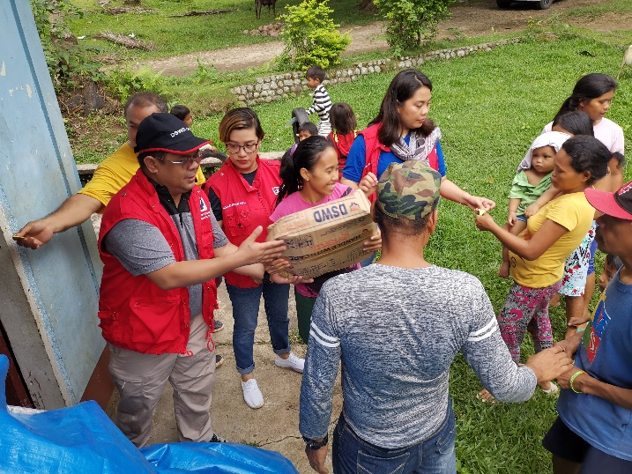
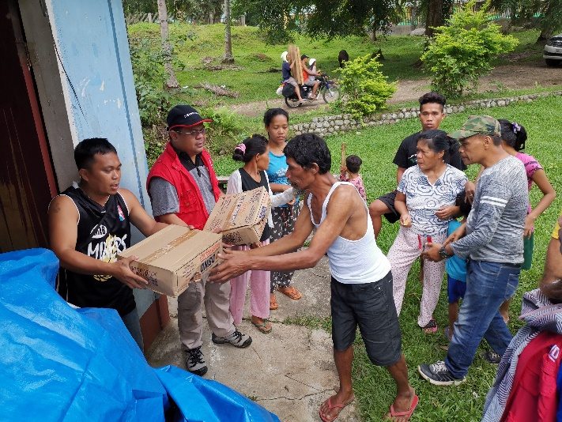

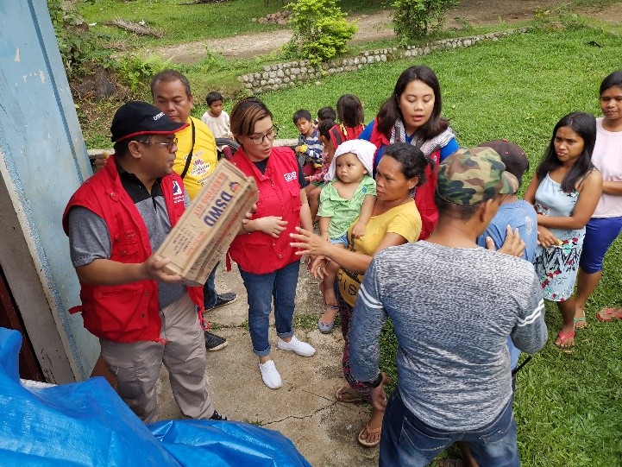
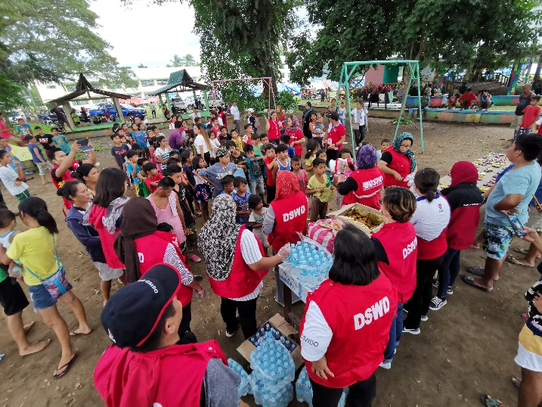
DSWD together with Philippine Coast Guard conducted play therapy at Bacungan Elementary School Evacuation Center (November 07, 2019)
