DSWD DROMIC Report #2 on the
Ms 6.6 Earthquake Incident in Tulunan, North Cotabato
as of 30 October 2019, 12NN

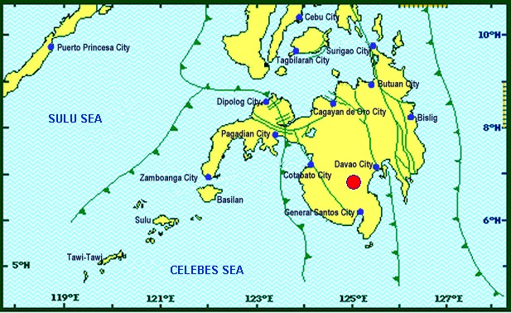
Situation Overview

On 29 October 2019 at 09:04 AM, a 6.6 magnitude earthquake jolted the municipality of Tulunan, North Cotabato (06.81°N, 125.03°E - 022 km S 79° E) with a tectonic origin and a depth of focus of 7 km. The earthquake was also felt in the neighboring municipalities of North Cotabato.

Date/Time: | 29 Oct 2019 - 09:04:43 AM
Reported Intensities: | Intensity VII- Tulunan and Makilala, Cotabato; Kidapawan City; Digos City, Bansalan,  Magsaysay, Davao del Sur and Malungon, Sarangani  Intensity VI- Koronadal City and Davao City  Intensity V- Cotabato City; Tampakan, Surallah, Banga and Tupi, South Cotabato;  General Santos City; Magpet, Cotabato; Tacurong City, Kalamansig, Bagumbayan, Sultan  Kudarat; Alabel, Sarangani; Kalilangan and Damulog, Bukidnon; Tagum City, Davao del Norte  Intensity IV- Cagayan De Oro City; Talakag, Manolo Fortich and Libona, Bukidnon;  Glan, Maitum, Maasim and Kiamba, Sarangani; Butuan City; Iligan City; Tubod and Bacolod,  Lanao del Norte  Intensity III- Molave, Zamboanga del Sur; Dipolog City, Sergio Osmeña Sr. and Polanco,  Zamboanga del Norte; Zamboanga City; Gingoog City, Misamis Oriental and Bislig City  Intensity II- Kabasalan, Zamboanga Sibugay, Mambajao, Camiguin and Isabela City, Basilan  Instrumental Intensities:  Intensity VII- Malungon, Sarangani  Intensity V- Cotabato City; Alabel, Sarangani and Tupi, South Cotabato  Intensity IV- Gingoog City, Misamis Oriental; Kiamba, Sarangani; General Santos City;  Cagayan De Oro City  Intensity II- Zamboanga City and Tulunan, Cotabato  Intensity I- Palo, Leyte; Dipolog City and Bislig City
Expecting Damage: | YES
Expecting Aftershocks: | YES
Source: DOST-PHIVOLCS Earthquake Bulletin

- Status of Affected Families / Persons
A total of 3,273 families or 16,365 persons were affected by the earthquake incident in 42 barangays in Regions XI and XII (see Table 1).

Table 1. Number of Affected Families / Persons
REGION / PROVINCE / MUNICIPALITY |  | NUMBER OF AFFECTED
 |  | Barangays | Families | Persons
GRAND TOTAL |  | 42 | 3,273 | 16,365
REGION XI |  | 12 | 935 | 4,675
Davao del Sur |  | 12 | 935 | 4,675
 | City of Digos (capital) | 3 | 173 | 865
 | Magsaysay | 9 | 762 | 3,810
REGION XII |  | 30 | 2,338 | 11,690
North Cotabato |  | 30 | 2,338 | 11,690
 | City of Kidapawan (capital) | 1 | 701 | 3,505
 | M'lang | 15 | 50 | 250
 | Tulunan | 14 | 1,587 | 7,935
Note: Ongoing assessment and validation being conducted.
Source: DSWD-FOs XI and XII

- Status of Displaced Families / Persons
- Inside Evacuation Center
There are 874 families or 4,370 persons taking temporary shelter in three (3) evacuation centers in Regions XI and XII (see Table 2).

Table 2. Number of Displaced Families / Persons Inside Evacuation Center
REGION / PROVINCE / MUNICIPALITY |  | NUMBER OF EVACUATION CENTERS (ECs) |  | INSIDE ECs
 |  |  |  | Families |  | Persons
 |  | CUM | NOW | CUM | NOW | CUM | NOW
GRAND TOTAL |  | 2 | 2 | 874 | 874 | 4,370 | 9,020
REGION XI |  | 1 | 1 | 173 | 173 | 865 | 865
Davao del Sur |  | 1 | 1 | 173 | 173 | 865 | 865
 | City of Digos (capital) | 1 | 1 | 173 | 173 | 865 | 865
REGION XII |  | 1 | 1 | 701 | 701 | 3,505 | 8,155
North Cotabato |  | 1 | 1 | 701 | 701 | 3,505 | 8,155
 | City of Kidapawan (capital) | 1 | 1 | 701 | 701 | 3,505 | 3,505
Note: Ongoing assessment and validation being conducted.
Source: DSWD-FOs XI and XII

- Outside Evacuation Center
There are 980 families or 4,900 persons currently staying with their relatives and/or friends (see Table 3).

Table 3. Number of Displaced Families / Persons Outside Evacuation Center
REGION / PROVINCE / MUNICIPALITY |  | OUTSIDE ECs
 |  | Families |  | Persons
 |  | CUM | NOW | CUM | NOW
GRAND TOTAL |  | 980 | 980 | 4,900 | 4,900
REGION XII |  | 980 | 980 | 4,900 | 4,900
North Cotabato |  | 980 | 980 | 4,900 | 4,900
 | M'lang | 50 | 50 | 250 | 250
 | Tulunan | 930 | 930 | 4,650 | 4,650
Note: Ongoing assessment and validation being conducted.
Source: DSWD-FO XII

- Damaged Houses
There are 1,143 damaged houses; of which, 341 are totally damaged and 802 are
partially damaged (see Table 4).

Table 4. Number of Damaged Houses
REGION / PROVINCE / MUNICIPALITY |  | NO. OF DAMAGED HOUSES
 |  | Total | Totally | Partially
GRAND TOTAL |  | 1,143 | 341 | 802
REGION XII |  | 1,143 | 341 | 802
North Cotabato |  | 1,143 | 341 | 802
 | M'lang | 37 | 10 | 27
 | Tulunan | 1,106 | 331 | 775
Note: Ongoing assessment and validation being conducted
Source: DSWD-FO XII

- Assistance Provided
A total of ₱949,358.00 worth of assistance was provided by DSWD to the affected families (see Table 5).

Table 5. Cost of Assistance Provided to Affected Families / Persons
REGION / PROVINCE / MUNICIPALITY |  | TOTAL COST OF ASSISTANCE
 |  | DSWD | LGU | NGOs | OTHERS | GRAND TOTAL
GRAND TOTAL |  | 949,358.00 | - | - | - | 949,358.00
REGION XII |  | 949,358.00 | - | - | - | 949,358.00
North Cotabato |  | 949,358.00 | - | - | - | 949,358.00
 | City of Kidapawan (capital) | 657,500.00 | - | - | - | 657,500.00
 | M'lang | 123,508.00 | - | - | - | 123,508.00
 | Tulunan | 168,350.00 | - | - | - | 168,350.00
Note: Ongoing assessment and validation being conducted
Source: DSWD-FO XII

DSWD DISASTER RESPONSE INFORMATION

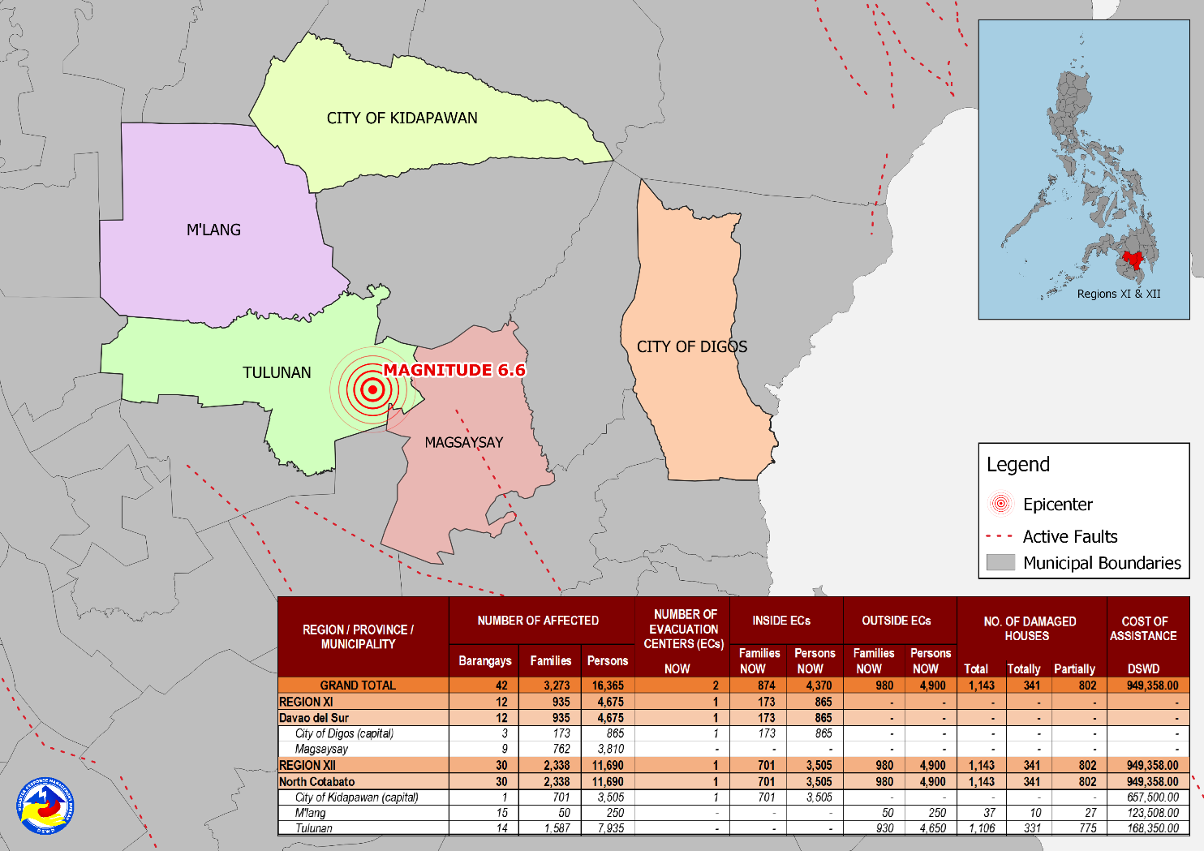

Situational Reports

DSWD-DRMB
DATE | SITUATIONS / ACTIONS UNDERTAKEN
30 October 2019 | - The Disaster Response Management Bureau (DRMB) is continuously coordinating with concerned field offices for significant disaster response updates.  - All QRT members and emergency equipment are on standby and ready for deployment.

DSWD-NRLMB
DATE | SITUATIONS / ACTIONS UNDERTAKEN
30 October 2019 | - DSWD-NRLMB augmented 50 Family Tents, 500 Sleeping Kits, 500 Pre-cut Laminated Sacks and 500 Family Food Packs and is now in transit through C130 to General Santos City.

DSWD-FO XI
DATE | ACTION(S) TAKEN
30 October 2019 | - DSWD-FO XI is in close coordination with the concerned LGU/MSWDO of Davao del Sur for any significant update.

DSWD-FO XII
DATE | ACTION(S) TAKEN
30 October 2019 | - The Sangguniang Panlalawigan of Cotabato approved the SB Resolution No. 569 declaring the entire province of Cotabato under the State of Calamity.  - DSWD-FO XII provided 350 family food packs and 10 rolls of laminated sacks to the affected families in Tulunan, North Cotabato.  - DSWD-FO XII provided 1500 family food pack and 20 rolls of laminated sack to the affected families in Kidapawan City, North Cotabato.  - DSWD-FO XII provided 308 family food pack to the affected families in M’lang, North Cotabato.  - DSWD-FO XII DRMD staff conducted an actual validation in all affected areas in North Cotabato.
29 October 2019 | - All QRT members are on standby and ready for activation if there is a need for deployment.  - 4 vehicles are ready for utilization in case of response activation.  - Employees except for QRT and DRMD staff are advised to vacate the building and go home.  - Tents were provided to Reception and Study Center for Children (RSCC) for the use of clients and staff as evacuation area while the safety of the building is assessed.  - DSWD-FO XII requested laminated sacks and sleeping kits from NROC.  - All municipal and provincial based DSWD staff are directed to conduct rapid assessment to their respective areas of assignment.
***
The Disaster Response Operations Monitoring and Information Center (DROMIC) of the DSWD-DRMB is closely coordinating with DSWD-FO XII for any significant disaster response updates.

Prepared by: Reviewed by: Releasing Officer:

MARIEL B. FERRARIZ RODEL V. CABADDU IMEE ROSE S. CASTILLO
DIANE C. PELEGRINO

PHOTO DOCUMENTATION
