DSWD DROMIC Report #22 on the
Ms 6.6 Earthquake Incident in Tulunan, North Cotabato
as of 11 November 2019, 6PM

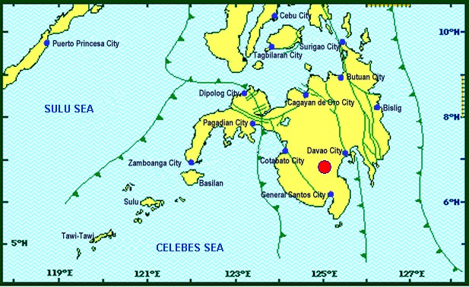
Situation Overview

On 29 October 2019 at 09:04 AM, a 6.6 magnitude earthquake jolted the municipality of Tulunan, North Cotabato (06.81°N, 125.03°E - 022 km S 79°E) with a tectonic origin and a depth of focus of 7 km. The earthquake was also felt in the neighboring municipalities of North Cotabato and Davao Region.

Source: DOST-PHIVOLCS Earthquake Bulletin

- Status of Affected Families / Persons
A total of 53,612 families or 261,742 persons were affected by the earthquake incident in 335 barangays in Regions XI and XII (see Table 1).

Table 1. Number of Affected Families / Persons
REGION / PROVINCE / MUNICIPALITY |  | NUMBER OF AFFECTED
 |  | Barangay | Families | Persons
GRAND TOTAL |  | 335 | 53,612 | 261,742
REGION XI |  | 151 | 20,350 | 95,432
Davao del Sur |  | 143 | 20,289 | 95,127
 | Bansalan | 24 | 6,371 | 26,384
 | City of Digos (capital) | 13 | 2,044 | 10,220
 | Hagonoy | 21 | 894 | 3,961
 | Kiblawan | 14 | 70 | 350
 | Magsaysay | 22 | 8,904 | 44,475
 | Malalag | 3 | 229 | 1,145
 | Matanao | 31 | 1,550 | 7,457
 | Padada | 1 | 39 | 195
 | Santa Cruz | 11 | 38 | 190
 | Sulop | 3 | 150 | 750
Davao Occidental |  | 8 | 61 | 305
 | Malita | 1 | 1 | 5
 | Santa Maria | 7 | 60 | 300
REGION XII |  | 184 | 33,262 | 166,310
North Cotabato |  | 182 | 33,206 | 166,030
 | Antipas | 13 | 250 | 1,250
 | Arakan | 11 | 108 | 540
 | Kabacan | 3 | 75 | 375
 | City of Kidapawan (capital) | 28 | 2,099 | 10,495
 | Magpet | 19 | 2,643 | 13,215
 | Makilala | 38 | 20,704 | 103,520
 | Matalam | 2 | 75 | 375
 | M'lang | 33 | 1,994 | 9,970
 | President Roxas | 6 | 164 | 820
 | Tulunan | 29 | 5,094 | 25,470
South Cotabato |  | 1 | 18 | 90
 | Tupi | 1 | 18 | 90
Sultan Kudarat |  | 1 | 38 | 190
 | Columbio | 1 | 38 | 190
Note: Ongoing assessment and validation being conducted.
Source: DSWD-FOs XI and XII

- Status of Displaced Families / Persons
- Inside Evacuation Center
There are 11,304 families or 52,856 persons taking temporary shelter in 69 evacuation centers in Regions XI and XII (see Table 2).

Table 2. Number of Displaced Families / Persons Inside Evacuation Centers
REGION / PROVINCE / MUNICIPALITY |  | NUMBER OF EVACUATION CENTERS (ECs) |  | NUMBER OF DISPLACED
 |  |  |  | INSIDE ECs
 |  |  |  | Families |  | Persons
 |  | CUM | NOW | CUM | NOW | CUM | NOW
GRAND TOTAL |  | 71 | 69 | 15,238 | 11,304 | 73,797 | 52,856
REGION XI |  | 42 | 40 | 8,461 | 4,527 | 39,912 | 18,971
Davao del Sur |  | 42 | 40 | 8,461 | 4,527 | 39,912 | 18,971
 | Bansalan | 9 | 7 | 4,000 | 852 | 19,790 | 3,287
 | City of Digos (capital) | 15 | 15 | 1,943 | 1,559 | 9,537 | 6,720
 | Hagonoy | 4 | 4 | 577 | 248 | 2,190 | 1,240
 | Magsaysay | 10 | 10 | 1,617 | 1,544 | 6,955 | 6,284
 | Matanao | 1 | 1 | 174 | 174 | 870 | 870
 | Sulop | 3 | 3 | 150 | 150 | 570 | 570
REGION XII |  | 29 | 29 | 6,777 | 6,777 | 33,885 | 33,885
North Cotabato |  | 29 | 29 | 6,777 | 6,777 | 33,885 | 33,885
 | City of Kidapawan (capital) | 9 | 9 | 2,029 | 2,029 | 10,145 | 10,145
 | Makilala | 20 | 20 | 4,748 | 4,748 | 23,740 | 23,740
Note: The decrease in the number of ECs and number of displaced is due to the validated report submitted by DSWD-FO XI. No ECs were opened in Santa Maria, Davao Occidental. Hence, ongoing assessment and validation being conducted.

Source: DSWD-FOs XI and XII

- Outside Evacuation Center
There are 11,434 families or 57,035 persons currently staying with their relatives and/or friends (see Table 3).

Table 3. Number of Displaced Families / Persons Outside Evacuation Centers
REGION / PROVINCE / MUNICIPALITY |  | NUMBER OF DISPLACED
 |  | OUTSIDE ECs
 |  | Families |  | Persons
 |  | CUM | NOW | CUM | NOW
GRAND TOTAL |  | 11,618 | 11,434 | 57,955 | 57,035
REGION XI |  | 10,353 | 10,169 | 51,630 | 50,710
Davao del Sur |  | 10,353 | 10,169 | 51,630 | 50,710
 | Bansalan | 2,923 | 2,786 | 14,480 | 13,795
 | Magsaysay | 7,402 | 7,355 | 37,010 | 36,775
 | Santa Cruz | 28 | 28 | 140 | 140
REGION XII |  | 1,265 | 1,265 | 6,325 | 6,325
North Cotabato |  | 1,265 | 1,265 | 6,325 | 6,325
 | Antipas | 32 | 32 | 160 | 160
 | Arakan | 108 | 108 | 540 | 540
 | Kabacan | 75 | 75 | 375 | 375
 | City of Kidapawan (capital) | 70 | 70 | 350 | 350
 | M'lang | 50 | 50 | 250 | 250
 | Tulunan | 930 | 930 | 4,650 | 4,650
Note: Ongoing assessment and validation being conducted.
Source: DSWD-FOs XI and XII

- Damaged Houses
There are 35,990 damaged houses; of which, 22,892 are totally damaged and 13,098 are partially damaged (see Table 4).

Table 4. Number of Damaged Houses
REGION / PROVINCE / MUNICIPALITY |  | NO. OF DAMAGED HOUSES
 |  | Total | Totally | Partially
GRAND TOTAL |  | 35,990 | 22,892 | 13,098
REGION XI |  | 7,112 | 1,775 | 5,337
Davao del Sur |  | 7,091 | 1,774 | 5,317
 | Bansalan | 858 | 174 | 684
 | Hagonoy | 334 | 41 | 293
 | Kiblawan | 1 | 1 | -
 | Magsaysay | 5,684 | 1,501 | 4,183
 | Matanao | 51 | 1 | 50
 | Padada | 2 | - | 2
 | Santa Cruz | 11 | 2 | 9
 | Sulop | 150 | 54 | 96
Davao Occidental |  | 21 | 1 | 20
 | Malita | 1 | 1 | -
 | Santa Maria | 20 | - | 20
REGION XII |  | 28,878 | 21,117 | 7,761
North Cotabato |  | 28,822 | 21,102 | 7,720
 | Antipas | 250 | 214 | 36
 | Arakan | 110 | 4 | 106
 | Kabacan | 58 | 2 | 56
 | City of Kidapawan (capital) | 1,366 | 38 | 1,328
 | Makilala | 20,704 | 18,997 | 1,707
 | Matalam | 121 | 1 | 120
 | M'lang | 955 | 89 | 866
 | President Roxas | 164 | 74 | 90
 | Tulunan | 5,094 | 1,683 | 3,411
South Cotabato |  | 18 | 1 | 17
 | Tupi | 18 | 1 | 17
Sultan Kudarat |  | 38 | 14 | 24
 | Columbio | 38 | 14 | 24
Note: Ongoing assessment and validation being conducted
Source: DSWD-FOs XI and XII

- Assistance Provided
A total of ₱39,165,616.92 worth of assistance was provided by DSWD to the affected families (see Table 5).

Table 5. Cost of Assistance Provided to Affected Families / Persons
REGION / PROVINCE / MUNICIPALITY |  | DSWD | LGU | NGOs | OTHERS | GRAND TOTAL
GRAND TOTAL |  | 39,165,616.92 | - | - | - | 39,165,616.92
REGION XI |  | 10,961,286.20 | - | - | - | 10,961,286.20
Davao del Sur |  | 10,961,286.20 | - | - | - | 10,961,286.20
 | Bansalan | 2,951,752.20 | - | - | - | 2,951,752.20
 | City of Digos (capital) | 1,454,100.00 | - | - | - | 1,454,100.00
 | Magsaysay | 4,868,720.00 | - | - | - | 4,868,720.00
 | Malalag | 527,330.00 | - | - | - | 527,330.00
 | Matanao | 1,159,384.00 | - | - | - | 1,159,384.00
REGION XII |  | 28,204,330.72 | - | - | - | 28,204,330.72
North Cotabato |  | 28,204,330.72 | - | - | - | 28,204,330.72
 | Arakan | 44,856.00 | - | - | - | 44,856.00
 | City of Kidapawan (capital) | 5,948,892.00 | - | - | - | 5,948,892.00
 | Magpet | 7,362,569.00 | - | - | - | 7,362,569.00
 | Makilala | 8,493,337.00 | - | - | - | 8,493,337.00
 | M'lang | 1,298,374.00 | - | - | - | 1,298,374.00
 | Tulunan | 5,056,302.72 | - | - | - | 5,056,302.72

Source: DSWD-FOs XI and XII

DSWD DISASTER RESPONSE INFORMATION
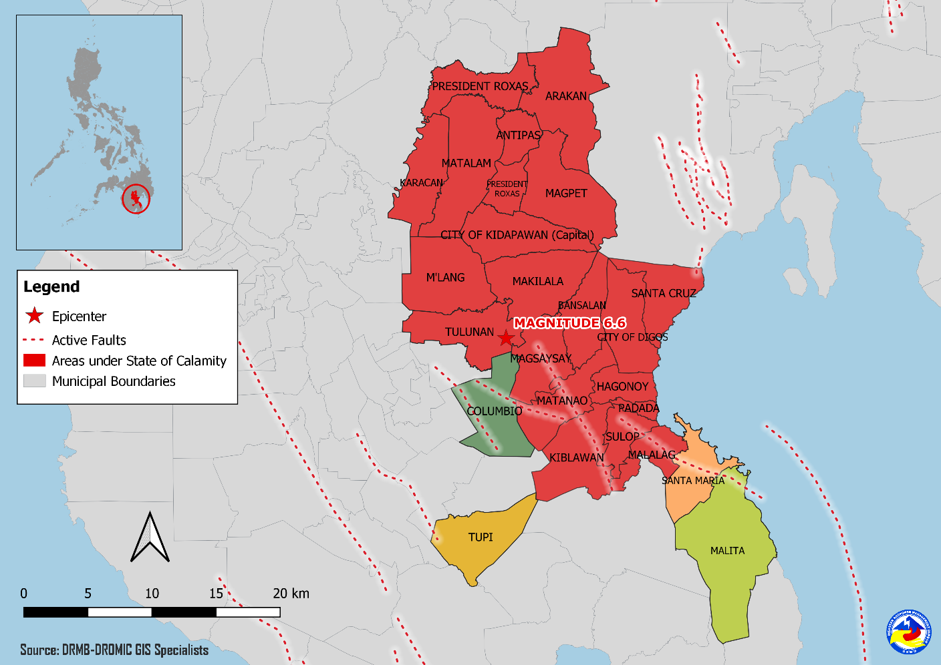

Situational Reports

DSWD-DRMB
DATE | SITUATIONS / ACTIONS UNDERTAKEN
11 November 2019 | - The Disaster Response Management Bureau (DRMB) is on BLUE alert status and is closely coordinating with the concerned field offices for significant disaster response updates.  - All QRT members and emergency equipment are on standby and ready for deployment.

DSWD-FO XI
DATE | ACTION(S) TAKEN
11 November 2019 | - DSWD-FO XI is still on RED alert status.  - A total of 600 FFPs were delivered in Bansalan, Davao del Sur last November 10, 2019. The goods were endorsed to the MSWDO and set for distribution to the IDPs for today. Thus, 230 Sleeping Kits and Hygiene Kits as well as 238 Drinking Kits have also been distributed to all affected families both Inside and Outside Evacuation Centers last November 10, 2019.  - In Digos Coliseum, a total of 150 FFPs, 75 Sleeping Kits, 75 Drinking Kits, 41 Laminated Sacks were provided to the IDPs in the said Evacuation Center. Further, the 14 Volunteers were each provided with Food Packs, Sleeping Kits and Laminated Sacks

DSWD-FO XII
DATE | ACTION(S) TAKEN
11 November 2019 | - DSWD-FO XII is still on RED alert status.

***
The Disaster Response Operations Monitoring and Information Center (DROMIC) of the DSWD-DRMB is closely coordinating with concerned DSWD Field Offices for any significant disaster response updates.

Prepared by:

MARIEL B. FERRARIZ
DIANE C. PELEGRINO

RODEL V. CABADDU
Releasing Officer

PHOTO DOCUMENTATION

Relief distribution in New Bulatukan, Makilala North Cotabato (November 02, 2019)
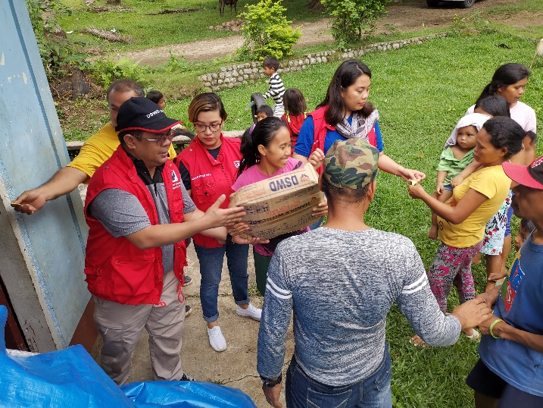
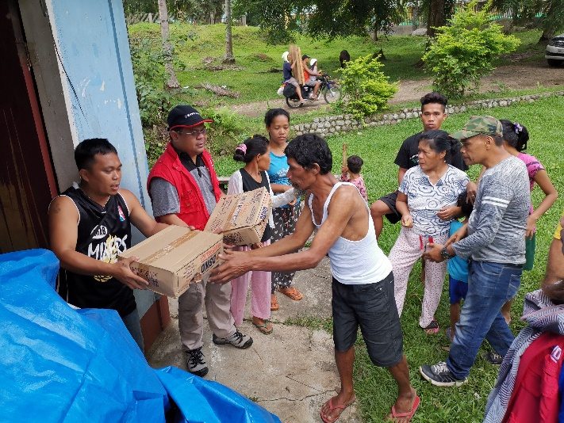

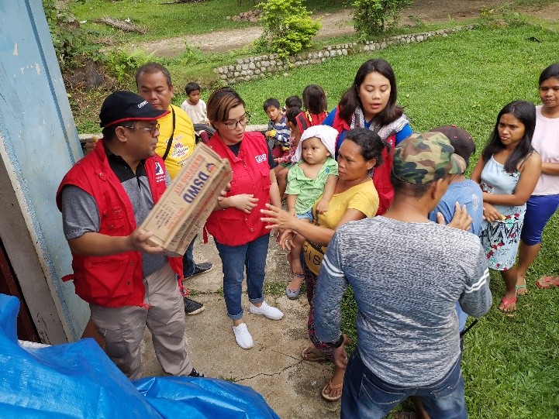
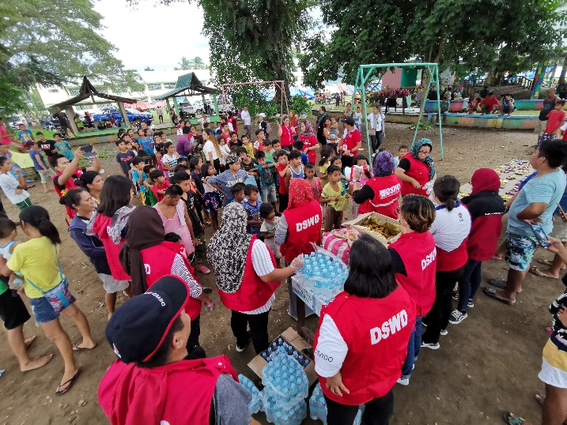
DSWD together with Philippine Coast Guard conducted play therapy at Bacungan Elementary School Evacuation Center (November 07, 2019)
