DSWD DROMIC Report #29 on the
Ms 6.6 Earthquake Incident in Tulunan, North Cotabato
as of 19 November 2019, 6PM


Situation Overview

On 29 October 2019 at 09:04 AM, a 6.6 magnitude earthquake jolted the municipality of Tulunan, North Cotabato (06.81°N, 125.03°E - 022 km S 79°E) with a tectonic origin and a depth of focus of 7 km. The earthquake was also felt in the neighboring municipalities of North Cotabato and Davao Region.

Source: DOST-PHIVOLCS Earthquake Bulletin

- Status of Affected Families / Persons
A total of 66,811 families or 326,816 persons were affected by the earthquake incident in 344 barangays in Regions XI and XII (see Table 1).

Table 1. Number of Affected Families / Person
REGION / PROVINCE / MUNICIPALITY |  | NUMBER OF AFFECTED
 |  | Barangay | Families | Persons
GRAND TOTAL |  | 344 | 66,811 | 326,816
REGION XI |  | 151 | 23,105 | 108,286
Davao del Sur |  | 143 | 23,044 | 107,981
 | Bansalan | 24 | 6,787 | 28,069
 | City of Digos (capital) | 13 | 2,044 | 10,220
 | Hagonoy | 21 | 1,510 | 8,181
 | Kiblawan | 14 | 70 | 350
 | Magsaysay | 22 | 8,904 | 44,475
 | Malalag | 3 | 229 | 1,145
 | Matanao | 31 | 2,598 | 11,031
 | Padada | 1 | 714 | 3,570
 | Santa Cruz | 11 | 38 | 190
 | Sulop | 3 | 150 | 750
Davao Occidental |  | 8 | 61 | 305
 | Malita | 1 | 1 | 5
 | Santa Maria | 7 | 60 | 300
REGION XII |  | 193 | 43,706 | 218,530
North Cotabato |  | 191 | 43,650 | 218,250
 | Antipas | 13 | 250 | 1,250
 | Arakan | 11 | 108 | 540
 | Kabacan | 12 | 258 | 1,290
 | City of Kidapawan (capital) | 28 | 2,099 | 10,495
 | Magpet | 19 | 2,643 | 13,215
 | Makilala | 38 | 20,704 | 103,520
 | Matalam | 2 | 75 | 375
 | M'lang | 33 | 1,994 | 9,970
 | President Roxas | 6 | 164 | 820
 | Tulunan | 29 | 15,355 | 76,775
South Cotabato |  | 1 | 18 | 90
 | Tupi | 1 | 18 | 90
Sultan Kudarat |  | 1 | 38 | 190
 | Columbio | 1 | 38 | 190
Note: Ongoing assessment and validation being conducted.
Source: DSWD-FOs XI and XII

- Status of Displaced Families / Persons
- Inside Evacuation Center
There are 9,941 families or 45,816 persons taking temporary shelter in 77 evacuation centers in Regions XI and XII (see Table 2).

Table 2. Number of Displaced Families / Persons Inside Evacuation Centers
REGION / PROVINCE / MUNICIPALITY |  | NUMBER OF EVACUATION CENTERS (ECs) |  | NUMBER OF DISPLACED
 |  |  |  | INSIDE ECs
 |  |  |  | Families |  | Persons
 |  | CUM | NOW | CUM | NOW | CUM | NOW
GRAND TOTAL |  | 84 | 77 | 14,561 | 9,941 | 70,349 | 45,816
REGION XI |  | 47 | 40 | 8,511 | 3,891 | 40,099 | 15,566
Davao del Sur |  | 47 | 40 | 8,511 | 3,891 | 40,099 | 15,566
 | Bansalan | 14 | 14 | 4,004 | 606 | 19,797 | 2,277
 | City of Digos (capital) | 15 | 9 | 1,943 | 1,074 | 9,664 | 3,763
 | Hagonoy | 4 | 3 | 577 | 300 | 2,190 | 1,636
 | Magsaysay | 10 | 10 | 1,663 | 1,587 | 7,008 | 6,450
 | Matanao | 1 | 1 | 174 | 174 | 870 | 870
 | Sulop | 3 | 3 | 150 | 150 | 570 | 570
REGION XII |  | 37 | 37 | 6,050 | 6,050 | 30,250 | 30,250
North Cotabato |  | 37 | 37 | 6,050 | 6,050 | 30,250 | 30,250
 | City of Kidapawan (capital) | 9 | 9 | 2,029 | 2,029 | 10,145 | 10,145
 | Makilala | 28 | 28 | 4,021 | 4,021 | 20,105 | 20,105
Note: The decrease in the number of displaced is due to the validated report submitted by DSWD-FO XII. Hence, ongoing assessment and validation being conducted.
Source: DSWD-FOs XI and XII

- Outside Evacuation Center
There are 12,002 families or 59,775 persons currently staying with their relatives and/or friends, or in open spaces (see Table 3).

Table 3. Number of Displaced Families / Persons Outside Evacuation Centers
REGION / PROVINCE / MUNICIPALITY |  | NUMBER OF DISPLACED
 |  | OUTSIDE ECs
 |  | Families |  | Persons
 |  | CUM | NOW | CUM | NOW
GRAND TOTAL |  | 12,186 | 12,002 | 60,695 | 59,775
REGION XI |  | 10,913 | 10,729 | 54,330 | 53,410
Davao del Sur |  | 10,913 | 10,729 | 54,330 | 53,410
 | Bansalan | 2,923 | 2,786 | 14,480 | 13,795
 | Hagonoy | 435 | 435 | 2,175 | 2,175
 | Magsaysay | 7,402 | 7,355 | 37,010 | 36,775
 | Matanao | 125 | 125 | 525 | 525
 | Santa Cruz | 28 | 28 | 140 | 140
REGION XII |  | 1,273 | 1,273 | 6,365 | 6,365
North Cotabato |  | 1,273 | 1,273 | 6,365 | 6,365
 | Antipas | 32 | 32 | 160 | 160
 | Arakan | 108 | 108 | 540 | 540
 | Kabacan | 75 | 75 | 375 | 375
 | City of Kidapawan (capital) | 70 | 70 | 350 | 350
 | M'lang | 50 | 50 | 250 | 250
 | Tulunan | 938 | 938 | 4,690 | 4,690
Note: Ongoing assessment and validation being conducted.
Source: DSWD-FOs XI and XII

- Damaged Houses
There are 38,802 damaged houses; of which, 23,321 are totally damaged and 15,481 are partially damaged (see Table 4).

Table 4. Number of Damaged Houses
REGION / PROVINCE / MUNICIPALITY |  | NO. OF DAMAGED HOUSES
 |  | Total | Totally | Partially
GRAND TOTAL |  | 38,802 | 23,321 | 15,481
REGION XI |  | 9,711 | 2,186 | 7,525
Davao del Sur |  | 9,690 | 2,185 | 7,505
 | Bansalan | 858 | 174 | 684
 | Hagonoy | 842 | 179 | 663
 | Kiblawan | 1 | 1 | -
 | Magsaysay | 7,402 | 1,609 | 5,793
 | Matanao | 51 | 1 | 50
 | Padada | 375 | 165 | 210
 | Santa Cruz | 11 | 2 | 9
 | Sulop | 150 | 54 | 96
Davao Occidental |  | 21 | 1 | 20
 | Malita | 1 | 1 | -
REGION XII |  | 29,091 | 21,135 | 7,956
North Cotabato |  | 29,035 | 21,120 | 7,915
 | Antipas | 250 | 214 | 36
 | Arakan | 110 | 4 | 106
 | Kabacan | 208 | 10 | 198
 | City of Kidapawan (capital) | 1,366 | 38 | 1,328
 | Makilala | 20,704 | 18,997 | 1,707
 | Matalam | 121 | 1 | 120
 | M'lang | 955 | 89 | 866
 | President Roxas | 164 | 74 | 90
 | Tulunan | 5,157 | 1,693 | 3,464
South Cotabato |  | 18 | 1 | 17
 | Tupi | 18 | 1 | 17
Sultan Kudarat |  | 38 | 14 | 24
 | Columbio | 38 | 14 | 24
Note: Ongoing assessment and validation being conducted
Source: DSWD-FOs XI and XII

- Assistance Provided
A total of ₱59,150,352.15 worth of assistance was provided by DSWD to the affected families (see Table 5).

Table 5. Cost of Assistance Provided to Affected Families / Persons
REGION / PROVINCE / MUNICIPALITY |  | DSWD | LGU | NGOs | OTHERS | GRAND TOTAL
GRAND TOTAL |  | 59,150,352.15 | - | - | - | 59,150,352.15
REGION XI |  | 27,515,413.95 | - | - | - | 27,515,413.95
Davao del Sur |  | 27,515,413.95 | - | - | - | 27,515,413.95
 | Bansalan | 7,957,103.55 | - | - | - | 7,957,103.55
 | City of Digos (capital) | 4,157,882.10 | - | - | - | 4,157,882.10
 | Hagonoy | 1,503,877.35 | - | - | - | 1,503,877.35
 | Magsaysay | 10,938,651.35 | - | - | - | 10,938,651.35
 | Malalag | 686,330.00 | - | - | - | 686,330.00
 | Matanao | 1,713,739.60 | - | - | - | 1,713,739.60
 | Padada | 326,534.00 | - | - | - | 326,534.00
 | Sulop | 231,296.00 | - | - | - | 231,296.00
REGION XII |  | 31,634,938.20 | - | - | - | 31,634,938.20
North Cotabato |  | 31,634,938.20 | - | - | - | 31,634,938.20
 | Arakan | 44,856.00 | - | - | - | 44,856.00
 | City of Kidapawan (capital) | 9,104,109.00 | - | - | - | 9,104,109.00
 | Magpet | 7,362,569.00 | - | - | - | 7,362,569.00
 | Makilala | 8,588,277.48 | - | - | - | 8,588,277.48
 | M'lang | 1,478,824.00 | - | - | - | 1,478,824.00
 | Tulunan | 5,056,302.72 | - | - | - | 5,056,302.72
Source: DSWD-FOs XI and XII

DSWD DISASTER RESPONSE INFORMATION
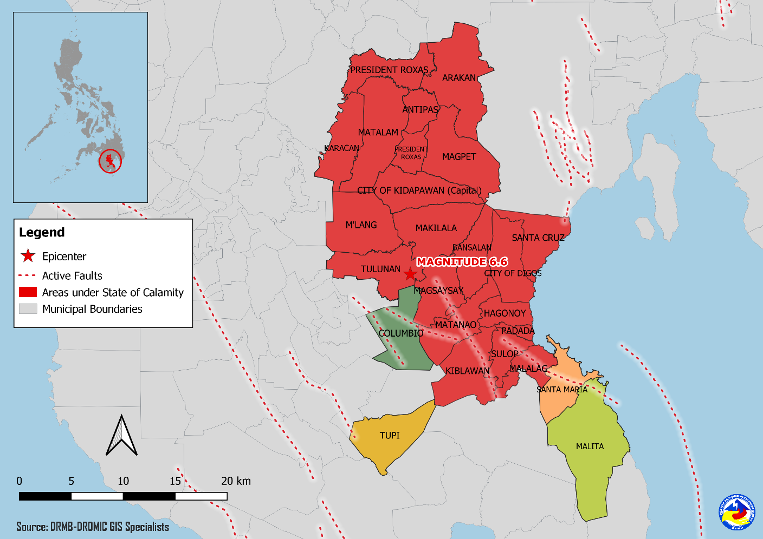
Situational Reports

DSWD-DRMB
DATE | SITUATIONS / ACTIONS UNDERTAKEN
19 November 2019 | - The Disaster Response Management Bureau (DRMB) is on BLUE alert status and is closely coordinating with the concerned field offices for significant disaster response updates.  - All QRT members and emergency equipment are on standby and ready for deployment.

DSWD-FO XI
DATE | SITUATIONS / ACTIONS UNDERTAKEN
16 November 2019 | - DSWD-FO XI is still on RED alert status.  - DSWD-FO XI provided medical assistance and burial assistance to injured individuals and bereaved families amounting to a total of ₱4,254,535.00.

DSWD-FO XII
DATE | SITUATIONS / ACTIONS UNDERTAKEN
19 November 2019 | - DSWD-FO XII is still on RED alert status.  - DSWD-FO XII provided a total of 659 family food packs, 1,500 sleeping kits, 214 sheets or 21 rolls of laminated socks, 460 kitchen kits and 8,088 pieces of Nutri-Del in Kidapawan Ctiy.  - DSWD-FO XII coordinated the delivery of 10 tents for identified child and women friendly spaces in 5 camps in Makilala, North Cotabato, namely: GSP camps, Santos Land, Rodero, Makilala Central, and MIMST Camp.

*****
The Disaster Response Operations Monitoring and Information Center (DROMIC) of the DSWD-DRMB is closely coordinating with concerned DSWD Field Offices for any significant disaster response updates.

Prepared by:

LESLIE R. JAWILI

MARC LEO L. BUTAC
Releasing Officer

PHOTO DOCUMENTATION

Relief distribution in New Bulatukan, Makilala North Cotabato (November 02, 2019)





DSWD together with Philippine Coast Guard conducted play therapy at Bacungan Elementary School Evacuation Center (November 07, 2019)



