DSWD DROMIC Report #35 on the
Ms 6.6 Earthquake Incident in Tulunan, North Cotabato
as of 27 November 2019, 6PM


Situation Overview

On 29 October 2019 at 09:04 AM, a 6.6 magnitude earthquake jolted the municipality of Tulunan, North Cotabato (06.81°N, 125.03°E - 022 km S 79°E) with a tectonic origin and a depth of focus of 7 km. The earthquake was also felt in the neighboring municipalities of North Cotabato and Davao Region.

Source: DOST-PHIVOLCS Earthquake Bulletin

- Status of Affected Families / Persons
A total of 66,489 families or 325,712 persons were affected by the earthquake incident in 362 barangays in Regions XI and XII (see Table 1).

Table 1. Number of Affected Families / Persons
REGION / PROVINCE / MUNICIPALITY |  | NUMBER OF AFFECTED
 |  | Barangay | Families | Persons
GRAND TOTAL |  | 362 | 66,489 | 325,712
REGION XI |  | 151 | 24,985 | 118,192
Davao del Sur |  | 143 | 24,924 | 117,887
 | Bansalan | 24 | 7,038 | 29,379
 | City of Digos (capital) | 13 | 2,044 | 10,220
 | Hagonoy | 21 | 1,516 | 8,181
 | Kiblawan | 14 | 70 | 350
 | Magsaysay | 22 | 9,331 | 46,575
 | Malalag | 3 | 229 | 1,145
 | Matanao | 31 | 3,794 | 17,527
 | Padada | 1 | 714 | 3,570
 | Santa Cruz | 11 | 38 | 190
 | Sulop | 3 | 150 | 750
Davao Occidental |  | 8 | 61 | 305
 | Malita | 1 | 1 | 5
 | Santa Maria | 7 | 60 | 300
REGION XII |  | 211 | 41,504 | 207,520
North Cotabato |  | 209 | 41,448 | 207,240
 | Antipas | 13 | 312 | 1,560
 | Arakan | 19 | 396 | 1,980
 | Kabacan | 12 | 264 | 1,320
 | City of Kidapawan (capital) | 28 | 2,099 | 10,495
 | Magpet | 19 | 2,770 | 13,850
 | Makilala | 38 | 20,704 | 103,520
 | Matalam | 12 | 649 | 3,245
 | M'lang | 33 | 2,099 | 10,495
 | President Roxas | 6 | 259 | 1,295
 | Tulunan | 29 | 11,896 | 59,480
South Cotabato |  | 1 | 18 | 90
 | Tupi | 1 | 18 | 90
Sultan Kudarat |  | 1 | 38 | 190
 | Columbio | 1 | 38 | 190
Note: The decrease in the number of affected families or persons is based on the ongoing assessment and validation.

Source: DSWD-FOs XI and XII

- Status of Displaced Families / Persons
- Inside Evacuation Center
There are 12,253 families or 56,750 persons taking temporary shelter in 107 evacuation centers in Regions XI and XII (see Table 2).

Table 2. Number of Displaced Families / Persons Inside Evacuation Centers
REGION / PROVINCE / MUNICIPALITY |  | NUMBER OF EVACUATION CENTERS (ECs) |  | NUMBER OF DISPLACED
 |  |  |  | INSIDE ECs
 |  |  |  | Families |  | Persons
 |  | CUM | NOW | CUM | NOW | CUM | NOW
GRAND TOTAL |  | 120 | 107 | 17,332 | 12,253 | 82,155 | 56,750
REGION XI |  | 52 | 39 | 9,387 | 4,308 | 42,430 | 17,025
Davao del Sur |  | 52 | 39 | 9,387 | 4,308 | 42,430 | 17,025
 | Bansalan | 18 | 16 | 4,724 | 1,249 | 21,440 | 5,177
 | City of Digos (capital) | 15 | 8 | 2,057 | 1,036 | 10,224 | 3,754
 | Hagonoy | 4 | 3 | 577 | 300 | 2,190 | 1,636
 | Magsaysay | 10 | 10 | 1,671 | 1,526 | 7,025 | 5,477
 | Matanao | 1 | 1 | 176 | 165 | 870 | 870
 | Padada | 1 | 1 | 32 | 32 | 111 | 111
 | Sulop | 3 | - | 150 | - | 570 | -
REGION XII |  | 68 | 68 | 7,945 | 7,945 | 39,725 | 39,725
North Cotabato |  | 68 | 68 | 7,945 | 7,945 | 39,725 | 39,725
 | Arakan | 5 | 5 | 151 | 151 | 755 | 755
 | City of Kidapawan (capital) | 9 | 9 | 2,029 | 2,029 | 10,145 | 10,145
 | Magpet | 26 | 26 | 1,744 | 1,744 | 8,720 | 8,720
 | Makilala | 28 | 28 | 4,021 | 4,021 | 20,105 | 20,105
Note: Ongoing assessment and validation being conducted.
Source: DSWD-FOs XI and XII

- Outside Evacuation Center
There are 25,989 families or 126,494 persons currently staying with their relatives and/or friends, or in open spaces (see Table 3).

Table 3. Number of Displaced Families / Persons Outside Evacuation Centers
REGION / PROVINCE / MUNICIPALITY |  | NUMBER OF DISPLACED
 |  | OUTSIDE ECs
 |  | Families |  | Persons
 |  | CUM | NOW | CUM | NOW
GRAND TOTAL |  | 26,218 | 25,989 | 130,472 | 126,494
REGION XI |  | 11,435 | 11,227 | 56,557 | 52,684
Davao del Sur |  | 11,435 | 11,227 | 56,557 | 52,684
 | Bansalan | 3,440 | 3,303 | 16,687 | 15,349
 | City of Digos (capital) | 5 | 5 | 20 | 20
 | Hagonoy | 435 | 435 | 2,175 | 2,175
 | Magsaysay | 7,402 | 7,331 | 37,010 | 34,475
 | Matanao | 125 | 125 | 525 | 525
 | Santa Cruz | 28 | 28 | 140 | 140
REGION XII |  | 14,783 | 14,762 | 73,915 | 73,810
North Cotabato |  | 14,783 | 14,762 | 73,915 | 73,810
 | Antipas | 33 | 32 | 165 | 160
 | Arakan | 10 | 10 | 50 | 50
 | Kabacan | 75 | 55 | 375 | 275
 | City of Kidapawan (capital) | 70 | 70 | 350 | 350
 | Matalam | 534 | 534 | 2,670 | 2,670
 | M'lang | 2,041 | 2,041 | 10,205 | 10,205
 | President Roxas | 219 | 219 | 1,095 | 1,095
 | Tulunan | 11,801 | 11,801 | 59,005 | 59,005
Note: Ongoing assessment and validation being conducted.
Source: DSWD-FOs XI and XII

- Damaged Houses
There are 41,898 damaged houses; of which, 24,264 are totally damaged and 17,634 are partially damaged (see Table 4).

Table 4. Number of Damaged Houses
REGION / PROVINCE / MUNICIPALITY |  | NO. OF DAMAGED HOUSES
 |  | Total | Totally | Partially
GRAND TOTAL |  | 41,898 | 24,264 | 17,634
REGION XI |  | 12,807 | 3,129 | 9,678
Davao del Sur |  | 12,506 | 3,020 | 9,486
 | Bansalan | 3,000 | 942 | 2,058
 | Hagonoy | 842 | 179 | 663
 | Kiblawan | 1 | 1 | -
 | Magsaysay | 7,402 | 1,609 | 5,793
 | Matanao | 725 | 68 | 657
 | Padada | 375 | 165 | 210
 | Santa Cruz | 11 | 2 | 9
 | Sulop | 150 | 54 | 96
Davao Occidental |  | 301 | 109 | 192
 | Malita | 1 | 1 | -
 | Santa Maria | 300 | 108 | 192
REGION XII |  | 29,091 | 21,135 | 7,956
North Cotabato |  | 29,035 | 21,120 | 7,915
 | Antipas | 250 | 214 | 36
 | Arakan | 110 | 4 | 106
 | Kabacan | 208 | 10 | 198
 | City of Kidapawan (capital) | 1,366 | 38 | 1,328
 | Makilala | 20,704 | 18,997 | 1,707
 | Matalam | 121 | 1 | 120
 | M'lang | 955 | 89 | 866
 | President Roxas | 164 | 74 | 90
 | Tulunan | 5,157 | 1,693 | 3,464
South Cotabato |  | 18 | 1 | 17
 | Tupi | 18 | 1 | 17
Sultan Kudarat |  | 38 | 14 | 24
 | Columbio | 38 | 14 | 24
Note: Ongoing assessment and validation being conducted.
Source: DSWD-FOs XI and XII

- Assistance Provided
A total of ₱84,069,481.85 worth of assistance was provided by DSWD to the affected families (see Table 5).

Table 5. Cost of Assistance Provided to Affected Families / Persons
REGION / PROVINCE / MUNICIPALITY |  | DSWD TOTAL | LGU | NGOs | OTHERS | GRAND TOTAL
GRAND TOTAL |  | 84,069,481.85 | - | - | - | 84,069,481.85
REGION XI |  | 43,131,239.65 | - | - | - | 43,131,239.65
Davao del Sur |  | 43,131,239.65 | - | - | - | 43,131,239.65
 | Bansalan | 13,932,753.65 | - | - | - | 13,932,753.65
 | City of Digos (capital) | 6,860,680.90 | - | - | - | 6,860,680.90
 | Hagonoy | 1,900,126.75 | - | - | - | 1,900,126.75
 | Magsaysay | 15,538,081.35 | - | - | - | 15,538,081.35
 | Malalag | 686,330.00 | - | - | - | 686,330.00
 | Matanao | 3,436,605.00 | - | - | - | 3,436,605.00
 | Padada | 545,366.00 | - | - | - | 545,366.00
 | Sulop | 231,296.00 | - | - | - | 231,296.00
REGION XII |  | 40,938,242.20 | - | - | - | 40,938,242.20
North Cotabato |  | 40,938,242.20 | - | - | - | 40,938,242.20
 | Arakan | 44,856.00 | - | - | - | 44,856.00
 | City of Kidapawan (capital) | 10,938,780.00 | - | - | - | 10,938,780.00
 | Magpet | 8,475,919.00 | - | - | - | 8,475,919.00
 | Makilala | 12,550,805.48 | - | - | - | 12,550,805.48
 | Matalam | 2,143,755.00 | - | - | - | 2,143,755.00
 | M'lang | 1,727,824.00 | - | - | - | 1,727,824.00
 | Tulunan | 5,056,302.72 | - | - | - | 5,056,302.72
Source: DSWD-FOs XI and XII
DSWD DISASTER RESPONSE INFORMATION
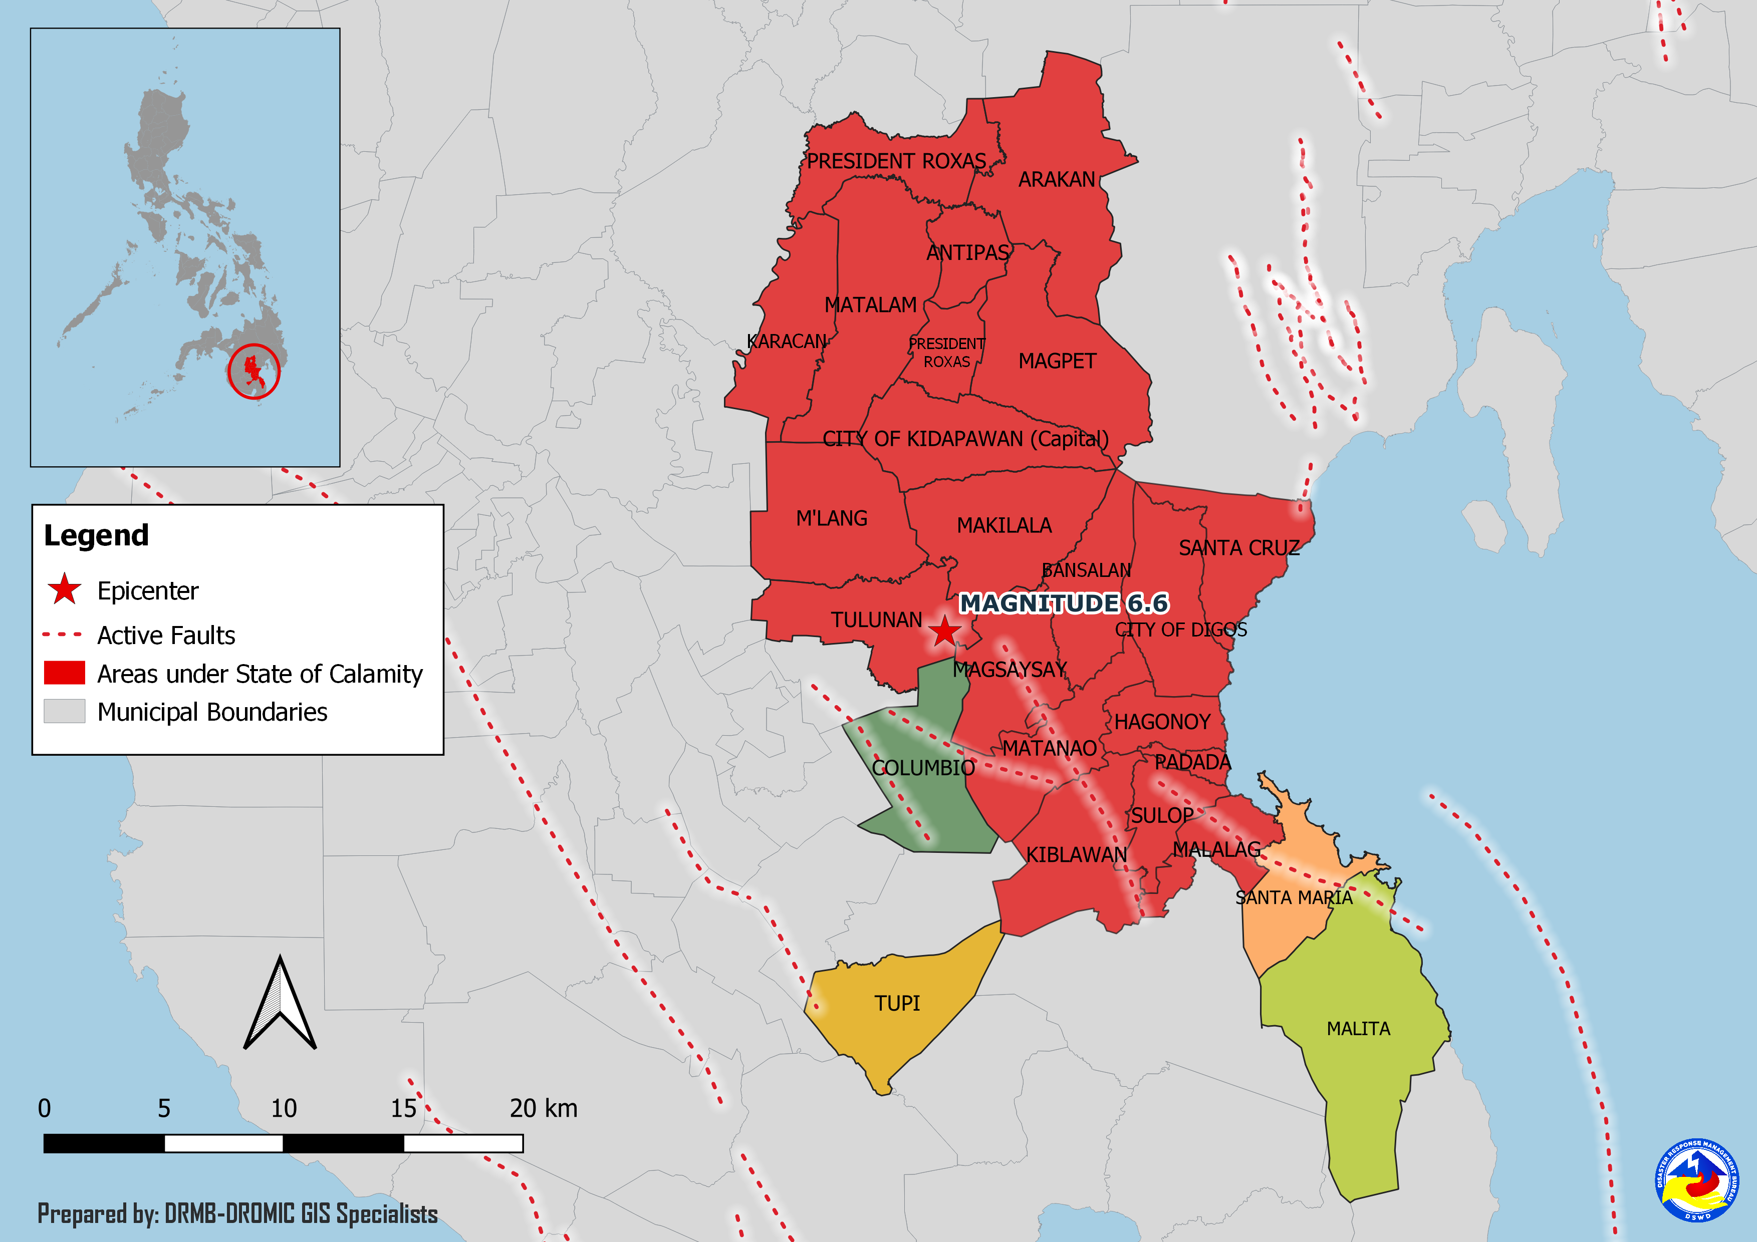
Situational Reports

DSWD-DRMB
DATE | SITUATIONS / ACTIONS UNDERTAKEN
27 November 2019 | - The Disaster Response Management Bureau (DRMB) is on BLUE alert status and is closely coordinating with the concerned Field Offices for significant disaster response updates.  - All QRT members and emergency equipment are on standby and ready for deployment.

DSWD-FO XI
DATE | SITUATIONS / ACTIONS UNDERTAKEN
27 November 2019 | - DSWD-FO XI is on BLUE alert status.  - DSWD-FO XI delivered 26 sleeping kits to Mary Mediatrix and 75 family tents to Balabag Evacuation Center in Digos City.  - DSWD-FO XI delivered 76 family food packs, 152 pieces of bottled water, 2 laminated sacks and 5 family tents to Aplaya Evacuation Center and 6 family tents to Balutakay Evacuation Center in Hagonoy, Davao del Sur.  - DSWD-FO XI delivered 500 sleeping kits and 500 drinking kits to be distributed to affected families in Bansalan.
21 November 2019 | - DSWD-FO XI delivered 494 family food packs, 63 hygiene kits, and 247 laminated sacks to Darapuay, Bansalan.  - DSWD-FO XI delivered 37 family food packs and 2 sleeping kits to Digos Coliseum.  - DSWD-FO XI conducted meeting with Municipal Coordinators to identify gaps and issues that need to be addressed inside the camps.
20 November 2019 | - DSWD-FO XI delivered 72 family tents, 161 sleeping kits, and 247 drinking kits to Bansalan, Davao del Sur.  - DSWD-FO XI delivered 91 family tents to Magsaysay, Davao del Sur.
16 November 2019 | - DSWD-FO XI provided medical assistance and burial assistance to injured individuals and bereaved families amounting to a total of ₱4,254,535.00.

DSWD-FO XII
DATE | SITUATIONS / ACTIONS UNDERTAKEN
26 November 2019 | - DSWD FO-XII provided financial assistance worth ₱3,000.00 through Assistance to Individual and Crisis Situation to 853 affected families in Makilala, North Cotabato amounting to a total of ₱2,559,000.00.
23 November 2019 | - DSWD FO-XII CIU provided financial assistance to 1,188 families in Makilala, North Cotabato. Each family received ₱3,000.00 amounting to a total of ₱3,564,000.00.  - DSWD F-XII released 649 kitchen kits, 649 malongs, 649 sleeping kits, 649 pieces of laminated sacks, and 649 water kits in Matalam, North Cotabato,
21 November 2019 | - Payout for financial assistance to individual in crisis situation in Tulunan and Makilala, North Cotabato was conducted.  - DSWD-FO XII deployed QRT members to monitor the existing evacuation centers in Makilila, North Cotabato.
20 November 2019 | - DSWD-FO XII Supplemental Feeding Program would be distributed supplies to 1,267 children in 51 Child Development Centers (home-based) in Makilala, North Cotabato.
19 November 2019 | - DSWD-FO XII provided a total of 659 family food packs, 1,500 sleeping kits, 214 sheets or 21 rolls of laminated socks, 460 kitchen kits and 8,088 pieces of Nutri-Del in Kidapawan Ctiy.  - DSWD-FO XII coordinated the delivery of 10 tents for identified child and women friendly spaces in 5 camps in Makilala, North Cotabato, namely: GSP camps, Santos Land, Rodero, Makilala Central, and MIMST Camp.

*****
The Disaster Response Operations Monitoring and Information Center (DROMIC) of the DSWD-DRMB is closely coordinating with concerned DSWD Field Offices for any significant disaster response updates.

Prepared by:

CLARRIE MAE A. CASTILLO

RODEL V. CABADDU
Releasing Officer
PHOTO DOCUMENTATION

Relief distribution in New Bulatukan, Makilala North Cotabato (November 02, 2019)





DSWD together with Philippine Coast Guard conducted play therapy at Bacungan Elementary School Evacuation Center (November 07, 2019)



