DSWD DROMIC Report #39 on the
Ms 6.6 Earthquake Incident in Tulunan, North Cotabato
as of 02 December 2019, 6PM



Situation Overview

On 29 October 2019 at 09:04 AM, a 6.6 magnitude earthquake jolted the municipality of Tulunan, North Cotabato (06.81°N, 125.03°E - 022 km S 79°E) with a tectonic origin and a depth of focus of 7 km. The earthquake was also felt in the neighboring municipalities of North Cotabato and Davao Region.

Source: DOST-PHIVOLCS Earthquake Bulletin

- Status of Affected Families / Persons
A total of 71,672 families or 348,981 persons were affected by the earthquake incident in 362 barangays in Regions XI and XII (see Table 1).

Table 1. Number of Affected Families / Persons
REGION / PROVINCE / MUNICIPALITY |  | NUMBER OF AFFECTED
 |  | Barangay | Families | Persons
GRAND TOTAL |  | 362 | 71,672 | 348,981
REGION XI |  | 151 | 25,467 | 117,956
Davao del Sur |  | 143 | 25,406 | 117,651
 | Bansalan | 25 | 7,498 | 29,264
 | City of Digos (capital) | 14 | 2,044 | 10,220
 | Hagonoy | 18 | 1,480 | 8,001
 | Kiblawan | 14 | 70 | 350
 | Magsaysay | 22 | 9,331 | 46,575
 | Malalag | 3 | 229 | 1,145
 | Matanao | 32 | 3,852 | 17,586
 | Padada | 1 | 714 | 3,570
 | Santa Cruz | 11 | 38 | 190
 | Sulop | 3 | 150 | 750
Davao Occidental |  | 8 | 61 | 305
 | Malita | 1 | 1 | 5
 | Santa Maria | 7 | 60 | 300
REGION XII |  | 211 | 46,205 | 231,025
North Cotabato |  | 209 | 46,149 | 230,745
 | Antipas | 13 | 312 | 1,560
 | Arakan | 19 | 396 | 1,980
 | Kabacan | 12 | 305 | 1,525
 | City of Kidapawan (capital) | 28 | 6,713 | 33,565
 | Magpet | 19 | 2,770 | 13,850
 | Makilala | 38 | 20,704 | 103,520
 | Matalam | 12 | 649 | 3,245
 | M'lang | 33 | 2,099 | 10,495
 | President Roxas | 6 | 305 | 1,525
 | Tulunan | 29 | 11,896 | 59,480
South Cotabato |  | 1 | 18 | 90
 | Tupi | 1 | 18 | 90
Sultan Kudarat |  | 1 | 38 | 190
 | Columbio | 1 | 38 | 190
Note: The decrease in the number of affected persons in Region XI is due to the validated report submitted by DSWD-FO XI. Ongoing assessment and validation being conducted.
Source: DSWD-FOs XI and XII

- Status of Displaced Families / Persons
- Inside Evacuation Center
There are 12,823 families or 58,346 persons taking temporary shelter in 103 evacuation centers in Regions XI and XII (see Table 2).

Table 2. Number of Displaced Families / Persons Inside Evacuation Centers
REGION / PROVINCE / MUNICIPALITY |  | NUMBER OF EVACUATION CENTERS (ECs) |  | NUMBER OF DISPLACED
 |  |  |  | INSIDE ECs
 |  |  |  | Families |  | Persons
 |  | CUM | NOW | CUM | NOW | CUM | NOW
GRAND TOTAL |  | 129 | 103 | 18,147 | 12,823 | 86,134 | 58,346
REGION XI |  | 53 | 36 | 9,292 | 4,269 | 41,859 | 15,576
Davao del Sur |  | 53 | 36 | 9,292 | 4,269 | 41,859 | 15,576
 | Bansalan | 18 | 14 | 4,741 | 1,345 | 21,379 | 4,770
 | City of Digos (capital) | 15 | 6 | 2,057 | 971 | 9,505 | 3,487
 | Hagonoy | 4 | 3 | 344 | 158 | 1,807 | 627
 | Magsaysay | 10 | 10 | 1,671 | 1,479 | 7,435 | 5,635
 | Matanao | 2 | 2 | 297 | 286 | 1,052 | 953
 | Padada | 1 | 1 | 32 | 30 | 111 | 104
 | Sulop | 3 | - | 150 | - | 570 | -
REGION XII |  | 76 | 67 | 8,855 | 8,554 | 44,275 | 42,770
North Cotabato |  | 76 | 67 | 8,855 | 8,554 | 44,275 | 42,770
 | Arakan | 5 | 5 | 151 | 151 | 755 | 755
 | City of Kidapawan (capital) | 9 | 9 | 2,029 | 2,029 | 10,145 | 10,145
 | Magpet | 26 | 26 | 1,744 | 1,744 | 8,720 | 8,720
 | Makilala | 36 | 27 | 4,931 | 4,630 | 24,655 | 23,150
Note: The decrease in the number of affected families or persons is due to the transfer of IDPs from Inside EC to Outside EC. Ongoing assessment and validation being conducted.
Source: DSWD-FOs XI and XII

- Outside Evacuation Center
There are 27,011 families or 131,534 persons currently staying with their relatives and/or friends, or in open spaces (see Table 3).

Table 3. Number of Displaced Families / Persons Outside Evacuation Centers
REGION / PROVINCE / MUNICIPALITY |  | NUMBER OF DISPLACED
 |  | OUTSIDE ECs
 |  | Families |  | Persons
 |  | CUM | NOW | CUM | NOW
GRAND TOTAL |  | 27,715 | 27,011 | 137,025 | 131,534
REGION XI |  | 12,932 | 12,426 | 63,110 | 58,609
Davao del Sur |  | 12,932 | 12,426 | 63,110 | 58,609
 | Bansalan* | 4,917 | 4,482 | 23,147 | 21,181
 | City of Digos (capital) | 5 | 5 | 20 | 20
 | Hagonoy | 435 | 435 | 2,175 | 2,175
 | Magsaysay | 7,402 | 7,331 | 37,010 | 34,475
 | Matanao | 125 | 125 | 525 | 525
 | Padada | 20 | 20 | 93 | 93
 | Sulop | - | - | - | -
REGION XII |  | 14,783 | 14,585 | 73,915 | 72,925
North Cotabato |  | 14,783 | 14,585 | 73,915 | 72,925
 | Arakan | 10 | 10 | 50 | 50
 | City of Kidapawan (capital) | 70 | 70 | 350 | 350
 | Magpet | - | - | - | -
 | Makilala | - | - | - | -
Note: *The increase in the number of families Outside EC is due to the added number of displaced families in Bansalan, Davao del Sur. Thus, ongoing assessment and validation being conducted.
Source: DSWD-FOs XI and XII

- Damaged Houses
There are 47,662 damaged houses; of which, 25,895 are totally damaged and 21,767 are partially damaged (see Table 4).

Table 4. Number of Damaged Houses
REGION / PROVINCE / MUNICIPALITY |  | NO. OF DAMAGED HOUSES
 |  | Total | Totally | Partially
GRAND TOTAL |  | 47,662 | 25,895 | 21,767
REGION XI |  | 13,482 | 3,332 | 10,150
Davao del Sur |  | 13,181 | 3,223 | 9,958
 | Bansalan | 3,675 | 1,145 | 2,530
 | Hagonoy | 842 | 179 | 663
 | Kiblawan | 1 | 1 | -
 | Magsaysay | 7,402 | 1,609 | 5,793
 | Matanao | 725 | 68 | 657
 | Padada | 375 | 165 | 210
 | Santa Cruz | 11 | 2 | 9
 | Sulop | 150 | 54 | 96
Davao Occidental |  | 301 | 109 | 192
 | Malita | 1 | 1 | -
 | Santa Maria | 300 | 108 | 192
REGION XII |  | 34,180 | 22,563 | 11,617
North Cotabato |  | 34,124 | 22,548 | 11,576
 | Antipas | 312 | 33 | 279
 | Arakan | 245 | 10 | 235
 | Kabacan | 261 | 14 | 247
 | City of Kidapawan (capital) | 5,697 | 1,681 | 4,016
 | Makilala | 20,704 | 18,997 | 1,707
 | Matalam | 534 | 10 | 524
 | M'lang | 955 | 89 | 866
 | President Roxas | 259 | 21 | 238
 | Tulunan | 5,157 | 1,693 | 3,464
South Cotabato |  | 18 | 1 | 17
 | Tupi | 18 | 1 | 17
Sultan Kudarat |  | 38 | 14 | 24
 | Columbio | 38 | 14 | 24
Note: Ongoing assessment and validation being conducted.
Source: DSWD-FOs XI and XII

- Assistance Provided
A total of ₱87,857,199.25 worth of assistance was provided by DSWD to the affected families (see Table 5).

Table 5. Cost of Assistance Provided to Affected Families / Persons
REGION / PROVINCE / MUNICIPALITY |  | DSWD TOTAL | LGU | NGOs | OTHERS | GRAND TOTAL
GRAND TOTAL |  | 87,857,199.25 | - | - | - | 87,857,199.25
REGION XI |  | 45,786,582.05 | - | - | - | 45,786,582.05
Davao del Sur |  | 45,786,582.05 | - | - | - | 45,786,582.05
 | Bansalan | 14,526,291.85 | - | - | - | 14,526,291.85
 | City of Digos (capital) | 7,436,736.30 | - | - | - | 7,436,736.30
 | Hagonoy | 1,900,126.75 | - | - | - | 1,900,126.75
 | Magsaysay | 15,544,981.35 | - | - | - | 15,544,981.35
 | Malalag | 686,330.00 | - | - | - | 686,330.00
 | Matanao | 4,915,453.80 | - | - | - | 4,915,453.80
 | Padada | 545,366.00 | - | - | - | 545,366.00
 | Sulop | 231,296.00 | - | - | - | 231,296.00
REGION XII |  | 42,070,617.20 | - | - | - | 42,070,617.20
North Cotabato |  | 42,070,617.20 | - | - | - | 42,070,617.20
 | Arakan | 644,761.00 | - | - | - | 644,761.00
 | City of Kidapawan (capital) | 10,938,780.00 | - | - | - | 10,938,780.00
 | Magpet | 8,475,919.00 | - | - | - | 8,475,919.00
 | Makilala | 12,550,805.48 | - | - | - | 12,550,805.48
 | Matalam | 2,676,225.00 | - | - | - | 2,676,225.00
 | M'lang | 1,727,824.00 | - | - | - | 1,727,824.00
 | Tulunan | 5,056,302.72 | - | - | - | 5,056,302.72
Source: DSWD-FOs XI and XII

DSWD DISASTER RESPONSE INFORMATION
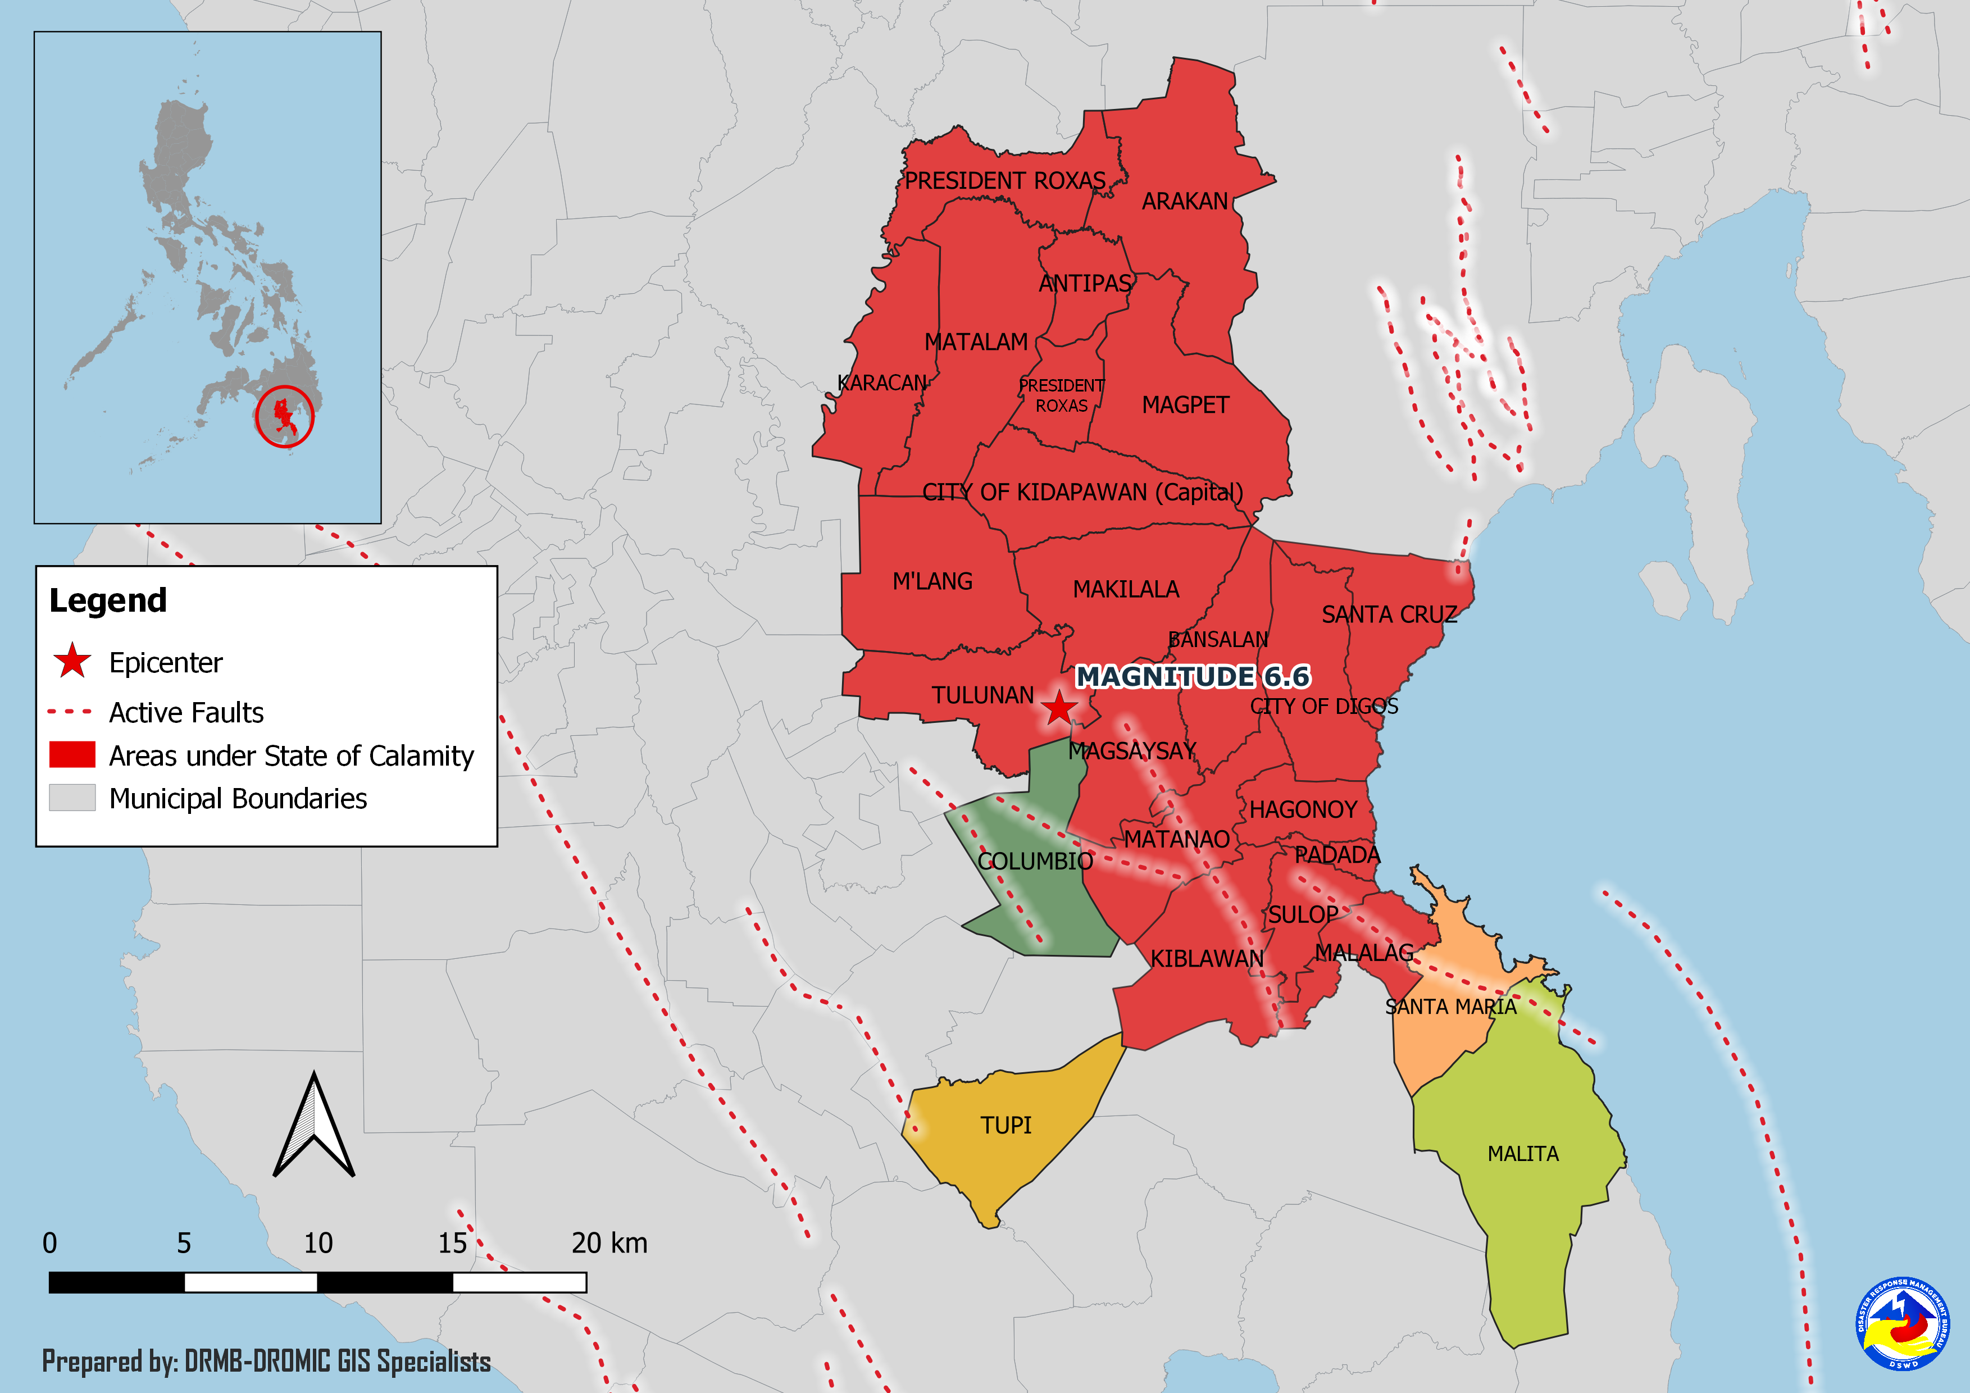
Situational Reports

DSWD-DRMB
DATE | SITUATIONS / ACTIONS UNDERTAKEN
02 December 2019 | - The Disaster Response Management Bureau (DRMB) is on BLUE alert status and is closely coordinating with the concerned Field Offices for significant disaster response updates.  - All QRT members and emergency equipment are on standby and ready for deployment.

DSWD-FO XI
DATE | SITUATIONS / ACTIONS UNDERTAKEN
28 November 2019 | - DSWD-FO XI is still on BLUE alert status.

DSWD-FO XII
DATE | SITUATIONS / ACTIONS UNDERTAKEN
01 December 2019 | - DSWD FO-XII DSWD joined the celebration of National Childrens’ Month in the evacuation center in Barangay Ilomavis, Kidapawan City. As part of the said celebration, DSWD will be distributing schools supplies and provide psychosocial activities to children affected by the earthquake.  - DSWD released 50 sets of family tents in LGU Makilala, North Cotabato.
29 November 2019 | - DSWD FO-XII DRMD staff led the Child Protection Working Group Meeting, Protection Cluster Meeting, and CCCM Cluster Meeting in Amas, Kidapawan City.  - DSWD FO-XII DRMD staff together with OCD XII conducted the needs assessment to EC’s in Makilala, North Cotabato.  - DSWD FO-XII DRMD staff attended the Inter-Agency and Sectoral Consultation Meeting at Capitol Rooftop, Amas, Kidapawan City.

*****
The Disaster Response Operations Monitoring and Information Center (DROMIC) of the DSWD-DRMB is closely coordinating with concerned DSWD Field Offices for any significant disaster response updates.

Prepared by:

MARIE JOYCE G. RAFANAN

JAN ERWIN ANDREW I. ONTANILLAS
Releasing Officer
PHOTO DOCUMENTATION

Relief distribution in New Bulatukan, Makilala North Cotabato (November 02, 2019)





DSWD together with Philippine Coast Guard conducted play therapy at Bacungan Elementary School Evacuation Center (November 07, 2019)



