DSWD DROMIC Report #4 on the
Earthquake Incident in Tulunan, North Cotabato
as of 19 October 2019, 12NN

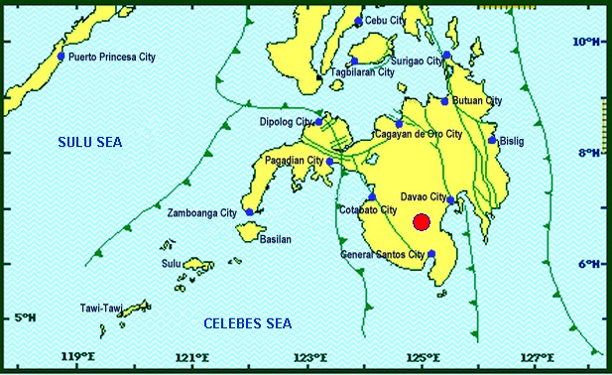
Situation Overview

On 16 October 2019 at 07:37 PM, a 6.3 magnitude earthquake jolted the municipality of Tulunan, North Cotabato (06.75°N, 125.00°E - 022 km S 59° E) with a tectonic origin and a depth of focus of 8 km. The earthquake was also felt in the neighboring municipalities of North Cotabato.

Date/Time: | 16 Oct 2019 - 07:37:04 PM
Reported Intensities: | Intensity VII - Tulunan, North Cotabato, M'Lang, North Cotabato, Kidapawan City  Intensity VI - Digos City, Davao del Sur; Sto. Nino, South Cotabato; Tacurong City  Intensity V - Alabel & Malungon, Sarangani; Lake Sebu, Polomolok, Tampakan & Tupi, South  Cotabato; Koronadal City; Roxas & Pikit, North Cotabato;General Santos City; Davao City;  Kalamansig, Lebak & Palimbang, Sultan Kudarat  Intensity IV - Kiamba, Sarangani; Esperanza & Rosario, Agusan del Sur; Kalilangan, Quezon,  Kadingilan & Damulog, Bukidnon; Mawab, Compostela Valley; Cotabato City; Matanog, Barira &  Sultan Kudarat, Maguindanao  Intensity III - Santa Josefa, Agusan del Sur; Iligan City; Dipolog City  Intensity II - Butuan City; Zamboanga City  Intensity I - Hinatuan, Surigao del Sur  Instrumental Intensities:  Intensity VII - Kidapawan City  Intensity V - Tupi and Polomolok, South Cotabato; Alabel, Sarangani  Intensity IV - Kiamba, Sarangani; T'Boli, South Cotabato; General Santos City  Intensity III - Cagayan de Oro City; Gingoog City, Misamis Oriental;  Intensity II - Cagayan de Oro, Misamis Oriental  Intensity I - Dipolog City; Bislig City
Expecting Damage: | YES
Expecting Aftershocks: | YES
Source: DOST-PHIVOLCS Earthquake Bulletin

- Status of Affected Families / Persons
A total of 3,879 families or 19,395 persons were affected by the earthquake incident in 76 barangays in Regions XI and XII (see Table 1).

Table 1. Number of Affected Families / Persons
REGION / PROVINCE / MUNICIPALITY |  | NUMBER OF AFFECTED
 |  | Barangays | Families | Persons
GRAND TOTAL |  | 76 | 3,879 | 19,395
REGION XI |  | 33 | 575 | 2,875
Davao del Sur |  | 33 | 575 | 2,875
 | Bansalan | 8 | 126 | 630
 | Magsaysay | 14 | 197 | 985
 | Matanao | 11 | 252 | 1,260
REGION XII |  | 43 | 3,304 | 16,520
North Cotabato |  | 43 | 3,304 | 16,520
 | City of Kidapawan (capital) | 1 | 500 | 2,500
 | Makilala | 25 | 2,256 | 11,280
 | M'lang | 1 | 5 | 25
 | Tulunan | 16 | 543 | 2,715
Note: Ongoing assessment and validation being conducted.
Source: DSWD-FOs XI and XII

- Status of Displaced Families / Persons
- Inside Evacuation Centers
There are 58 families or 352 persons who are taking temporary shelter in four (4) evacuation centers in Regions XI and XII (see Table 2).

Table 2. Displaced Families / Persons Inside Evacuation Center
REGION / PROVINCE / MUNICIPALITY |  | NUMBER OF EVACUATION CENTERS (ECs) |  | INSIDE ECs
 |  |  |  | Families |  | Persons
 |  | CUM | NOW | CUM | NOW | CUM | NOW
GRAND TOTAL |  | 5 | 4 | 558 | 58 | 2,852 | 352
REGION XI |  | 3 | 3 | 28 | 28 | 202 | 202
Davao del Sur |  | 3 | 3 | 28 | 28 | 202 | 202
 | Bansalan | 1 | 1 | 3 | 3 | 77 | 77
 | Matanao | 2 | 2 | 25 | 25 | 125 | 125
REGION XII |  | 2 | 1 | 530 | 30 | 2,650 | 150
North Cotabato |  | 2 | 1 | 530 | 30 | 2,650 | 150
 | City of Kidapawan (capital) | 1 | - | 500 | - | 2,500 | -
 | Makilala | 1 | 1 | 30 | 30 | 150 | 150
Note: *The reported affected families or persons in City of Kidapawan have already returned to their area of residence. Thus, ongoing assessment and validation being conducted.
Source: DSWD-FOs XI and XII

- Outside Evacuation Centers
There are 572 families or 2,798 persons who are currently staying with their relatives and/or friends (see Table 3).

Table 3. Number of Displaced Families / Persons Outside Evacuation Center
REGION / PROVINCE / MUNICIPALITY |  | OUTSIDE ECs
 |  | Families |  | Persons
 |  | CUM | NOW | CUM | NOW
GRAND TOTAL |  | 572 | 572 | 2,798 | 2,798
REGION XI |  | 547 | 547 | 2,673 | 2,673
Davao del Sur |  | 547 | 547 | 2,673 | 2,673
 | Bansalan | 123 | 123 | 553 | 553
 | Magsaysay | 197 | 197 | 985 | 985
 | Matanao | 227 | 227 | 1,135 | 1,135
REGION XII |  | 25 | 25 | 125 | 125
North Cotabato |  | 25 | 25 | 125 | 125
 | Makilala | 25 | 25 | 125 | 125
Note: Ongoing assessment and validation being conducted.
Source: DSWD-FOs XI and XII

- Damaged Houses
There are 1,353 damaged houses; of which, 482 are totally damaged and 871 are partially damaged (see Table 4).

Table 4. Number of Damaged Houses
REGION / PROVINCE / MUNICIPALITY |  | NO. OF DAMAGED HOUSES
 |  | Total | Totally | Partially
GRAND TOTAL |  | 1,353 | 482 | 871
REGION XI |  | 337 | 177 | 160
Davao del Sur |  | 337 | 177 | 160
 | Bansalan | 126 | 11 | 115
 | Magsaysay | 195 | 165 | 30
 | Matanao | 16 | 1 | 15
REGION XII |  | 1,016 | 305 | 711
North Cotabato |  | 1,016 | 305 | 711
 | Makilala | 637 | 153 | 484
 | M'lang | 5 | - | 5
 | Tulunan | 374 | 152 | 222
Note: Ongoing assessment and validation being conducted.
Source: DSWD-FOs XI and XII

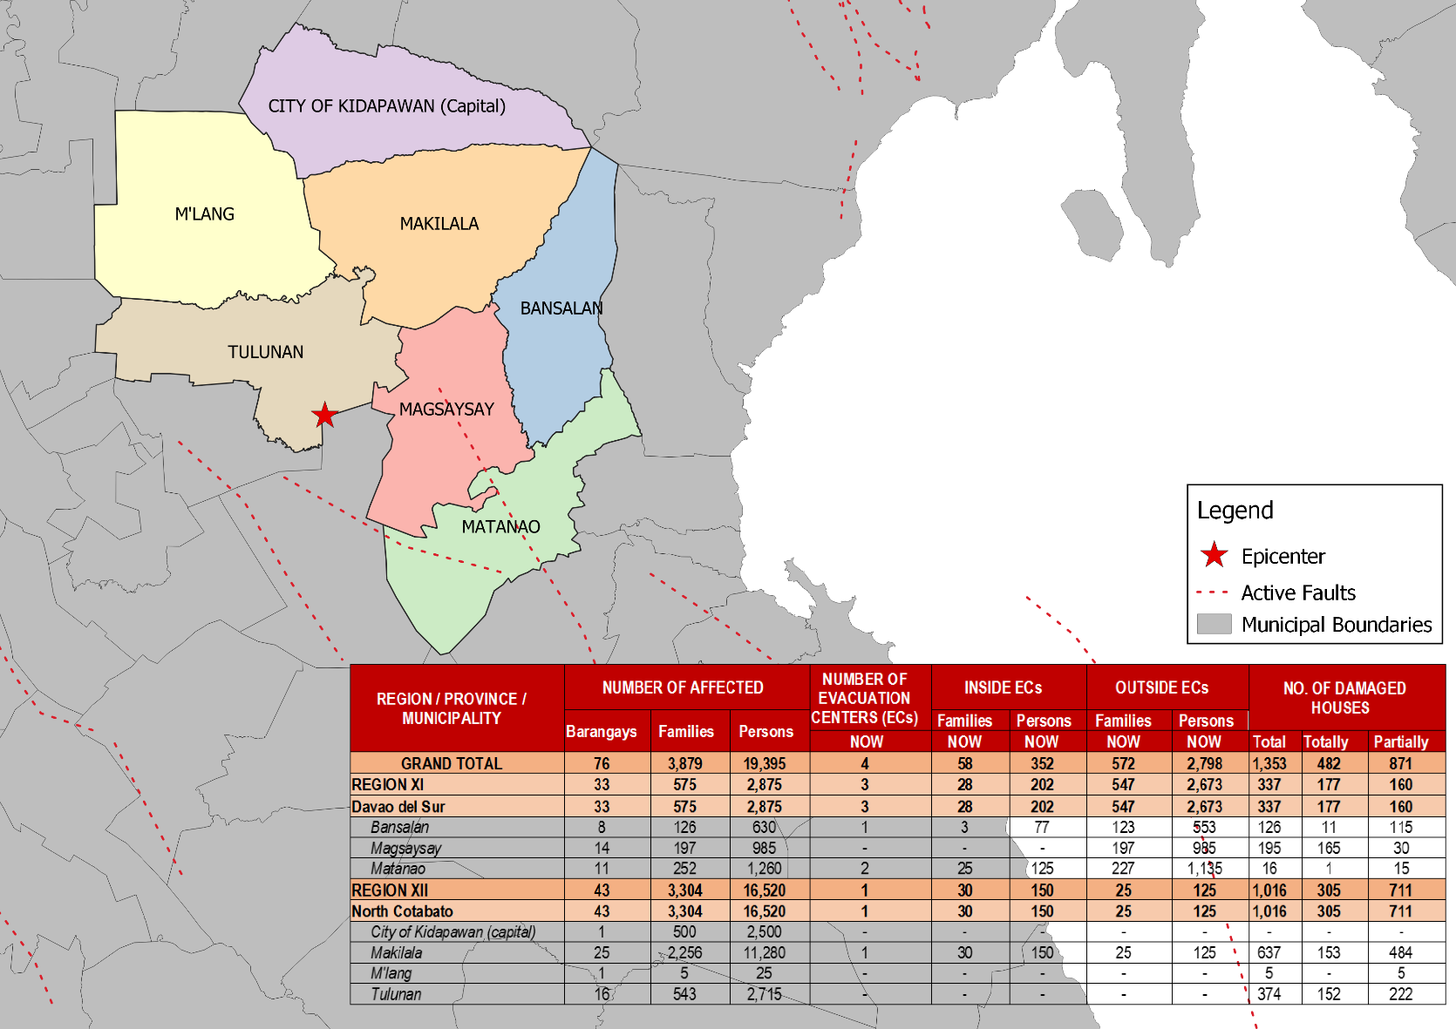
DSWD DISASTER RESPONSE INFORMATION
Source: DRMB-DROMIC GIS Specialists

Status of Prepositioned Resources: Stockpile and Standby Funds

The DSWD Central Office (CO), Field Offices (FOs), and National Resource Operations Center (NROC) have stockpiles and standby funds amounting to ₱1,962,461,844.39 with breakdown as follows:

- Standby Funds
A total of ₱1,109,437,849.36 standby funds in the CO and FOs. Of the said amount, ₱1,076,221,717.34 is the available Quick Response Fund (QRF) in the CO.

- Stockpiles
A total of 326,864 Family Food Packs (FFPs) amounting to ₱125,739,187.01 and available Food and Non-food Items (FNIs) amounting to ₱727,284,808.02.

 | STANDBY FUNDS | FAMILY FOOD PACKS |  | Other Food Items | Non Food Items | SUB-TOTAL (Food and NFIs) | Total STANDBY FUNDS & STOCKPILE
 |  | Quantity | Total Cost | Total Cost | Total Cost
TOTAL | 1,109,437,849.36 | 326,864 | 125,739,187.01 | 203,965,150.23 | 523,319,657.79 | 727,284,808.02 | 1,962,461,844.39
Central Office | 1,076,221,717.34 | - | - | - | - | - | 1,076,221,717.34
NRLMB-NROC | - | 44,791 | 19,694,103.74 | 58,320,536.47 | 286,261,308.65 | 344,581,845.12 | 364,275,948.86
NRLMB-VDRC | - | - | - | 7,256,200.00 | 6,387,750.00 | 13,643,950.00 | 13,643,950.00
I | 2,379,275.00 | 25,667 | 9,374,274.78 | 299,455.20 | 37,796,300.20 | 38,095,755.40 | 49,849,305.18
II | 3,559,531.66 | 28,662 | 9,214,300.12 | 998,872.00 | 2,219,096.75 | 3,217,968.75 | 15,991,800.53
III | 3,068,057.00 | 17,766 | 7,770,150.48 | 2,420,969.70 | 7,081,527.15 | 9,502,496.85 | 20,340,704.33
CALABARZON | 1,772,325.00 | 4,555 | 1,566,724.70 | 3,187,954.80 | 6,205,173.91 | 9,393,128.71 | 12,732,178.41
MIMAROPA | 1,156,022.58 | 27,060 | 11,311,080.00 | 1,030,561.74 | 10,663,131.29 | 11,693,693.03 | 24,160,795.61
V | 1,464,000.00 | 25,943 | 10,117,770.00 | 5,829,520.72 | 39,733,790.47 | 45,563,311.19 | 57,145,081.19
VI | 3,000,000.00 | 8,716 | 3,137,760.00 | 7,438,103.31 | 6,184,569.00 | 13,622,672.31 | 19,760,432.31
VII | 2,300.00 | 20,327 | 7,317,720.00 | 10,728,790.83 | 19,670,441.78 | 30,399,232.61 | 37,719,252.61
VIII | 3,755,235.00 | 27,852 | 10,273,889.32 | 3,812,769.98 | 24,315,046.08 | 28,127,816.06 | 42,156,940.38
IX | 1,888.85 | 12,742 | 4,587,120.00 | 1,363,280.00 | 14,657,720.14 | 16,021,000.14 | 20,610,008.99
X | 3,000,000.00 | 28,037 | 10,246,307.39 | 84,557,913.41 | 35,824,390.06 | 120,382,303.47 | 133,628,610.86
XI | 3,028,750.00 | 10,336 | 3,735,430.40 | 2,726,400.00 | 8,512,037.19 | 11,238,437.19 | 18,002,617.59
XII | 3,000,701.68 | 9,083 | 3,642,283.00 | 8,284,807.00 | 746,876.16 | 9,031,683.16 | 15,674,667.84
CARAGA | 708,696.75 | 13,446 | 5,483,547.72 | 210,180.68 | 3,612,431.96 | 3,822,612.64 | 10,014,857.11
NCR | 3,292,543.50 | 6,346 | 2,378,666.64 | 982,611.51 | 10,538,332.60 | 11,520,944.11 | 17,192,154.25
CAR | 26,805.00 | 15,535 | 5,888,058.72 | 4,516,222.88 | 2,909,734.40 | 7,425,957.28 | 13,340,821.00
* Quick Response Fund (QRF) as of 12 September 2019
** Status of Standby Funds and Stockpile as of 18 October 2019

Situational Reports

DSWD-DRMB
DATE | SITUATIONS / ACTIONS UNDERTAKEN
19 October 2019 | - The Disaster Response Management Bureau (DRMB) is continuously coordinating with DSWD-Field Offices for significant disaster response updates.  - All QRT members and emergency equipment are on standby and ready for deployment.

DSWD-FO XI
DATE | ACTION(S) TAKEN
18 October 2019 | - DSWD-FO XI conducted relief operation to the affected families in municipalities of Magsaysay, Bansalan and Matanao Davao Del Sur.
17 October 2019 | - DSWD-FO XI through the Disaster Response Monitoring and Information Center (DROMIC) was continuously coordinating with the Municipal Social Welfare and Development Office (MSWDO) of Magsaysay, Davao del Sur for updates and possible augmentation support for the affected families.  - DSWD-FO XI coordinated with Office of the Civil Defense (OCD) XI for updates on the status of affected families.  - DSWD-FO XI conducted ocular visit and assessment to the affected families.

DSWD-FO XII
DATE | ACTION(S) TAKEN
19 October 2019 | - The Sangguniang Bayan of LGU Makilala signed the SB Resolution No. 46 last October 17 declaring the entire municipality under the State of Calamity.  - DSWD XII will initially provide 2,256 Family Food Pack and laminated sacks to the affected families in Makilala, North Cotabato. Schedule is set this Sunday, 20 October 2019.
18 October 2019 | - DSWD-FO XII staff assisted in the conduct of Rapid Damage Assessment and Needs Analysis (RDANA) in North Cotabato.
17 October 2019 | - There were reported landslide incidents in the municipality of Tulunan affecting two (2) sitios.  - The CSWDO and MSWDO together with their respective MDRRMOs was doing their assessment to get accurate data on the numbers of families affected and the extent of damaged structures.  - DSWD-FO XII QRT members were on standby and were ready for activation if there’s a need for deployment.  - Four (4) vehicles were ready for utilization in case of response activation.  - DSWD-FO XII DRMD staff conducted an actual validation in North Cotabato areas.  - DSWD-FO XII attended the Emergency Meeting headed by OCD XII.

***
The Disaster Response Operations Monitoring and Information Center (DROMIC) of the DSWD-DRMB is closely monitoring the effects of Earthquake Incident and is coordinating with the concerned DSWD-Field Offices for any significant updates.

Prepared by:

DIANE C. PELEGRINO
GLENNALD O. PORILLO

RODEL V. CABADDU
Releasing Officer

