DSWD DROMIC Report #4 on the
Ms 6.6 Earthquake Incident in Tulunan, North Cotabato
as of 31 October 2019, 12AM

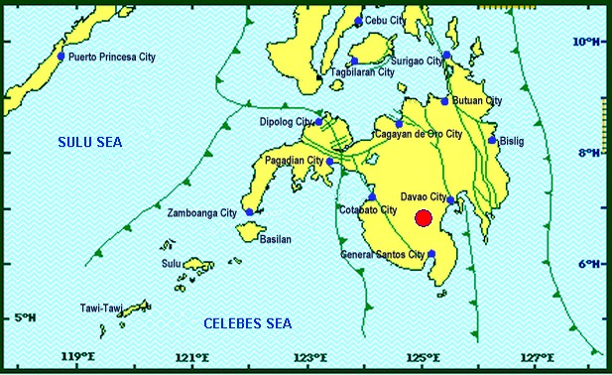

Situation Overview

On 29 October 2019 at 09:04 AM, a 6.6 magnitude earthquake jolted the municipality of Tulunan, North Cotabato (06.81°N, 125.03°E - 022 km S 79° E) with a tectonic origin and a depth of focus of 7 km. The earthquake was also felt in the neighboring municipalities of North Cotabato.

Date/Time: | 29 Oct 2019 - 09:04:43 AM
Reported Intensities: | Intensity VII- Tulunan and Makilala, Cotabato; Kidapawan City; Digos City, Bansalan,  Magsaysay, Davao del Sur and Malungon, Sarangani  Intensity VI- Koronadal City and Davao City  Intensity V- Cotabato City; Tampakan, Surallah, Banga and Tupi, South Cotabato;  General Santos City; Magpet, Cotabato; Tacurong City, Kalamansig, Bagumbayan, Sultan  Kudarat; Alabel, Sarangani; Kalilangan and Damulog, Bukidnon; Tagum City, Davao del Norte  Intensity IV- Cagayan De Oro City; Talakag, Manolo Fortich and Libona, Bukidnon;  Glan, Maitum, Maasim and Kiamba, Sarangani; Butuan City; Iligan City; Tubod and Bacolod,  Lanao del Norte  Intensity III- Molave, Zamboanga del Sur; Dipolog City, Sergio Osmeña Sr. and Polanco,  Zamboanga del Norte; Zamboanga City; Gingoog City, Misamis Oriental and Bislig City  Intensity II- Kabasalan, Zamboanga Sibugay, Mambajao, Camiguin and Isabela City, Basilan  Instrumental Intensities:  Intensity VII- Malungon, Sarangani  Intensity V- Cotabato City; Alabel, Sarangani and Tupi, South Cotabato  Intensity IV- Gingoog City, Misamis Oriental; Kiamba, Sarangani; General Santos City;  Cagayan De Oro City  Intensity II- Zamboanga City and Tulunan, Cotabato  Intensity I- Palo, Leyte; Dipolog City and Bislig City
Expecting Damage: | YES
Expecting Aftershocks: | YES
Source: DOST-PHIVOLCS Earthquake Bulletin
- Status of Affected Families / Persons
A total of 5,126 families or 25,630 persons were affected by the earthquake incident in 59 barangays in Regions XI and XII (see Table 1).

Table 1. Number of Affected Families / Persons
REGION / PROVINCE / MUNICIPALITY |  | NUMBER OF AFFECTED
 |  | Barangays | Families | Persons
GRAND TOTAL |  | 59 | 5,126 | 25,630
REGION XI |  | 20 | 1,622 | 8,110
Davao del Sur |  | 20 | 1,622 | 8,110
 | Bansalan | 8 | 687 | 3,435
 | City of Digos (capital) | 3 | 173 | 865
 | Magsaysay | 9 | 762 | 3,810
REGION XII |  | 39 | 3,504 | 17,520
North Cotabato |  | 39 | 3,504 | 17,520
 | City of Kidapawan (capital) | 4 | 1,292 | 6,460
 | Makilala | 6 | 575 | 2,875
 | M'lang | 15 | 50 | 250
 | Tulunan | 14 | 1,587 | 7,935
Note: Ongoing assessment and validation being conducted.
Source: DSWD-FOs XI and XII

- Status of Displaced Families / Persons
- Inside Evacuation Center
There are 2,552 families or 12,760 persons taking temporary shelter in nineteen (19) evacuation centers in Regions XI and XII (see Table 2).

Table 2. Number of Displaced Families / Persons Inside Evacuation Center
REGION / PROVINCE / MUNICIPALITY |  | NUMBER OF EVACUATION CENTERS (ECs) |  | INSIDE ECs
 |  |  |  | Families |  | Persons
 |  | CUM | NOW | CUM | NOW | CUM | NOW
GRAND TOTAL |  | 19 | 19 | 2,552 | 2,552 | 12,760 | 12,760
REGION XI |  | 15 | 15 | 1,260 | 1,260 | 6,300 | 6,300
Davao del Sur |  | 15 | 15 | 1,260 | 1,260 | 6,300 | 6,300
 | Bansalan | 9 | 9 | 561 | 561 | 2,805 | 2,805
 | City of Digos (capital) | 1 | 1 | 173 | 173 | 865 | 865
 | Magsaysay | 5 | 5 | 526 | 526 | 2,630 | 2,630
REGION XII |  | 4 | 4 | 1,292 | 1,292 | 6,460 | 6,460
North Cotabato |  | 4 | 4 | 1,292 | 1,292 | 6,460 | 6,460
 | City of Kidapawan (capital) | 4 | 4 | 1,292 | 1,292 | 6,460 | 6,460
Note: Ongoing assessment and validation being conducted.
Source: DSWD-FOs XI and XII

- Outside Evacuation Center
There are 1,342 families or 6,710 persons currently staying with their relatives and/or friends (see Table 3).

Table 3. Number of Displaced Families / Persons Outside Evacuation Center
REGION / PROVINCE / MUNICIPALITY |  | OUTSIDE ECs
 |  | Families |  | Persons
 |  | CUM | NOW | CUM | NOW
GRAND TOTAL |  | 1,342 | 1,342 | 6,710 | 6,710
REGION XI |  | 362 | 362 | 1,810 | 1,810
Davao del Sur |  | 362 | 362 | 1,810 | 1,810
 | Bansalan | 126 | 126 | 630 | 630
 | Magsaysay | 236 | 236 | 1,180 | 1,180
REGION XII |  | 980 | 980 | 4,900 | 4,900
North Cotabato |  | 980 | 980 | 4,900 | 4,900
 | M'lang | 50 | 50 | 250 | 250
 | Tulunan | 930 | 930 | 4,650 | 4,650
Note: Ongoing assessment and validation being conducted.
Source: DSWD-FOs XI and XII

- Damaged Houses
There are 2,212 damaged houses; of which, 1,138 are totally damaged and 1,074 are partially damaged (see Table 4).

Table 4. Number of Damaged Houses
REGION / PROVINCE / MUNICIPALITY |  | NO. OF DAMAGED HOUSES
 |  | Total | Totally | Partially
GRAND TOTAL |  | 2,212 | 1,138 | 1,074
REGION XI |  | 514 | 183 | 331
Davao del Sur |  | 514 | 183 | 331
 | Bansalan | 241 | 66 | 175
 | Magsaysay | 273 | 117 | 156
REGION XII |  | 1,698 | 955 | 743
North Cotabato |  | 1,698 | 955 | 743
 | Makilala | 555 | 170 | 385
 | M'lang | 37 | 10 | 27
 | Tulunan | 1,106 | 775 | 331
Note: Ongoing assessment and validation being conducted
Source: DSWD-FOs XI and XII

- Assistance Provided
A total of ₱949,358.00 worth of assistance was provided by DSWD to the affected families (see Table 5).

Table 5. Cost of Assistance Provided to Affected Families / Persons
REGION / PROVINCE / MUNICIPALITY |  | TOTAL COST OF ASSISTANCE
 |  | DSWD | LGU | NGOs | OTHERS | GRAND TOTAL
GRAND TOTAL |  | 949,358.00 | - | - | - | 949,358.00
REGION XII |  | 949,358.00 | - | - | - | 949,358.00
North Cotabato |  | 949,358.00 | - | - | - | 949,358.00
 | City of Kidapawan (capital) | 657,500.00 | - | - | - | 657,500.00
 | M'lang | 123,508.00 | - | - | - | 123,508.00
 | Tulunan | 168,350.00 | - | - | - | 168,350.00
Note: Ongoing assessment and validation being conducted
Source: DSWD-FO XII

DSWD DISASTER RESPONSE INFORMATION

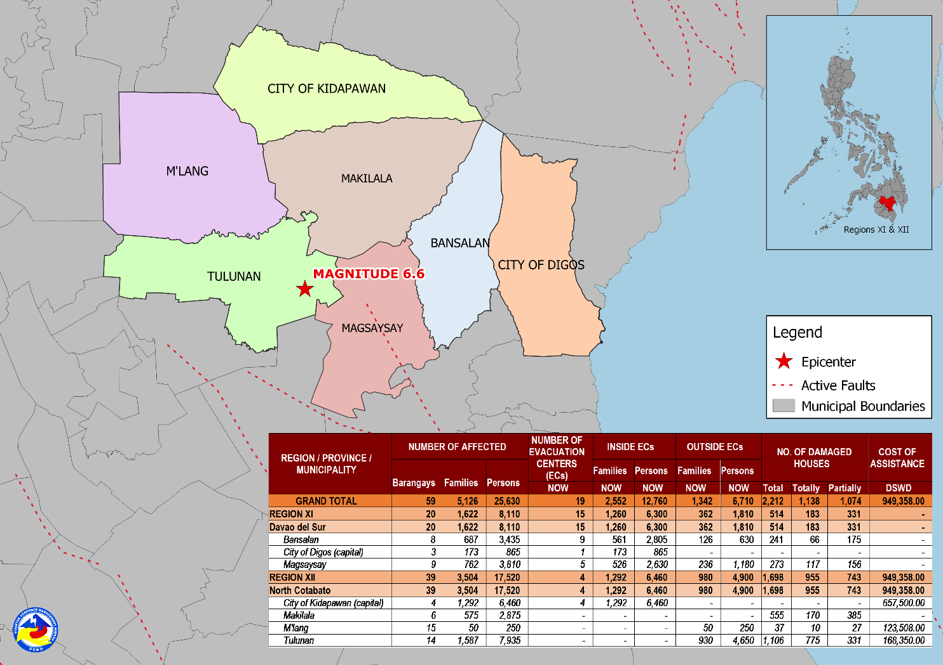

Source: DRMB-DROMIC GIS Specialists

Situational Reports

DSWD-DRMB
DATE | SITUATIONS / ACTIONS UNDERTAKEN
31 October 2019 | - The Disaster Response Management Bureau (DRMB) is on BLUE alert level status and is closely coordinating with concerned field offices for significant disaster response updates.  - All QRT members and emergency equipment are on standby and ready for deployment.

DSWD-NRLMB
DATE | SITUATIONS / ACTIONS UNDERTAKEN
30 October 2019 | - DSWD-NRLMB augmented 50 family tents, 500 sleeping kits, 500 pre-cut laminated sacks and 166 family food packs through C130 that arrived in General Santos City.

DSWD-FO X
DATE | ACTION(S) TAKEN
30 October 2019 | - DSWD-FO X was in close coordination with the concerned City Disaster Risk Reduction Management Offices (CDRRMOs) and Municipal Disaster Risk Reduction Management Offices (MDRRMOs) for any significant update.

DSWD-FO XI
DATE | ACTION(S) TAKEN
31 October 2019 | - Ongoing distribution of family food packs to affected families in the municipality of Magsaysay, Davao del Sur. Tents will also be distributed.  - DSWD-FO XI is in close coordination with the Local Government Units (LGUs) through the Municipal Social Welfare and Development Offices (MSWDOs) particularly in the municipalities of Davao del Sur for any significant updates.

DSWD-FO XII
DATE | ACTION(S) TAKEN
30 October 2019 | - The Sangguniang Panlalawigan of Cotabato approved the SB Resolution No. 569 declaring the entire province of Cotabato under State of Calamity.  - DSWD-FO XII provided 350 family food packs and 10 rolls of laminated sacks to the affected families in Tulunan, North Cotabato.  - DSWD-FO XII provided 1,500 family food packs and 20 rolls of laminated sacks to the affected families in Kidapawan City, North Cotabato.  - DSWD-FO XII provided 308 family food packs to the affected families in M’lang, North Cotabato.  - DSWD-FO XII through the Disaster Response Management Division (DRMD) staff conducted an actual validation in all affected areas in North Cotabato.  - DSWD-FO XII through the Crisis Intervention Unit (CIU) provided ₱5,000 each to fifteen (15) injured individuals in Brgy. Daig, Tulunan, North Cotabato.  - DSWD-FO XII through the CIU provided ₱10,000 to the bereaved families of Narciso Nestor in Koronadal City.
29 October 2019 | - DSWD-FO XII was on RED alert level status.  - All QRT members were on standby and ready for activation if there’s a need for deployment.  - 4 vehicles were ready for utilization in case of response activation.  - Employees except for QRT and DRMD staff were advised to vacate the building and go home.  - Tents were provided to Reception and Study Center for Children (RSCC) for the use of clients and staff as evacuation area while the safety of the building was assessed.  - DSWD-FO XII requested laminated sacks and sleeping kits from NROC.  - All municipal and provincial based DSWD staff were directed to conduct rapid assessment to their respective areas of assignment.

***
The Disaster Response Operations Monitoring and Information Center (DROMIC) of the DSWD-DRMB is closely coordinating with DSWD Field Offices for any significant disaster response updates.

Prepared by:

MARIE JOYCE G. RAFANAN
CLARRIE MAE A. CASTILLO

JAN ERWIN ANDREW I. ONTANILLAS
Releasing Officer

PHOTO DOCUMENTATION

Loading of Goods at NROC
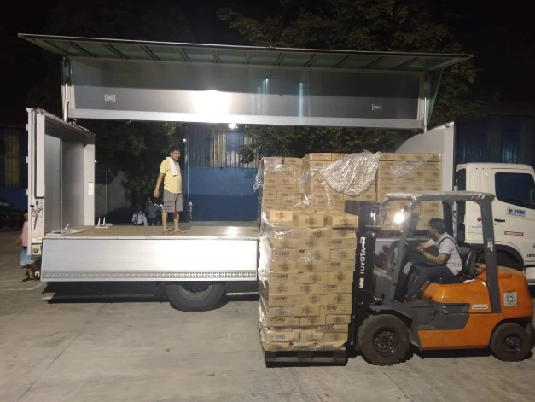
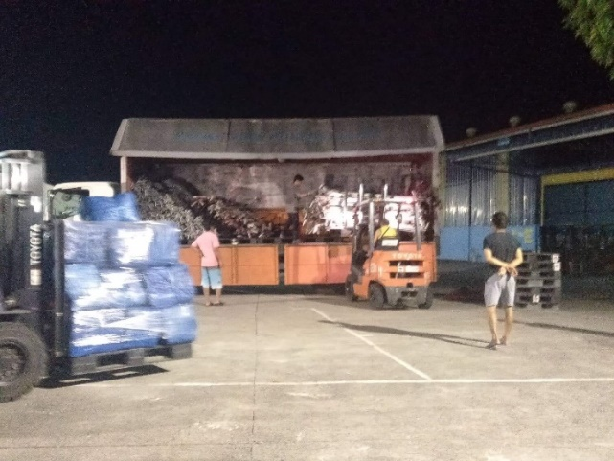

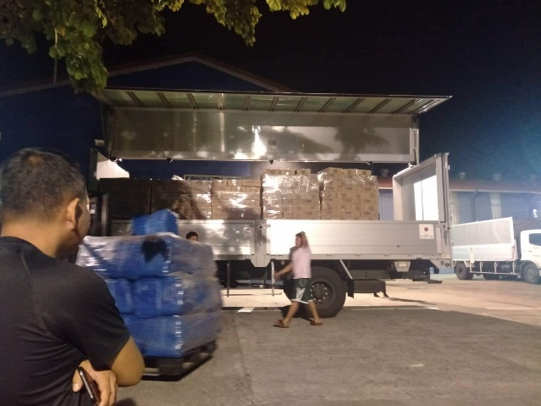
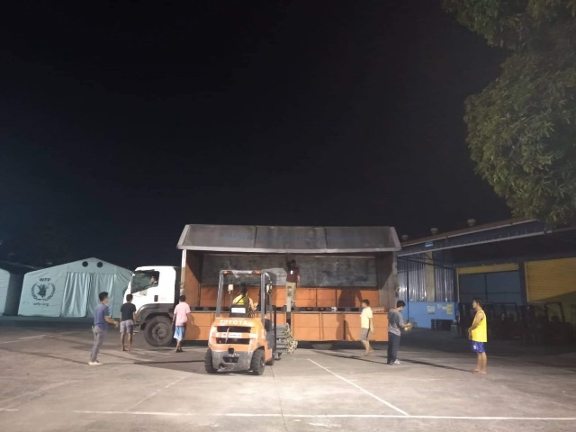

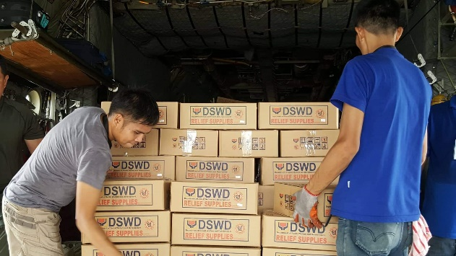
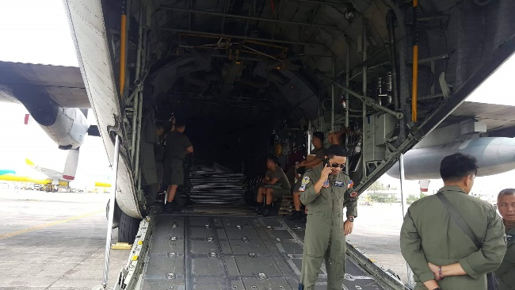
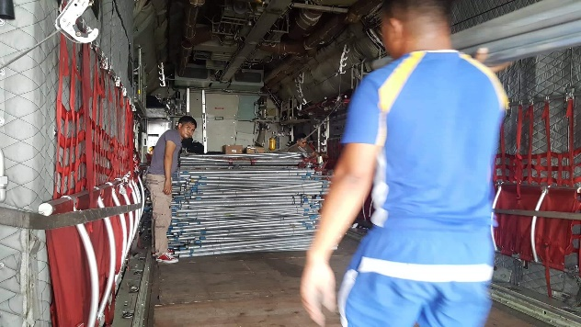
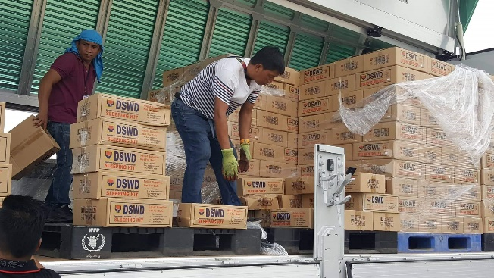
Loading of Goods at Villamor Airbase

