DSWD DROMIC Report #41 on the
Ms 6.6 Earthquake Incident in Tulunan, North Cotabato
as of 04 December 2019, 6PM



Situation Overview

On 29 October 2019 at 09:04 AM, a 6.6 magnitude earthquake jolted the municipality of Tulunan, North Cotabato (06.81°N, 125.03°E - 022 km S 79°E) with a tectonic origin and a depth of focus of 7 km. The earthquake was also felt in the neighboring municipalities of North Cotabato and Davao Region.

Source: DOST-PHIVOLCS Earthquake Bulletin

- Status of Affected Families / Persons
A total of 71,653 families or 349,036 persons were affected by the earthquake incident in 362 barangays in Regions XI and XII (see Table 1).

Table 1. Number of Affected Families / Persons
REGION / PROVINCE / MUNICIPALITY |  | NUMBER OF AFFECTED
 |  | Barangay | Families | Persons
GRAND TOTAL |  | 362 | 71,653 | 349,036
REGION XI |  | 151 | 25,448 | 118,011
Davao del Sur |  | 143 | 25,387 | 117,706
 | Bansalan | 25 | 7,479 | 29,319
 | City of Digos (capital) | 14 | 2,044 | 10,220
 | Hagonoy | 18 | 1,480 | 8,001
 | Kiblawan | 14 | 70 | 350
 | Magsaysay | 22 | 9,331 | 46,575
 | Malalag | 3 | 229 | 1,145
 | Matanao | 32 | 3,852 | 17,586
 | Padada | 1 | 714 | 3,570
 | Santa Cruz | 11 | 38 | 190
 | Sulop | 3 | 150 | 750
Davao Occidental |  | 8 | 61 | 305
 | Malita | 1 | 1 | 5
 | Santa Maria | 7 | 60 | 300
REGION XII |  | 211 | 46,205 | 231,025
North Cotabato |  | 209 | 46,149 | 230,745
 | Antipas | 13 | 312 | 1,560
 | Arakan | 19 | 396 | 1,980
 | Kabacan | 12 | 305 | 1,525
 | City of Kidapawan (capital) | 28 | 6,713 | 33,565
 | Magpet | 19 | 2,770 | 13,850
 | Makilala | 38 | 20,704 | 103,520
 | Matalam | 12 | 649 | 3,245
 | M'lang | 33 | 2,099 | 10,495
 | President Roxas | 6 | 305 | 1,525
 | Tulunan | 29 | 11,896 | 59,480
South Cotabato |  | 1 | 18 | 90
 | Tupi | 1 | 18 | 90
Sultan Kudarat |  | 1 | 38 | 190
 | Columbio | 1 | 38 | 190
Note: The decrease in the number of affected families in Region XI is due to the validated report submitted by DSWD-FO XI. Ongoing assessment and validation being conducted.
Source: DSWD-FOs XI and XII

- Status of Displaced Families / Persons
- Inside Evacuation Center
There are 12,823 families or 58,346 persons taking temporary shelter in 103 evacuation centers in Regions XI and XII (see Table 2).

Table 2. Number of Displaced Families / Persons Inside Evacuation Centers
REGION / PROVINCE / MUNICIPALITY |  | NUMBER OF EVACUATION CENTERS (ECs) |  | NUMBER OF DISPLACED
 |  |  |  | INSIDE ECs
 |  |  |  | Families |  | Persons
 |  | CUM | NOW | CUM | NOW | CUM | NOW
GRAND TOTAL |  | 132 | 103 | 18,147 | 12,823 | 86,134 | 58,346
REGION XI |  | 56 | 36 | 9,292 | 4,269 | 41,859 | 15,576
Davao del Sur |  | 56 | 36 | 9,292 | 4,269 | 41,859 | 15,576
 | Bansalan | 21 | 14 | 4,741 | 1,345 | 21,379 | 4,770
 | City of Digos (capital) | 15 | 6 | 2,057 | 971 | 9,505 | 3,487
 | Hagonoy | 4 | 3 | 344 | 158 | 1,807 | 627
 | Magsaysay | 10 | 10 | 1,671 | 1,479 | 7,435 | 5,635
 | Matanao | 2 | 2 | 297 | 286 | 1,052 | 953
 | Padada | 1 | 1 | 32 | 30 | 111 | 104
 | Sulop | 3 | - | 150 | - | 570 | -
REGION XII |  | 76 | 67 | 8,855 | 8,554 | 44,275 | 42,770
North Cotabato |  | 76 | 67 | 8,855 | 8,554 | 44,275 | 42,770
 | Arakan | 5 | 5 | 151 | 151 | 755 | 755
 | City of Kidapawan (capital) | 9 | 9 | 2,029 | 2,029 | 10,145 | 10,145
 | Magpet | 26 | 26 | 1,744 | 1,744 | 8,720 | 8,720
 | Makilala | 36 | 27 | 4,931 | 4,630 | 24,655 | 23,150
Note: The decrease in the number of affected families or persons is due to the transfer of IDPs from Inside EC to Outside EC. Ongoing assessment and validation being conducted.
Source: DSWD-FOs XI and XII

- Outside Evacuation Center
There are 27,022 families or 130,899 persons currently staying with their relatives and/or friends, or in open spaces (see Table 3).

Table 3. Number of Displaced Families / Persons Outside Evacuation Centers
REGION / PROVINCE / MUNICIPALITY |  | NUMBER OF DISPLACED
 |  | OUTSIDE ECs
 |  | Families |  | Persons
 |  | CUM | NOW | CUM | NOW
GRAND TOTAL |  | 27,726 | 27,022 | 137,080 | 130,899
REGION XI |  | 12,943 | 12,437 | 63,165 | 57,974
Davao del Sur |  | 12,943 | 12,437 | 63,165 | 57,974
 | Bansalan | 4,928 | 4,493 | 23,202 | 20,546
 | City of Digos (capital) | 5 | 5 | 20 | 20
 | Hagonoy | 435 | 435 | 2,175 | 2,175
 | Magsaysay | 7,402 | 7,331 | 37,010 | 34,475
 | Matanao | 125 | 125 | 525 | 525
 | Padada | 20 | 20 | 93 | 93
 | Santa Cruz | 28 | 28 | 140 | 140
REGION XII |  | 14,783 | 14,585 | 73,915 | 72,925
North Cotabato |  | 14,783 | 14,585 | 73,915 | 72,925
 | Antipas | 33 | 33 | 165 | 165
 | Arakan | 10 | 10 | 50 | 50
 | Kabacan | 75 | 55 | 375 | 275
 | City of Kidapawan (capital) | 70 | 70 | 350 | 350
 | Matalam | 534 | 534 | 2,670 | 2,670
 | M'lang | 2,041 | 2,041 | 10,205 | 10,205
 | President Roxas | 219 | 41 | 1,095 | 205
 | Tulunan | 11,801 | 11,801 | 59,005 | 59,005
Note: *The increase in the number of families Outside EC is due to the added number of displaced families in Bansalan, Davao del Sur. Thus, ongoing assessment and validation being conducted.
Source: DSWD-FOs XI and XII

- Damaged Houses
There are 47,525 damaged houses; of which, 25,821 are totally damaged and 21,704 are partially damaged (see Table 4).

Table 4. Number of Damaged Houses
REGION / PROVINCE / MUNICIPALITY |  | NO. OF DAMAGED HOUSES
 |  | Total | Totally | Partially
GRAND TOTAL |  | 47,525 | 25,821 | 21,704
REGION XI |  | 13,482 | 3,332 | 10,150
Davao del Sur |  | 13,181 | 3,223 | 9,958
 | Bansalan | 3,675 | 1,145 | 2,530
 | Hagonoy | 842 | 179 | 663
 | Kiblawan | 1 | 1 | -
 | Magsaysay | 7,402 | 1,609 | 5,793
 | Matanao | 725 | 68 | 657
 | Padada | 375 | 165 | 210
 | Santa Cruz | 11 | 2 | 9
 | Sulop | 150 | 54 | 96
Davao Occidental |  | 301 | 109 | 192
 | Malita | 1 | 1 | -
 | Santa Maria | 300 | 108 | 192
REGION XII |  | 34,043 | 22,489 | 11,554
North Cotabato |  | 33,987 | 22,474 | 11,513
 | Antipas | 312 | 33 | 279
 | Arakan | 192 | 15 | 177
 | Kabacan | 261 | 14 | 247
 | City of Kidapawan (capital) | 5,697 | 1,681 | 4,016
 | Magpet | 974 | 111 | 863
 | Makilala | 20,704 | 18,997 | 1,707
 | Matalam | 534 | 10 | 524
 | M'lang | 1,991 | 535 | 1,456
 | President Roxas | 259 | 21 | 238
 | Tulunan | 3,063 | 1,057 | 2,006
South Cotabato |  | 18 | 1 | 17
 | Tupi | 18 | 1 | 17
Sultan Kudarat |  | 38 | 14 | 24
 | Columbio | 38 | 14 | 24
Note: The 2,094 decrease in the number of damaged houses in Tulunan, North Cotabato and 50 damaged house in Kabacan, North Cotabato are due to the validated report submitted by the LGUs to DSWD-FO XII. Ongoing assessment and validation being conducted.
Source: DSWD-FOs XI and XII
- Assistance Provided
A total of ₱87,857,199.25 worth of assistance was provided by DSWD to the affected families (see Table 5).

Table 5. Cost of Assistance Provided to Affected Families / Persons
REGION / PROVINCE / MUNICIPALITY |  | DSWD TOTAL | LGU | NGOs | OTHERS | GRAND TOTAL
GRAND TOTAL |  | 87,857,199.25 | - | - | - | 87,857,199.25
REGION XI |  | 45,786,582.05 | - | - | - | 45,786,582.05
Davao del Sur |  | 45,786,582.05 | - | - | - | 45,786,582.05
 | Bansalan | 14,526,291.85 | - | - | - | 14,526,291.85
 | City of Digos (capital) | 7,436,736.30 | - | - | - | 7,436,736.30
 | Hagonoy | 1,900,126.75 | - | - | - | 1,900,126.75
 | Magsaysay | 15,544,981.35 | - | - | - | 15,544,981.35
 | Malalag | 686,330.00 | - | - | - | 686,330.00
 | Matanao | 4,915,453.80 | - | - | - | 4,915,453.80
 | Padada | 545,366.00 | - | - | - | 545,366.00
 | Sulop | 231,296.00 | - | - | - | 231,296.00
REGION XII |  | 42,070,617.20 | - | - | - | 42,070,617.20
North Cotabato |  | 42,070,617.20 | - | - | - | 42,070,617.20
 | Arakan | 644,761.00 | - | - | - | 644,761.00
 | City of Kidapawan (capital) | 10,938,780.00 | - | - | - | 10,938,780.00
 | Magpet | 8,475,919.00 | - | - | - | 8,475,919.00
 | Makilala | 12,550,805.48 | - | - | - | 12,550,805.48
 | Matalam | 2,676,225.00 | - | - | - | 2,676,225.00
 | M'lang | 1,727,824.00 | - | - | - | 1,727,824.00
 | Tulunan | 5,056,302.72 | - | - | - | 5,056,302.72
Source: DSWD-FOs XI and XII

DSWD DISASTER RESPONSE INFORMATION
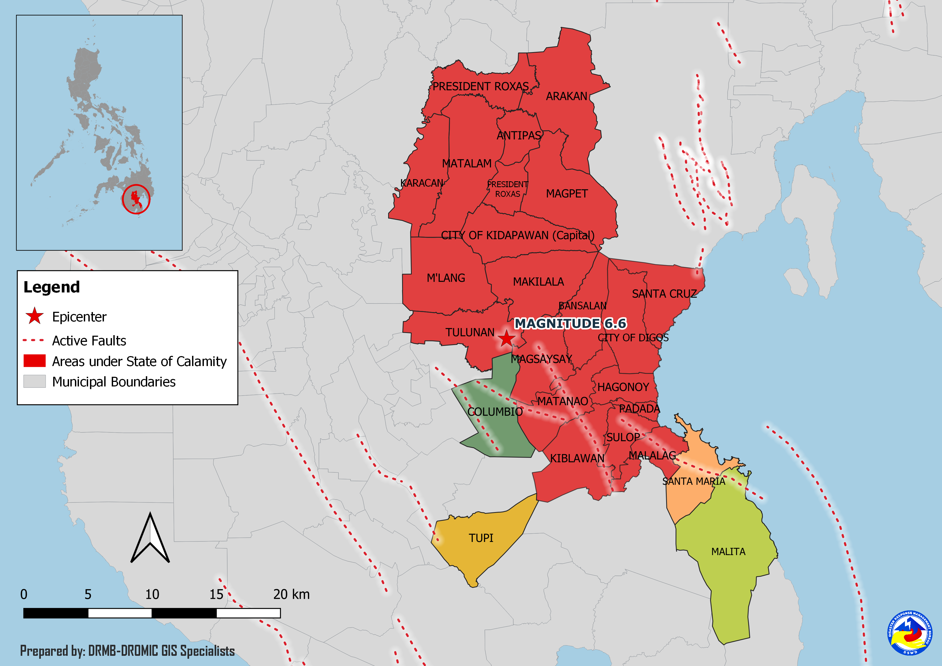
Situational Reports

DSWD-DRMB
DATE | SITUATIONS / ACTIONS UNDERTAKEN
03 December 2019 | - The Disaster Response Management Bureau (DRMB) is on BLUE alert status and is closely coordinating with the concerned Field Offices for significant disaster response updates.  - All QRT members and emergency equipment are on standby and ready for deployment.

DSWD-FO XI
DATE | SITUATIONS / ACTIONS UNDERTAKEN
28 November 2019 | - DSWD-FO XI is still on BLUE alert status.

DSWD-FO XII
DATE | SITUATIONS / ACTIONS UNDERTAKEN
04 December 2019 | - DSWD-FO XII is continuously providing cash assistance to the IDP’s in Makilala, and Kidapawan City, North Cotabato through CIU-AICS.  - DSWD-FO XII conducted meeting with MAT Leaders in Makilala, North Cotabato.

*****
The Disaster Response Operations Monitoring and Information Center (DROMIC) of the DSWD-DRMB is closely coordinating with concerned DSWD Field Offices for any significant disaster response updates.

Prepared by:

DIANE C. PELEGRINO
MARIEL B. FERRARIZ

RODEL V. CABADDU
Releasing Officer
PHOTO DOCUMENTATION

Relief distribution in New Bulatukan, Makilala North Cotabato





DSWD together with Philippine Coast Guard conducted play therapy at Bacungan Elementary School Evacuation Center



