DSWD DROMIC Report #46 on the
Ms 6.6 Earthquake Incident in Tulunan, North Cotabato
as of 12 December 2019, 6PM



Situation Overview

On 29 October 2019 at 09:04 AM, a 6.6 magnitude earthquake jolted the municipality of Tulunan, North Cotabato (06.81°N, 125.03°E - 022 km S 79°E) with a tectonic origin and a depth of focus of 7 km. The earthquake was also felt in the neighboring municipalities of North Cotabato and Davao Region.

Source: DOST-PHIVOLCS Earthquake Bulletin

- Status of Affected Families / Persons
A total of 71,707 families or 351,628 persons were affected by the earthquake incident in 371 barangays in Regions XI and XII (see Table 1).

Table 1. Number of Affected Families / Persons
REGION / PROVINCE / MUNICIPALITY |  | NUMBER OF AFFECTED
 |  | Barangay | Families | Persons
GRAND TOTAL |  | 371 | 71,707 | 351,628
REGION XI |  | 160 | 25,555 | 120,868
Davao del Sur |  | 151 | 25,354 | 119,863
 | Bansalan | 25 | 7,060 | 29,444
 | City of Digos (capital) | 14 | 2,044 | 10,220
 | Hagonoy | 18 | 1,480 | 8,001
 | Kiblawan | 21 | 456 | 2,280
 | Magsaysay | 22 | 9,331 | 46,575
 | Malalag | 3 | 229 | 1,145
 | Matanao | 32 | 3,852 | 17,688
 | Padada | 2 | 714 | 3,570
 | Santa Cruz | 11 | 38 | 190
 | Sulop | 3 | 150 | 750
Davao Occidental |  | 9 | 201 | 1,005
 | Malita | 1 | 1 | 5
 | Santa Maria | 8 | 200 | 1,000
REGION XII |  | 211 | 46,152 | 230,760
North Cotabato |  | 209 | 46,096 | 230,480
 | Antipas | 13 | 312 | 1,560
 | Arakan | 19 | 343 | 1,715
 | Kabacan | 12 | 305 | 1,525
 | City of Kidapawan (capital) | 28 | 6,713 | 33,565
 | Magpet | 19 | 2,770 | 13,850
 | Makilala | 38 | 20,704 | 103,520
 | Matalam | 12 | 649 | 3,245
 | M'lang | 33 | 2,099 | 10,495
 | President Roxas | 6 | 305 | 1,525
 | Tulunan | 29 | 11,896 | 59,480
South Cotabato |  | 1 | 18 | 90
 | Tupi | 1 | 18 | 90
Sultan Kudarat |  | 1 | 38 | 190
 | Columbio | 1 | 38 | 190
Note: Ongoing assessment and validation being conducted.
Source: DSWD-FOs XI and XII

- Status of Displaced Families / Persons
- Inside Evacuation Center
There are 11,405 families or 52,477 persons taking temporary shelter in 91 evacuation centers in Regions XI and XII (see Table 2).

Table 2. Number of Displaced Families / Persons Inside Evacuation Centers
REGION / PROVINCE / MUNICIPALITY |  | NUMBER OF EVACUATION CENTERS (ECs) |  | NUMBER OF DISPLACED
 |  |  |  | INSIDE ECs
 |  |  |  | Families |  | Persons
 |  | CUM | NOW | CUM | NOW | CUM | NOW
GRAND TOTAL |  | 132 | 91 | 16,109 | 11,405 | 76,345 | 52,477
REGION XI |  | 56 | 31 | 7,254 | 3,572 | 32,070 | 13,312
Davao del Sur |  | 56 | 31 | 7,254 | 3,572 | 32,070 | 13,312
 | Bansalan* | 21 | 12 | 2,703 | 1,094 | 11,389 | 4,002
 | City of Digos (capital) | 15 | 3 | 2,057 | 560 | 9,604 | 2,088
 | Hagonoy | 4 | 3 | 344 | 158 | 1,807 | 627
 | Magsaysay | 10 | 10 | 1,671 | 1,464 | 7,435 | 5,608
 | Matanao | 2 | 2 | 297 | 266 | 1,154 | 883
 | Padada | 1 | 1 | 32 | 30 | 111 | 104
 | Sulop | 3 | - | 150 | - | 570 | -
REGION XII |  | 76 | 60 | 8,855 | 7,833 | 44,275 | 39,165
North Cotabato |  | 76 | 60 | 8,855 | 7,833 | 44,275 | 39,165
 | Arakan | 5 | 5 | 151 | 151 | 755 | 755
 | City of Kidapawan (capital) | 9 | 9 | 2,029 | 2,029 | 10,145 | 10,145
 | Magpet | 26 | 19 | 1,744 | 1,023 | 8,720 | 5,115
 | Makilala | 36 | 27 | 4,931 | 4,630 | 24,655 | 23,150
Note: *The decrease in the number of displaced (CUM) is due to the duplication of data in the affected families and individuals in Bansalan, Davao del Sur. Hence, ongoing assessment and validation being conducted.
Source: DSWD-FOs XI and XII

- Outside Evacuation Center
There are 24,318 families or 117,379 persons currently staying with their relatives and/or friends, or in open spaces (see Table 3).

Table 3. Number of Displaced Families / Persons Outside Evacuation Centers
REGION / PROVINCE / MUNICIPALITY |  | NUMBER OF DISPLACED
 |  | OUTSIDE ECs
 |  | Families |  | Persons
 |  | CUM | NOW | CUM | NOW
GRAND TOTAL |  | 27,726 | 24,318 | 137,080 | 117,379
REGION XI |  | 12,943 | 12,437 | 63,165 | 57,974
Davao del Sur |  | 12,943 | 12,437 | 63,165 | 57,974
 | Bansalan | 4,928 | 4,493 | 23,202 | 20,546
 | City of Digos (capital) | 5 | 5 | 20 | 20
 | Hagonoy | 435 | 435 | 2,175 | 2,175
 | Magsaysay | 7,402 | 7,331 | 37,010 | 34,475
 | Matanao | 125 | 125 | 525 | 525
 | Padada | 20 | 20 | 93 | 93
 | Santa Cruz | 28 | 28 | 140 | 140
REGION XII |  | 14,783 | 11,881 | 73,915 | 59,405
North Cotabato |  | 14,783 | 11,881 | 73,915 | 59,405
 | Antipas | 33 | - | 165 | -
 | Arakan | 10 | 10 | 50 | 50
 | Kabacan | 75 | - | 375 | -
 | City of Kidapawan (capital) | 70 | 70 | 350 | 350
 | Matalam | 534 | - | 2,670 | -
 | M'lang | 2,041 | - | 10,205 | -
 | President Roxas | 219 | - | 1,095 | -
 | Tulunan | 11,801 | 11,801 | 59,005 | 59,005
Note: Ongoing assessment and validation being conducted.
Source: DSWD-FOs XI and XII

- Damaged Houses
There are 47,476 damaged houses; of which, 25,795 are totally damaged and 21,681 are partially damaged (see Table 4).

Table 4. Number of Damaged Houses
REGION / PROVINCE / MUNICIPALITY |  | NO. OF DAMAGED HOUSES
 |  | Total | Totally | Partially
GRAND TOTAL |  | 47,476 | 25,795 | 21,681
REGION XI |  | 13,433 | 3,306 | 10,127
Davao del Sur |  | 13,232 | 3,240 | 9,992
 | Bansalan | 3,675 | 1,145 | 2,530
 | Hagonoy | 842 | 179 | 663
 | Kiblawan | 52 | 18 | 34
 | Magsaysay | 7,402 | 1,609 | 5,793
 | Matanao | 725 | 68 | 657
 | Padada | 375 | 165 | 210
 | Santa Cruz | 11 | 2 | 9
 | Sulop | 150 | 54 | 96
Davao Occidental |  | 201 | 66 | 135
 | Malita | 1 | 1 | -
 | Santa Maria | 200 | 65 | 135
REGION XII |  | 34,043 | 22,489 | 11,554
North Cotabato |  | 33,987 | 22,474 | 11,513
 | Antipas | 312 | 33 | 279
 | Arakan | 192 | 15 | 177
 | Kabacan | 261 | 14 | 247
 | City of Kidapawan (capital) | 5,697 | 1,681 | 4,016
 | Magpet | 974 | 111 | 863
 | Makilala | 20,704 | 18,997 | 1,707
 | Matalam | 534 | 10 | 524
 | M'lang | 1,991 | 535 | 1,456
 | President Roxas | 259 | 21 | 238
 | Tulunan | 3,063 | 1,057 | 2,006
South Cotabato |  | 18 | 1 | 17
 | Tupi | 18 | 1 | 17
Sultan Kudarat |  | 38 | 14 | 24
 | Columbio | 38 | 14 | 24
Note: The decrease in the number of damaged houses in Sta. Maria is based on the updated report submitted by MSWDO to DSWD-FO XI. Thus, ongoing assessment and validation being conducted.
Source: DSWD-FOs XI and XII

- Assistance Provided
A total of ₱94,878,069.91 worth of assistance was provided by DSWD to the affected families (see Table 5).

Table 5. Cost of Assistance Provided to Affected Families / Persons
REGION / PROVINCE / MUNICIPALITY |  | DSWD TOTAL | LGU | NGOs | OTHERS | GRAND TOTAL
GRAND TOTAL |  | 94,878,069.91 | - | - | - | 94,878,069.91
REGION XI |  | 52,807,452.71 | - | - | - | 52,807,452.71
Davao del Sur |  | 52,690,352.71 | - | - | - | 52,690,352.71
 | Bansalan | 15,777,971.84 | - | - | - | 15,777,971.84
 | City of Digos (capital) | 8,191,412.83 | - | - | - | 8,191,412.83
 | Hagonoy | 1,943,279.73 | - | - | - | 1,943,279.73
 | Kiblawan | 4,437,877.50 | - | - | - | 4,437,877.50
 | Magsaysay | 15,565,298.92 | - | - | - | 15,565,298.92
 | Malalag | 703,815.00 | - | - | - | 703,815.00
 | Matanao | 5,251,270.71 | - | - | - | 5,251,270.71
 | Padada | 573,897.39 | - | - | - | 573,897.39
 | Sulop | 245,528.79 | - | - | - | 245,528.79
Davao Occidental |  | 117,100.00 | - | - | - | 117,100.00
 | Santa Maria | 117,100.00 | - | - | - | 117,100.00
REGION XII |  | 42,070,617.20 | - | - | - | 42,070,617.20
North Cotabato |  | 42,070,617.20 | - | - | - | 42,070,617.20
 | Arakan | 644,761.00 | - | - | - | 644,761.00
 | City of Kidapawan (capital) | 10,938,780.00 | - | - | - | 10,938,780.00
 | Magpet | 8,475,919.00 | - | - | - | 8,475,919.00
 | Makilala | 12,550,805.48 | - | - | - | 12,550,805.48
 | Matalam | 2,676,225.00 | - | - | - | 2,676,225.00
 | M'lang | 1,727,824.00 | - | - | - | 1,727,824.00
 | Tulunan | 5,056,302.72 | - | - | - | 5,056,302.72
Source: DSWD-FOs XI and XII

DSWD DISASTER RESPONSE INFORMATION
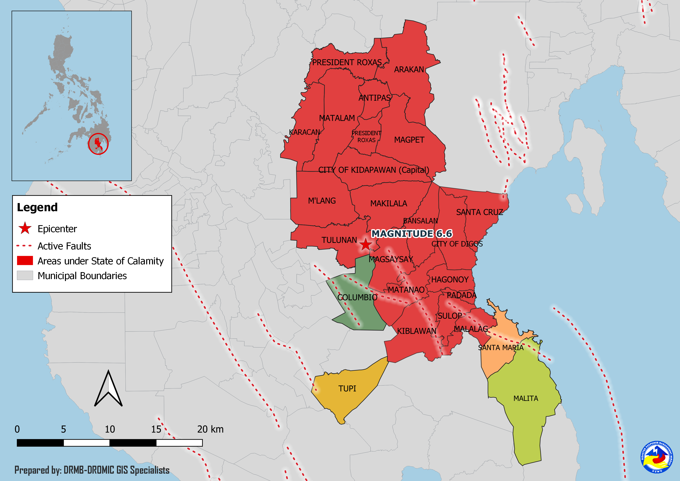
Situational Reports

DSWD-DRMB
DATE | SITUATIONS / ACTIONS UNDERTAKEN
12 December 2019 | - The Disaster Response Management Bureau (DRMB) is on BLUE alert status and is closely coordinating with the concerned Field Offices for significant disaster response updates.

DSWD-FO XI
DATE | SITUATIONS / ACTIONS UNDERTAKEN
12 December 2019 | - DSWD-FO XI is still on BLUE alert status.
10 December 2019 | - DSWD-FO XI provided financial assistance through Cash-for Work amounting to ₱1,985,445.00 and burial and medical assistance worth ₱5,754,535.00 to the affected families.

DSWD-FO XII
DATE | SITUATIONS / ACTIONS UNDERTAKEN
11 December 2019 | - DSWD-FO XII through the Crisis Intervention Unit provided a total of ₱1,248,000.00 financial assistance to 416 affected families wherein each family received ₱3,000.00.

*****
The Disaster Response Operations Monitoring and Information Center (DROMIC) of the DSWD-DRMB is closely coordinating with concerned DSWD Field Offices for any significant disaster response updates.

Prepared by:

DIANE C. PELEGRINO
MARIE JOYCE G. RAFANAN

LESLIE R. JAWILI
Releasing Officer
PHOTO DOCUMENTATION

Relief distribution in New Bulatukan, Makilala North Cotabato





DSWD together with Philippine Coast Guard conducted play therapy at Bacungan Elementary School Evacuation Center



