DSWD DROMIC Report #55 on the
Ms 6.6 Earthquake Incident in Tulunan, North Cotabato
as of 04 March 2020, 6PM



Situation Overview

On 29 October 2019 at 09:04 AM, a 6.6 magnitude earthquake jolted the municipality of Tulunan, North Cotabato (06.81°N, 125.03°E - 022 km S 79°E) with a tectonic origin and a depth of focus of 7 km. The earthquake was also felt in the neighboring municipalities of North Cotabato and Davao Region.

Source: DOST-PHIVOLCS Earthquake Bulletin

- Status of Affected Families / Persons
A total of 72,578 families or 355,983 persons were affected by the earthquake incident in 379 barangays in Regions XI and XII (see Table 1).

Table 1. Number of Affected Families / Persons
REGION / PROVINCE / MUNICIPALITY |  | NUMBER OF AFFECTED
 |  | Barangay | Families | Persons
GRAND TOTAL |  | 379 | 72,578 | 355,983
REGION XI |  | 168 | 25,817 | 122,178
Davao del Sur |  | 159 | 25,616 | 121,173
 | Bansalan | 25 | 7,060 | 29,444
 | City of Digos (capital) | 14 | 2,044 | 10,220
 | Hagonoy | 18 | 1,480 | 8,001
 | Kiblawan | 21 | 456 | 2,280
 | Magsaysay | 22 | 9,331 | 46,575
 | Malalag | 11 | 491 | 2,455
 | Matanao | 32 | 3,852 | 17,688
 | Padada | 2 | 714 | 3,570
 | Santa Cruz | 11 | 38 | 190
 | Sulop | 3 | 150 | 750
Davao Occidental |  | 9 | 201 | 1,005
 | Malita | 1 | 1 | 5
 | Santa Maria | 8 | 200 | 1,000
REGION XII |  | 211 | 46,761 | 233,805
North Cotabato |  | 209 | 46,705 | 233,525
 | Antipas | 13 | 312 | 1,560
 | Arakan | 19 | 343 | 1,715
 | Kabacan | 12 | 305 | 1,525
 | City of Kidapawan (capital) | 28 | 7,322 | 36,610
 | Magpet | 19 | 2,770 | 13,850
 | Makilala | 38 | 20,704 | 103,520
 | Matalam | 12 | 649 | 3,245
 | M'lang | 33 | 2,099 | 10,495
 | President Roxas | 6 | 305 | 1,525
 | Tulunan | 29 | 11,896 | 59,480
South Cotabato |  | 1 | 18 | 90
 | Tupi | 1 | 18 | 90
Sultan Kudarat |  | 1 | 38 | 190
 | Columbio | 1 | 38 | 190
Note: Ongoing assessment and validation being conducted.
Source: DSWD-FOs XI and XII

- Status of Displaced Families / Persons
- Inside Evacuation Center
There are 8,666 families or 39,359 persons taking temporary shelter in 67 evacuation centers in Regions XI and XII (see Table 2).

Table 2. Number of Displaced Families / Persons Inside Evacuation Centers
REGION / PROVINCE / MUNICIPALITY |  | NUMBER OF EVACUATION CENTERS (ECs) |  | NUMBER OF DISPLACED
 |  |  |  | INSIDE ECs
 |  |  |  | Families |  | Persons
 |  | CUM | NOW | CUM | NOW | CUM | NOW
GRAND TOTAL |  | 138 | 67 | 18,059 | 8,666 | 86,025 | 39,359
REGION XI |  | 56 | 30 | 7,254 | 3,171 | 32,000 | 11,884
Davao del Sur |  | 56 | 30 | 7,254 | 3,171 | 32,000 | 11,884
 | Bansalan | 21 | 12 | 2,703 | 783 | 11,319 | 2,811
 | City of Digos (capital) | 15 | 3 | 2,057 | 560 | 9,604 | 2,088
 | Hagonoy | 4 | 3 | 344 | 158 | 1,807 | 627
 | Magsaysay | 10 | 10 | 1,671 | 1,464 | 7,435 | 5,608
 | Matanao | 2 | 1 | 297 | 176 | 1,154 | 646
 | Padada | 1 | 1 | 32 | 30 | 111 | 104
 | Sulop | 3 | - | 150 | - | 570 | -
REGION XII |  | 82 | 37 | 10,805 | 5,495 | 54,025 | 27,475
North Cotabato |  | 82 | 37 | 10,805 | 5,495 | 54,025 | 27,475
 | Arakan | 5 | 5 | 151 | 151 | 755 | 755
 | City of Kidapawan (capital) | 13 | 6 | 3,044 | 1,240 | 15,220 | 6,200
 | Magpet | 26 | 2 | 1,744 | 188 | 8,720 | 940
 | Makilala | 38 | 24 | 5,866 | 3,916 | 29,330 | 19,580
Note: *The decrease in the number of displaced (CUM) is due to the duplication of data in the affected families and individuals in Bansalan, Davao del Sur. Hence, ongoing assessment and validation being conducted.
Source: DSWD-FOs XI and XII

- Outside Evacuation Center
There are 24,318 families or 117,379 persons currently staying with their relatives and/or friends, or in open spaces (see Table 3).

Table 3. Number of Displaced Families / Persons Outside Evacuation Centers
REGION / PROVINCE / MUNICIPALITY |  | NUMBER OF DISPLACED
 |  | OUTSIDE ECs
 |  | Families |  | Persons
 |  | CUM | NOW | CUM | NOW
GRAND TOTAL |  | 27,726 | 24,318 | 137,080 | 117,379
REGION XI |  | 12,943 | 12,437 | 63,165 | 57,974
Davao del Sur |  | 12,943 | 12,437 | 63,165 | 57,974
 | Bansalan | 4,928 | 4,493 | 23,202 | 20,546
 | City of Digos (capital) | 5 | 5 | 20 | 20
 | Hagonoy | 435 | 435 | 2,175 | 2,175
 | Magsaysay | 7,402 | 7,331 | 37,010 | 34,475
 | Matanao | 125 | 125 | 525 | 525
 | Padada | 20 | 20 | 93 | 93
 | Santa Cruz | 28 | 28 | 140 | 140
REGION XII |  | 14,783 | 11,881 | 73,915 | 59,405
North Cotabato |  | 14,783 | 11,881 | 73,915 | 59,405
 | Antipas | 33 | - | 165 | -
 | Arakan | 10 | 10 | 50 | 50
 | Kabacan | 75 | - | 375 | -
 | City of Kidapawan (capital) | 70 | 70 | 350 | 350
 | Matalam | 534 | - | 2,670 | -
 | M'lang | 2,041 | - | 10,205 | -
 | President Roxas | 219 | - | 1,095 | -
 | Tulunan | 11,801 | 11,801 | 59,005 | 59,005
Note: Ongoing assessment and validation being conducted.
Source: DSWD-FOs XI and XII

- Damaged Houses
There are 47,476 damaged houses; of which, 25,795 are totally damaged and 21,681 are partially damaged (see Table 4).

Table 4. Number of Damaged Houses
REGION / PROVINCE / MUNICIPALITY |  | NO. OF DAMAGED HOUSES
 |  | Total | Totally | Partially
GRAND TOTAL |  | 47,476 | 25,795 | 21,681
REGION XI |  | 13,433 | 3,306 | 10,127
Davao del Sur |  | 13,232 | 3,240 | 9,992
 | Bansalan | 3,675 | 1,145 | 2,530
 | Hagonoy | 842 | 179 | 663
 | Kiblawan | 52 | 18 | 34
 | Magsaysay | 7,402 | 1,609 | 5,793
 | Matanao | 725 | 68 | 657
 | Padada | 375 | 165 | 210
 | Santa Cruz | 11 | 2 | 9
 | Sulop | 150 | 54 | 96
Davao Occidental |  | 201 | 66 | 135
 | Malita | 1 | 1 | -
 | Santa Maria | 200 | 65 | 135
REGION XII |  | 34,043 | 22,489 | 11,554
North Cotabato |  | 33,987 | 22,474 | 11,513
 | Antipas | 312 | 33 | 279
 | Arakan | 192 | 15 | 177
 | Kabacan | 261 | 14 | 247
 | City of Kidapawan (capital) | 5,697 | 1,681 | 4,016
 | Magpet | 974 | 111 | 863
 | Makilala | 20,704 | 18,997 | 1,707
 | Matalam | 534 | 10 | 524
 | M'lang | 1,991 | 535 | 1,456
 | President Roxas | 259 | 21 | 238
 | Tulunan | 3,063 | 1,057 | 2,006
South Cotabato |  | 18 | 1 | 17
 | Tupi | 18 | 1 | 17
Sultan Kudarat |  | 38 | 14 | 24
 | Columbio | 38 | 14 | 24
Note: The decrease in the number of damaged houses in Sta. Maria is based on the updated report submitted by MSWDO to DSWD-FO XI. Thus, ongoing assessment and validation being conducted.
Source: DSWD-FOs XI and XII

- Assistance Provided
A total of ₱103,651,654.91 worth of assistance was provided by DSWD to the affected families (see Table 5).

Table 5. Cost of Assistance Provided to Affected Families / Persons
REGION / PROVINCE / MUNICIPALITY |  | DSWD | LGU | NGOs | OTHERS | GRAND TOTAL
GRAND TOTAL |  | 103,651,654.91 | - | - | - | 103,651,654.91
REGION XI |  | 49,319,177.71 | - | - | - | 49,319,177.71
Davao del Sur |  | 49,202,077.71 | - | - | - | 49,202,077.71
 | Bansalan | 15,911,471.84 | - | - | - | 15,911,471.84
 | City of Digos (capital) | 8,382,212.83 | - | - | - | 8,382,212.83
 | Hagonoy | 1,943,279.73 | - | - | - | 1,943,279.73
 | Kiblawan | 574,127.50 | - | - | - | 574,127.50
 | Magsaysay | 15,565,298.92 | - | - | - | 15,565,298.92
 | Malalag | 703,815.00 | - | - | - | 703,815.00
 | Matanao | 5,302,445.71 | - | - | - | 5,302,445.71
 | Padada | 573,897.39 | - | - | - | 573,897.39
 | Sulop | 245,528.79 | - | - | - | 245,528.79
Davao Occidental |  | 117,100.00 | - | - | - | 117,100.00
 | Santa Maria | 117,100.00 | - | - | - | 117,100.00
REGION XII |  | 54,332,477.20 | - | - | - | 54,332,477.20
North Cotabato |  | 54,332,477.20 | - | - | - | 54,332,477.20
 | Arakan | 3,172,649.00 | - | - | - | 3,172,649.00
 | City of Kidapawan (capital) | 13,530,270.00 | - | - | - | 13,530,270.00
 | Magpet | 8,475,919.00 | - | - | - | 8,475,919.00
 | Makilala | 19,673,237.48 | - | - | - | 19,673,237.48
 | Matalam | 2,676,225.00 | - | - | - | 2,676,225.00
 | M'lang | 1,747,874.00 | - | - | - | 1,747,874.00
 | Tulunan | 5,056,302.72 | - | - | - | 5,056,302.72
Note: *The decrease in the cost of assistance provided in Kiblawan, Davao del Sur is based on the actual costing of Drinking Kits as per report submitted by DSWD-FO XI. Thus, ongoing assessment and validation being conducted.
Source: DSWD-FOs XI and XII

DSWD DISASTER RESPONSE INFORMATION
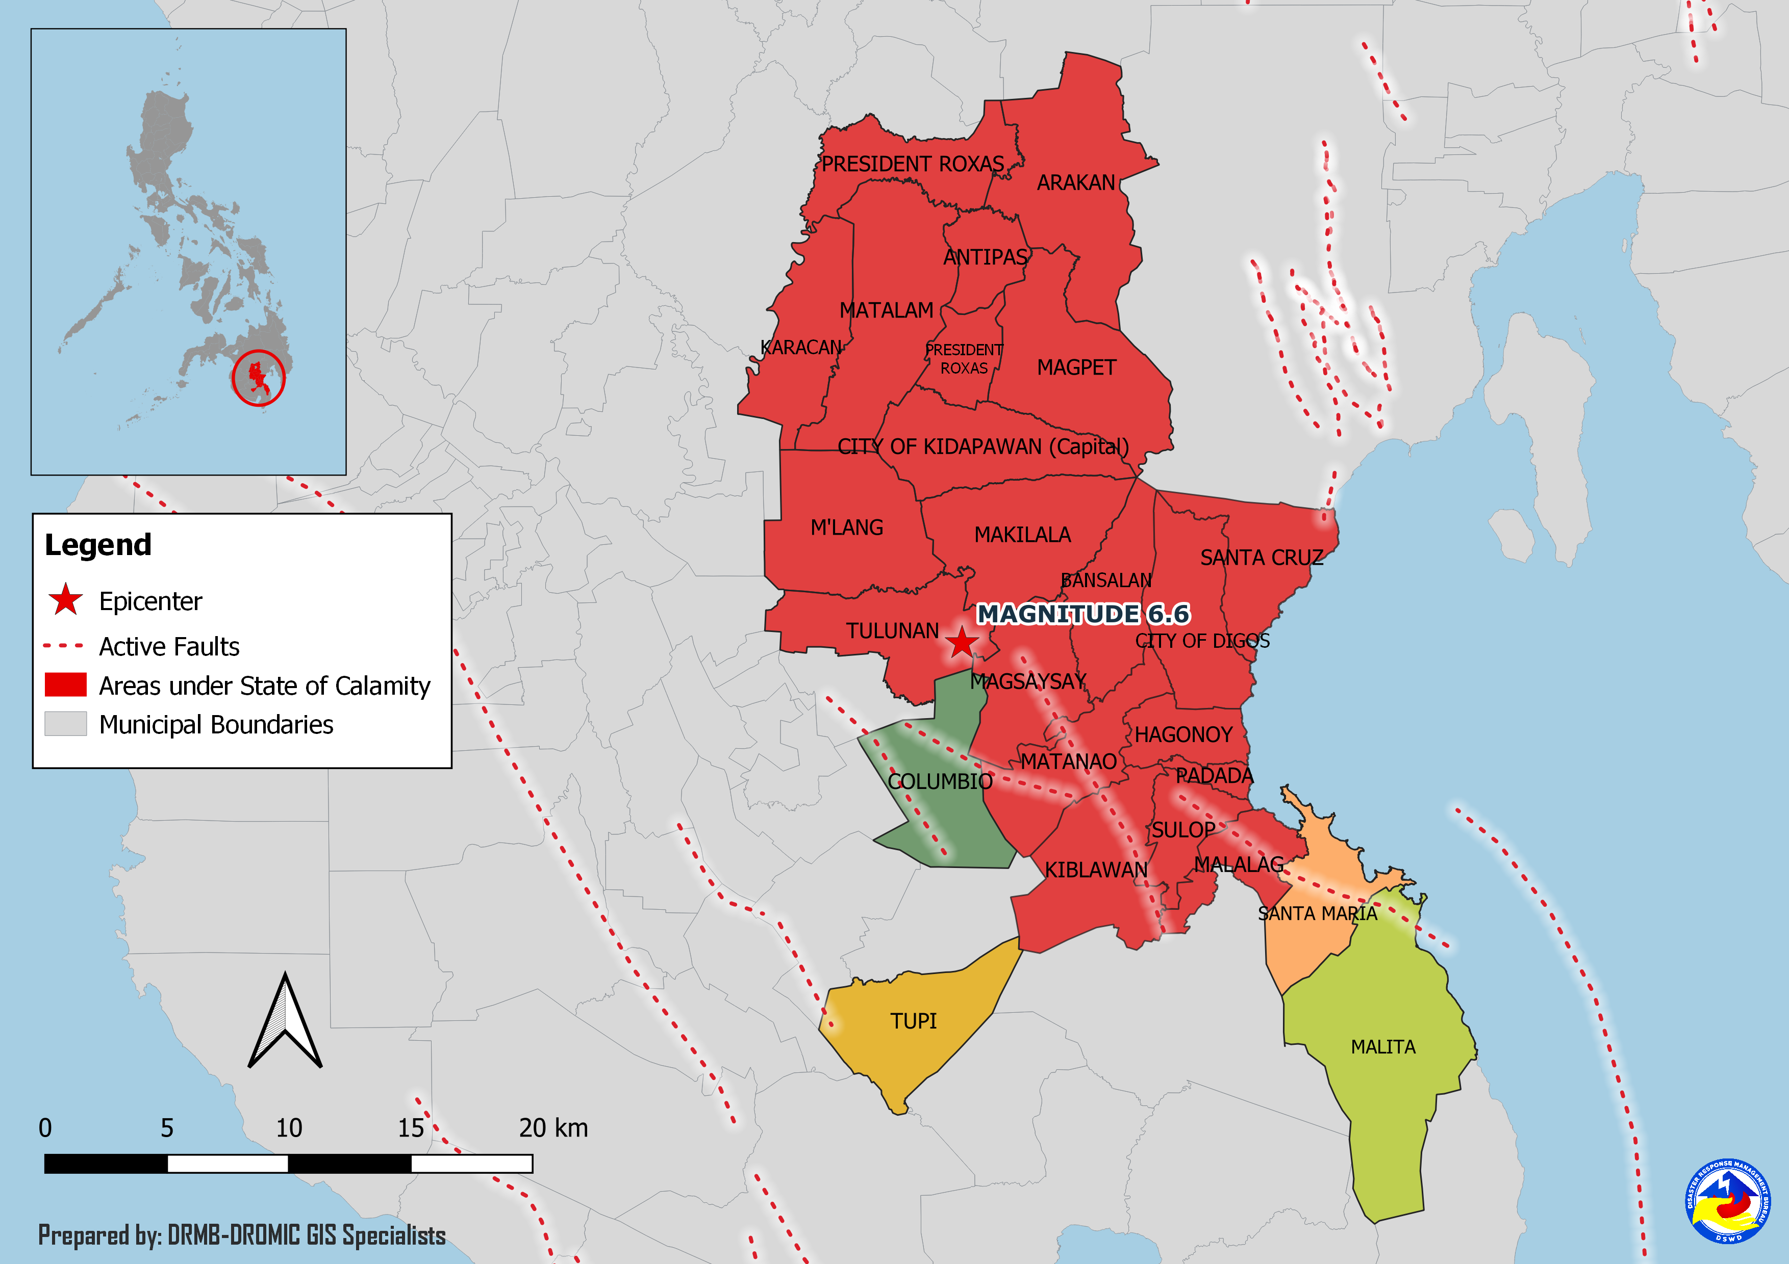
Situational Reports

DSWD-DRMB
DATE | SITUATIONS / ACTIONS UNDERTAKEN
04 March 2020 | - The Disaster Response Management Bureau (DRMB) is closely coordinating with the concerned Field Offices for significant disaster response updates.

DSWD-FO XI
DATE | SITUATIONS / ACTIONS UNDERTAKEN
13 December 2019 | - DSWD-FO XI is still on BLUE alert status.
10 December 2019 | - DSWD-FO XI provided financial assistance through Cash-for Work amounting to ₱1,985,445.00 and burial and medical assistance worth ₱5,754,535.00 to the affected families.

DSWD-FO XII
DATE | SITUATIONS / ACTIONS UNDERTAKEN
- March 2020 | - DSWD-FO XII released 800 Family Food Packs, 1,030 Nutri Del, and 1,030 Arozcaldo to LGU Arakan.  - DSWD-FO XII released the following relief goods to LGU Makilala:  - 1,371 Kitchen Kits amounting to ₱1,039,218 on January 28, 2020  - 2,188 Kitchen Kits and 1,350 Sleeping Kits on January 29, 2020  - 833 Kitchen Kits and 2,409 Sleeping Kits on January 31, 2020

*****
The Disaster Response Operations Monitoring and Information Center (DROMIC) of the DSWD-DRMB is closely coordinating with concerned DSWD Field Offices for any significant disaster response updates.

Prepared by:

MARIE JOYCE G. RAFANAN

RODEL V. CABADDU
Releasing Officer
PHOTO DOCUMENTATION

Relief distribution in New Bulatukan, Makilala North Cotabato





DSWD together with Philippine Coast Guard conducted play therapy at Bacungan Elementary School Evacuation Center



