DSWD DROMIC Report #58 on the
Ms 6.6 Earthquake Incident in Tulunan, North Cotabato
as of 28 August 2020, 6PM

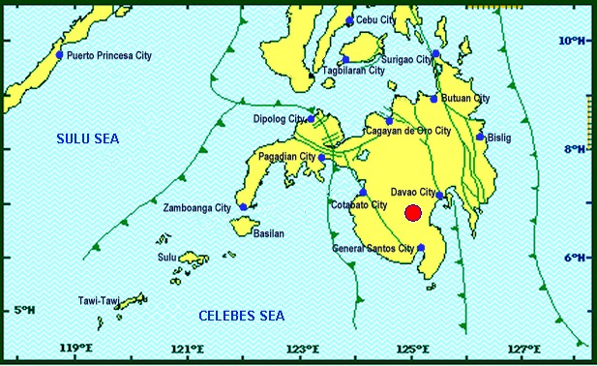

Situation Overview

On 29 October 2019 at 09:04 AM, a 6.6 magnitude earthquake jolted the municipality of Tulunan, North Cotabato (06.81°N, 125.03°E - 022 km S 79°E) with a tectonic origin and a depth of focus of 7 km. The earthquake was also felt in the neighboring municipalities of North Cotabato and Davao Region.

Source: DOST-PHIVOLCS Earthquake Bulletin

- Status of Affected Families / Persons
A total of 72,578 families or 355,983 persons in 379 barangays in Regions XI and XII were affected by the earthquake incident (see Table 1).

Table 1. Number of Affected Families / Persons
REGION / PROVINCE / MUNICIPALITY |  | NUMBER OF AFFECTED
 |  | Barangay | Families | Persons
GRAND TOTAL |  | 379 | 72,578 | 355,983
REGION XI |  | 168 | 25,817 | 122,178
Davao del Sur |  | 159 | 25,616 | 121,173
 | Bansalan | 25 | 7,060 | 29,444
 | City of Digos (capital) | 14 | 2,044 | 10,220
 | Hagonoy | 18 | 1,480 | 8,001
 | Kiblawan | 21 | 456 | 2,280
 | Magsaysay | 22 | 9,331 | 46,575
 | Malalag | 11 | 491 | 2,455
 | Matanao | 32 | 3,852 | 17,688
 | Padada | 2 | 714 | 3,570
 | Santa Cruz | 11 | 38 | 190
 | Sulop | 3 | 150 | 750
Davao Occidental |  | 9 | 201 | 1,005
 | Malita | 1 | 1 | 5
 | Santa Maria | 8 | 200 | 1,000
REGION XII |  | 211 | 46,761 | 233,805
North Cotabato |  | 209 | 46,705 | 233,525
 | Antipas | 13 | 312 | 1,560
 | Arakan | 19 | 343 | 1,715
 | Kabacan | 12 | 305 | 1,525
 | City of Kidapawan (capital) | 28 | 7,322 | 36,610
 | Magpet | 19 | 2,770 | 13,850
 | Makilala | 38 | 20,704 | 103,520
 | Matalam | 12 | 649 | 3,245
 | M'lang | 33 | 2,099 | 10,495
 | President Roxas | 6 | 305 | 1,525
 | Tulunan | 29 | 11,896 | 59,480
South Cotabato |  | 1 | 18 | 90
 | Tupi | 1 | 18 | 90
Sultan Kudarat |  | 1 | 38 | 190
 | Columbio | 1 | 38 | 190
Note: Ongoing assessment and validation being conducted.
Source: DSWD-FOs XI and XII

- Status of Displaced Families / Persons
- Inside Evacuation Center
There are 4,951 families or 20,784 persons taking temporary shelter in 42 evacuation centers in Regions XI and XII (see Table 2).

Table 2. Number of Displaced Families / Persons Inside Evacuation Centers
REGION / PROVINCE / MUNICIPALITY |  | NUMBER OF EVACUATION CENTERS (ECs) |  | NUMBER OF DISPLACED
 |  |  |  | INSIDE ECs
 |  |  |  | Families |  | Persons
 |  | CUM | NOW | CUM | NOW | CUM | NOW
GRAND TOTAL |  | 139 | 42 | 18,100 | 4,951 | 86,230 | 20,784
REGION XI |  | 56 | 30 | 7,254 | 3,171 | 32,000 | 11,884
Davao del Sur |  | 56 | 30 | 7,254 | 3,171 | 32,000 | 11,884
 | Bansalan | 21 | 12 | 2,703 | 783 | 11,319 | 2,811
 | City of Digos (capital) | 15 | 3 | 2,057 | 560 | 9,604 | 2,088
 | Hagonoy | 4 | 3 | 344 | 158 | 1,807 | 627
 | Magsaysay | 10 | 10 | 1,671 | 1,464 | 7,435 | 5,608
 | Matanao | 2 | 1 | 297 | 176 | 1,154 | 646
 | Padada | 1 | 1 | 32 | 30 | 111 | 104
REGION XII |  | 83 | 12 | 10,846 | 1,780 | 54,230 | 8,900
North Cotabato |  | 83 | 12 | 10,846 | 1,780 | 54,230 | 8,900
 | City of Kidapawan (capital) | 13 | 2 | 3,044 | 200 | 15,220 | 1,000
 | Magpet | 26 | 1 | 1,744 | 144 | 8,720 | 720
 | Makilala | 39 | 9 | 5,907 | 1,436 | 29,535 | 7,180
Note: Ongoing assessment and validation being conducted.
Source: DSWD-FOs XI and XII

- Outside Evacuation Center
There are 12,437 families or 57,974 persons currently staying with their relatives and/or friends, or in open spaces (see Table 3).

Table 3. Number of Displaced Families / Persons Outside Evacuation Centers
REGION / PROVINCE / MUNICIPALITY |  | NUMBER OF DISPLACED
 |  | OUTSIDE ECs
 |  | Families |  | Persons
 |  | CUM | NOW | CUM | NOW
GRAND TOTAL |  | 27,726 | 12,437 | 137,080 | 57,974
REGION XI |  | 12,943 | 12,437 | 63,165 | 57,974
Davao del Sur |  | 12,943 | 12,437 | 63,165 | 57,974
 | Bansalan | 4,928 | 4,493 | 23,202 | 20,546
 | City of Digos (capital) | 5 | 5 | 20 | 20
 | Hagonoy | 435 | 435 | 2,175 | 2,175
 | Magsaysay | 7,402 | 7,331 | 37,010 | 34,475
 | Matanao | 125 | 125 | 525 | 525
 | Padada | 20 | 20 | 93 | 93
 | Santa Cruz | 28 | 28 | 140 | 140
REGION XII |  | 14,783 | - | 73,915 | -
North Cotabato |  | 14,783 | - | 73,915 | -
 | Antipas | 33 | - | 165 | -
 | Arakan | 10 | - | 50 | -
 | Kabacan | 75 | - | 375 | -
 | City of Kidapawan (capital) | 70 | - | 350 | -
 | Matalam | 534 | - | 2,670 | -
 | M'lang | 2,041 | - | 10,205 | -
 | President Roxas | 219 | - | 1,095 | -
 | Tulunan | 11,801 | - | 59,005 | -
Note: Ongoing assessment and validation being conducted.
Source: DSWD-FOs XI and XII

- Damaged Houses
There are 43,136 damaged houses; of which, 12,179 are totally damaged and 30,957 are partially damaged (see Table 4).

Table 4. Number of Damaged Houses
REGION / PROVINCE / MUNICIPALITY |  | NO. OF DAMAGED HOUSES
 |  | Total | Totally | Partially
GRAND TOTAL |  | 43,136 | 12,179 | 30,957
REGION XI |  | 13,433 | 3,306 | 10,127
Davao del Sur |  | 13,232 | 3,240 | 9,992
 | Bansalan | 3,675 | 1,145 | 2,530
 | Hagonoy | 842 | 179 | 663
 | Kiblawan | 52 | 18 | 34
 | Magsaysay | 7,402 | 1,609 | 5,793
 | Matanao | 725 | 68 | 657
 | Padada | 375 | 165 | 210
 | Santa Cruz | 11 | 2 | 9
 | Sulop | 150 | 54 | 96
Davao Occidental |  | 201 | 66 | 135
 | Malita | 1 | 1 | -
 | Santa Maria | 200 | 65 | 135
REGION XII |  | 29,703 | 8,873 | 20,830
North Cotabato |  | 29,647 | 8,858 | 20,789
 | Antipas | 301 | 18 | 283
 | Arakan | 192 | 15 | 177
 | Kabacan | 267 | 5 | 262
 | City of Kidapawan (capital) | 6,724 | 875 | 5,849
 | Magpet | 1,161 | 118 | 1,043
 | Makilala | 15,721 | 6,180 | 9,541
 | Matalam | 345 | 13 | 332
 | M'lang | 1,991 | 535 | 1,456
 | President Roxas | 333 | 36 | 297
 | Tulunan | 2,612 | 1,063 | 1,549
South Cotabato |  | 18 | 1 | 17
 | Tupi | 18 | 1 | 17
Sultan Kudarat |  | 38 | 14 | 24
 | Columbio | 38 | 14 | 24
Source: DSWD-FOs XI and XII

- Assistance Provided
A total of ₱105,703,524.91 worth of assistance was provided by DSWD to the affected families (see Table 5).

Table 5. Cost of Assistance Provided to Affected Families / Persons
REGION / PROVINCE / MUNICIPALITY |  | DSWD | LGU | NGOs | OTHERS | GRAND TOTAL
GRAND TOTAL |  | 105,703,524.91 | - | - | - | 105,703,524.91
REGION XI |  | 49,319,177.71 | - | - | - | 49,319,177.71
Davao del Sur |  | 49,202,077.71 | - | - | - | 49,202,077.71
 | Bansalan | 15,911,471.84 | - | - | - | 15,911,471.84
 | City of Digos (capital) | 8,382,212.83 | - | - | - | 8,382,212.83
 | Hagonoy | 1,943,279.73 | - | - | - | 1,943,279.73
 | Kiblawan | 574,127.50 | - | - | - | 574,127.50
 | Magsaysay | 15,565,298.92 | - | - | - | 15,565,298.92
 | Malalag | 703,815.00 | - | - | - | 703,815.00
 | Matanao | 5,302,445.71 | - | - | - | 5,302,445.71
 | Padada | 573,897.39 | - | - | - | 573,897.39
 | Sulop | 245,528.79 | - | - | - | 245,528.79
Davao Occidental |  | 117,100.00 | - | - | - | 117,100.00
 | Santa Maria | 117,100.00 | - | - | - | 117,100.00
REGION XII |  | 56,384,347.20 | - | - | - | 56,384,347.20
North Cotabato |  | 56,384,347.20 | - | - | - | 56,384,347.20
 | Arakan | 3,172,649.00 | - | - | - | 3,172,649.00
 | City of Kidapawan (capital) | 13,530,270.00 | - | - | - | 13,530,270.00
 | Magpet | 8,475,919.00 | - | - | - | 8,475,919.00
 | Makilala | 21,633,857.48 | - | - | - | 21,633,857.48
 | Matalam | 2,767,475.00 | - | - | - | 2,767,475.00
 | M'lang | 1,747,874.00 | - | - | - | 1,747,874.00
 | Tulunan | 5,056,302.72 | - | - | - | 5,056,302.72
Note: Ongoing assessment and validation being conducted.
Source: DSWD-FOs XI and XII

DSWD DISASTER RESPONSE INFORMATION
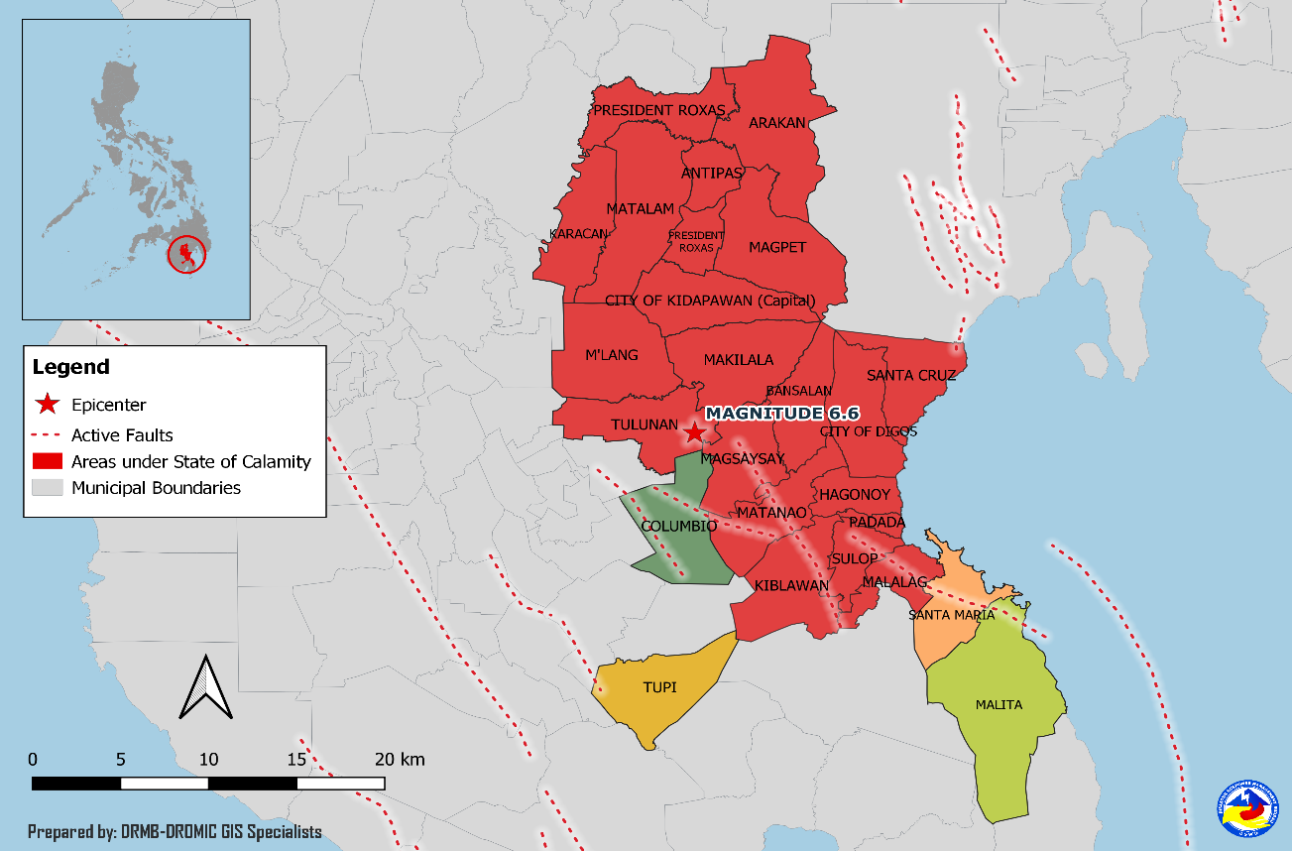
Situational Reports

DSWD-DRMB
DATE | SITUATIONS / ACTIONS UNDERTAKEN
28 August 2020 | - The Disaster Response Management Bureau (DRMB) is closely coordinating with the concerned Field Offices for significant disaster response updates.

DSWD-FO XI
DATE | SITUATIONS / ACTIONS UNDERTAKEN
13 December 2019 | - DSWD-FO XI is still on BLUE alert status.
10 December 2019 | - DSWD-FO XI provided financial assistance through Cash-for Work amounting to ₱1,985,445.00 and burial and medical assistance worth ₱5,754,535.00 to the affected families.

DSWD-FO XII
DATE | SITUATIONS / ACTIONS UNDERTAKEN
28 August 2020 | - DSWD-FO XII provided 20 rolls of laminated sacks, 642 flashlight batteries and 2,592 Hexamine cooker to LGU of Makilala, North Cotabato.
04 August 2020 | - Most of the ECs closed in Kidapawan, North Cotabato were due to the transfer of IDPs from EC to transitory sites; of which, 43 families are temporarily staying at Brgy. Perez Transitory Site, 163 families at Brgy. Ilomavis Transitory Site and 197 families at Brgy. Balabag Transitory Site.  - DSWD-FO XII released 1,300 family food packs, 816 collapsible water container, 3,218 malong and 50 rolls of laminated sacks to LGU of Makilala, North Cotabato on 30 June 2020.
11 June 2020 | - DSWD-FO XII received sacks of rice donated by the Republic of Korea. As of 04 August 2020, the following affected LGUs have received the donated rice:  LGU No. of Bags Date Withdrawn  Magpet 465 April 16, 2020  M’lang 364 April 16, 2020  Makilala 3,155 April 17, 18 and 20, 2020  Arakan 101 April 17, 2020  President Roxas 95 April 17, 2020  Kidapawan City 1,148 April 20, 2020  Antipas 96 April 20, 2020  Tulunan 1,834 April 20, 2020  Matalam 147 April 21, 2020  Kabacan 95 April 23, 2020  TOTAL 7,500

*****
The Disaster Response Operations Monitoring and Information Center (DROMIC) of the DSWD-DRMB is closely coordinating with concerned DSWD Field Offices for any significant disaster response updates.

Prepared by:

JOANNA CAMILLE R. JACINTO

JEM ERIC F. FAMORCAN
Releasing Officer
PHOTO DOCUMENTATION

Relief distribution in New Bulatukan, Makilala North Cotabato
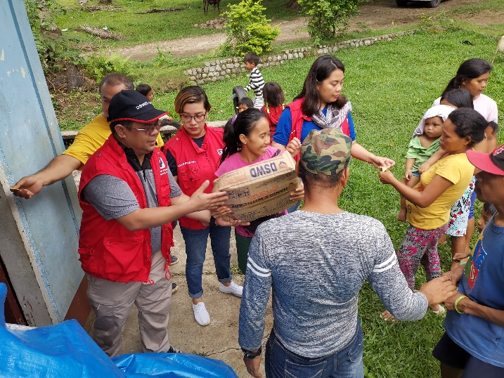
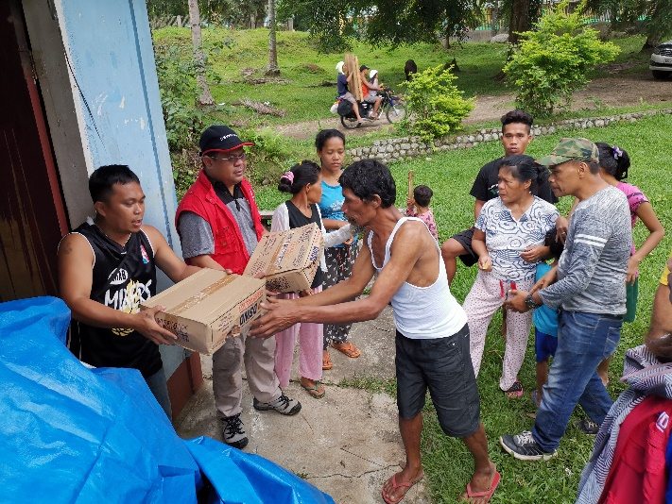

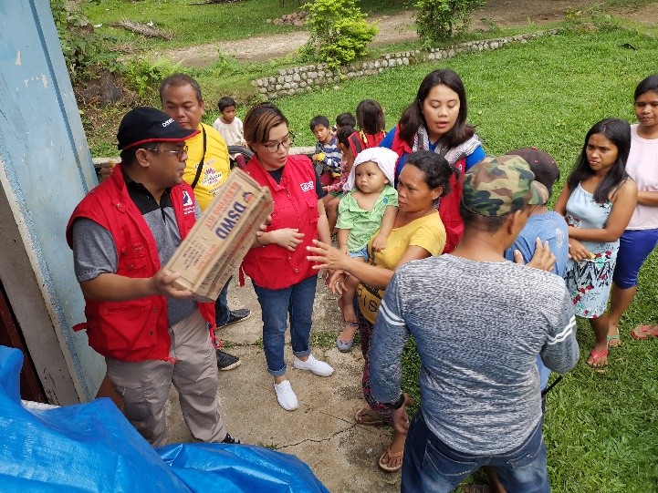
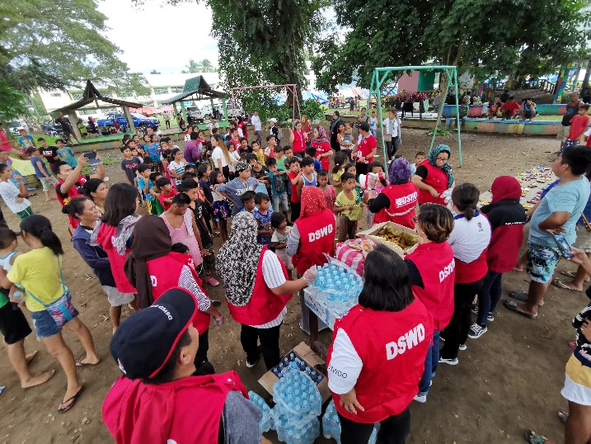
DSWD together with Philippine Coast Guard conducted play therapy at Bacungan Elementary School Evacuation Center
