DSWD DROMIC Report #6 on the
Earthquake Incident in Tulunan, North Cotabato
as of 21 October 2019, 12NN

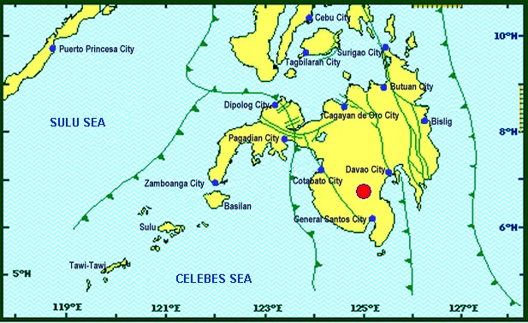
Situation Overview

On 16 October 2019 at 07:37 PM, a 6.3 magnitude earthquake jolted the municipality of Tulunan, North Cotabato (06.75°N, 125.00°E - 022 km S 59° E) with a tectonic origin and a depth of focus of 8 km. The earthquake was also felt in the neighboring municipalities of North Cotabato.

Date/Time: | 16 Oct 2019 - 07:37:04 PM
Reported Intensities: | Intensity VII - Tulunan, North Cotabato, M'Lang, North Cotabato, Kidapawan City  Intensity VI - Digos City, Davao del Sur; Sto. Nino, South Cotabato; Tacurong City  Intensity V - Alabel & Malungon, Sarangani; Lake Sebu, Polomolok, Tampakan & Tupi, South  Cotabato; Koronadal City; Roxas & Pikit, North Cotabato;General Santos City; Davao City;  Kalamansig, Lebak & Palimbang, Sultan Kudarat  Intensity IV - Kiamba, Sarangani; Esperanza & Rosario, Agusan del Sur; Kalilangan, Quezon,  Kadingilan & Damulog, Bukidnon; Mawab, Compostela Valley; Cotabato City; Matanog, Barira &  Sultan Kudarat, Maguindanao  Intensity III - Santa Josefa, Agusan del Sur; Iligan City; Dipolog City  Intensity II - Butuan City; Zamboanga City  Intensity I - Hinatuan, Surigao del Sur  Instrumental Intensities:  Intensity VII - Kidapawan City  Intensity V - Tupi and Polomolok, South Cotabato; Alabel, Sarangani  Intensity IV - Kiamba, Sarangani; T'Boli, South Cotabato; General Santos City  Intensity III - Cagayan de Oro City; Gingoog City, Misamis Oriental;  Intensity II - Cagayan de Oro, Misamis Oriental  Intensity I - Dipolog City; Bislig City
Expecting Damage: | YES
Expecting Aftershocks: | YES
Source: DOST-PHIVOLCS Earthquake Bulletin

- Status of Affected Families / Persons
A total of 4,629 families or 23,145 persons were affected by the earthquake incident in 92 barangays in Regions XI and XII (see Table 1).

Table 1. Number of Affected Families / Persons
REGION / PROVINCE / MUNICIPALITY |  | NUMBER OF AFFECTED
 |  | Barangays | Families | Persons
GRAND TOTAL |  | 92 | 4,629 | 23,145
REGION XI |  | 36 | 847 | 4,235
Davao del Sur |  | 36 | 847 | 4,235
 | Bansalan | 8 | 126 | 630
 | Magsaysay | 17 | 469 | 2,345
 | Matanao | 11 | 252 | 1,260
REGION XII |  | 56 | 3,782 | 18,910
North Cotabato |  | 56 | 3,782 | 18,910
 | City of Kidapawan (capital) | 1 | 500 | 2,500
 | Makilala | 25 | 2,256 | 11,280
 | M'lang | 1 | 5 | 25
 | Tulunan | 29 | 1,021 | 5,105
Note: The increase in the number of affected families or persons in the municipality of Makilala is based on the validated report submitted by DSWD-FO XII. Ongoing assessment and validation being conducted.
Source: DSWD-FOs XI and XII

- Status of Displaced Families / Persons
- Inside Evacuation Centers
There are 269 families or 1,407 persons who are taking temporary shelter in three (3) evacuation centers in Regions XI and XII (see Table 2).

Table 2. Displaced Families / Persons Inside Evacuation Center
REGION / PROVINCE / MUNICIPALITY |  | NUMBER OF EVACUATION CENTERS (ECs) |  | INSIDE ECs
 |  |  |  | Families |  | Persons
 |  | CUM | NOW | CUM | NOW | CUM | NOW
GRAND TOTAL |  | 6 | 3 | 794 | 269 | 4,032 | 1,407
REGION XI |  | 4 | 2 | 264 | 239 | 1,382 | 1,257
Davao del Sur |  | 4 | 2 | 264 | 239 | 1,382 | 1,257
 | Bansalan | 1 | 1 | 3 | 3 | 77 | 77
 | Magsaysay | 1 | 1 | 236 | 236 | 1,180 | 1,180
 | Matanao | 2 | - | 25 | - | 125 | -
REGION XII |  | 2 | 1 | 530 | 30 | 2,650 | 150
North Cotabato |  | 2 | 1 | 530 | 30 | 2,650 | 150
 | City of Kidapawan (capital) | 1 | - | 500 | - | 2,500 | -
 | Makilala | 1 | 1 | 30 | 30 | 150 | 150
Note: *The reported affected families or persons in City of Kidapawan have already returned to their area of residence. Thus, ongoing assessment and validation being conducted.
Source: DSWD-FOs XI and XII

- Outside Evacuation Centers
There are 608 families or 2,978 persons who are currently staying with their relatives and/or friends (see Table 3).

Table 3. Number of Displaced Families / Persons Outside Evacuation Center
REGION / PROVINCE / MUNICIPALITY |  | OUTSIDE ECs
 |  | Families |  | Persons
 |  | CUM | NOW | CUM | NOW
GRAND TOTAL |  | 608 | 608 | 2,978 | 2,978
REGION XI |  | 583 | 583 | 2,853 | 2,853
Davao del Sur |  | 583 | 583 | 2,853 | 2,853
 | Bansalan | 123 | 123 | 553 | 553
 | Magsaysay | 233 | 233 | 1,165 | 1,165
 | Matanao | 227 | 227 | 1,135 | 1,135
REGION XII |  | 25 | 25 | 125 | 125
North Cotabato |  | 25 | 25 | 125 | 125
 | Makilala | 25 | 25 | 125 | 125
Note: Ongoing assessment and validation being conducted.
Source: DSWD-FOs XI and XII
- Damaged Houses
There are 2,439 damaged houses; of which, 710 are totally damaged and 1,729 are partially damaged (see Table 4).

Table 4. Number of Damaged Houses
REGION / PROVINCE / MUNICIPALITY |  | NO. OF DAMAGED HOUSES
 |  | Total | Totally | Partially
GRAND TOTAL |  | 2,439 | 710 | 1,729
REGION XI |  | 776 | 177 | 599
Davao del Sur |  | 776 | 177 | 599
 | Bansalan | 126 | 11 | 115
 | Magsaysay | 634 | 165 | 469
 | Matanao | 16 | 1 | 15
REGION XII |  | 1,663 | 533 | 1,130
North Cotabato |  | 1,663 | 533 | 1,130
 | Makilala | 637 | 153 | 484
 | M'lang | 5 | - | 5
 | Tulunan | 1,021 | 380 | 641
Note: Ongoing assessment and validation being conducted.
Source: DSWD-FOs XI and XII

- Assistance Provided
A total of ₱1,360,994.00 worth of assistance was provided by DSWD to the affected families (see Table 4).

Table 4. Cost of Assistance Provided to Affected Families / Persons
REGION / PROVINCE / MUNICIPALITY |  | TOTAL COST OF ASSISTANCE
 |  | DSWD | LGU | NGOs | OTHERS | GRAND TOTAL
GRAND TOTAL |  | 1,360,994.00 | - | - | - | 1,360,994.00
REGION XII |  | 1,360,994.00 | - | - | - | 1,360,994.00
North Cotabato |  | 1,360,994.00 | - | - | - | 1,360,994.00
 | Makilala | 904,656.00 | - | - | - | 904,656.00
 | Tulunan | 456,338.00 | - | - | - | 456,338.00
Note: Ongoing assessment and validation being conducted.
Source: DSWD-FO XII

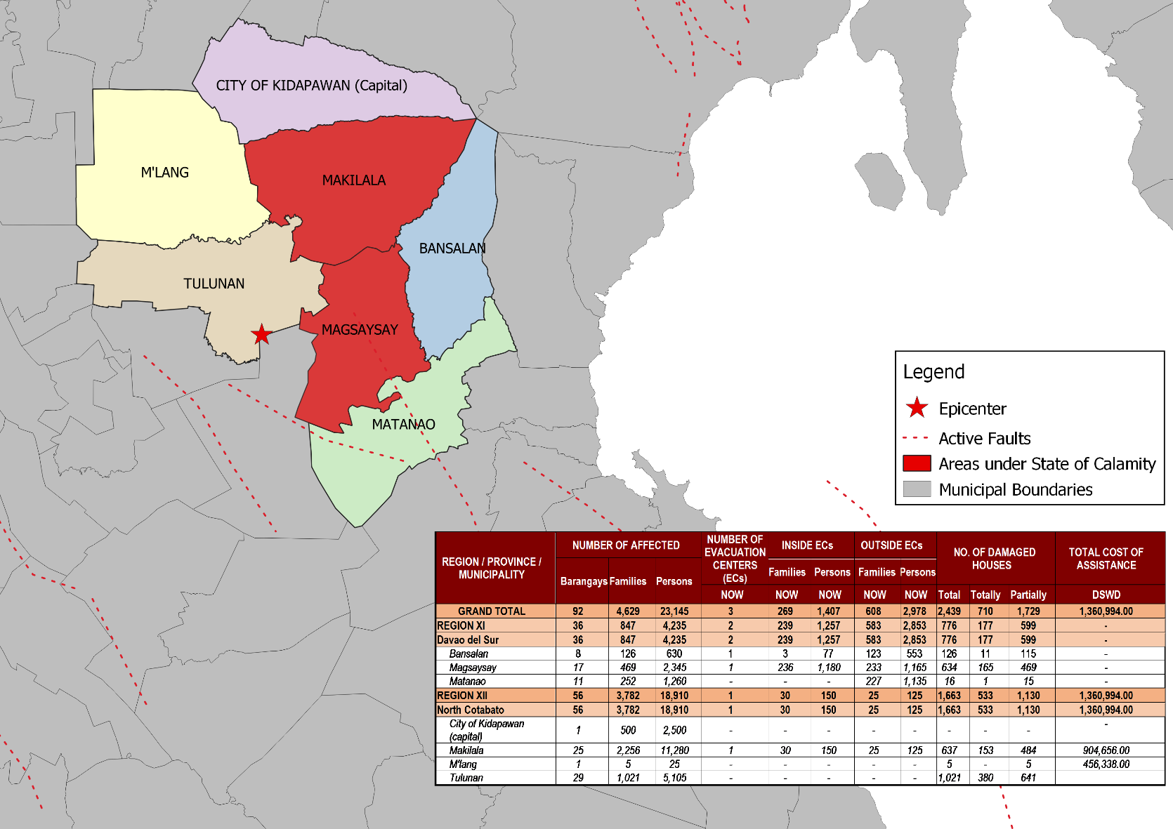
DSWD DISASTER RESPONSE INFORMATION
Source: DRMB-DROMIC GIS Specialists

Situational Reports

DSWD-DRMB
DATE | SITUATIONS / ACTIONS UNDERTAKEN
21 October 2019 | - The Disaster Response Management Bureau (DRMB) is continuously coordinating with DSWD-Field Offices for significant disaster response updates.  - All QRT members and emergency equipment are on standby and ready for deployment.

DSWD-FO XI
DATE | ACTION(S) TAKEN
20 October 2019 | - The municipality of Magsaysay is declared under State of Calamity.  - DSWD-FO XI provided 900 Family Food Packs worth ₱325,260.00 and 230 Sleeping Kits worth ₱158,700.00 to the affected families.
18 October 2019 | - DSWD-FO XI conducted relief operation to the affected families in municipalities of Magsaysay, Bansalan and Matanao Davao Del Sur.
17 October 2019 | - DSWD-FO XI through the Disaster Response Monitoring and Information Center (DROMIC) was continuously coordinating with the Municipal Social Welfare and Development Office (MSWDO) of Magsaysay, Davao del Sur for updates and possible augmentation support for the affected families.  - DSWD-FO XI coordinated with Office of the Civil Defense (OCD) XI for updates on the status of affected families.  - DSWD-FO XI conducted ocular visit and assessment to the affected families.

DSWD-FO XII
DATE | ACTION(S) TAKEN
20 October 2019 | - DSWD-FO XII provided 2,25 FFPs, 10 rolls of Laminated Sacks and 7 tents to the affected families in Makilala, North Cotabato.  - DSWD-FO XII provided 1,138 FFPs, and 31 rolls of laminated sacks 8ftx100m to the affected families in Tulunan, North Cotabato.
19 October 2019 | - The Sangguniang Bayan of LGU Makilala signed the SB Resolution No. 46 last October 17 declaring the entire municipality under State of Calamity.
18 October 2019 | - DSWD-FO XII staff assisted in the conduct of Rapid Damage Assessment and Needs Analysis (RDANA) in North Cotabato.
17 October 2019 | - There were reported landslide incidents in the municipality of Tulunan affecting two (2) sitios.  - The CSWDO and MSWDO together with their respective MDRRMOs was doing their assessment to get accurate data on the numbers of families affected and the extent of damaged structures.  - DSWD-FO XII QRT members were on standby and were ready for activation if there’s a need for deployment.  - Four (4) vehicles were ready for utilization in case of response activation.  - DSWD-FO XII DRMD staff conducted an actual validation in North Cotabato areas.  - DSWD-FO XII attended the Emergency Meeting headed by OCD XII.

***
The Disaster Response Operations Monitoring and Information Center (DROMIC) of the DSWD-DRMB is closely monitoring the effects of Earthquake Incident and is coordinating with the concerned DSWD-Field Offices for any significant updates.

Prepared by:

CLARRIE MAE A. CASTILLO
MARIEL B. FERRARIZ

RODEL V. CABADDU
Releasing Officer

