DSWD DROMIC Report #7 on the
Ms 6.6 Earthquake Incident in Tulunan, North Cotabato
as of 01 November 2019, 6PM

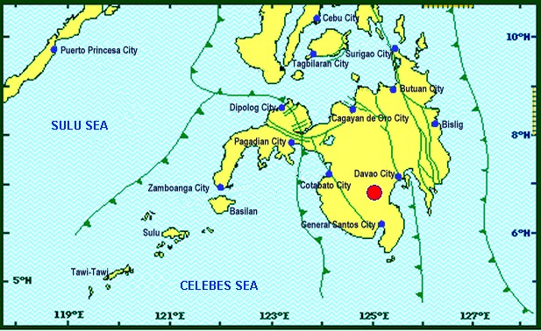

Situation Overview

On 29 October 2019 at 09:04 AM, a 6.6 magnitude earthquake jolted the municipality of Tulunan, North Cotabato (06.81°N, 125.03°E - 022 km S 79° E) with a tectonic origin and a depth of focus of 7 km. The earthquake was also felt in the neighboring municipalities of North Cotabato.

Date/Time: | 29 Oct 2019 - 09:04:43 AM
Reported Intensities: | Intensity VII- Tulunan and Makilala, Cotabato; Kidapawan City; Digos City, Bansalan,  Magsaysay, Davao del Sur and Malungon, Sarangani  Intensity VI- Koronadal City and Davao City  Intensity V- Cotabato City; Tampakan, Surallah, Banga and Tupi, South Cotabato;  General Santos City; Magpet, Cotabato; Tacurong City, Kalamansig, Bagumbayan, Sultan  Kudarat; Alabel, Sarangani; Kalilangan and Damulog, Bukidnon; Tagum City, Davao del Norte  Intensity IV- Cagayan De Oro City; Talakag, Manolo Fortich and Libona, Bukidnon;  Glan, Maitum, Maasim and Kiamba, Sarangani; Butuan City; Iligan City; Tubod and Bacolod,  Lanao del Norte  Intensity III- Molave, Zamboanga del Sur; Dipolog City, Sergio Osmeña Sr. and Polanco,  Zamboanga del Norte; Zamboanga City; Gingoog City, Misamis Oriental and Bislig City  Intensity II- Kabasalan, Zamboanga Sibugay, Mambajao, Camiguin and Isabela City, Basilan  Instrumental Intensities:  Intensity VII- Malungon, Sarangani  Intensity V- Cotabato City; Alabel, Sarangani and Tupi, South Cotabato  Intensity IV- Gingoog City, Misamis Oriental; Kiamba, Sarangani; General Santos City;  Cagayan De Oro City  Intensity II- Zamboanga City and Tulunan, Cotabato  Intensity I- Palo, Leyte; Dipolog City and Bislig City
Expecting Damage: | YES
Expecting Aftershocks: | YES
Source: DOST-PHIVOLCS Earthquake Bulletin
- Status of Affected Families / Persons
A total of 13,743 families or 68,715 persons were affected by the earthquake incident in 142 barangays in Regions XI and XII (see Table 1).

Table 1. Number of Affected Families / Persons
REGION / PROVINCE / MUNICIPALITY |  | NUMBER OF AFFECTED
 |  | Barangays | Families | Persons
GRAND TOTAL |  | 142 | 13,743 | 68,715
REGION XI |  | 61 | 2,945 | 14,725
Davao del Sur |  | 56 | 2,924 | 14,620
 | Bansalan | 17 | 718 | 3,590
 | City of Digos (capital) | 3 | 173 | 865
 | Kiblawan | 1 | 1 | 5
 | Magsaysay | 21 | 1,951 | 9,755
 | Matanao | 2 | 51 | 255
 | Padada | 1 | 2 | 10
 | Santa Cruz | 11 | 28 | 140
Davao Occidental |  | 5 | 21 | 105
 | Malita | 1 | 1 | 5
 | Santa Maria | 4 | 20 | 100
REGION XII |  | 81 | 10,798 | 53,990
North Cotabato |  | 81 | 10,798 | 53,990
 | City of Kidapawan (capital) | 4 | 1,292 | 6,460
 | Makilala | 33 | 6,152 | 30,760
 | M'lang | 15 | 117 | 585
 | Tulunan | 29 | 3,237 | 16,185
Note: Ongoing assessment and validation being conducted.

Source: DSWD-FOs XI and XII

- Status of Displaced Families / Persons
- Inside Evacuation Center
There are 2,984 families or 14,920 persons taking temporary shelter in twenty-two (22) evacuation centers in Regions XI and XII (see Table 2).

Table 2. Number of Displaced Families / Persons Inside Evacuation Center
REGION / PROVINCE / MUNICIPALITY |  | NUMBER OF EVACUATION CENTERS (ECs) |  | INSIDE ECs
 |  |  |  | Families |  | Persons
 |  | CUM | NOW | CUM | NOW | CUM | NOW
GRAND TOTAL |  | 22 | 22 | 2,984 | 2,984 | 14,920 | 14,920
REGION XI |  | 18 | 18 | 1,692 | 1,692 | 8,460 | 8,460
Davao del Sur |  | 18 | 18 | 1,692 | 1,692 | 8,460 | 8,460
 | Bansalan | 9 | 9 | 561 | 561 | 2,805 | 2,805
 | City of Digos (capital) | 1 | 1 | 173 | 173 | 865 | 865
 | Magsaysay | 8 | 8 | 958 | 958 | 4,790 | 4,790
REGION XII |  | 4 | 4 | 1,292 | 1,292 | 6,460 | 6,460
North Cotabato |  | 4 | 4 | 1,292 | 1,292 | 6,460 | 6,460
 | City of Kidapawan (capital) | 4 | 4 | 1,292 | 1,292 | 6,460 | 6,460
Note: Ongoing assessment and validation being conducted.
Source: DSWD-FOs XI and XII

- Outside Evacuation Center
There are 1,370 families or 6,850 persons currently staying with their relatives and/or friends (see Table 3).

Table 3. Number of Displaced Families / Persons Outside Evacuation Center
REGION / PROVINCE / MUNICIPALITY |  | OUTSIDE ECs
 |  | Families |  | Persons
 |  | CUM | NOW | CUM | NOW
GRAND TOTAL |  | 1,370 | 1,370 | 6,850 | 6,850
REGION XI |  | 390 | 390 | 1,950 | 1,950
Davao del Sur |  | 390 | 390 | 1,950 | 1,950
 | Bansalan | 126 | 126 | 630 | 630
 | Magsaysay | 236 | 236 | 1,180 | 1,180
 | Santa Cruz | 28 | 28 | 140 | 140
REGION XII |  | 980 | 980 | 4,900 | 4,900
North Cotabato |  | 980 | 980 | 4,900 | 4,900
 | M'lang | 50 | 50 | 250 | 250
 | Tulunan | 930 | 930 | 4,650 | 4,650
Note: Ongoing assessment and validation being conducted.
Source: DSWD-FOs XI and XII

- Damaged Houses
There are 12,261 damaged houses; of which, 3,550 are totally damaged and 8,711 are partially damaged (see Table 4).

Table 4. Number of Damaged Houses
REGION / PROVINCE / MUNICIPALITY |  | NO. OF DAMAGED HOUSES
 |  | Total | Totally | Partially
GRAND TOTAL |  | 12,261 | 3,550 | 8,711
REGION XI |  | 2,755 | 453 | 2,302
Davao del Sur |  | 2,734 | 452 | 2,282
 | Bansalan | 718 | 162 | 556
 | Kiblawan | 1 | 1 | -
 | Magsaysay | 1,951 | 286 | 1,665
 | Matanao | 51 | 1 | 50
 | Padada | 2 | - | 2
 | Santa Cruz | 11 | 2 | 9
Davao Occidental |  | 21 | 1 | 20
 | Malita | 1 | 1 | -
 | Santa Maria | 20 | - | 20
REGION XII |  | 9,506 | 3,097 | 6,409
North Cotabato |  | 9,506 | 3,097 | 6,409
 | Makilala | 6,152 | 1,765 | 4,387
 | M'lang | 117 | 73 | 44
 | Tulunan | 3,237 | 1,259 | 1,978
Note: Ongoing assessment and validation being conducted
Source: DSWD-FOs XI and XII

- Assistance Provided
A total of ₱3,190,258.00 worth of assistance was provided by DSWD to the affected families (see Table 5).

Table 5. Cost of Assistance Provided to Affected Families / Persons
REGION / PROVINCE / MUNICIPALITY |  | TOTAL COST OF ASSISTANCE
 |  | DSWD | LGU | NGOs | OTHERS | GRAND TOTAL
GRAND TOTAL |  | 3,190,258.00 | - | - | - | 3,190,258.00
REGION XI |  | 387,700.00 | - | - | - | 387,700.00
Davao del Sur |  | 387,700.00 | - | - | - | 387,700.00
 | Magsaysay | 387,700.00 | - | - | - | 387,700.00
REGION XII |  | 2,802,558.00 | - | - | - | 2,802,558.00
North Cotabato |  | 2,802,558.00 | - | - | - | 2,802,558.00
 | City of Kidapawan (capital) | 657,500.00 | - | - | - | 657,500.00
 | M'lang | 123,508.00 | - | - | - | 123,508.00
 | Tulunan | 2,021,550.00 | - | - | - | 2,021,550.00
Note: Ongoing assessment and validation being conducted
Source: DSWD-FO XII

DSWD DISASTER RESPONSE INFORMATION

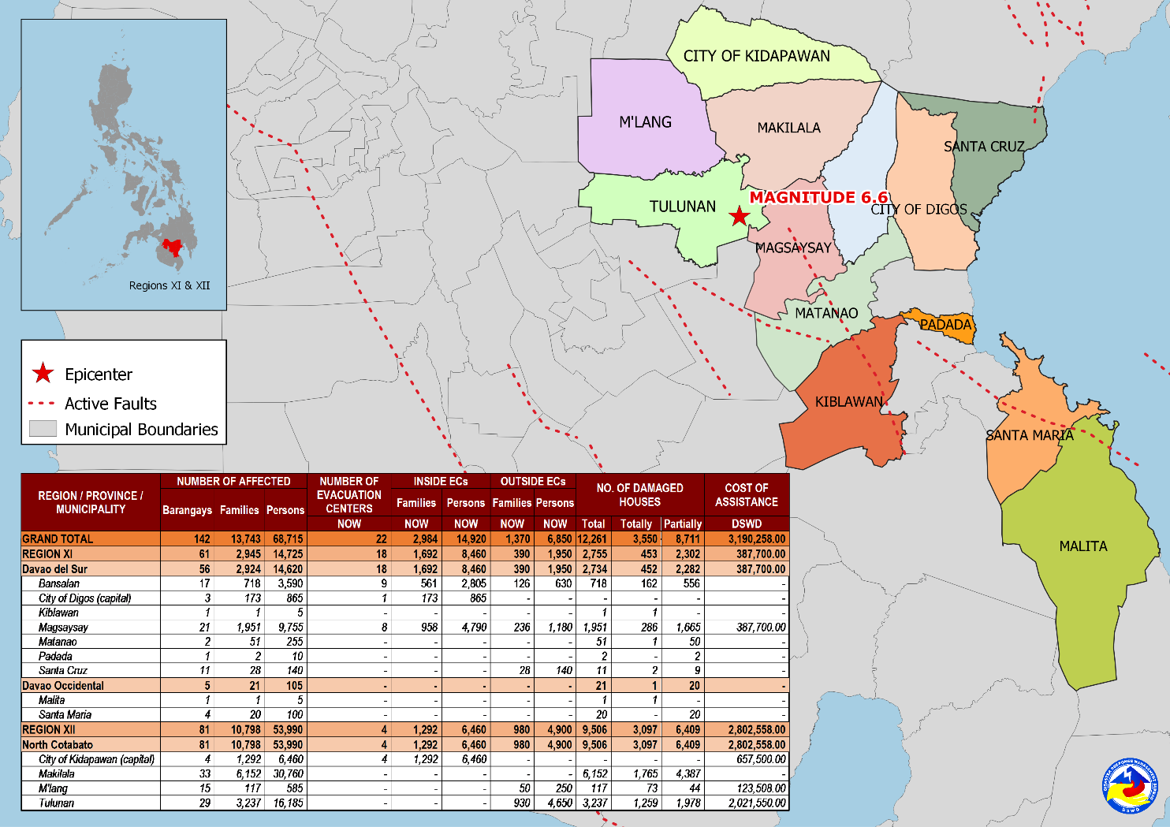

Source: DRMB-DROMIC GIS Specialists

Situational Reports

DSWD-DRMB
DATE | SITUATIONS / ACTIONS UNDERTAKEN
01 November 2019 | - The Disaster Response Management Bureau (DRMB) is on BLUE alert level status and is closely coordinating with concerned field offices for significant disaster response updates.  - All QRT members and emergency equipment are on standby and ready for deployment.

DSWD-NRLMB
DATE | SITUATIONS / ACTIONS UNDERTAKEN
01 November 2019 | - A total of 187 Sleeping kits are now at Davao International Airport transported via Air Asia Airlines.
31 October 2019 | - A total of 500 Family Food Packs, 500 pcs. of Sleeping Kits and 500 pcs. of Laminated Sacks were loaded today at NAIA Terminal 4 (via Air Asia).
30 October 2019 | - DSWD-NRLMB augmented 50 family tents, 500 sleeping kits, 500 pre-cut laminated sacks and 166 family food packs through C130 that arrived in General Santos City.  - A total of 125 sets of Family Tents were already in transit via 1x10 wheeler wingvan going to Field Office XI.  - A total of 2,815 pieces of Sleeping Kits, 2,160 pieces of Kitchen Kits, 4,800 pieces of Laminated Sacks and 125 Set of Family Tents were already in transit via 4x10 wheeler wingvan going to Field Office XII.

DSWD-FO X
DATE | ACTION(S) TAKEN
01 November 2019 | - DSWD-FO X deployed Eleven (11) Regional QRT members for augmention support to Field Office XI.
30 October 2019 | - DSWD-FO X was in close coordination with the concerned City Disaster Risk Reduction Management Offices (CDRRMOs) and Municipal Disaster Risk Reduction Management Offices (MDRRMOs) for any significant update.

DSWD-FO XI
DATE | ACTION(S) TAKEN
01 November 2019 | - DSWD-FO XI is on RED alert level status.  - Augmentation assistance of 3,000 Family Food Packs from Field Office CARAGA are now in Field office XI  - DSWD-FO XI provided 500 Family Food Packs and 300 Sleeping Kits to the affected families in Magsaysay, Davao del Sur.
31 October 2019 | - DSWD-FO XI deployed ten (10) Camp Managers to the affected municipalities of Davao del Sur.  - Ongoing distribution of family food packs to affected families in the municipality of Matanao, Davao del Sur
30 October 2019 | - Ongoing distribution of family food packs to affected families in the municipality of Magsaysay, Davao del Sur.  - DSWD-FO XI distributed ten (10) Family Tents in the municipality of Magsaysay, Davao del Sur.  - DSWD-FO XI is in close coordination with the Local Government Units (LGUs) through the Municipal Social Welfare and Development Offices (MSWDOs) particularly in the municipalities of Davao del Sur for any significant updates.

DSWD-FO XII
DATE | ACTION(S) TAKEN
01 November 2019 | - DSWD-FO XII delivered 1,200 Family Food Packs and 100 rolls of Pre-cut Laminated Sacks in Tulunan, North Cotabato.
31 October 2019 | - DSW-FO XII activated the Quick Response Team.  - DSW-FO XII deployed Group 1 of the Quick Response Team for possible Technical Assistance and Resource Augmentation.
30 October 2019 | - DSWD-FO XII provided 350 family food packs and 10 rolls of laminated sacks to the affected families in Tulunan, North Cotabato.  - DSWD-FO XII provided 1,500 family food packs and 20 rolls of laminated sacks to the affected families in Kidapawan City, North Cotabato.  - DSWD-FO XII provided 308 family food packs to the affected families in M’lang, North Cotabato.  - DSWD-FO XII through the Disaster Response Management Division (DRMD) staff conducted an actual validation in all affected areas in North Cotabato.  - DSWD-FO XII through the Crisis Intervention Unit (CIU) provided ₱5,000 each to fifteen (15) injured individuals in Brgy. Daig, Tulunan, North Cotabato.  - DSWD-FO XII through the CIU provided₱10,000 to the bereaved families of Narciso Nestor in Koronadal City.
29 October 2019 | - DSWD-FO XII is on RED alert level status.  - All QRT members were on standby and ready for activation if there’s a need for deployment.  - 4 vehicles were ready for utilization in case of response activation.  - Employees except for QRT and DRMD staff were advised to vacate the building and go home.  - Tents were provided to Reception and Study Center for Children (RSCC) for the use of clients and staff as evacuation area while the safety of the building was assessed.  - DSWD-FO XII requested laminated sacks and sleeping kits from NROC.  - All municipal and provincial based DSWD staff were directed to conduct rapid assessment to their respective areas of assignment.

***
The Disaster Response Operations Monitoring and Information Center (DROMIC) of the DSWD-DRMB is closely coordinating with DSWD Field Offices for any significant disaster response updates.

Prepared by:

MARIEL B. FERRARIZ
DIANE C. PELEGRINO

RODEL V. CABADDU
Releasing Officer

PHOTO DOCUMENTATION

Loading of Goods at NROC (October 30, 2019)
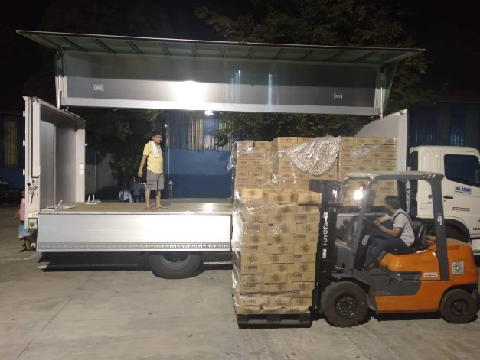
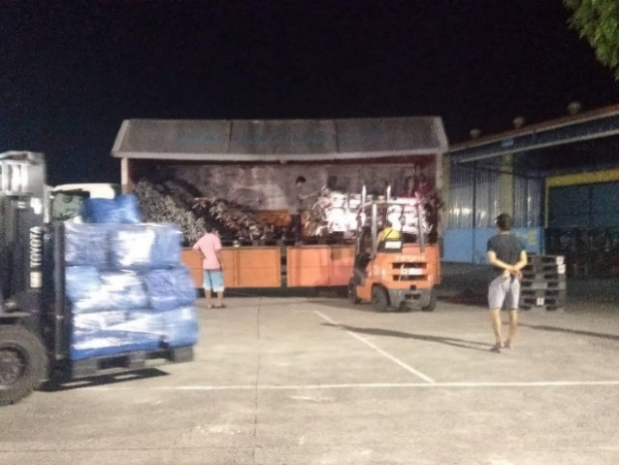

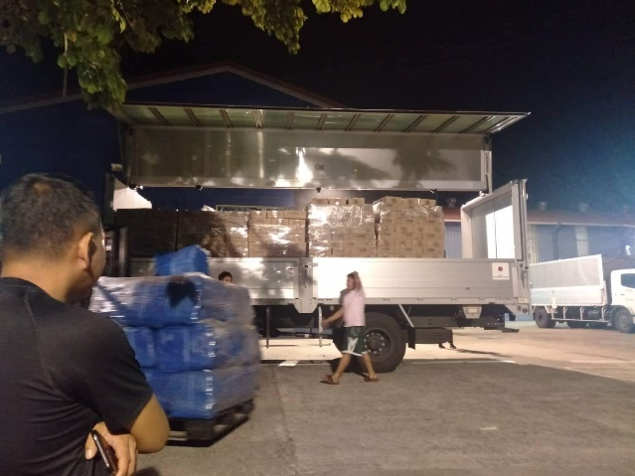
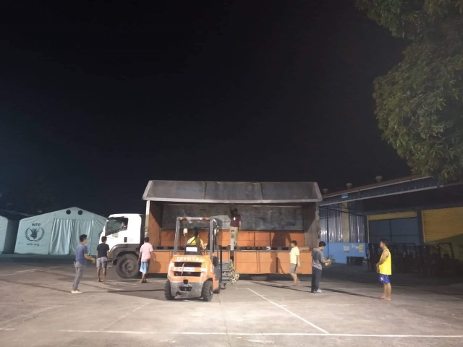

Loading of Goods at Villamor Airbase (October 30, 2019)
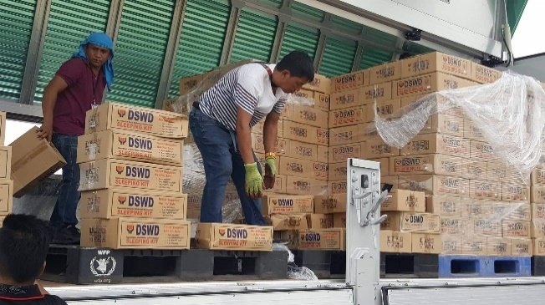
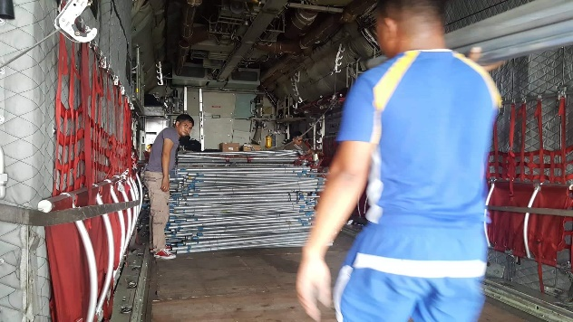

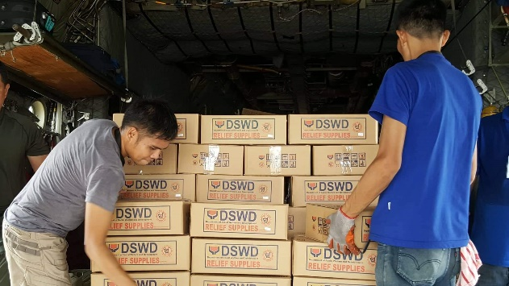
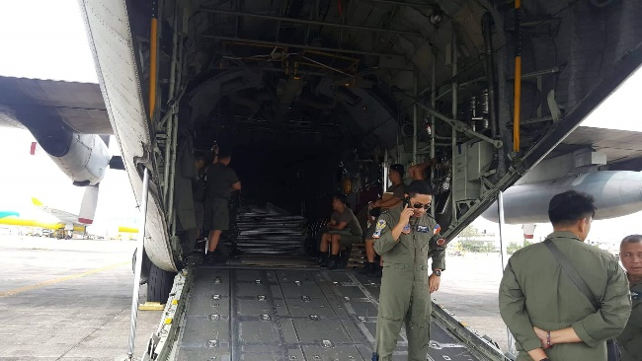

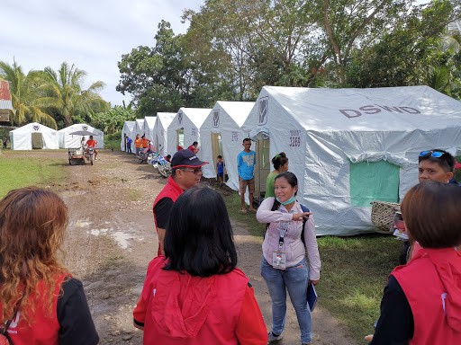
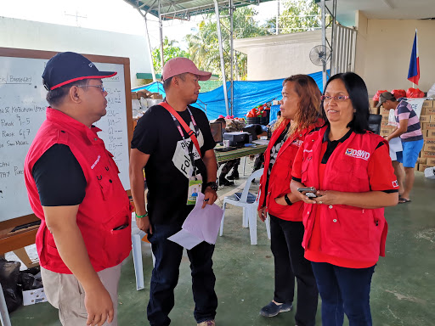
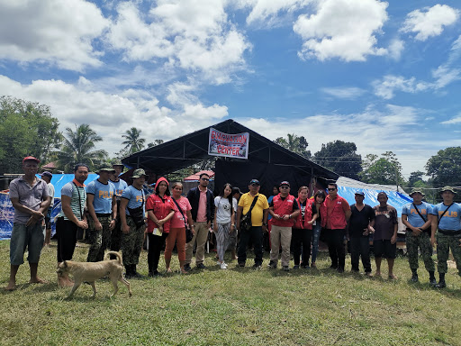
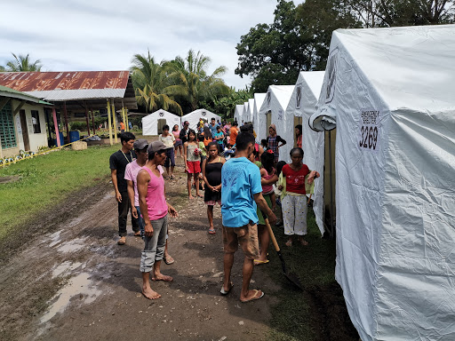
Evacuation Site Visit at Magsaysay, Davao del Sur (Oct. 31, 2019)

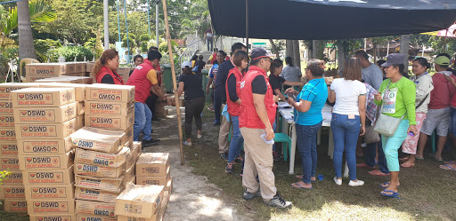
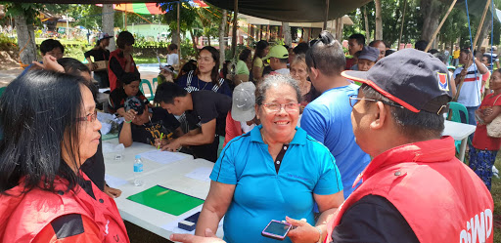
Relief distribution in coordination with LGU Matanao in Davao del Sur. (October 31, 2019)

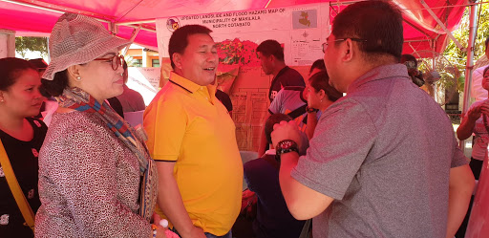
Meeting with Mayor Armando M. Quibod (middle) of Makilala, North Cotabato during the field monitoring of DSWD-DRMB headed by Dir. Rodolfo M. Encabo (right). (November 1, 2019)

