DSWD DROMIC Report #8 on the
Earthquake Incident in Tulunan, North Cotabato
as of 22 October 2019, 12NN

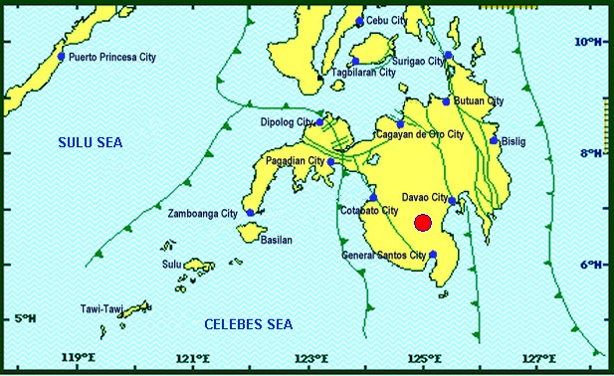
Situation Overview

On 16 October 2019 at 07:37 PM, a 6.3 magnitude earthquake jolted the municipality of Tulunan, North Cotabato (06.75°N, 125.00°E - 022 km S 59°E) with a tectonic origin and a depth of focus of 8 km. The earthquake was also felt in the neighboring municipalities of North Cotabato and other Mindanao Provinces.

Date/Time: | 16 Oct 2019 - 07:37:04 PM
Reported Intensities: | Intensity VII - Tulunan, North Cotabato, M'Lang, North Cotabato, Kidapawan City  Intensity VI - Digos City, Davao del Sur; Sto. Nino, South Cotabato; Tacurong City  Intensity V - Alabel & Malungon, Sarangani; Lake Sebu, Polomolok, Tampakan & Tupi, South Cotabato; Koronadal City; Roxas & Pikit, North Cotabato;General Santos City; Davao City; Kalamansig, Lebak & Palimbang, Sultan Kudarat  Intensity IV - Kiamba, Sarangani; Esperanza & Rosario, Agusan del Sur; Kalilangan, Quezon, Kadingilan & Damulog, Bukidnon; Mawab, Compostela Valley; Cotabato City; Matanog, Barira & Sultan Kudarat, Maguindanao  Intensity III - Santa Josefa, Agusan del Sur; Iligan City; Dipolog City  Intensity II - Butuan City; Zamboanga City  Intensity I - Hinatuan, Surigao del Sur  Instrumental Intensities:  Intensity VII - Kidapawan City  Intensity V - Tupi and Polomolok, South Cotabato; Alabel, Sarangani  Intensity IV - Kiamba, Sarangani; T'Boli, South Cotabato; General Santos City  Intensity III - Cagayan de Oro City; Gingoog City, Misamis Oriental;  Intensity II - Cagayan de Oro, Misamis Oriental  Intensity I - Dipolog City; Bislig City
Expecting Damage: | YES
Expecting Aftershocks: | YES
Source: DOST-PHIVOLCS Earthquake Bulletin

- Status of Affected Families / Persons
A total of 6,298 families or 30,490 persons were affected by the earthquake incident in 123 barangays in Regions XI and XII (see Table 1).

Table 1. Number of Affected Families / Persons
REGION / PROVINCE / MUNICIPALITY |  | NUMBER OF AFFECTED
 |  | Barangays | Families | Persons
GRAND TOTAL |  | 123 | 6,298 | 30,490
REGION XI |  | 36 | 847 | 4,235
Davao del Sur |  | 36 | 847 | 4,235
 | Bansalan | 8 | 126 | 630
 | Magsaysay | 17 | 469 | 2,345
 | Matanao | 11 | 252 | 1,260
REGION XII |  | 87 | 5,451 | 26,255
North Cotabato |  | 85 | 5,439 | 26,195
 | City of Kidapawan (capital) | 4 | 763 | 3,815
 | Magpet | 3 | 87 | 435
 | Makilala | 38 | 3,311 | 15,555
 | Matalam | 1 | 2 | 10
 | M'lang | 10 | 255 | 1,275
 | Tulunan | 29 | 1,021 | 5,105
Sultan Kudarat |  | 2 | 12 | 60
 | Columbio | 2 | 12 | 60
Note: Ongoing assessment and validation being conducted.
Source: DSWD-FOs XI and XII

- Status of Displaced Families / Persons
- Inside Evacuation Centers
There are 1,026 families or 5,192 persons who are taking temporary shelter in four (4) evacuation centers in Regions XI and XII (see Table 2).

Table 2. Number of Displaced Families / Persons Inside Evacuation Centers
REGION / PROVINCE / MUNICIPALITY |  | NUMBER OF EVACUATION CENTERS (ECs) |  | INSIDE ECs
 |  |  |  | Families |  | Persons
 |  | CUM | NOW | CUM | NOW | CUM | NOW
GRAND TOTAL |  | 6 | 4 | 1,051 | 1,026 | 5,317 | 5,192
REGION XI |  | 4 | 2 | 264 | 239 | 1,382 | 1,257
Davao del Sur |  | 4 | 2 | 264 | 239 | 1,382 | 1,257
 | Bansalan | 1 | 1 | 3 | 3 | 77 | 77
 | Magsaysay | 1 | 1 | 236 | 236 | 1,180 | 1,180
REGION XII |  | 2 | 2 | 787 | 787 | 3,935 | 3,935
North Cotabato |  | 2 | 2 | 787 | 787 | 3,935 | 3,935
 | City of Kidapawan (capital)* | 1 | 1 | 757 | 757 | 3,785 | 3,785
 | Makilala | 1 | 1 | 30 | 30 | 150 | 150
* The previously reported 500 affected families in City of Kidapawan have returned to the evacuation center (EC) including additional 257 displaced families. Thus, one (1) EC was reopened to cater the affected families. Ongoing assessment and validation being conducted.
Source: DSWD-FOs XI and XII

- Outside Evacuation Centers
There are 608 families or 2,978 persons who are currently staying with their relatives and/or friends (see Table 3).

Table 3. Number of Displaced Families / Persons Outside Evacuation Centers
REGION / PROVINCE / MUNICIPALITY |  | OUTSIDE ECs
 |  | Families |  | Persons
 |  | CUM | NOW | CUM | NOW
GRAND TOTAL |  | 608 | 608 | 2,978 | 2,978
REGION XI |  | 583 | 583 | 2,853 | 2,853
Davao del Sur |  | 583 | 583 | 2,853 | 2,853
 | Bansalan | 123 | 123 | 553 | 553
 | Magsaysay | 233 | 233 | 1,165 | 1,165
 | Matanao | 227 | 227 | 1,135 | 1,135
REGION XII |  | 25 | 25 | 125 | 125
North Cotabato |  | 25 | 25 | 125 | 125
 | Makilala | 25 | 25 | 125 | 125
Note: Ongoing assessment and validation being conducted.
Source: DSWD-FOs XI and XII

- Damaged Houses
There are 5,495 damaged houses; of which, 939 are totally damaged and 4,556 are partially damaged (see Table 4).

Table 4. Number of Damaged Houses
REGION / PROVINCE / MUNICIPALITY |  | NO. OF DAMAGED HOUSES
 |  | Total | Totally | Partially
GRAND TOTAL |  | 5,495 | 939 | 4,556
REGION XI |  | 776 | 177 | 599
Davao del Sur |  | 776 | 177 | 599
 | Bansalan | 126 | 11 | 115
 | Magsaysay | 634 | 165 | 469
 | Matanao | 16 | 1 | 15
REGION XII |  | 4,719 | 762 | 3,957
North Cotabato |  | 4,713 | 762 | 3,951
 | City of Kidapawan (capital) | 37 | - | 37
 | Magpet | 87 | 4 | 83
 | Makilala* | 3,311 | 378 | 2,933
 | Matalam | 2 | - | 2
 | M'lang* | 255 | - | 255
 | Tulunan | 1,021 | 380 | 641
Sultan Kudarat |  | 6 | - | 6
 | Columbio | 6 | - | 6
* The increase in the number of damaged houses in the municipalities of Makilala and M’lang is based on the validated report submitted by the LGUs. Thus, ongoing assessment and validation being conducted.
Source: DSWD-FOs XI and XII

- Assistance Provided
A total of ₱1,475,794.00 worth of assistance was provided by DSWD to the affected families (see Table 4).

Table 4. Cost of Assistance Provided to Affected Families / Persons
REGION / PROVINCE / MUNICIPALITY |  | TOTAL COST OF ASSISTANCE
 |  | DSWD | LGU | NGOs | OTHERS | GRAND TOTAL
GRAND TOTAL |  | 1,475,794.00 | - | - | - | 1,475,794.00
REGION XII |  | 1,475,794.00 | - | - | - | 1,475,794.00
North Cotabato |  | 1,475,794.00 | - | - | - | 1,475,794.00
 | Makilala | 932,656.00 | - | - | - | 932,656.00
 | Tulunan | 543,138.00 | - | - | - | 543,138.00
Note: Ongoing assessment and validation being conducted.
Source: DSWD-FO XII

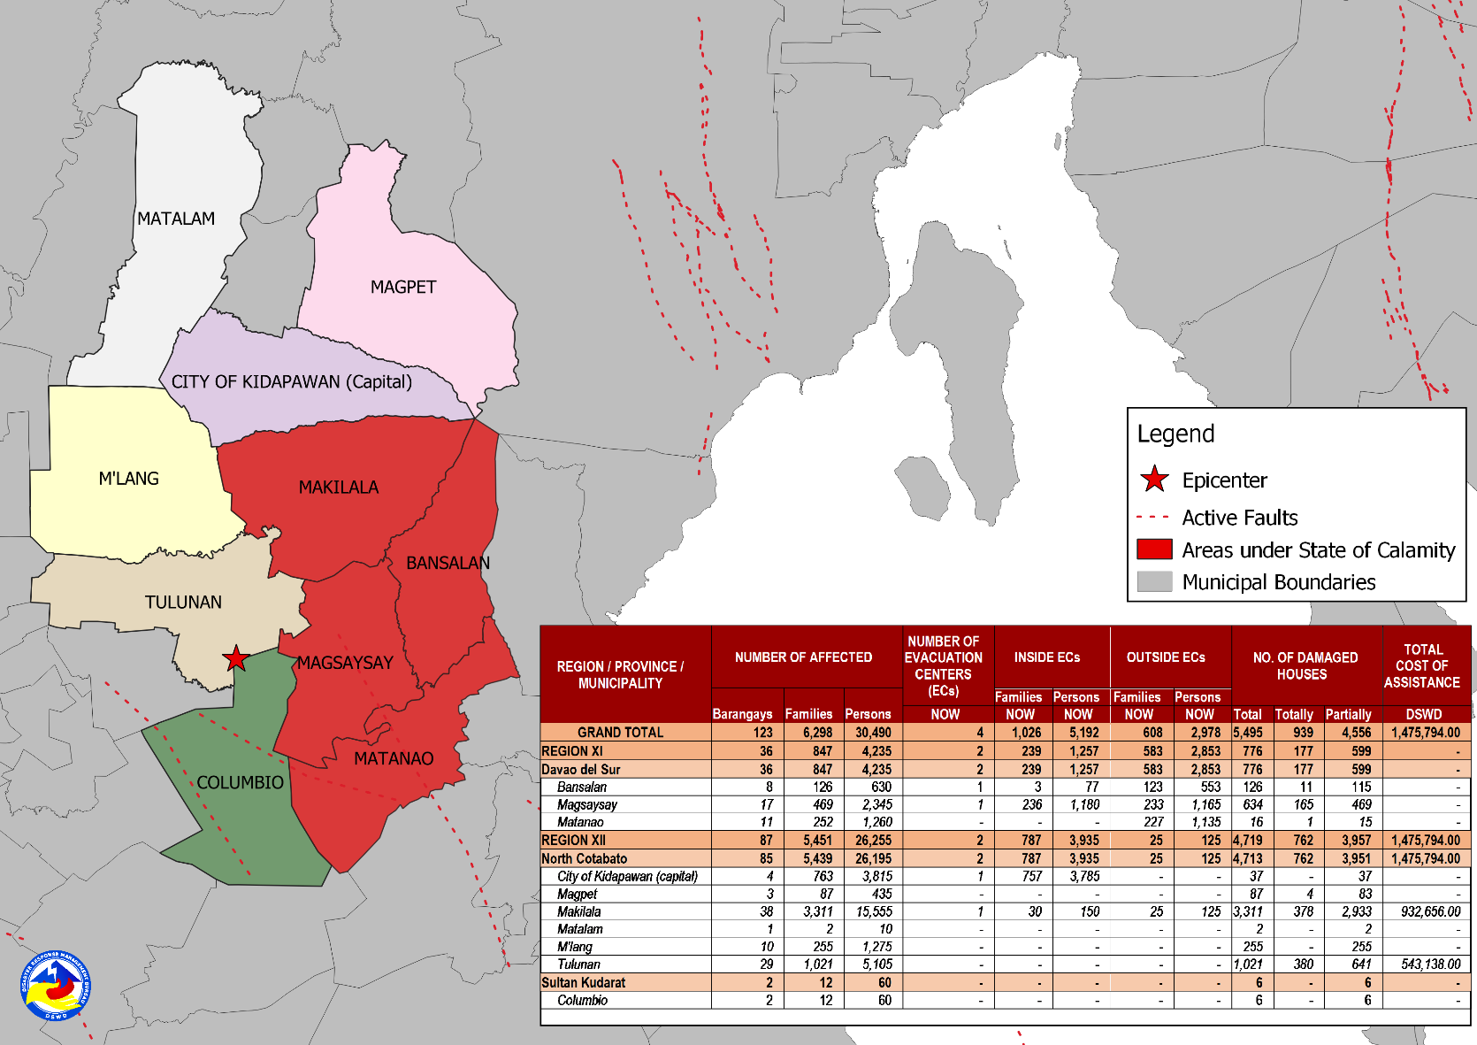
DSWD DISASTER RESPONSE INFORMATION
Source: DRMB-DROMIC GIS Specialists

Situational Reports

DSWD-DRMB
DATE | SITUATIONS / ACTIONS UNDERTAKEN
22 October 2019 | - The Disaster Response Management Bureau (DRMB) is continuously coordinating with the concerned DSWD Field Offices for significant disaster response updates.  - All QRT members and emergency equipment are on standby and ready for deployment.

DSWD-FO XI
DATE | ACTION(S) TAKEN
20 October 2019 | - The municipality of Magsaysay was declared under State of Calamity.  - DSWD-FO XI provided 900 family food packs worth ₱325,260.00 and 230 sleeping kits worth ₱158,700.00 to the affected families.

DSWD-FO XII
DATE | ACTION(S) TAKEN
- October 2019 | - DSWD-FO XII through the Disaster Response Management Division (DRMD) Staff together with P/C/MAT leaders monitored the disaster incident in Tulunan, M’lang and Kidapawan City, North Cotabato in coordination with the Municipal Social Welfare Development Offices (MSWDOs) of the said municipalities.
20 October 2019 | - DSWD-FO XII provided 2,256 FFPs, 10 rolls of laminated sacks and 7 tents to the affected families in Makilala, North Cotabato.  - DSWD-FO XII provided 1,138 FFPs, and 31 rolls of laminated sacks 8ftx100m to the affected families in Tulunan, North Cotabato.

***
The Disaster Response Operations Monitoring and Information Center (DROMIC) of the DSWD-DRMB is closely monitoring the effects of Earthquake Incident and is coordinating with the concerned DSWD Field Offices for any significant updates.

Prepared by:

MARIE JOYCE G. RAFANAN
CLARRIE MAE A. CASTILLO

MARC LEO L. BUTAC
Releasing Officer

