DSWD DROMIC Report #8 on the
Mw 6.6 Earthquake Incident in Cataingan, Masbate
as of 28 August 2020, 6PM

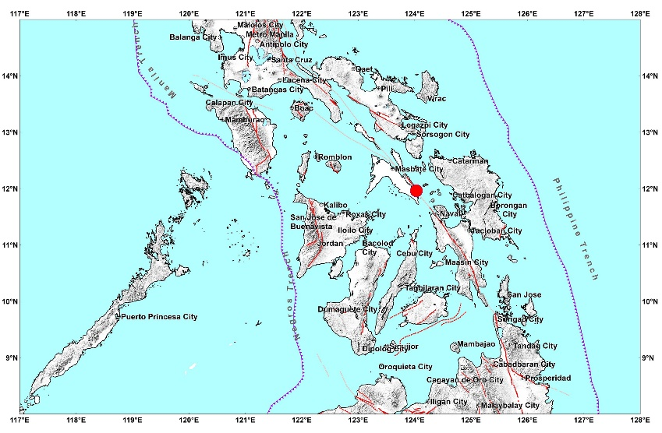

Situation Overview

On 18 August 2020 at 8:03 AM, a 6.6 magnitude earthquake jolted the municipality of Cataingan, Masbate (11.96°N, 124.03°E - 007 km S 29° E) with a tectonic origin and a depth of focus of 21 km. The earthquake was also felt in the neighboring municipalities of Masbate.

Source: DOST-PHIVOLCS Earthquake Bulletin

- Status of Affected Families / Persons
There are 1,522 families or 6,225 persons affected by the earthquake incident in 56 Barangays in Masbate Province (see Table 1).

Table 1. Number of Affected Families / Persons
REGION / PROVINCE / MUNICIPALITY |  | NUMBER OF AFFECTED
 |  | Barangays | Families | Persons
GRAND TOTAL |  | 56 | 1,522 | 6,225
REGION V |  | 56 | 1,522 | 6,225
Masbate |  | 56 | 1,522 | 6,225
 | Cataingan | 26 | 915 | 3,866
 | Cawayan | 2 | 10 | 50
 | Esperanza | 3 | 13 | 56
 | Palanas | 12 | 237 | 918
 | Pio V. Corpuz (Limbuhan) | 13 | 347 | 1,335
Note: Ongoing assessment and validation are continuously being conducted.
Source: DSWD-FO V

- Status of Displaced Families / Persons
  - Inside Evacuation Center
There are 272 families or 1,134 persons taking temporary shelter in 12 evacuation centers (see Table 2).

Table 2. Number of Displaced Families / Persons Inside Evacuation Centers
REGION / PROVINCE / MUNICIPALITY |  | NUMBER OF EVACUATION CENTERS (ECs) |  | NUMBER OF DISPLACED
 |  |  |  | INSIDE ECs
 |  |  |  | Families |  | Persons
 |  | CUM | NOW | CUM | NOW | CUM | NOW
GRAND TOTAL |  | 15 | 12 | 292 | 272 | 1,227 | 1,134
REGION V |  | 15 | 12 | 292 | 272 | 1,227 | 1,134
Masbate |  | 15 | 12 | 292 | 272 | 1,227 | 1,134
 | Cataingan | 11 | 8 | 164 | 144 | 678 | 585
 | Pio V. Corpuz (Limbuhan) | 4 | 4 | 128 | 128 | 549 | 549
Note: Ongoing assessment and validation are continuously being conducted.
Source: DSWD-FO V

  - Outside Evacuation Center
There were 10 families or 42 persons who took temporary shelter with their relatives and/or friends (see Table 3).

Table 3. Number of Displaced Families / Persons Outside Evacuation Centers
REGION / PROVINCE / MUNICIPALITY |  | NUMBER OF DISPLACED
 |  | OUTSIDE ECs
 |  | Families |  | Persons
 |  | CUM | NOW | CUM | NOW
GRAND TOTAL |  | 10 | 10 | 42 | 42
REGION V |  | 10 | 10 | 42 | 42
Masbate |  | 10 | 10 | 42 | 42
 | Cataingan | 10 | 10 | 42 | 42
Note: Ongoing assessment and validation are continuously being conducted.
Source: DSWD-FO V

- Damaged Houses
There are 1,014 damaged houses; of which, 137 are totally damaged and 877 are partially damaged (see Table 4).

Table 4. Number of Damaged Houses
REGION / PROVINCE / MUNICIPALITY |  | NO. OF DAMAGED HOUSES
 |  | Total | Totally | Partially
GRAND TOTAL |  | 1,014 | 137 | 877
REGION V |  | 1,014 | 137 | 877
Masbate |  | 1,014 | 137 | 877
 | Cataingan | 452 | 118 | 334
 | Cawayan | 10 | - | 10
 | Esperanza | 13 | - | 13
 | Palanas | 237 | 7 | 230
 | Pio V. Corpuz (Limbuhan) | 302 | 12 | 290
Note: Ongoing assessment and validation are continuously being conducted.
Source: DSWD-FO V

- Assistance Provided
A total of ₱590,478.36 worth of assistance was provided by DSWD to the affected families (see Table 5).

Table 5. Cost of Assistance Provided to Affected Families / Persons
REGION / PROVINCE / MUNICIPALITY |  | COST OF ASSISTANCE
 |  | DSWD | LGU | NGOs | OTHERS | GRAND TOTAL
GRAND TOTAL |  | 590,478.36 | - | - | - | 590,478.36
REGION V |  | 590,478.36 | - | - | - | 590,478.36
Masbate |  | 590,478.36 | - | - | - | 590,478.36
 | Cataingan | 366,058.60 | - | - | - | 366,058.60
 | Palanas | 83,419.76 | - | - | - | 83,419.76
 | Pio V. Corpuz (Limbuhan) | 141,000.00 | - | - | - | 141,000.00
Source: DSWD-FO V

DSWD DISASTER RESPONSE INFORMATION
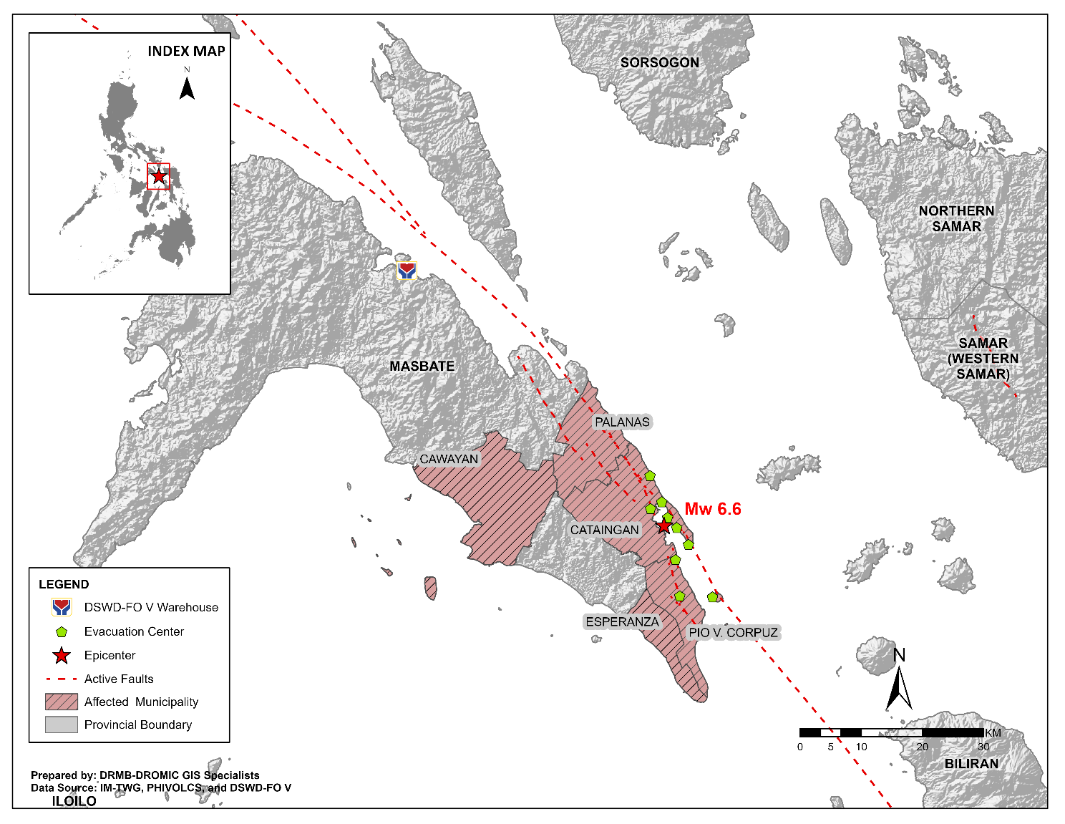

Situational Reports

DSWD-DRMB
DATE | SITUATIONS / ACTIONS UNDERTAKEN
28 August 2020 | - The Disaster Response Management Bureau (DRMB) is on BLUE alert status.  - DSWD-DRMB Disaster Operations and Support Division (DOSD) continuously facilitates the downloading of funds to DSWD-Field Offices.  - DSWD-DRMB Preparedness for Response Division (PRD) in coordination with other DRMB divisions and concerned offices, is continuously monitoring and updating the status of the Standby Funds.  - DSWD-DRMB DOSD in coordination with other DRMB divisions and concerned offices, is continuously facilitating the replenishment of the Standby Funds.  - DSWD-DRMB is continuously coordinating with DSWD-FO V for significant disaster response updates.  - All QRT members and emergency equipment are on standby and ready for deployment.

DSWD-FO V
DATE | SITUATIONS / ACTIONS UNDERTAKEN
28 August 2020 | - DSWD-FO V released 1,103 family food packs, 11 rolls of laminated sacks and 4 tents amounting to a total of ₱590,478.36 as augmentation support to LGUs of Cataingan, Palanas and Pio V. Corpuz.  - DSWD-FO V extended ₱5,000.00 worth of financial assistance thru AICS to each family with totally damaged houses in Cataingan, Pio V. Corpuz and Palanas, Masbate. A total of ₱500,000.00 was provided to 100 families.  - DSWD-FO V in coordination with the Philippine Navy transported additional 1,000 family food packs amounting to ₱412,980.00 to Masbate.  - DSWD FO V conducted Critical Incident Stress Debriefing (CISD) to the residents of Brgy. Matayum who are affected with by the Earthquake.  - DSWD-FO V continuously conducts assessment as to the needs of the affected families for possible augmentation.  - The Resource Operation Section ensures the availability of family food packs and non-food items as need arises.  - PAT and MAT members in Masbate Province are activated and instructed to coordinate with the P/MDRRMOs, C/MSWDOs for significant reports and updates on the 6.6 magnitude earthquake.  - DSWD-FO V DRMD continuous to monitor updates and information relative to the 6.6 magnitude earthquake.

*****
The Disaster Response Operations Monitoring and Information Center (DROMIC) of the DSWD-DRMB is closely coordinating with DSWD-FO V for any significant updates and actions taken relative to 6.6 earthquake incident in Cataingan, Masbate.

Prepared by:

JEM ERIC F. FAMORCAN

RODEL V. CABADDU
Releasing Officer

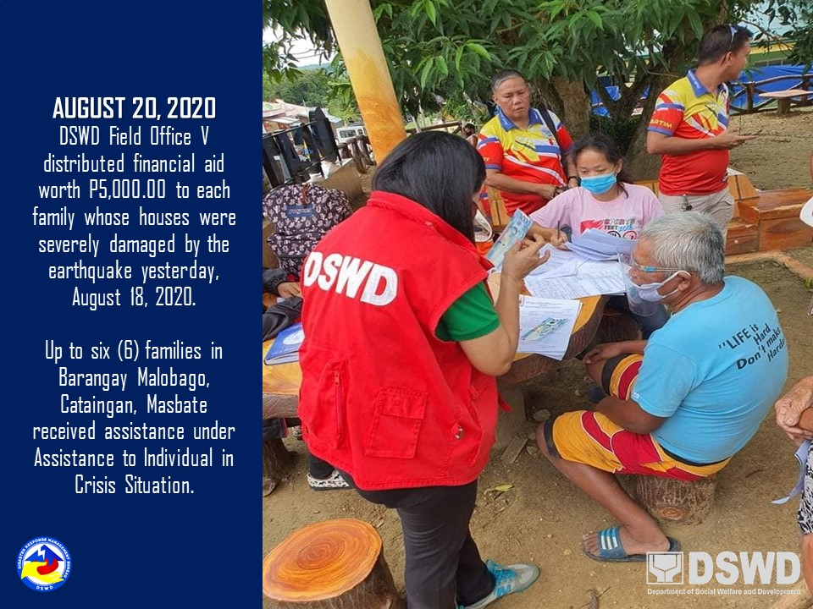
PHOTO DOCUMENTATION

