DSWD DROMIC Report #9 on the
Earthquake Incident in Tulunan, North Cotabato
as of 22 October 2019, 6PM

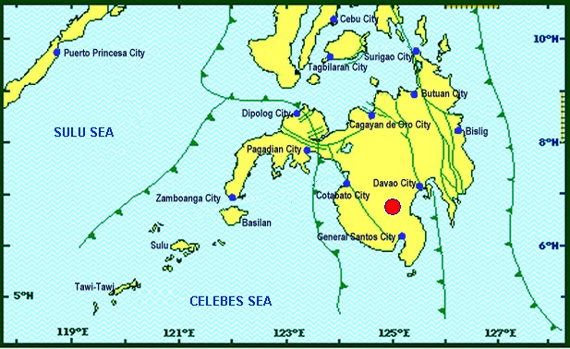
Situation Overview

On 16 October 2019 at 07:37 PM, a 6.3 magnitude earthquake jolted the municipality of Tulunan, North Cotabato (06.75°N, 125.00°E - 022 km S 59°E) with a tectonic origin and a depth of focus of 8 km. The earthquake was also felt in the neighboring municipalities of North Cotabato and other Mindanao Provinces.

Date/Time: | 16 Oct 2019 - 07:37:04 PM
Reported Intensities: | Intensity VII - Tulunan, North Cotabato, M'Lang, North Cotabato, Kidapawan City  Intensity VI - Digos City, Davao del Sur; Sto. Nino, South Cotabato; Tacurong City  Intensity V - Alabel & Malungon, Sarangani; Lake Sebu, Polomolok, Tampakan & Tupi, South Cotabato; Koronadal City; Roxas & Pikit, North Cotabato;General Santos City; Davao City; Kalamansig, Lebak & Palimbang, Sultan Kudarat  Intensity IV - Kiamba, Sarangani; Esperanza & Rosario, Agusan del Sur; Kalilangan, Quezon, Kadingilan & Damulog, Bukidnon; Mawab, Compostela Valley; Cotabato City; Matanog, Barira & Sultan Kudarat, Maguindanao  Intensity III - Santa Josefa, Agusan del Sur; Iligan City; Dipolog City  Intensity II - Butuan City; Zamboanga City  Intensity I - Hinatuan, Surigao del Sur  Instrumental Intensities:  Intensity VII - Kidapawan City  Intensity V - Tupi and Polomolok, South Cotabato; Alabel, Sarangani  Intensity IV - Kiamba, Sarangani; T'Boli, South Cotabato; General Santos City  Intensity III - Cagayan de Oro City; Gingoog City, Misamis Oriental;  Intensity II - Cagayan de Oro, Misamis Oriental  Intensity I - Dipolog City; Bislig City
Expecting Damage: | YES
Expecting Aftershocks: | YES

Source: DOST-PHIVOLCS Earthquake Bulletin

- Status of Affected Families / Persons
A total of 7,293 families or 35,465 persons were affected by the earthquake incident in 127 barangays in Regions XI and XII (see Table 1).

Table 1. Number of Affected Families / Persons
REGION / PROVINCE / MUNICIPALITY |  | NUMBER OF AFFECTED
 |  | Barangays | Families | Persons
GRAND TOTAL |  | 127 | 7,293 | 35,465
REGION XI |  | 40 | 1,842 | 9,210
Davao del Sur |  | 36 | 1,822 | 9,110
 | Bansalan | 8 | 496 | 2,480
 | Magsaysay | 17 | 1,180 | 5,900
 | Matanao | 11 | 146 | 730
Davao Occidental |  | 4 | 20 | 100
 | Santa Maria | 4 | 20 | 100
REGION XII |  | 87 | 5,451 | 26,255
North Cotabato |  | 85 | 5,439 | 26,195
 | City of Kidapawan (capital) | 4 | 763 | 3,815
 | Magpet | 3 | 87 | 435
 | Makilala | 38 | 3,311 | 15,555
 | Matalam | 1 | 2 | 10
 | M'lang | 10 | 255 | 1,275
 | Tulunan | 29 | 1,021 | 5,105
Sultan Kudarat |  | 2 | 12 | 60
 | Columbio | 2 | 12 | 60
Note: Ongoing assessment and validation being conducted.
Source: DSWD-FOs XI and XII

- Status of Displaced Families / Persons
- Inside Evacuation Centers
There are 936 families or 4,604 persons taking temporary shelter in three (3) evacuation centers in Regions XI and XII (see Table 2).

Table 2. Number of Displaced Families / Persons Inside Evacuation Centers
REGION / PROVINCE / MUNICIPALITY |  | NUMBER OF EVACUATION CENTERS (ECs) |  | INSIDE ECs
 |  |  |  | Families |  | Persons
 |  | CUM | NOW | CUM | NOW | CUM | NOW
GRAND TOTAL |  | 6 | 3 | 1,051 | 936 | 5,317 | 4,604
REGION XI |  | 4 | 1 | 264 | 149 | 1,382 | 669
Davao del Sur |  | 4 | 1 | 264 | 149 | 1,382 | 669
 | Bansalan | 1 | - | 3 | - | 77 | -
 | Magsaysay | 1 | 1 | 236 | 149 | 1,180 | 669
 | Matanao | 2 | - | 25 | - | 125 | -
REGION XII |  | 2 | 2 | 787 | 787 | 3,935 | 3,935
North Cotabato |  | 2 | 2 | 787 | 787 | 3,935 | 3,935
 | City of Kidapawan (capital) | 1 | 1 | 757 | 757 | 3,785 | 3,785
 | Makilala | 1 | 1 | 30 | 30 | 150 | 150
Note: Ongoing assessment and validation being conducted.
Source: DSWD-FOs XI and XII

- Outside Evacuation Centers
There are 407 families or 2,035 persons currently staying with their relatives and/or friends (see Table 3).

Table 3. Number of Displaced Families / Persons Outside Evacuation Centers
REGION / PROVINCE / MUNICIPALITY |  | OUTSIDE ECs
 |  | Families |  | Persons
 |  | CUM | NOW | CUM | NOW
GRAND TOTAL |  | 608 | 407 | 2,978 | 2,035
REGION XI |  | 583 | 382 | 2,853 | 1,910
Davao del Sur |  | 583 | 382 | 2,853 | 1,910
 | Bansalan | 123 | 109 | 553 | 545
 | Magsaysay | 233 | 203 | 1,165 | 1,015
 | Matanao | 227 | 70 | 1,135 | 350
REGION XII |  | 25 | 25 | 125 | 125
North Cotabato |  | 25 | 25 | 125 | 125
 | Makilala | 25 | 25 | 125 | 125
Note: Ongoing assessment and validation being conducted.
Source: DSWD-FOs XI and XII

- Damaged Houses
There are 6,310 damaged houses; of which, 1,288 are totally damaged and 5,022 are partially damaged (see Table 4).

Table 4. Number of Damaged Houses
REGION / PROVINCE / MUNICIPALITY |  | NO. OF DAMAGED HOUSES
 |  | Total | Totally | Partially
GRAND TOTAL |  | 6,310 | 1,288 | 5,022
REGION XI |  | 1,591 | 526 | 1,065
Davao del Sur |  | 1,571 | 526 | 1,045
 | Bansalan | 245 | 64 | 181
 | Magsaysay | 1,180 | 359 | 821
 | Matanao | 146 | 103 | 43
Davao Occidental |  | 20 | - | 20
 | Santa Maria | 20 | - | 20
REGION XII |  | 4,719 | 762 | 3,957
North Cotabato |  | 4,713 | 762 | 3,951
 | City of Kidapawan (capital) | 37 | - | 37
 | Magpet | 87 | 4 | 83
 | Makilala | 3,311 | 378 | 2,933
 | Matalam | 2 | - | 2
 | M'lang | 255 | - | 255
 | Tulunan | 1,021 | 380 | 641
Sultan Kudarat |  | 6 | - | 6
 | Columbio | 6 | - | 6
Note: Ongoing assessment and validation being conducted.
Source: DSWD-FOs XI and XII

- Assistance Provided
A total of ₱1,475,794.00 worth of assistance was provided by DSWD to the affected families (see Table 4).

Table 4. Cost of Assistance Provided to Affected Families / Persons
REGION / PROVINCE / MUNICIPALITY |  | TOTAL COST OF ASSISTANCE
 |  | DSWD | LGU | NGOs | OTHERS | GRAND TOTAL
GRAND TOTAL |  | 1,475,794.00 | - | - | - | 1,475,794.00
REGION XII |  | 1,475,794.00 | - | - | - | 1,475,794.00
North Cotabato |  | 1,475,794.00 | - | - | - | 1,475,794.00
 | Makilala | 932,656.00 | - | - | - | 932,656.00
 | Tulunan | 543,138.00 | - | - | - | 543,138.00
Note: Ongoing assessment and validation being conducted.
Source: DSWD-FO XII

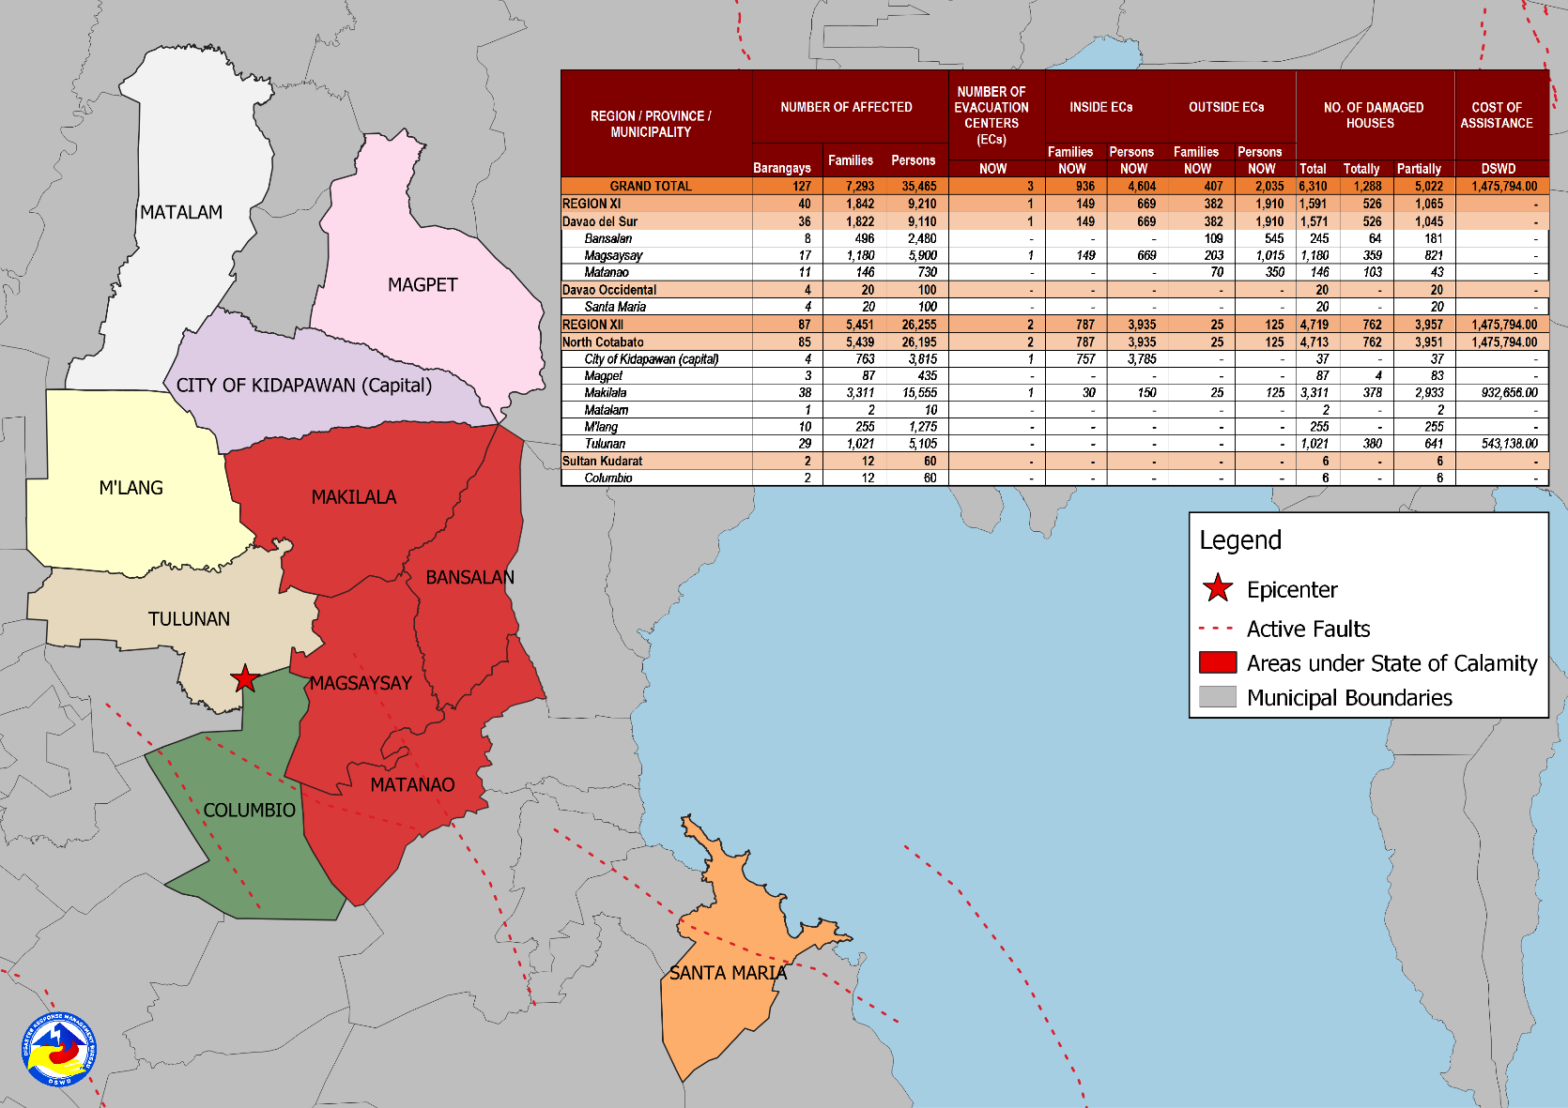
DSWD DISASTER RESPONSE INFORMATION
Source: DRMB-DROMIC GIS Specialists

Situational Reports

DSWD-DRMB
DATE | SITUATIONS / ACTIONS UNDERTAKEN
22 October 2019 | - The Disaster Response Management Bureau (DRMB) is continuously coordinating with the concerned DSWD Field Offices for significant disaster response updates.  - All QRT members and emergency equipment are on standby and ready for deployment.

DSWD-FO XI
DATE | ACTION(S) TAKEN
22 October 2019 | - Rapid Damage Assessment and Needs Analysis (RDANA) of the Composite Team is ongoing.
20 October 2019 | - The municipality of Magsaysay was declared under State of Calamity.  - DSWD-FO XI provided 900 family food packs worth ₱325,260.00 and 230 sleeping kits worth ₱158,700.00 to the affected families.

DSWD-FO XII
DATE | ACTION(S) TAKEN
- October 2019 | - DSWD-FO XII through the Disaster Response Management Division (DRMD) Staff together with P/C/MAT leaders monitored the disaster incident in Tulunan, M’lang and Kidapawan City, North Cotabato in coordination with the Municipal Social Welfare Development Offices (MSWDOs) of the said municipalities.
20 October 2019 | - DSWD-FO XII provided 2,256 FFPs, 10 rolls of laminated sacks and 7 tents to the affected families in Makilala, North Cotabato.  - DSWD-FO XII provided 1,138 FFPs, and 31 rolls of laminated sacks 8ftx100m to the affected families in Tulunan, North Cotabato.

***
The Disaster Response Operations Monitoring and Information Center (DROMIC) of the DSWD-DRMB is closely monitoring the effects of Earthquake Incident and is coordinating with the concerned DSWD Field Offices for any significant updates.

Prepared by:

MARIE JOYCE G. RAFANAN
CLARRIE MAE A. CASTILLO

MARC LEO L. BUTAC
Releasing Officer

