DSWD DROMIC Terminal Report on the
Ms 6.6 Earthquake Incident in Tulunan, North Cotabato
18 December 2020, 6PM

Situation Overview

This is the final report on the Earthquak Incident that occurred in Tulunan, North Cotabato on 29 October 2019 at 09:04 AM, with a magnitude of 6.6 The earthquake was also felt in the neighboring municipalities of North Cotabato and Davao Region.
Source: DOST-PHIVOLCS Earthquake Bulletin

- Status of Affected Families / Persons
A total of 72,578 families or 355,983 persons in 379 barangays in Regions XI and XII were affected by the earthquake incident (see Table 1).

Table 1. Number of Affected Families / Persons
REGION / PROVINCE / MUNICIPALITY |  | NUMBER OF AFFECTED
 |  | Barangay | Families | Persons
GRAND TOTAL |  | 379 | 72,578 | 355,983
REGION XI |  | 168 | 25,817 | 122,178
Davao del Sur |  | 159 | 25,616 | 121,173
 | Bansalan | 25 | 7,060 | 29,444
 | City of Digos (capital) | 14 | 2,044 | 10,220
 | Hagonoy | 18 | 1,480 | 8,001
 | Kiblawan | 21 | 456 | 2,280
 | Magsaysay | 22 | 9,331 | 46,575
 | Malalag | 11 | 491 | 2,455
 | Matanao | 32 | 3,852 | 17,688
 | Padada | 2 | 714 | 3,570
 | Santa Cruz | 11 | 38 | 190
 | Sulop | 3 | 150 | 750
Davao Occidental |  | 9 | 201 | 1,005
 | Malita | 1 | 1 | 5
 | Santa Maria | 8 | 200 | 1,000
REGION XII |  | 211 | 46,761 | 233,805
North Cotabato |  | 209 | 46,705 | 233,525
 | Antipas | 13 | 312 | 1,560
 | Arakan | 19 | 343 | 1,715
 | Kabacan | 12 | 305 | 1,525
 | City of Kidapawan (capital) | 28 | 7,322 | 36,610
 | Magpet | 19 | 2,770 | 13,850
 | Makilala | 38 | 20,704 | 103,520
 | Matalam | 12 | 649 | 3,245
 | M'lang | 33 | 2,099 | 10,495
 | President Roxas | 6 | 305 | 1,525
 | Tulunan | 29 | 11,896 | 59,480
South Cotabato |  | 1 | 18 | 90
 | Tupi | 1 | 18 | 90
Sultan Kudarat |  | 1 | 38 | 190
 | Columbio | 1 | 38 | 190
Source: DSWD-FOs XI and XII

- Status of Displaced Families / Persons
- Inside Evacuation Center
There are 4,951 families or 20,784 persons taking temporary shelter in 42 evacuation centers in Regions XI and XII (see Table 2).

Table 2. Number of Displaced Families / Persons Inside Evacuation Centers
REGION / PROVINCE / MUNICIPALITY |  | NUMBER OF EVACUATION CENTERS (ECs) |  | NUMBER OF DISPLACED
 |  |  |  | INSIDE ECs
 |  |  |  | Families |  | Persons
 |  | CUM | NOW | CUM | NOW | CUM | NOW
GRAND TOTAL |  | 139 | 42 | 18,100 | 4,951 | 86,230 | 20,784
REGION XI |  | 56 | 30 | 7,254 | 3,171 | 32,000 | 11,884
Davao del Sur |  | 56 | 30 | 7,254 | 3,171 | 32,000 | 11,884
 | Bansalan | 21 | 12 | 2,703 | 783 | 11,319 | 2,811
 | City of Digos (capital) | 15 | 3 | 2,057 | 560 | 9,604 | 2,088
 | Hagonoy | 4 | 3 | 344 | 158 | 1,807 | 627
 | Magsaysay | 10 | 10 | 1,671 | 1,464 | 7,435 | 5,608
 | Matanao | 2 | 1 | 297 | 176 | 1,154 | 646
 | Padada | 1 | 1 | 32 | 30 | 111 | 104
REGION XII |  | 83 | 12 | 10,846 | 1,780 | 54,230 | 8,900
North Cotabato |  | 83 | 12 | 10,846 | 1,780 | 54,230 | 8,900
 | City of Kidapawan (capital) | 13 | 2 | 3,044 | 200 | 15,220 | 1,000
 | Magpet | 26 | 1 | 1,744 | 144 | 8,720 | 720
 | Makilala | 39 | 9 | 5,907 | 1,436 | 29,535 | 7,180
Source: DSWD-FOs XI and XII

- Outside Evacuation Center
There are 12,437 families or 57,974 persons currently staying with their relatives and/or friends, or in open spaces (see Table 3).

Table 3. Number of Displaced Families / Persons Outside Evacuation Centers
REGION / PROVINCE / MUNICIPALITY |  | NUMBER OF DISPLACED
 |  | OUTSIDE ECs
 |  | Families |  | Persons
 |  | CUM | NOW | CUM | NOW
GRAND TOTAL |  | 27,726 | 12,437 | 137,080 | 57,974
REGION XI |  | 12,943 | 12,437 | 63,165 | 57,974
Davao del Sur |  | 12,943 | 12,437 | 63,165 | 57,974
 | Bansalan | 4,928 | 4,493 | 23,202 | 20,546
 | City of Digos (capital) | 5 | 5 | 20 | 20
 | Hagonoy | 435 | 435 | 2,175 | 2,175
 | Magsaysay | 7,402 | 7,331 | 37,010 | 34,475
 | Matanao | 125 | 125 | 525 | 525
 | Padada | 20 | 20 | 93 | 93
 | Santa Cruz | 28 | 28 | 140 | 140
REGION XII |  | 14,783 | - | 73,915 | -
North Cotabato |  | 14,783 | - | 73,915 | -
 | Antipas | 33 | - | 165 | -
 | Arakan | 10 | - | 50 | -
 | Kabacan | 75 | - | 375 | -
 | City of Kidapawan (capital) | 70 | - | 350 | -
 | Matalam | 534 | - | 2,670 | -
 | M'lang | 2,041 | - | 10,205 | -
 | President Roxas | 219 | - | 1,095 | -
 | Tulunan | 11,801 | - | 59,005 | -
Source: DSWD-FOs XI and XII

- Damaged Houses
There are 43,627 damaged houses; of which, 12,206 are totally damaged and 31,421 are partially damaged (see Table 4).

Table 4. Number of Damaged Houses
REGION / PROVINCE / MUNICIPALITY | NO. OF DAMAGED HOUSES
 | Total | Totally | Partially
GRAND TOTAL | 43,627 | 12,206 | 31,421
REGION XI | 13,924 | 3,333 | 10,591
Davao del Sur | 13,723 | 3,267 | 10,456
Bansalan | 3,675 | 1,145 | 2,530
Hagonoy | 842 | 179 | 663
Kiblawan | 52 | 18 | 34
Magsaysay | 7,402 | 1,609 | 5,793
Malalag | 491 | 27 | 464
Matanao | 725 | 68 | 657
Padada | 375 | 165 | 210
Santa Cruz | 11 | 2 | 9
Sulop | 150 | 54 | 96
Davao Occidental | 201 | 66 | 135
Malita | 1 | 1 | -
Santa Maria | 200 | 65 | 135
REGION XII | 29,703 | 8,873 | 20,830
North Cotabato | 29,647 | 8,858 | 20,789
Antipas | 301 | 18 | 283
Arakan | 192 | 15 | 177
Kabacan | 267 | 5 | 262
City of Kidapawan (capital) | 6,724 | 875 | 5,849
Magpet | 1,161 | 118 | 1,043
Makilala | 15,721 | 6,180 | 9,541
Matalam | 345 | 13 | 332
M'lang | 1,991 | 535 | 1,456
President Roxas | 333 | 36 | 297
Tulunan | 2,612 | 1,063 | 1,549
South Cotabato | 18 | 1 | 17
Tupi | 18 | 1 | 17
Sultan Kudarat | 38 | 14 | 24
Columbio | 38 | 14 | 24
Source: DSWD-FOs XI and XII

- Assistance Provided
A total of ₱106,694,449.91 worth of assistance was provided by DSWD to the affected families (see Table 5).

Table 5. Cost of Assistance Provided to Affected Families / Persons
REGION / PROVINCE / MUNICIPALITY | DSWD TOTAL | LGU | NGOs | OTHERS | GRAND TOTAL
GRAND TOTAL | 106,694,449.91 | - | - | - | 106,694,449.91
REGION XI | 50,310,102.71 | - | - | - | 50,310,102.71
Davao del Sur | 50,193,002.71 | - | - | - | 50,193,002.71
Bansalan | 15,911,471.84 | - | - | - | 15,911,471.84
City of Digos (capital) | 8,382,212.83 | - | - | - | 8,382,212.83
Hagonoy | 1,943,279.73 | - | - | - | 1,943,279.73
Kiblawan | 574,127.50 | - | - | - | 574,127.50
Magsaysay | 16,556,223.92 | - | - | - | 16,556,223.92
Malalag | 703,815.00 | - | - | - | 703,815.00
Matanao | 5,302,445.71 | - | - | - | 5,302,445.71
Padada | 573,897.39 | - | - | - | 573,897.39
Sulop | 245,528.79 | - | - | - | 245,528.79
Davao Occidental | 117,100.00 | - | - | - | 117,100.00
Santa Maria | 117,100.00 | - | - | - | 117,100.00
REGION XII | 56,384,347.20 | - | - | - | 56,384,347.20
North Cotabato | 56,384,347.20 | - | - | - | 56,384,347.20
Arakan | 3,172,649.00 | - | - | - | 3,172,649.00
City of Kidapawan (capital) | 13,530,270.00 | - | - | - | 13,530,270.00
Magpet | 8,475,919.00 | - | - | - | 8,475,919.00
Makilala | 21,633,857.48 | - | - | - | 21,633,857.48
Matalam | 2,767,475.00 | - | - | - | 2,767,475.00
M'lang | 1,747,874.00 | - | - | - | 1,747,874.00
Tulunan | 5,056,302.72 | - | - | - | 5,056,302.72
Source: DSWD-FOs XI and XII
Situational Reports

DSWD-FO XI
DATE | SITUATIONS / ACTIONS UNDERTAKEN
20 December 2019 | - DSWD-FO XI is submitted their terminal report.  - The remaining displaced families and persons inside evacuation centers have carried over to the 6.9 Earthquake which occurred last December 15, 2019 wherein they were also affected.

DSWD-FO XII
DATE | SITUATIONS / ACTIONS UNDERTAKEN
30 October 2020 | - DSWD-FO XII submitted their terminal report.  - The needs of the displaced families and persons shall continuously be provided by the LGUs.

*****
The Disaster Response Operations Monitoring and Information Center (DROMIC) of the DSWD-DRMB is closely coordinating with concerned DSWD Field Offices for any significant disaster response updates.

Prepared by: Releasing Officer

MARIEL B. FERRARIZ LESLIE R. JAWILI

PHOTO DOCUMENTATION

Relief distribution in New Bulatukan, Makilala North Cotabato
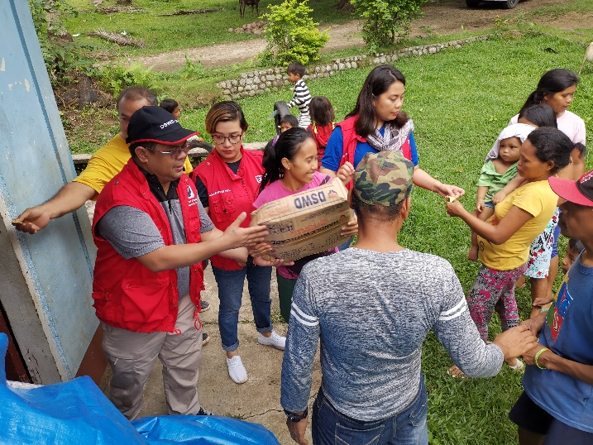
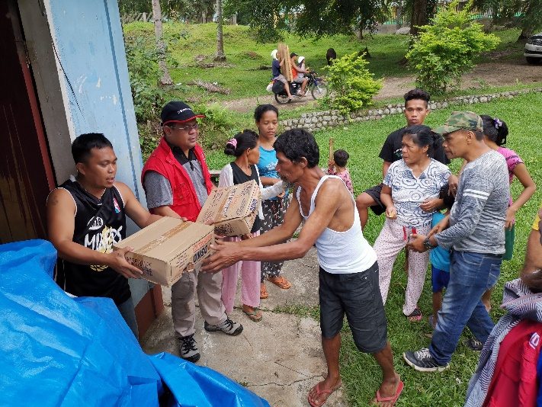

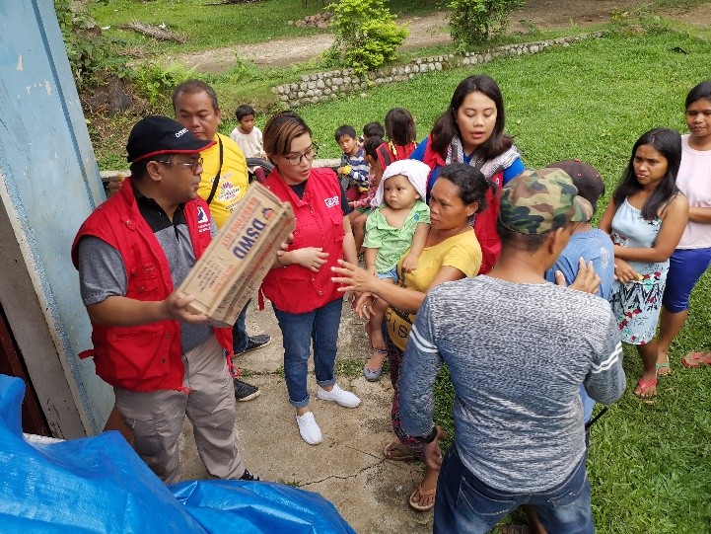
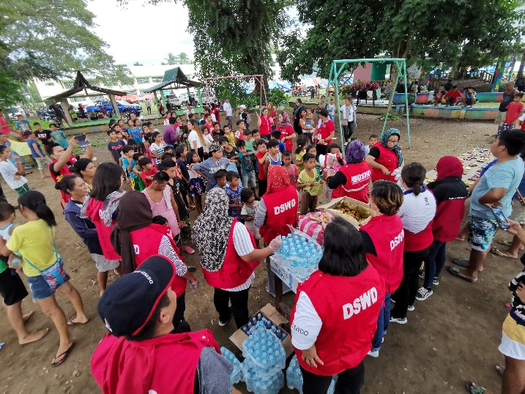
DSWD together with Philippine Coast Guard conducted play therapy at Bacungan Elementary School Evacuation Center
