DSWD DROMIC Terminal Report on the
Preparedness for Response on Tropical Depression “MARILYN”
01 October 2019, 6PM

This is the final report on the Preparedness for Response on Tropical Depression (TD) “MARILYN” which entered the Philippine Area of Responsibility (PAR) on 13 September 2019. TD “Marilyn” did not make any landfall in the country but has brought occasional light to moderate rains with at times heavy rain showers as it exited PAR on 15 September 2019.
Source: DOST-PAGASA
PREDICTIVE ANALYTICS FOR HUMANITARIAN RESPONSE
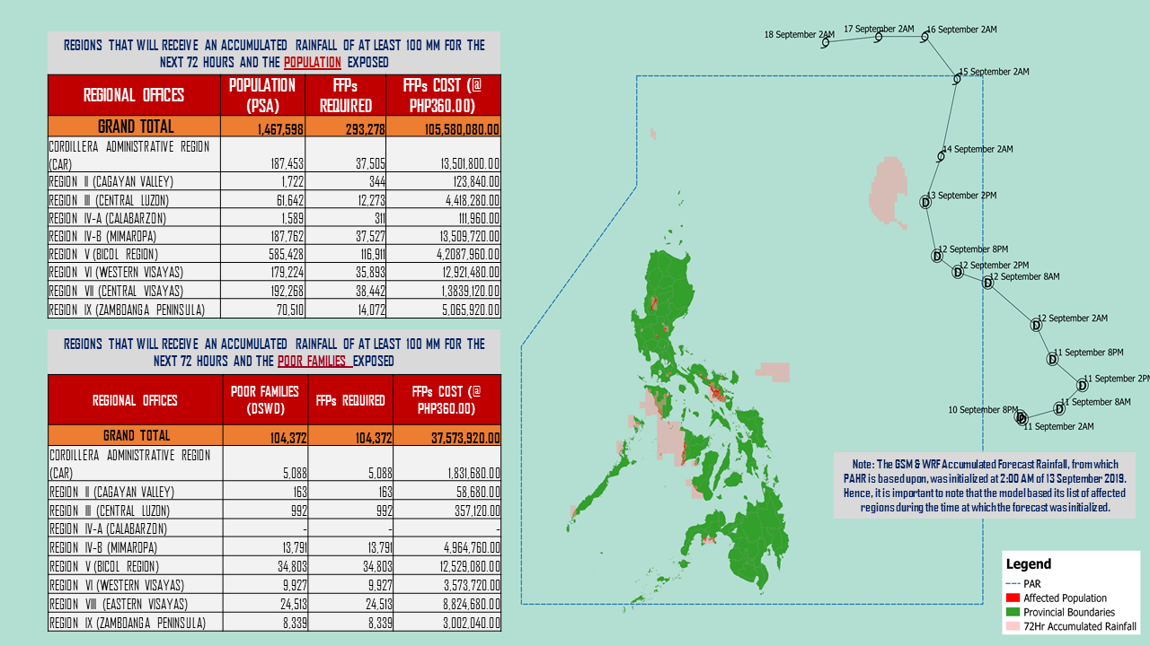

Source: DRMB-DROMIC GIS Specialists
Status of Prepositioned Resources: Stockpile and Standby Funds

The DSWD Central Office (CO), Field Offices (FOs), and National Resource Operations Center (NROC) have stockpiles and standby funds amounting to ₱1,818,166,982.55 with breakdown as follows (see Table 1):

- Standby Funds
A total of ₱1,114,541,754.24 standby funds in the CO and FOs. Of the said amount, ₱1,076,221,717.34 is the available Quick Response Fund (QRF) in the CO.

- Stockpiles
A total of 312,550 Family Food Packs (FFPs) amounting to ₱119,666,784.30 and available Food and Non-food Items (FNIs) amounting to ₱583,958,444.01.

FIELD OFFICE | STANDBY FUNDS | STOCKPILES |  |  |  |  | Total STANDBY FUNDS & STOCKPILE
 |  | Family Food Packs |  | Other Food Items | Non Food Items | SUB-TOTAL (Food and NFIs)
 |  | Quantity | Total Cost | Total Cost | Total Cost
TOTAL | 1,114,541,754.24 | 312,550 | 119,666,784.30 | 126,278,492.82 | 457,679,951.19 | 583,958,444.01 | 1,818,166,982.55
Central Office | 1,076,221,717.34 |  |  |  |  |  | 1,076,221,717.34
NRLMB - NROC | - | 57,190 | 23,637,070.60 | 64,397,137.30 | 317,168,000.53 | 381,565,137.83 | 405,202,208.43
NRLMB - VDRC | - | - | - | 179,200.00 | 13,048,203.51 | 13,227,403.51 | 13,227,403.51
I | 2,379,275.00 | 18,071 | 6,658,208.84 | 299,455.20 | 14,428,240.70 | 14,727,695.90 | 23,765,179.74
II | 3,638,241.66 | 28,662 | 9,214,300.12 | 84,672.00 | 349,602.75 | 434,274.75 | 13,286,816.53
III | 3,068,057.00 | 17,780 | 7,776,830.72 | 979,469.70 | 241,406.00 | 1,220,875.70 | 12,065,763.42
CALABARZON | 1,772,325.00 | 4,390 | 1,551,416.60 | 3,387,338.80 | 3,175,812.37 | 6,563,151.17 | 9,886,892.77
MIMAROPA | 1,777,188.26 | 30,835 | 12,889,030.00 | 1,030,561.74 | 859,605.00 | 1,890,166.74 | 16,556,385.00
V | 1,464,000.00 | 26,743 | 10,429,770.00 | 5,829,520.72 | 40,198,290.47 | 46,027,811.19 | 57,921,581.19
VI | 3,000,000.00 | 19,984 | 7,194,240.00 | 7,465,853.31 | 3,711,406.00 | 11,177,259.31 | 21,371,499.31
VII | 2,300.00 | 13,589 | 4,892,040.00 | 12,543,564.82 | 15,674,264.51 | 28,217,829.33 | 33,112,169.33
VIII | 3,202,960.00 | 13,093 | 4,724,972.06 | 2,902,519.84 | 896,387.00 | 3,798,906.84 | 11,726,838.90
IX | 1,888.85 | 12,867 | 4,632,120.00 | 2,237,290.00 | 3,793,242.35 | 6,030,532.35 | 10,664,541.20
X | 3,000,000.00 | 17,724 | 6,380,640.00 | 7,045,538.80 | 26,072,016.06 | 33,117,554.86 | 42,498,194.86
XI | 3,028,750.00 | 10,436 | 3,771,570.40 | 2,819,200.00 | 8,100,389.58 | 10,919,589.58 | 17,719,909.98
XII | 3,000,701.68 | 6,839 | 2,742,439.00 | 9,147,389.00 | 833,017.26 | 9,980,406.26 | 15,723,546.94
CARAGA | 3,000,000.00 | 13,496 | 5,397,138.72 | 227,028.56 | 3,206,423.70 | 3,433,452.26 | 11,830,590.98
NCR | 3,292,543.50 | 4,716 | 1,685,145.76 | 982,611.51 | 1,016,541.00 | 1,999,152.51 | 6,976,841.77
CAR | 2,691,805.95 | 16,135 | 6,089,851.48 | 4,720,141.52 | 4,907,102.40 | 9,627,243.92 | 18,408,901.35
*Quick Response Fund (QRF) as of 12 September 2019

Situational Reports

DSWD-FO I
DATE | SITUATIONS / ACTIONS UNDERTAKEN
- October 2019 | - DSWD-FO I submitted their terminal report.

DSWD-FO II
DATE | SITUATIONS / ACTIONS UNDERTAKEN
- October 2019 | - DSWD-FO II submitted their terminal report.  - There were 6 families or 15 persons who have pre-emptively evacuated at Brgy. Ballesteros in Aurora, Isabela.  REGION / PROVINCE / MUNICIPALITY NUMBER OF AFFECTED NUMBER OF EVACUATION CENTERS (ECs)  Barangays Families Persons  GRAND TOTAL 1 6 15 1  REGION II 1 6 15 1  Isabela 1 6 15 1  Aurora 1 6 15 1

DSWD-FO MIMAROPA
DATE | SITUATIONS / ACTIONS UNDERTAKEN
01 October 2019 | - DSWD-FO MIMAROPA submitted their terminal report.

DSWD-FO CAR
DATE | SITUATIONS / ACTIONS UNDERTAKEN
01 October 2019 | - DSWD-FO CAR submitted their terminal report.

*****
The Disaster Response Operations Monitoring and Information Center (DROMIC) of the DSWD-DRMB is closely monitoring the effects of TD Marilyn and is coordinating with the concerned DSWD-Field Offices for any significant updates.

PREPARED BY:

MARIE JOYCE G. RAFANAN

JAN ERWIN ANDREW I. ONTANILLAS
Releasing Officer

