DSWD DROMIC Terminal Report on the
Tornado Incident in Rizal, Occidental Mindoro
12 October 2019, 12NN

This is the final report on the tornado incident that ripped through Barangays Adela, San Pedro and Sto. Niño, Rizal in Occidental Mindoro on 18 September 2019 which caused damage to the houses of the affected families.
Source: DSWD-FO MIMAROPA

- Status of Affected Families / Persons
A total of 13 families or 47 persons were affected by the tornado incident in 3 barangays in Rizal, Occidental Mindoro (see Table 1).

Table 1. Number of Affected Families / Persons
REGION / PROVINCE / MUNICIPALITY |  | NUMBER OF AFFECTED
 |  | Barangays | Families | Persons
GRAND TOTAL |  | 3 | 13 | 47
MIMAROPA |  | 3 | 13 | 47
Occidental Mindoro |  | 3 | 13 | 47
 | Rizal | 3 | 13 | 47
Source: DSWD-FO MIMAROPA

- Status of Displaced Families / Persons
There are 3 families or 8 persons who are currently staying with their relatives (see Table 2).

Table 2. Number of Displaced Families / Persons Outside Evacuation Center
REGION / PROVINCE / MUNICIPALITY |  | OUTSIDE ECs
 |  | Families |  | Persons
 |  | CUM | NOW | CUM | NOW
GRAND TOTAL |  | 13 | 3 | 47 | 8
MIMAROPA |  | 13 | 3 | 47 | 8
Occidental Mindoro |  | 13 | 3 | 47 | 8
 | Rizal | 13 | 3 | 47 | 8
Note: Based on the report of LGU of Rizal the houses of the 3 families have been assessed to be totally damaged. Thus, they are currently staying with their relatives and/or friends. Their needs shall be continuously monitored and managed by the LGU Rizal.

Source: DSWD-FO MIMAROPA

- Damaged Houses
There are 13 damaged houses; of which, 3 are totally damaged and 10 are partially damaged (see Table 3).

Table 3. Number of Damaged Houses
REGION / PROVINCE / MUNICIPALITY |  | NO. OF DAMAGED HOUSES
 |  | Total | Totally | Partially
GRAND TOTAL |  | 13 | 3 | 10
MIMAROPA |  | 13 | 3 | 10
Occidental Mindoro |  | 13 | 3 | 10
 | Rizal | 13 | 3 | 10
Source: DSWD-FO MIMAROPA

- Assistance Provided
A total of ₱45,000.00 worth of assistance was provided to the affected families; of which, ₱6,750.00 was provided by DSWD and ₱38,250.00 from LGU (see Table 4).

Table 4. Cost of Assistance Provided to Affected Families / Persons
REGION / PROVINCE / MUNICIPALITY |  | TOTAL COST OF ASSISTANCE
 |  | DSWD | LGU | NGOs | OTHERS | GRAND TOTAL
GRAND TOTAL |  | 6,750.00 | 38,250.00 | - | - | 45,000.00
MIMAROPA |  | 6,750.00 | 38,250.00 | - | - | 45,000.00
Occidental Mindoro |  | 6,750.00 | 38,250.00 | - | - | 45,000.00
 | Rizal | 6,750.00 | 38,250.00 | - | - | 45,000.00
Source: DSWD-FO MIMAROPA

SITUATIONAL REPORT

DSWD-FO MIMAROPA
DATE | SITUATIONS / ACTIONS UNDERTAKEN
12 October 2019 | - DSWD-FO MIMAROPA submitted their terminal report.  - LGU of Rizal has provided Emergency Shelter Assistance (ESA) to the families whose houses were totally and partially damaged worth of ₱10,000.00 and ₱5,000.00 respectively.

*****
The Disaster Response Operations Monitoring and Information Center (DROMIC) of the DSWD-DRMB continues to closely coordinate with DSWD-FO MIMAROPA for any request of Technical Assistance and Resource Augmentation (TARA).
.

Prepared by:

MARIJOY V. SAN BUENAVENTURA

JAN ERWIN ANDREW I. ONTANILLAS
Releasing Officer

PHOTO DOCUMENTATION

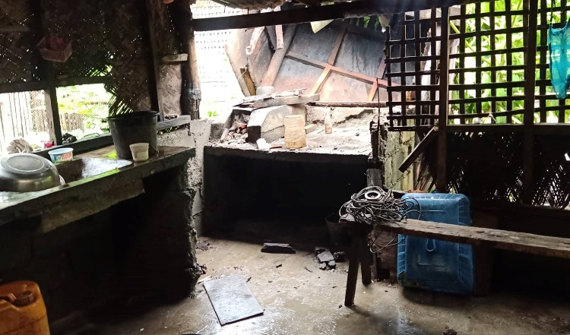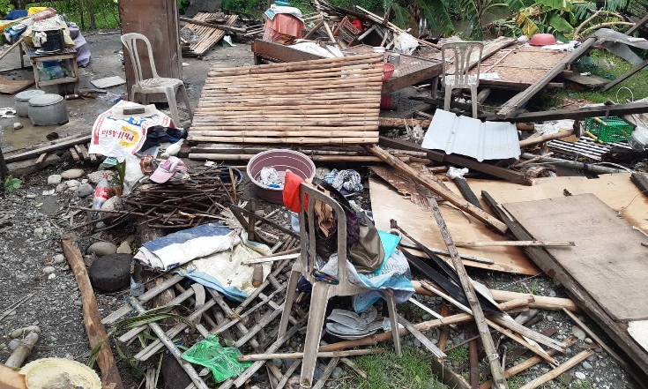
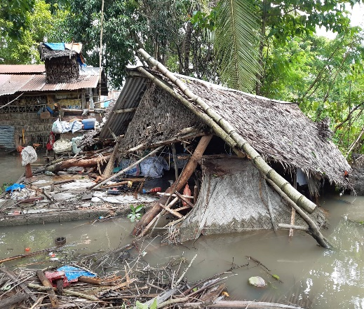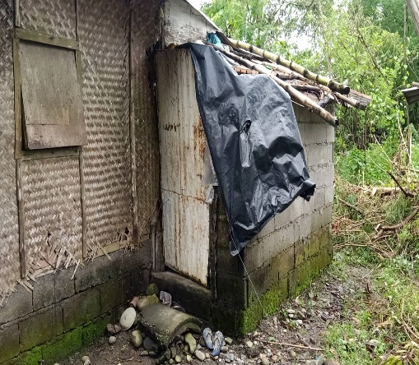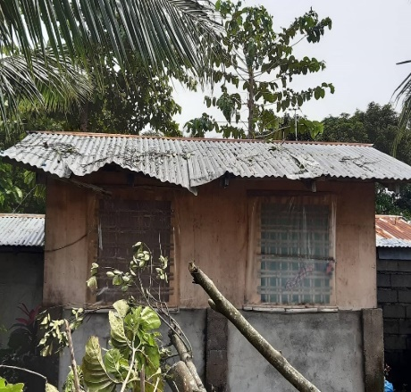
Damaged houses in Brgy. Adela, Rizal, Occidental Mindoro.

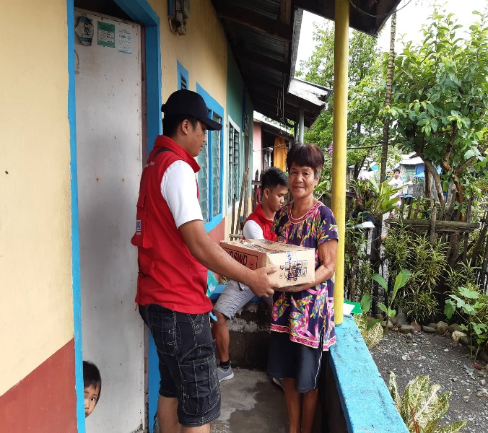
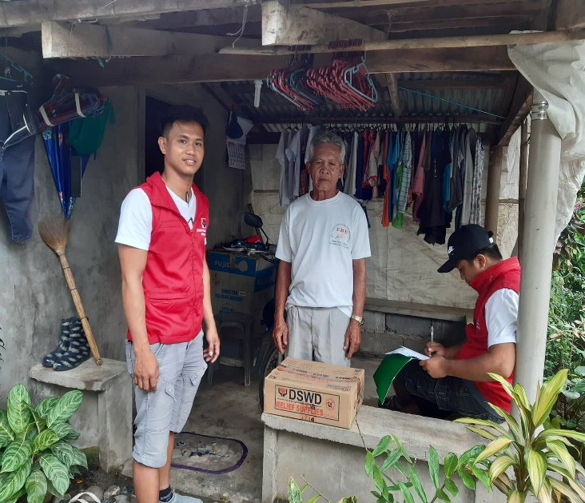
Distribution of Family Food Packs (FFPs) to the affected families.

