DSWD DROMIC Preparedness for Response Report
#1 on Tropical Storm "Ramon"
as of 13 November 2019, 6PM

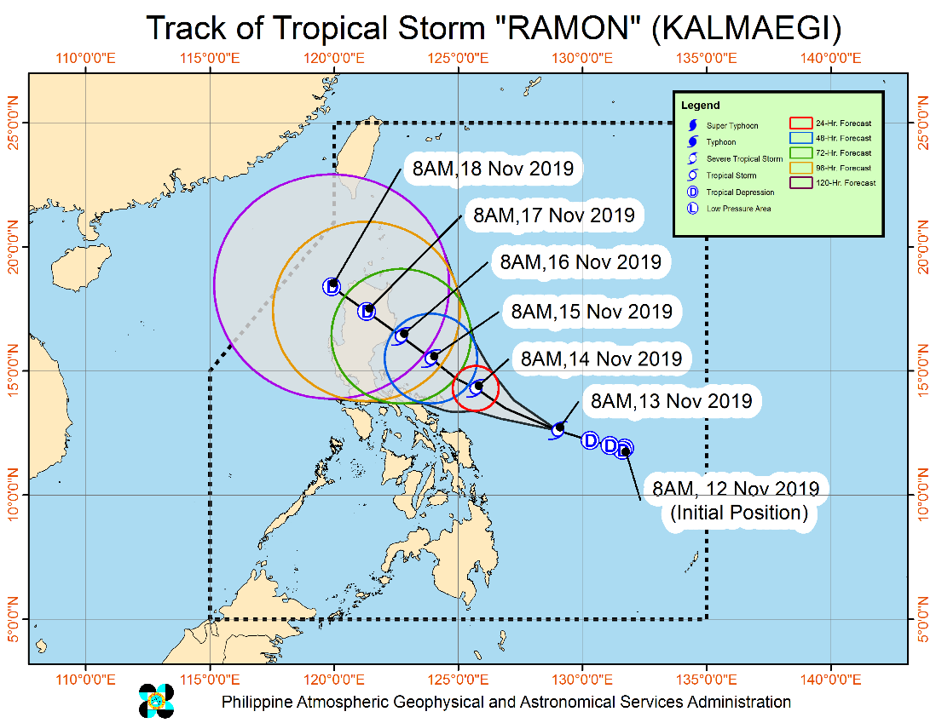
Situation Overview

"RAMON" INTENSIFIES INTO A TROPICAL STORM WHILE MOVING WEST-NORTHWESTWARD.
- "RAMON" intensified into a Tropical Storm at 8:00 AM today.
- Today, light to moderate with occasional heavy rains may be experienced over Catanduanes, Camarines Sur, Albay and Sorsogon. Light to moderate with intermittent heavy rains over Camarines Norte, Masbate, Northern Samar and Eastern Samar.
- Tomorrow, light to moderate with occasional heavy rains may be experienced over the eastern portion of Cagayan, Isabela, and Northern Aurora. Light to moderate with intermittent heavy rains over Bicol Region, Apayao, Quezon, Northern Samar and the rest of Cagayan, Isabela and Aurora.
- Residents in the aforementioned areas, especially those living in areas identified to be highly or very highly susceptible to flooding and rain-induced landslides, are advised to take precautionary measures, coordinate with local disaster risk reduction and management offices, and continue monitoring for updates, especially the Thunderstorm or Rainfall Advisories and Heavy Rainfall Warnings to be issued by PAGASA Regional Services Divisions.
- Sea travel is risky, especially for small sea crafts, over the seaboards of areas under Tropical Cyclone Wind Signal (TCWS), the seaboards of Northern Luzon, and the eastern seaboards of Central and Southern Luzon due to prevailing or forecast rough sea conditions.
At 10:00 AM today, the center of Tropical Storm "RAMON" was estimated based on all available data at 385 km East Northeast of Borongan City, Eastern Samar or 450 km East of Catarman, Northern Samar (12.6 °N, 128.8 °E )
Source: DOST-PAGASA Severe Weather Bulletin
PREDICTIVE ANALYTICS FOR HUMANITARIAN RESPONSE

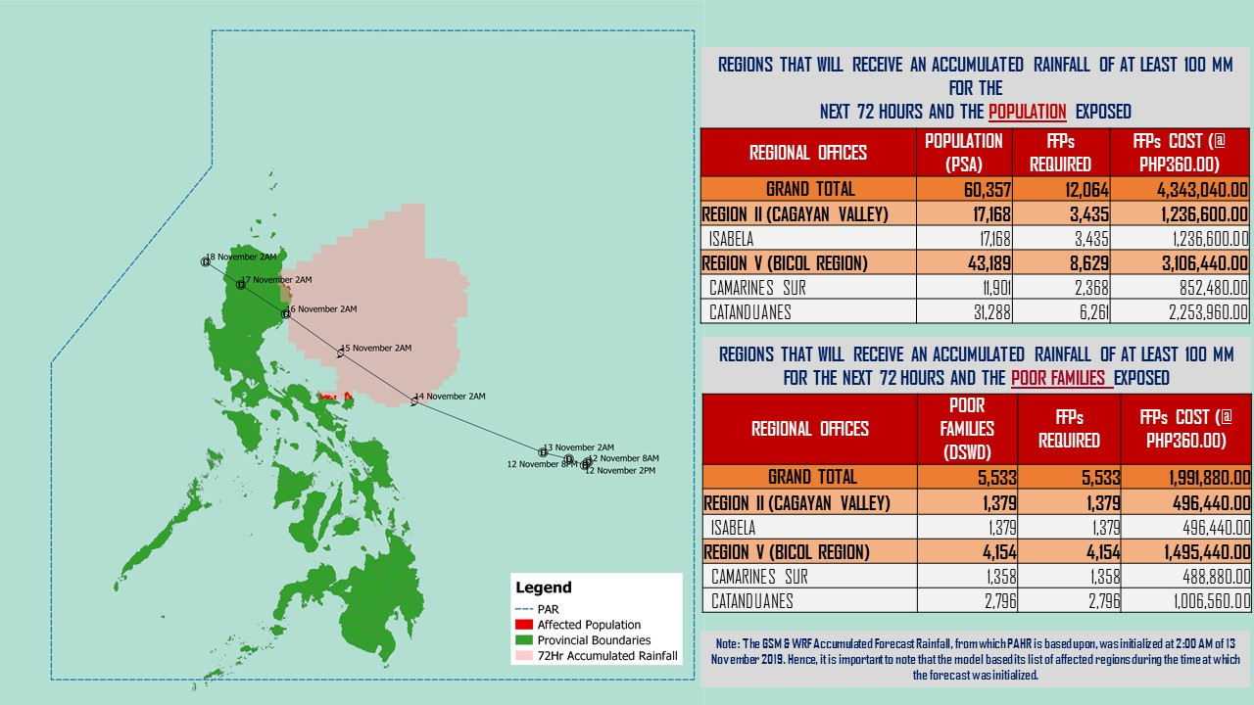

Source: DRMB-DROMIC GIS Specialists
Status of Prepositioned Resources: Stockpile and Standby Funds

The DSWD Central Office (CO), Field Offices (FOs), and National Resource Operations Center (NROC) have stockpiles and standby funds amounting to ₱1,496,207,504.77 with breakdown as follows (see Table 1):

- Standby Funds
A total of ₱698,435,459.36 standby funds in the CO and FOs. Of the said amount, ₱649,940,827.34is the available Quick Response Fund (QRF) in the CO.

- Stockpiles
A total of 294,650 Family Food Packs (FFPs) amounting to ₱113,402,264.79 and available Food and Non-food Items (FNIs) amounting to ₱684,369,780.62.

FIELD OFFICE | STANDBY FUNDS | STOCKPILES |  |  |  |  | Total STANDBY FUNDS & STOCKPILE
 |  | Family Food Packs |  | Other Food Items | Non Food Items | SUB-TOTAL (Food and NFIs)
 |  | Quantity | Total Cost | Total Cost | Total Cost
TOTAL | 698,435,459.36 | 294,650 | 113,402,264.79 | 203,351,101.50 | 481,018,679.12 | 684,369,780.62 | 1,496,207,504.77
Central Office | 649,940,827.34 | 0 | - | - | - | - | 649,940,827.34
NRLMB - NROC | - | 41,355 | 16,742,377.50 | 47,651,978.63 | 253,167,097.15 | 300,819,075.78 | 317,561,453.28
NRLMB - VDRC | - | 0 | - | 7,256,200.00 | 4,090,050.00 | 11,346,250.00 | 11,346,250.00
I | 2,379,275.00 | 16,182 | 7,579,674.78 | 299,455.20 | 37,645,525.20 | 37,944,980.40 | 47,903,930.18
II | 3,559,531.66 | 28,662 | 9,214,300.12 | 998,872.00 | 2,219,096.75 | 3,217,968.75 | 15,991,800.53
III | 3,068,057.00 | 13,073 | 5,221,262.84 | 2,420,969.70 | 7,080,011.65 | 9,500,981.35 | 17,790,301.19
CALABARZON | 3,000,325.00 | 6,405 | 2,264,433.70 | 3,187,954.80 | 6,205,173.91 | 9,393,128.71 | 14,657,887.41
MIMAROPA | 2,379,022.58 | 29,087 | 12,158,366.00 | 697,934.74 | 10,663,131.29 | 11,361,066.03 | 25,898,454.61
V | 3,000,000.00 | 23,143 | 9,025,770.00 | 5,689,296.56 | 27,646,190.47 | 33,335,487.03 | 45,361,257.03
VI | 3,000,000.00 | 20,328 | 7,318,080.00 | 3,840,805.72 | 6,133,853.25 | 9,974,658.97 | 20,292,738.97
VII | 3,002,300.00 | 17,707 | 6,374,520.00 | 10,249,977.14 | 12,087,081.27 | 22,337,058.41 | 31,713,878.41
VIII | 3,755,235.00 | 29,152 | 11,146,890.42 | 3,285,093.94 | 24,286,537.08 | 27,571,631.02 | 42,473,756.44
IX | 3,001,888.85 | 12,047 | 4,336,920.00 | 1,359,070.00 | 15,270,573.64 | 16,629,643.64 | 23,968,452.49
X | 3,000,000.00 | 13,373 | 4,881,567.39 | 101,734,166.36 | 31,257,328.54 | 132,991,494.90 | 140,873,062.29
XI | 3,028,750.00 | 6,681 | 2,414,513.40 | 2,630,400.00 | 8,201,218.31 | 10,831,618.31 | 16,274,881.71
XII | 3,000,701.68 | 4,176 | 1,670,592.00 | 4,714,128.00 | 5,322,796.16 | 10,036,924.16 | 14,708,217.84
CARAGA | 3,000,196.75 | 12,367 | 5,043,509.94 | 2,297,802.56 | 749,790.46 | 3,047,593.02 | 11,091,299.71
NCR | 3,292,543.50 | 6,346 | 2,378,666.64 | 982,611.51 | 10,538,332.60 | 11,520,944.11 | 17,192,154.25
CAR | 3,026,805.00 | 14,566 | 5,630,820.06 | 4,054,384.64 | 18,454,891.39 | 22,509,276.03 | 31,166,901.09
*Quick Response Fund (QRF) as of 12 November 2019

Situational Reports

DSWD-DRMB
DATE | SITUATIONS / ACTIONS UNDERTAKEN
13 November 2019 | - The Disaster Response Management Bureau (DRMB) is on BLUE alert status and is closely coordinating with the concerned field offices for significant disaster response updates  - All QRT members and emergency equipment are on standby and ready for deployment.  - Based on the concluded Pre-Disaster Risk Assessment (PDRA) Meeting, no raising of alert level is advised.

DSWD-FO I
DATE | SITUATIONS / ACTIONS UNDERTAKEN
13 November 2019 | - DSWD-FO I is closely monitoring the possible effects of the Tropical Storm “Ramon”.  - Provincial Operations Offices (POOs) is in close coordination with the different Provincial/City/Municipal Disaster Risk Reduction and Management Councils (P/C/MDRRMCs) who are currently monitoring the adverse effects that might be brought by the weather disturbance.

DSWD-FO CALABARZON
DATE | SITUATIONS / ACTIONS UNDERTAKEN
13 November 2019 | - DSWD-FO CALABARZON Emergency Operation Center is already activated to monitor the possible effects of Tropical Storm “Ramon”.  - DSWD-FO CALABARZON is continuously coordinating with the concerned LSWDOs with pre-disaster being conducted.  - DSWD-FO CALABARZON coordinated with SWAD Team Leaders and Provincial Action Team of the CALABARZON and advised them to monitor and coordinate with the LGUs to gather reports on the possible effects of Tropical Storm “Ramon”.

DSWD-FO MIMAROPA
DATE | SITUATIONS / ACTIONS UNDERTAKEN
13 November 2019 | - DSWD-FO MIMAROPA alerted all P/C/M QRT in five provinces of MIMAROPA to regularly monitor the situations in the area.  - DSWD-FO MIMAROPA is in close coordination with the Office of Civil Defense and RDDRMC MIMAROPA for any warning signal updates.  - All members of Rapid Emergency Telecommunications Team are on on-call and standby status ready for deployment if needed.  - DSWD-FO MIMAROPA Ensured that the Rapid Emergency Telecommunications Equipment (GX Terminal, BGAN Terminals and Satellite Phones) are in good condition and ready for deployment to areas that will experience potential emergencies.  - DSWD-FO MIMAROPA Ensured that there is an on-call truck available for delivery of goods and equipment to areas that will be affected

DSWD-FO V
DATE | SITUATIONS / ACTIONS UNDERTAKEN
- November 2019 | - DSWD-FO V is on BLUE alert level status.  - DSWD-FO V is continuously monitoring weather updates and information.  - DSWD-FO V Resource Operation Section ensures the availability of family food packs and non-food items as need arises.  - DSWD-FO V QRTs were alerted and advised to be prepared for augmentation support needed from the field and/or 24/7 duty at the DRMD Operation Center.  - DSWD-FO V PAT and MAT members in the 6 provinces are on standby and were instructed to coordinate with the P/MDRRMOs for status reports and updates.

DSWD-FO CAR
DATE | SITUATIONS / ACTIONS UNDERTAKEN
- November 2019 | - DSWD-FO CAR is continuously monitoring the situation on ground.  - Municipal Action Teams are on alert and on standby.  - Rapid Emergency Telecommunications Team (RETT) including the International Maritime/Marine Satellite (INMARSAT) equipment are on standby.  - The Operations Center is on BLUE alert in accordance to the alert level status of Cordillera Regional Disaster Risk Reduction and Management Council (CRDRRMC).

*****
The Disaster Response Operations Monitoring and Information Center (DROMIC) of the DSWD-DRMB is closely monitoring the effects of TS Ramon and is coordinating with the concerned DSWD-Field Offices for any significant updates.

PREPARED BY:

MARIEL B. FERRARIZ

LESLIE R. JAWILI
Releasing Officer

