DSWD DROMIC Preparedness for Response Report
#1 on Tropical Storm "Sarah"
as of 20 November 2019, 6PM

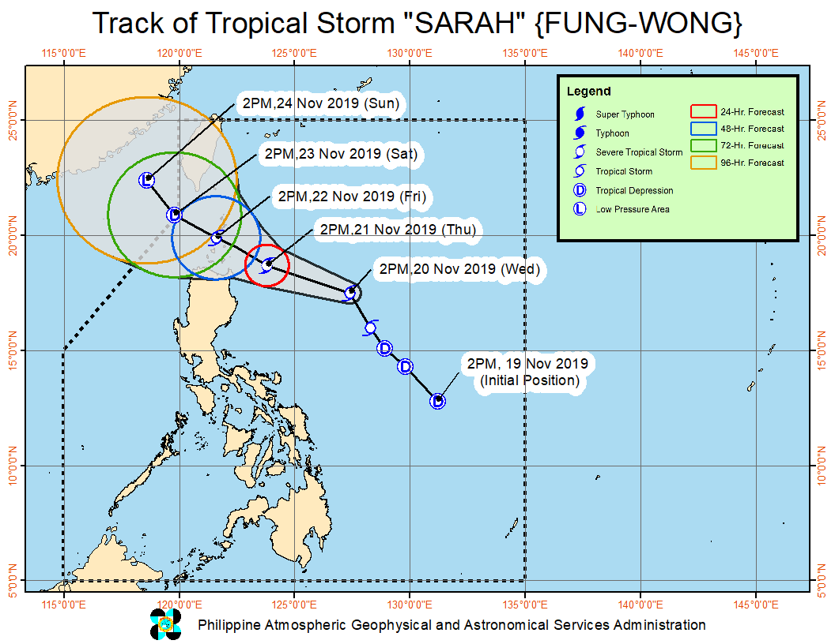
Situation Overview

At 4:00 PM today, the center of Tropical Storm (TS) "SARAH" was estimated based on all available data at 540 km East of Tuguegarao City, Cagayan (17.9°N, 126.8°E). TS "Sarah" slightly accelerates while maintaining its strength.
- Tropical Cyclone Wind Signal (TCWS) #1 has been lifted over the northeastern portion of Isabela and the southeastern portion of Cagayan.
- Rainfall outlook for tonight: light to moderate with occasional heavy rains over Batanes, Cagayan including Babuyan Islands, Apayao, and the northern portion of Ilocos Norte. Light to moderate with intermittent heavy rains over Ilocos Sur, Abra, Kalinga, Mt. Province, Ifugao, Isabela, La Union, Benguet and the rest of Ilocos Norte.
- Residents in the aforementioned areas, especially those living in areas identified to be highly or very highly susceptible to flooding and rain-induced landslides, are advised to take appropriate actions, coordinate with local disaster risk reduction and management offices, and continue monitoring for updates, especially the Thunderstorm or Rainfall Advisories and Heavy Rainfall Warnings to be issued by PAGASA Regional Services Divisions.
- Sea travel is risky, especially for small sea crafts, over the seaboards of areas under TCWS, seaboards of Northern and Central Luzon and the western seaboard of Southern Luzon due to prevailing or forecast rough sea conditions caused by TS “SARAH” and the Northeast Monsoon.
Source: DOST-PAGASA Severe Weather Bulletin
PREDICTIVE ANALYTICS FOR HUMANITARIAN RESPONSE

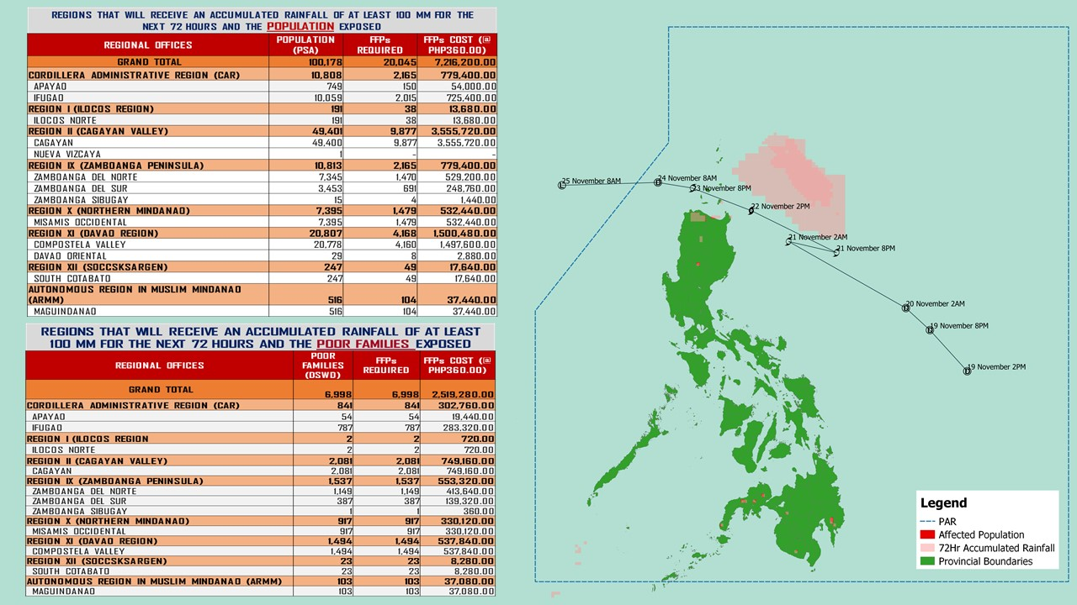

Source: DRMB-DROMIC GIS Specialists
Status of Prepositioned Resources: Stockpile and Standby Funds

The DSWD Central Office (CO), Field Offices (FOs), and National Resource Operations Center (NROC) have stockpiles and standby funds amounting to ₱1,369,837,443.05 with breakdown as follows (see Table 1):

- Standby Funds
A total of ₱589,436,668.77 standby funds in the CO and FOs. Of the said amount, ₱548,990,071.00 is the available Quick Response Fund (QRF) in the CO.

- Stockpiles
A total of 306,006 family food packs (FFPs) amounting to ₱116,117,670.78 and available food and non-food items (FNIs) amounting to ₱664,283,103.50.

FIELD OFFICE | STANDBY FUNDS | STOCKPILES |  |  |  |  | Total STANDBY FUNDS & STOCKPILE
 |  | FAMILY FOOD PACKS |  | Other Food Items | Non Food Items | SUB-TOTAL (Food and NFIs)
 |  | Quantity | Total Cost | Total Cost | Total Cost
TOTAL | 589,436,668.77 | 306,006 | 116,117,670.78 | 205,277,471.59 | 459,005,631.91 | 664,283,103.50 | 1,369,837,443.05
Central Office* | 548,990,071.00 | - | - | - | - | - | 548,990,071.00
NRLMB - NROC | - | 33,669 | 14,374,980.02 | 44,209,878.31 | 253,324,826.40 | 297,534,704.71 | 311,909,684.73
NRLMB - VDRC | - | - | - | 7,256,200.00 | 4,090,050.00 | 11,346,250.00 | 11,346,250.00
I | 2,379,275.00 | 19,538 | 7,148,466.58 | 299,455.20 | 37,645,525.20 | 37,944,980.40 | 47,472,721.98
II | 3,559,531.66 | 25,238 | 8,051,342.04 | 639,602.00 | 3,418,408.75 | 4,058,010.75 | 15,668,884.45
III | 3,068,057.00 | 12,631 | 5,054,566.96 | 2,420,969.70 | 7,079,253.90 | 9,500,223.60 | 17,622,847.56
CALABARZON | 1,785,325.00 | 6,405 | 2,264,433.70 | 3,187,954.80 | 5,523,160.91 | 8,711,115.71 | 12,760,874.41
MIMAROPA | 3,046,722.58 | 29,087 | 12,158,366.00 | 697,934.74 | 10,663,131.29 | 11,361,066.03 | 26,566,154.61
V | 3,000,000.00 | 23,143 | 9,025,770.00 | 5,689,296.56 | 27,595,439.69 | 33,284,736.25 | 45,310,506.25
VI | 2,040,000.00 | 13,828 | 4,978,080.00 | 3,840,535.67 | 5,285,253.00 | 9,125,788.67 | 16,143,868.67
VII | 752,800.00 | 14,455 | 5,203,800.00 | 11,401,656.30 | 11,950,331.27 | 23,351,987.57 | 29,308,587.57
VIII | 3,755,235.00 | 24,952 | 9,485,562.42 | 3,285,093.94 | 24,068,382.08 | 27,353,476.02 | 40,594,273.44
IX | 3,001,888.85 | 12,047 | 4,336,920.00 | 1,359,070.00 | 15,443,104.14 | 16,802,174.14 | 24,140,982.99
X | 3,000,000.00 | 15,091 | 5,515,032.00 | 104,919,180.78 | 13,257,041.80 | 118,176,222.58 | 126,691,254.58
XI | 322,644.00 | 33,481 | 12,100,033.40 | 3,875,600.00 | 5,285,389.50 | 9,160,989.50 | 21,583,666.90
XII | 1,415,770.18 | 5,923 | 2,371,139.00 | 5,518,659.00 | 4,938,296.16 | 10,456,955.16 | 14,243,864.34
CARAGA | 3,000,000.00 | 16,083 | 6,032,304.90 | 1,947,237.00 | 749,790.46 | 2,697,027.46 | 11,729,332.36
NCR | 3,292,543.50 | 6,346 | 2,378,666.64 | 982,611.51 | 10,538,332.60 | 11,520,944.11 | 17,192,154.25
CAR | 3,026,805.00 | 14,089 | 5,638,207.12 | 3,746,536.08 | 18,149,914.76 | 21,896,450.84 | 30,561,462.96
*Quick Response Fund (QRF) as of 15 November 2019

Situational Reports

DSWD-DRMB
DATE | SITUATIONS / ACTIONS UNDERTAKEN
20 November 2019 | - The Disaster Response Management Bureau (DRMB) is on BLUE alert status and is closely coordinating with the concerned field offices for significant disaster response updates  - All QRT members and emergency equipment are on standby and ready for deployment.

DSWD-FO I
DATE | SITUATIONS / ACTIONS UNDERTAKEN
20 November 2019 | - DSWD-FO I is closely monitoring the possible effects of the TS “Sarah”.  - Provincial Operations Offices (POOs) are in close coordination with the different Provincial/City/Municipal Disaster Risk Reduction and Management Councils (P/C/MDRRMCs) to monitor the adverse effects of TS “Sarah” that might be brought by the weather disturbance.

DSWD-FO MIMAROPA
DATE | SITUATIONS / ACTIONS UNDERTAKEN
20 November 2019 | - DSWD-FO MIMAROPA alerted all P/C/M QRT in five provinces of MIMAROPA to regularly monitor the situations in the area.  - DSWD-FO MIMAROPA is in close coordination with the Office of Civil Defense and RDDRMC MIMAROPA for any warning signal updates.  - All members of Rapid Emergency Telecommunications Team are on on-call and standby status ready for deployment if needed.  - DSWD-FO MIMAROPA ensured that the Rapid Emergency Telecommunications Equipment (GX Terminal, BGAN Terminals and Satellite Phones) are in good condition and ready for deployment to areas that will experience potential emergencies.  - DSWD-FO MIMAROPA ensured that there is an on-call truck available for delivery of goods and equipment to areas that will be affected.

DSWD-FO VIII
DATE | SITUATIONS / ACTIONS UNDERTAKEN
20 November 2019 | - DSWD-FO VIII Disaster Response Management Division -Disaster Response Information Management Section (DRMD-DRIMS) is monitoring the weather situation and is in close coordination with SWADTs, QRTs and PDOs for any eventualities on the ground.  - All Quick Response Team (QRT) members and DRMD staff are alerted in case augmentation is needed.  - Regional Resource Operation Section (RROS) is also alerted to ensure the readiness of dispatching the food and non-food commodities.

DSWD-FO CAR
DATE | SITUATIONS / ACTIONS UNDERTAKEN
20 November 2019 | - DSWD-FO CAR is continuously monitoring the situation on the ground.  - Municipal Action Teams are on alert and on standby.  - Rapid Emergency Telecommunications Team (RETT) including the INMARSAT equipment are on standby.  - The Operations Center is on RED alert in accordance to the alert level status of Cordillera Regional Disaster Risk Reduction and Management Council (CRDRRMC).

*****
The Disaster Response Operations Monitoring and Information Center (DROMIC) of the DSWD-DRMB is closely monitoring the effects of TS Sarah and is coordinating with the concerned DSWD Field Offices for any significant updates.

PREPARED BY:

CLARRIE MAE A. CASTILLO
MARIEL B. FERRARIZ

MARC LEO L. BUTAC
Releasing Officer

