DSWD DROMIC Preparedness for Response Report
#2 on Typhoon "TISOY"
as of 29 November 2019, 6PM

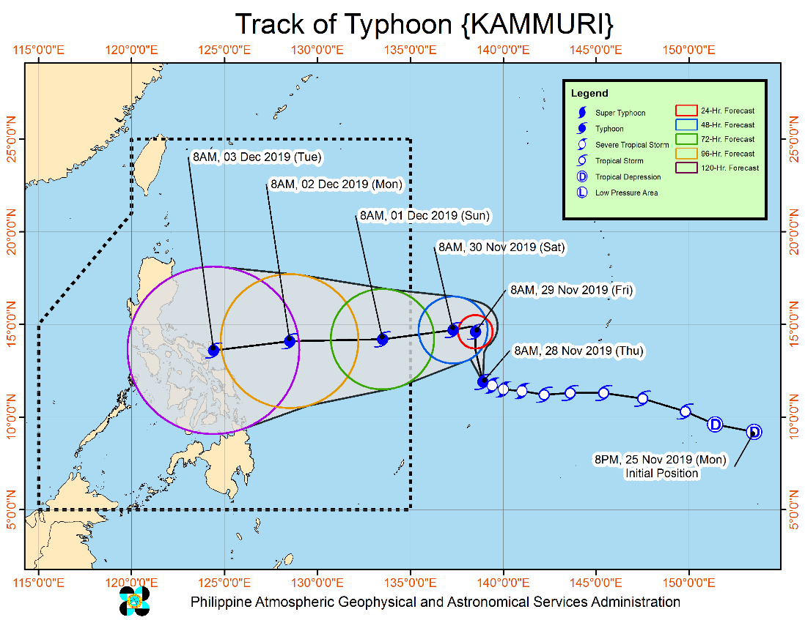
Situation Overview

The center of Typhoon "KAMMURI" was estimated based on all available data at 1,430 km East of Visayas (Outside PAR) (11.9°N,138.8°E). "KAMMURI" intensifies into a Typhoon as it slows down while moving west-northwestward. "KAMMURI" is forecast to enter the Philippine Area of Responsibility (PAR) between Saturday evening (30 November) and Sunday (01 December) morning and will be named "TISOY" as the 20th Philippine tropical cyclone for 2019. Tropical Cyclone Wind Signal #1 may be raised over the eastern portion of Bicol Region-Eastern Visayas area on Sunday. Disruption of maritime travel may be experienced in these areas. Steady intensification is likely throughout the forecast period. The outer rainbands of "KAMMURI" may bring scattered rains and thunderstorms over Bicol Region and Eastern Visayas on Monday (02 December).
Source: DOST-PAGASA Severe Weather Bulletin

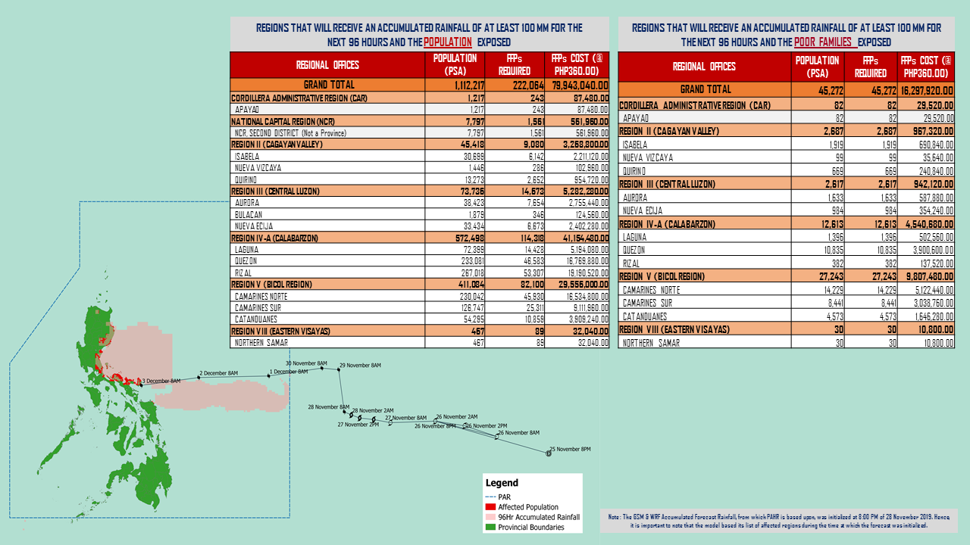
PREDICTIVE ANALYTICS FOR HUMANITARIAN RESPONSE

Prepared by: DRMB-DROMIC GIS Specialists
Status of Prepositioned Resources: Stockpile and Standby Funds

The DSWD Central Office (CO), Field Offices (FOs), and National Resource Operations Center (NROC) have stockpiles and standby funds amounting to ₱1,353,912,860.63 with breakdown as follows (see Table 1):

- Standby Funds
A total of ₱586,890,340.46 standby funds in the CO and FOs. Of the said amount, ₱548,990,071.00 is the available Quick Response Fund (QRF) in the CO.

- Stockpiles
A total of 299,489 family food packs (FFPs) amounting to ₱115,375,181.72 and available food and non-food items (FNIs) amounting to ₱651,647,338.45.

FIELD OFFICE | STANDBY FUNDS | FAMILY FOOD PACKS |  | Other Food Items | Non Food Items | SUB-TOTAL (Food and NFIs) | Total STANDBY FUNDS & STOCKPILE
 |  | Quantity | Total Cost | Total Cost | Total Cost
TOTAL | 586,890,340.46 | 299,489 | 115,375,181.72 | 198,892,269.76 | 452,755,068.69 | 651,647,338.45 | 1,353,912,860.63
Central Office | 548,990,071.00 | 0 | - | - | - | - | 548,990,071.00
NRLMB - NROC | - | 36,718 | 15,509,556.20 | 43,155,892.91 | 246,903,110.99 | 290,059,003.90 | 305,568,560.10
NRLMB - VDRC | - | 0 | - | 7,256,200.00 | 4,090,050.00 | 11,346,250.00 | 11,346,250.00
I | 2,379,275.00 | 14,303 | 5,178,166.58 | 299,455.20 | 37,645,525.20 | 37,944,980.40 | 45,502,421.98
II | 3,564,703.35 | 26,940 | 10,550,187.76 | 639,602.00 | 3,514,865.95 | 4,154,467.95 | 18,269,359.06
III | 3,068,057.00 | 12,629 | 5,053,812.68 | 2,420,969.70 | 6,042,738.40 | 8,463,708.10 | 16,585,577.78
CALABARZON | 1,785,325.00 | 6,405 | 2,264,433.70 | 3,187,954.80 | 5,523,160.91 | 8,711,115.71 | 12,760,874.41
MIMAROPA | 3,046,722.58 | 29,087 | 12,158,366.00 | 697,934.74 | 10,663,131.29 | 11,361,066.03 | 26,566,154.61
V | 3,000,000.00 | 23,140 | 9,024,600.00 | 5,689,296.56 | 27,591,623.94 | 33,280,920.50 | 45,305,520.50
VI | 2,040,000.00 | 13,828 | 4,978,080.00 | 3,840,535.67 | 5,285,253.00 | 9,125,788.67 | 16,143,868.67
VII | 752,800.00 | 12,565 | 4,523,400.00 | 11,682,706.50 | 11,950,331.27 | 23,633,037.77 | 28,909,237.77
VIII | 1,203,735.00 | 18,960 | 7,169,851.74 | 3,285,093.94 | 24,068,382.08 | 27,353,476.02 | 35,727,062.76
IX | 3,001,888.85 | 13,322 | 4,795,920.00 | 2,453,920.00 | 15,492,234.14 | 17,946,154.14 | 25,743,962.99
X | 3,000,000.00 | 17,823 | 6,498,552.00 | 97,334,812.23 | 13,481,175.80 | 110,815,988.03 | 120,314,540.03
XI | 322,644.00 | 33,481 | 12,100,033.40 | 3,875,600.00 | 5,285,389.50 | 9,160,989.50 | 21,583,666.90
XII | 1,415,770.18 | 5,923 | 2,371,139.00 | 6,482,259.00 | 5,918,551.16 | 12,400,810.16 | 16,187,719.34
CARAGA | 3,000,000.00 | 15,325 | 5,782,957.50 | 1,947,237.00 | 685,755.46 | 2,632,992.46 | 11,415,949.96
NCR | 3,292,543.50 | 6,346 | 2,378,666.64 | 982,611.51 | 10,538,332.60 | 11,520,944.11 | 17,192,154.25
CAR | 3,026,805.00 | 12,694 | 5,037,458.52 | 3,660,188.00 | 18,075,457.00 | 21,735,645.00 | 29,799,908.52
*Quick Response Fund (QRF) as of 28 November 2019

Situational Reports

DSWD-DRMB
DATE | SITUATIONS / ACTIONS UNDERTAKEN
29 November 2019 | - The Disaster Response Management Bureau (DRMB) is on BLUE alert status and is closely coordinating with the concerned field offices for significant disaster response updates  - All QRT members and emergency equipment are on standby and ready for deployment.

DSWD-FO NCR
DATE | SITUATIONS / ACTIONS UNDERTAKEN
29 November 2019 | - DSWD-FO NCR composed of organic staff from the Field Office and Centers and Residential Care Facilities (C/RCFs) are activated and on standby in response to any eventualities. The assignment of said staff is scheduled per day.  - The DSWD-NCR has established its EOC located at Room 109, FO-NCR, Sampaloc, Manila.

DSWD-FO I
DATE | SITUATIONS / ACTIONS UNDERTAKEN
29 November 2019 | - DSWD-FO I is closely monitoring the possible effects of Severe Tropical Storm “KAMMURI”, even outside PAR, and in close coordination with the Office of Civil Defense (OCD) Region I.  - Provincial Operations Offices (POOs) are in close coordination with the different Provincial/City/Municipal Disaster Risk Reduction and Management Councils (P/C/MDRRMCs) and Provincial/City/Municipal Social Welfare and Development Offices (P/C/MSWDOs) to monitor the adverse effects that might be brought by the weather disturbance.

DSWD-FO CALABARZON
DATE | SITUATIONS / ACTIONS UNDERTAKEN
29 November 2019 | - DSWD-FO CALABARZON Emergency Operations Center is already activated to monitor the possible effects of TY Kammuri.  - DSWD-FO CALABARZON has constant communication with the Local Social Welfare and Development Offices (LSWDOs) with pre-disaster assessments being conducted.  - DSWD-FO CALABARZON is in close coordination with the Local Government Units (LGUs) with regards to the preparedness efforts undertaken in the Flood, Landslide and Storm Surge prone areas.  - DSWD-FO CALABARZON coordinated with SWAD Team Leaders and Provincial Action Team of the CALABARZON and advised them to monitor and coordinate with the LGUs to gather reports on the possible effects of Typhoon Kammuri.  - DSWD-FO CALABARZON have coordinated with the Administrative Division to ensure that the Disaster Response Vehicle and the six-wheeler wing van is readily available to transport personnel and goods to disaster-stricken areas should need arises.

DSWD-FO MIMAROPA
DATE | SITUATIONS / ACTIONS UNDERTAKEN
28 November 2019 | - DSWD-FO MIMAROPA alerted all P/C/M QRT in five provinces of MIMAROPA to regularly monitor the situations in the area.  - DSWD-FO MIMAROPA is in close coordination with the Office of Civil Defense and RDDRMC MIMAROPA for any warning signal updates.  - All members of Rapid Emergency Telecommunications Team are on on-call and standby status ready for deployment if needed.  - DSWD-FO MIMAROPA ensured that the Rapid Emergency Telecommunications Equipment (GX Terminal, BGAN Terminals and Satellite Phones) are in good condition and ready for deployment to areas that will experience potential emergencies.  - DSWD-FO MIMAROPA ensured that there is an on-call truck available for delivery of goods and equipment to areas that will be affected.

DSWD-FO V
DATE | SITUATIONS / ACTIONS UNDERTAKEN
29 November 2019 | - DSWD-FO V is continuously monitoring weather updates and information.  - Resource Operation Section ensures the availability of family food packs and non-food items as need arises.  - DSWD-FO V QRTs were alerted and advised to be prepared for augmentation support needed from the field and/or 24/7 duty at the DRMD Operation Center.  - PAT and MAT members in the 6 provinces are on standby and were instructed to coordinate with the P/MDRRMOs for status reports and updates.

DSWD-FO VIII
DATE | SITUATIONS / ACTIONS UNDERTAKEN
28 November 2019 | - DSWD-FO VIII Disaster Response Management Division -Disaster Response Information Management Section (DRMD-DRIMS) is monitoring the weather situation and is in close coordination with SWADTs, QRTs and PDOs for any eventualities on the ground.  - All Quick Response Team (QRT) members and DRMD staff are alerted in case augmentation is needed.  - Regional Resource Operation Section (RROS) is also alerted to ensure the readiness of dispatching the food and non-food commodities.

DSWD-FO CAR
DATE | SITUATIONS / ACTIONS UNDERTAKEN
29 November 2019 | - Quick Response Teams (QRT), Provincial Social Welfare and Development Teams (PSWADT), Municipal Action Teams (MAT) are on alert and on standby.  - Rapid Emergency Telecommunications Team (RETT) including the INMARSAT equipment are on standby.  - The Operations Center is on BLUE alert in accordance to the alert level status of Cordillera Regional Disaster Risk Reduction and Management Council (CRDRRMC).  - DSWD-FO CAR coordinated with the OCD re list of barangays with High and Moderate Landslide Susceptibility and barangays with Very High, High and Moderate Flood Susceptibility.  - DSWD-FO CAR Mapped the Landslide Susceptibility listed barangays from MGB through the OCD CAR.

*****
The Disaster Response Operations Monitoring and Information Center (DROMIC) of the DSWD-DRMB is closely monitoring the effects of TS Sarah and is coordinating with the concerned DSWD Field Offices for any significant updates.

Prepared by:

CLARRIE MAE A. CASTILLO
MARIEL B. FERRARIZ
DIANE C. PELEGRINO

RODEL V. CABADDU
Releasing Officer

