DSWD DROMIC Report #1 on the
Mw 5.9 Earthquake Incident in Kadingilan, Bukidnon
as of 20 November 2019, 6PM

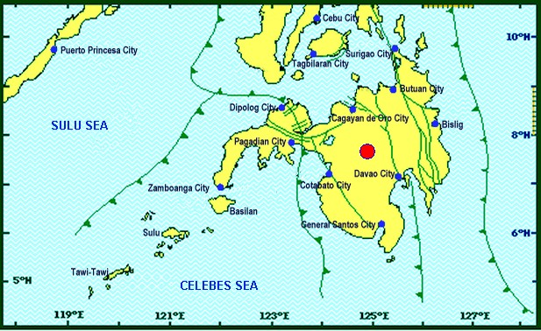

Situation Overview

On 18 November 2019 at 09:22 PM, a 5.9 moment magnitude (Mw) earthquake jolted the municipality of Kadingilan, Bukidnon (07.66°N, 124.89°E - 008 km N 24°W) with a tectonic origin and a depth of focus of 5 km. The earthquake was also felt in the neighboring municipalities of Bukidnon.

Date/Time: | 18 Nov 2019 - 09:22:08 PM
Reported Intensities: | Intensity VI - Kadingilan, Kalilangan, Don Carlos, Maramag, Kitaotao and San Fernando, Bukidnon  Intensity V - Damulog, Talakag and Valencia City, Bukidnon; Midsayap, Cotabato; Kidapawan  City; Marawi City  Intensity IV - Impasugong and Malaybalay, Bukidnon; Malungon, Sarangani; Antipas, Cotabato,  Rosario, Agusan Del Sur; Cotabato City; Davao City; Koronadal City; Cagayan De Oro City  Intensity III - Malitbog, Bukidnon; Tupi, South Cotabato; Manticao, Misamis Oriental; Tubod and  Bacolod, Lanao Del Norte; Alabel, Sarangani; Gingoog City; Pagadian City; Iligan City  Intensity II - Polomolok, Lake Sebu and Tampakan, South Cotabato; Kiamba, Sarangani;  Mambajao, Camiguin; Sindangan and Polanco, Zamboanga Del Norte; Molave, Zamboanga Del  Sur; Dipolog City; General Santos City  Intensity I - Zamboanga City  Instrumental Intensities:  Intensity IV - Cagayan De Oro City; Kidapawan City; Koronadal City; Malungon, Sarangani  Intensity III - Gingoog City; Davao City; Tupi, South Cotabato; Alabel, Sarangani  Intensity II - Kiamba, Sarangani; General Santos City  Intensity I - Zamboanga City; Bislig City
Expecting Damage: | YES
Expecting Aftershocks: | YES
Source: DOST-PHIVOLCS Earthquake Bulletin

- Status of Affected Families / Persons
A total of 501 families or 2,177 persons were affected by the earthquake incident in 15 barangays in Region X (see Table 1).

Table 1. Number of Affected Families / Person
REGION / PROVINCE / MUNICIPALITY |  | NUMBER OF AFFECTED
 |  | Barangay | Families | Persons
GRAND TOTAL |  | 15 | 501 | 2,177
REGION X |  | 15 | 501 | 2,177
Bukidnon |  | 15 | 501 | 2,177
 | Dangcagan | 7 | 66 | 330
 | Don Carlos | 1 | 164 | 492
 | Kadingilan | 7 | 271 | 1,355
Note: Ongoing assessment and validation being conducted.
Source: DSWD-FO X

- Status of Displaced Families / Persons
- Inside Evacuation Center
There are 164 families or 492 persons taking temporary shelter in Don Carlos Gymnasium in Don Carlos, Bukidnon (see Table 2).

Table 2. Number of Displaced Families / Persons Inside Evacuation Centers
REGION / PROVINCE / MUNICIPALITY |  | NUMBER OF EVACUATION CENTERS (ECs) |  | NUMBER OF DISPLACED
 |  |  |  | INSIDE ECs
 |  |  |  | Families |  | Persons
 |  | CUM | NOW | CUM | NOW | CUM | NOW
GRAND TOTAL |  | 1 | 1 | 164 | 164 | 492 | 492
REGION X |  | 1 | 1 | 164 | 164 | 492 | 492
Bukidnon |  | 1 | 1 | 164 | 164 | 492 | 492
 | Don Carlos | 1 | 1 | 164 | 164 | 492 | 492
Note: Ongoing assessment and validation being conducted.
Source: DSWD-FO X

- Damaged Houses
There are 271 damaged houses; of which, 37 are totally damaged and 234 are partially damaged (see Table 4).

Table 4. Number of Damaged Houses
REGION / PROVINCE / MUNICIPALITY |  | NO. OF DAMAGED HOUSES
 |  | Total | Totally | Partially
GRAND TOTAL |  | 271 | 37 | 234
REGION X |  | 271 | 37 | 234
Bukidnon |  | 271 | 37 | 234
 | Kadingilan | 271 | 37 | 234
Note: Ongoing assessment and validation being conducted for the partially and totally damaged houses in Dangcagan, Bukidnon.
Source: DSWD-FO X

Situational Reports

DSWD-DRMB
DATE | SITUATIONS / ACTIONS UNDERTAKEN
20 November 2019 | - The Disaster Response Management Bureau (DRMB) is closely coordinating with DSWD-FO X for significant disaster response updates.  - All QRT members and emergency equipment are on standby and ready for deployment.  - DRMB-DROMIC Operations Center is on BLUE ALERT status.

DSWD-FO X
DATE | ACTION(S) TAKEN
20 November 2019 | - DSWD-FO X through the Disaster Response Management Division (DRMD) headed by the Division Chief and four of the Field Office staff went to the area for a Damage Assessment and Needs Analysis.  - DSWD-FO X is in constant monitoring with the situation on the ground and is in close coordination with the respective Provincial/City/Municipal/Local Disaster Risk Reduction and Management Offices (P/C/M/LDRRMOs) and Social Welfare and Development Team Leader (SWADTL) of each province in the region.

*****
The Disaster Response Operations Monitoring and Information Center (DROMIC) of the DSWD-DRMB is closely coordinating with DSWD Field Offices for any significant disaster response updates.

Prepared by:

DIANE C. PELEGRINO

MARC LEO L. BUTAC
Releasing Officer

