DSWD DROMIC Report #3 on the Effects of
Tail-End of a Cold Front Enhanced by STS “QUIEL”
as of 09 November 2019, 6PM

SITUATION OVERVIEW

On 05 November 2019, the Tropical Depression West Southwest of Iba, Zambales has entered the Philippine Area of Responsibility (PAR) and was named “Quiel”. It has intensified into a Tropical Storm on the same day while moving eastward. “Quiel” and the Tail-End of a Cold Front brought moderate with occasional heavy rains over Northern Luzon particularly in Ilocos Region, Batanes, Cagayan and Apayao. On 07 November 2019, “Quiel” has intensified into a Severe Tropical Storm (STS) while moving slowly eastward. It became a Typhoon on 08 November 2019 as it moved southwestward. It exited PAR today and the Tail-End of a Cold Front continues to affect Northern Luzon.

Source: PAGASA Severe Weather Bulletin

- Status of Affected Families / Persons
20,416 families or 84,635 persons were affected by the Effects of a Tail-End of a Cold Front enhanced by STS “Quiel” in 220 barangays in Regions I, II and CAR (see Table 1).

Table 1. Affected Families / Persons
REGION / PROVINCE / MUNICIPALITY |  | NUMBER OF AFFECTED
 |  | Barangay | Families | Persons
GRAND TOTAL |  | 220 | 20,416 | 84,635
REGION I |  | 4 | 227 | 908
Ilocos Norte |  | 4 | 227 | 908
 | Paoay | 4 | 227 | 908
REGION II |  | 180 | 19,567 | 81,524
Cagayan |  | 180 | 19,567 | 81,524
 | Abulug | 20 | 4,717 | 21,158
 | Allacapan | 18 | 3,120 | 12,501
 | Aparri | 14 | 3,661 | 14,617
 | Baggao | 1 | 10 | 35
 | Ballesteros | 3 | 40 | 119
 | Camalaniugan | 21 | 837 | 3,466
 | Claveria | 34 | 2,262 | 9,345
 | Gonzaga | 2 | 18 | 81
 | Lal-lo | 7 | 648 | 3,185
 | Lasam | 8 | 284 | 1,714
 | Pamplona | 17 | 1,092 | 3,856
 | Sanchez-Mira | 14 | 2,038 | 8,150
 | Santa Ana | 2 | 186 | 599
 | Santa Praxedes | 10 | 159 | 634
 | Santa Teresita | 9 | 495 | 2,064
CAR |  | 36 | 622 | 2,203
Apayao |  | 36 | 622 | 2,203
 | Conner | 2 | 16 | 66
 | Flora | 9 | 215 | 744
 | Kabugao (capital) | 2 | 49 | 175
 | Luna | 9 | 106 | 339
 | Pudtol | 7 | 60 | 237
 | Santa Marcela | 7 | 176 | 642
Note: Ongoing assessment and validation being conducted.
Source: DSWD-FOs I, II and CAR

- Status of Displaced Families / Persons
- Inside Evacuation Centers
There are 937 families or 3,551 persons taking temporary shelter in 41 evacuation centers in Regions II and CAR (see Table 2).

Table 2. Status of Displaced Families / Persons Inside Evacuation Centers
REGION / PROVINCE / MUNICIPALITY |  | NUMBER OF EVACUATION CENTERS (ECs) |  | INSIDE ECs
 |  |  |  | Families |  | Persons
 |  | CUM | NOW | CUM | NOW | CUM | NOW
GRAND TOTAL |  | 80 | 41 | 1,580 | 937 | 5,863 | 3,551
REGION II |  | 60 | 28 | 1,384 | 780 | 5,157 | 2,978
Cagayan |  | 60 | 28 | 1,384 | 780 | 5,157 | 2,978
 | Abulug | 4 | 4 | 100 | 100 | 530 | 530
 | Allacapan | 1 | 1 | 64 | 48 | 284 | 213
 | Aparri | 11 | 11 | 438 | 438 | 1,572 | 1,572
 | Baggao | 1 | 1 | 10 | 10 | 35 | 35
 | Ballesteros | 4 | 4 | 79 | 79 | 245 | 245
 | Camalaniugan | 3 | 3 | 29 | 29 | 240 | 240
 | Gonzaga | 3 | - | 18 | - | 81 | -
 | Lal-lo | 5 | 3 | 37 | 22 | 126 | 72
 | Lasam | 2 | - | 69 | - | 231 | -
 | Pamplona | 15 | - | 308 | - | 1,150 | -
 | Sanchez-Mira | 9 | - | 175 | - | 580 | -
 | Santa Ana | 1 | 1 | 54 | 54 | 71 | 71
 | Santa Teresita | 1 | - | 3 | - | 12 | -
CAR |  | 20 | 13 | 196 | 157 | 706 | 573
Apayao |  | 20 | 13 | 196 | 157 | 706 | 573
 | Flora | 1 | 1 | 9 | 9 | 25 | 25
 | Kabugao (capital) | 2 | 2 | 44 | 44 | 155 | 155
 | Luna | 7 | - | 39 | - | 133 | -
 | Pudtol | 9 | 9 | 60 | 60 | 237 | 237
 | Santa Marcela | 1 | 1 | 44 | 44 | 156 | 156
Note: Ongoing assessment and validation being conducted.
Source: DSWD-FOs II and CAR

- Outside Evacuation Centers
554 families or 2,171 persons are currently staying with their relatives and/or friends in Regions I, II and CAR (see Table 3).

Table 3. Status of Displaced Families / Persons Outside Evacuation Centers
REGION / PROVINCE / MUNICIPALITY |  | OUTSIDE ECs
 |  | Families |  | Persons
 |  | CUM | NOW | CUM | NOW
GRAND TOTAL |  | 875 | 554 | 3,329 | 2,171
REGION I |  | 3 | - | 12 | -
Ilocos Norte |  | 3 | - | 12 | -
 | Paoay | 3 | - | 12 | -
REGION II |  | 451 | 133 | 1,841 | 695
Cagayan |  | 451 | 133 | 1,841 | 695
 | Abulug | 2 | 2 | 10 | 10
 | Aparri | 3 | 3 | 16 | 16
 | Ballesteros | 5 | 5 | 19 | 19
 | Camalaniugan | 55 | 55 | 321 | 321
 | Claveria | 1 | - | 4 | -
 | Lal-lo | 62 | 62 | 306 | 306
 | Pamplona | 149 | - | 462 | -
 | Sanchez-Mira | 15 | 6 | 69 | 23
 | Santa Praxedes | 159 | - | 634 | -
CAR |  | 421 | 421 | 1,476 | 1,476
Apayao |  | 421 | 421 | 1,476 | 1,476
 | Conner | 16 | 16 | 66 | 66
 | Flora | 201 | 201 | 699 | 699
 | Kabugao (capital) | 5 | 5 | 20 | 20
 | Luna | 67 | 67 | 205 | 205
 | Santa Marcela | 132 | 132 | 486 | 486
Note: Ongoing assessment and validation being conducted.
Source: DSWD-FOs I, II and CAR

- Damaged Houses
There are 7 damaged houses; of which, 6 are totally damaged and 1 is partially damaged (see Table 4).

Table 4. Status of Damaged Houses
REGION / PROVINCE / MUNICIPALITY |  | NO. OF DAMAGED HOUSES
 |  | Total | Totally | Partially
GRAND TOTAL |  | 7 | 6 | 1
REGION I |  | 2 | 2 | -
Ilocos Norte |  | 2 | 2 | -
 | Paoay | 2 | 2 | -
REGION II |  | 3 | 2 | 1
Cagayan |  | 3 | 2 | 1
 | Claveria | 1 | - | 1
 | Santa Praxedes | 2 | 2 | -
CAR |  | 2 | 2 | -
Apayao |  | 2 | 2 | -
 | Kabugao (capital) | 2 | 2 | -
Note: Ongoing assessment and validation being conducted.
Source: DSWD-FOs I, II and CAR

- Assistance Provided
A total of ₱2,409,474.42 worth of assistance was provided to the affected families; of which, ₱1,817,532.42 was provided by DSWD and ₱591,942.00 by LGUs (see Table 5).

Table 5. Cost of Assistance Provided to Affected Families / Persons
REGION / PROVINCE / MUNICIPALITY |  | TOTAL COST OF ASSISTANCE
 |  | DSWD | LGUs | NGOs | OTHERS | GRAND TOTAL
GRAND TOTAL |  | 1,817,532.42 | 591,942.00 | - | - | 2,409,474.42
REGION I |  | - | 70,370.00 | - | - | 70,370.00
Ilocos Norte |  | - | 70,370.00 | - | - | 70,370.00
 | Paoay | - | 70,370.00 | - | - | 70,370.00
REGION II |  | 1,595,869.92 | - | - | - | 1,595,869.92
Cagayan |  | 1,595,869.92 | - | - | - | 1,595,869.92
 | Abulug | 93,478.88 | - | - | - | 93,478.88
 | Allacapan | 773,394.40 | - | - | - | 773,394.40
 | Lal-lo | 180,000.00 | - | - | - | 180,000.00
 | Lasam | 56,038.88 | - | - | - | 56,038.88
 | Pamplona | 129,478.88 | - | - | - | 129,478.88
 | Sanchez-Mira | 183,478.88 | - | - | - | 183,478.88
 | Santa Praxedes | 180,000.00 | - | - | - | 180,000.00
CAR |  | 221,662.50 | 521,572.00 | - | - | 743,234.50
Apayao |  | 221,662.50 | 521,572.00 | 0.00 | 0.00 | 743,234.50
 | Conner | - | 58,000.00 | - | - | 58,000.00
 | Flora | - | 197,500.00 | - | - | 197,500.00
 | Kabugao (capital) | - | 25,000.00 | - | - | 25,000.00
 | Luna | - | 110,000.00 | - | - | 110,000.00
 | Pudtol | - | 81,072.00 | - | - | 81,072.00
 | Santa Marcela | 221,662.50 | 50,000.00 | - | - | 271,662.50
Note: Ongoing assessment and validation being conducted.
Source: DSWD-FOs I, II and CAR

Situational Reports

DSWD-DRMB
DATE | SITUATIONS / ACTIONS UNDERTAKEN
November 09, 2019 | - The Disaster Response Operations Monitoring and Information Center (DROMIC) of DSWD-DRMB is closely coordinating with the concerned DSWD Field Offices for significant disaster response updates.

DSWD-FO I
DATE | SITUATION / PREPAREDNESS ACTIONS
November 08, 2019 | - DSWD-FO I closely monitored the effects of the Severe Tropical Storm “QUIEL” and coordinated with the Social Welfare and Development (SWAD) Team Leaders, the Provincial/City/Municipal Disaster Risk Reduction and Management Councils (P/C/MDRRMCs) and Provincial/City/Municipal Social Welfare and Development Offices (P/C/MSWDOs) for any significant updates.

DSWD-FO II
DATE | SITUATION / PREPAREDNESS ACTIONS
November 09, 2019 | - DSWD-FO II provided 500 FFPs to the Municipality of Sta. Teresita while 734 FFPs, 50 sleeping kits, and other non-food items are being prepared for the Municipality of Camalaniugan.  - DSWD-FO II is continuously coordinating with MSWDOs and MDRRMOs of the affected municipalities relative to the flooding incident due to the tail-end of a cold front and Amihan which caused continuous rain.  - Two (2) teams composed of four (4) members each are deployed in the affected municipalities for monitoring and assessment of the status of affected families.  - SWADTs, CIMATS, DRMT are on 24 hours duty to monitor and validate the affected families and individuals due to flooding and possible flashfloods.
November 08, 2019 | - DSWD-FO II through the Disaster Response Management Division (DRMD) staff distributed family food packs (FFPs) and ready-to-eat food (RTEF) to the affected families in Abulug, Lasam, Sanchez Mira, Santa Praxedes, Allacapan, and Pamplona.  - DRMD staff assessed the situation and provided augmentation to the LGUs.  - DRMD ensured that the food and non-food items are available for augmentation to the affected municipalities.  - The Regional Resource Operation Section (RROS) under DRMD ensured that the relief goods are readily available at any given time.

DSWD-FO CAR
DATE | SITUATION / PREPAREDNESS ACTIONS
November 09, 2019 | - Rapid Emergency Telecommunications Team (RETT) including INMARSAT equipment are on standby.  - The DRMD is continuously monitoring the situation.  - DSWD-FO CAR continuously coordinates with the QRTs on duty and PDOs assigned at the PSWAD offices for updates.  - DSWD-FO CAR prepared and facilitated the hauling of family food packs in Apayao.  - DSWD-FO CAR is on BLUE alert status.
November 08, 2019 | - Quick Response Teams (QRTs) were advised to be on standby and on call.  - The Provincial Social Welfare and Development Teams (PSWADT), Municipal Action Teams and DRMD Project Development Officers (PDO) IIs were alerted, and members were on standby to respond to the possible effects of the weather disturbance.

*****
The Disaster Response Operations Monitoring and Information Center (DROMIC) of the DSWD-DRMB continues to closely coordinate with the concerned DSWD Field Offices for any significant disaster response updates.

Prepared by: Releasing Officer:

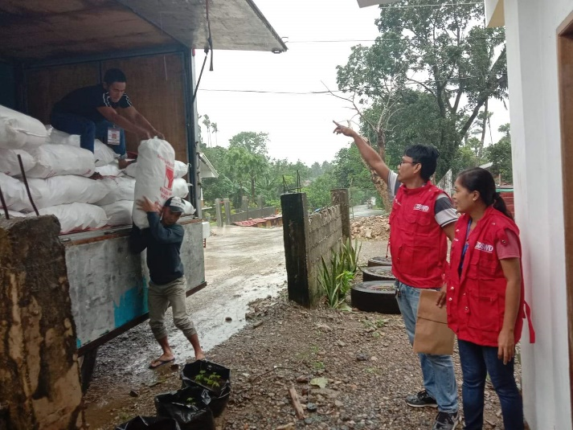
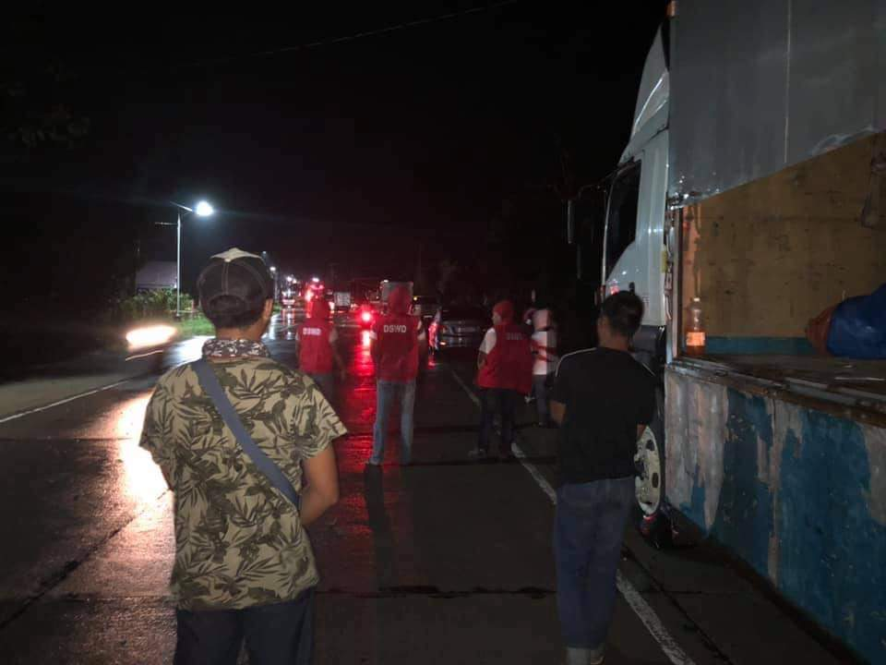
JAN ERWIN ANDREW I. ONTANILLAS MARC LEO L. BUTAC

