DSWD DROMIC Report #3 on the
Mw 5.9 Earthquake Incident in Kadingilan, Bukidnon
as of 24 November 2019, 6PM

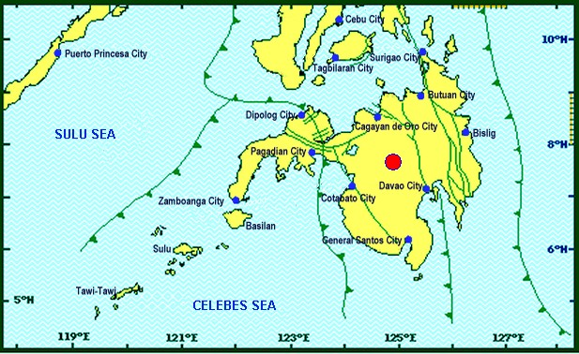

Situation Overview

On 18 November 2019 at 09:22 PM, a 5.9 moment magnitude (Mw) earthquake jolted the municipality of Kadingilan, Bukidnon (07.66°N, 124.89°E - 008 km N 24°W) with a tectonic origin and a depth of focus of 5 km. The earthquake was also felt in the neighboring municipalities of Bukidnon.

Date/Time: | 18 Nov 2019 - 09:22:08 PM
Reported Intensities: | Intensity VI - Kadingilan, Kalilangan, Don Carlos, Maramag, Kitaotao and San Fernando, Bukidnon  Intensity V - Damulog, Talakag and Valencia City, Bukidnon; Midsayap, Cotabato; Kidapawan  City; Marawi City  Intensity IV - Impasugong and Malaybalay, Bukidnon; Malungon, Sarangani; Antipas, Cotabato,  Rosario, Agusan Del Sur; Cotabato City; Davao City; Koronadal City; Cagayan De Oro City  Intensity III - Malitbog, Bukidnon; Tupi, South Cotabato; Manticao, Misamis Oriental; Tubod and  Bacolod, Lanao Del Norte; Alabel, Sarangani; Gingoog City; Pagadian City; Iligan City  Intensity II - Polomolok, Lake Sebu and Tampakan, South Cotabato; Kiamba, Sarangani;  Mambajao, Camiguin; Sindangan and Polanco, Zamboanga Del Norte; Molave, Zamboanga Del  Sur; Dipolog City; General Santos City  Intensity I - Zamboanga City  Instrumental Intensities:  Intensity IV - Cagayan De Oro City; Kidapawan City; Koronadal City; Malungon, Sarangani  Intensity III - Gingoog City; Davao City; Tupi, South Cotabato; Alabel, Sarangani  Intensity II - Kiamba, Sarangani; General Santos City  Intensity I - Zamboanga City; Bislig City
Expecting Damage: | YES
Expecting Aftershocks: | YES
Source: DOST-PHIVOLCS Earthquake Bulletin

- Status of Affected Families / Persons
A total of 581 families or 2,477 persons were affected by the earthquake incident in 16 barangays in Region X (see Table 1).

Table 1. Number of Affected Families / Person
REGION / PROVINCE / MUNICIPALITY |  | NUMBER OF AFFECTED
 |  | Barangay | Families | Persons
GRAND TOTAL |  | 16 | 581 | 2,477
REGION X |  | 16 | 581 | 2,477
Bukidnon |  | 16 | 581 | 2,477
 | Dangcagan | 7 | 66 | 330
 | Don Carlos | 1 | 164 | 492
 | Kadingilan | 7 | 271 | 1,355
 | Maramag | 1 | 80 | 300
Note: Ongoing assessment and validation being conducted.
Source: DSWD-FO X

- Status of Displaced Families / Persons
- Inside Evacuation Center
There are 244 families or 792 persons taking temporary shelter in two (2) evacuation centers in Bukidnon (see Table 2).

Table 2. Number of Displaced Families / Persons Inside Evacuation Centers
REGION / PROVINCE / MUNICIPALITY |  | NUMBER OF EVACUATION CENTERS (ECs) |  | NUMBER OF DISPLACED
 |  |  |  | INSIDE ECs
 |  |  |  | Families |  | Persons (Actual)
 |  | CUM | NOW | CUM | NOW | CUM | NOW
GRAND TOTAL |  | 2 | 2 | 244 | 244 | 792 | 792
REGION X |  | 2 | 2 | 244 | 244 | 792 | 792
Bukidnon |  | 2 | 2 | 244 | 244 | 792 | 792
 | Don Carlos | 1 | 1 | 164 | 164 | 492 | 492
 | Maramag | 1 | 1 | 80 | 80 | 300 | 300
Note: Ongoing assessment and validation being conducted.
Source: DSWD-FO X

- Damaged Houses
There are 271 damaged houses; of which, 37 are totally damaged and 234 are partially damaged (see Table 4).

Table 4. Number of Damaged Houses
REGION / PROVINCE / MUNICIPALITY |  | NO. OF DAMAGED HOUSES
 |  | Total | Totally | Partially
GRAND TOTAL |  | 271 | 37 | 234
REGION X |  | 271 | 37 | 234
Bukidnon |  | 271 | 37 | 234
 | Kadingilan | 271 | 37 | 234
Note: Ongoing assessment and validation being conducted for the partially and totally damaged houses in Dangcagan, Bukidnon.
Source: DSWD-FO X

- Assistance Provided
A total of ₱360,720.00 worth of assistance was provided by DSWD to the affected families (see Table 5).

Table 5. Cost of Assistance Provided to Affected Families / Persons
REGION / PROVINCE /  MUNICIPALITY |  | COST OF ASSISTANCE
 |  | DSWD | LGU | NGOs | OTHERS | GRAND TOTAL
GRAND TOTAL |  | 360,720.00 | - | - | - | 360,720.00
REGION X |  | 360,720.00 | - | - | - | 360,720.00
Bukidnon |  | 360,720.00 | - | - | - | 360,720.00
 | Dangcagan | 47,520.00 | - | - | - | 47,520.00
 | Don Carlos | 118,080.00 | - | - | - | 118,080.00
 | Kadingilan | 195,120.00 | - | - | - | 195,120.00
Source: DSWD-FO X

Situational Reports

DSWD-DRMB
DATE | SITUATIONS / ACTIONS UNDERTAKEN
24 November 2019 | - The Disaster Response Management Bureau (DRMB) is closely coordinating with DSWD-FO X for significant disaster response updates.  - DRMB Operations Center is on BLUE ALERT status.

DSWD-FO X
DATE | ACTION(S) TAKEN
24 November 2019 | - DSWD-FO X is in constant monitoring with the situation on the ground and is in close coordination with the respective Provincial/City/Municipal/Local Disaster Risk Reduction and Management Offices (P/C/M/LDRRMOs) and Social Welfare and Development Team Leader (SWADTL) of each province in the region.
20 November 2019 | - DSWD-FO X through the Disaster Response Management Division (DRMD) headed by the Division Chief and four (4) of the Field Office staff went to the area for a Damage Assessment and Needs Analysis.

*****
The Disaster Response Operations Monitoring and Information Center (DROMIC) of the DSWD-DRMB is closely coordinating with DSWD-FO X for any significant disaster response updates.

Prepared by:

DIANE C. PELEGRINO

MARC LEO L. BUTAC
Releasing Officer

