DSWD DROMIC Terminal Report on the Effects of
Tail-End of a Cold Front Enhanced by Typhoon “QUIEL”
09 December 2019, 6PM

This is the final report on the Tropical Depression West Southwest of Iba, Zambales which entered the Philippine Area of Responsibility (PAR) on 05 November 2019. The Tropical Depression was named “Quiel” and has intensified into a Tropical Storm on the same day while moving eastward. “Quiel” and the Tail-End of a Cold Front brought moderate with occasional heavy rains over Northern Luzon particularly in Ilocos Region, Batanes, Cagayan and Apayao. On 07 November 2019, “Quiel” has intensified into a Severe Tropical Storm (STS) while moving slowly eastward. It became a Typhoon on 08 November 2019 as it moved southwestward. It exited PAR on 09 November 2019 and the Tail-End of a Cold Front continues to affect Northern Luzon.

SUMMARY

- Status of Affected Families / Persons
37,746 families or 154,985 persons were affected by the effects of Tail-End of a Cold Front enhanced by Typhoon “Quiel” in 321 barangays in Regions I, II and CAR (see Table 1).

Table 1. Number of Affected Families / Persons
REGION / PROVINCE / MUNICIPALITY |  | NUMBER OF AFFECTED
 |  | Barangay | Families | Persons
GRAND TOTAL |  | 321 | 37,746 | 154,985
REGION I |  | 4 | 601 | 2,404
Ilocos Norte |  | 4 | 601 | 2,404
 | Paoay | 4 | 601 | 2,404
REGION II |  | 204 | 27,630 | 116,307
Cagayan |  | 204 | 27,630 | 116,307
 | Abulug | 19 | 6,703 | 31,180
 | Allacapan | 27 | 6,232 | 24,911
 | Aparri | 17 | 4,396 | 17,422
 | Baggao | 1 | 10 | 35
 | Ballesteros | 4 | 969 | 4,410
 | Buguey | 5 | 950 | 3,918
 | Camalaniugan | 21 | 965 | 3,926
 | Claveria | 34 | 2,262 | 9,345
 | Gonzaga | 2 | 18 | 81
 | Lal-lo | 10 | 664 | 3,263
 | Lasam | 8 | 284 | 1,714
 | Pamplona | 18 | 1,256 | 4,573
 | Sanchez-Mira | 14 | 2,046 | 8,150
 | Santa Ana | 5 | 221 | 681
 | Santa Praxedes | 10 | 159 | 634
 | Santa Teresita | 9 | 495 | 2,064
CAR |  | 113 | 9,515 | 36,274
Apayao |  | 113 | 9,515 | 36,274
 | Calanasan (Bayag) | 20 | 3,730 | 14,084
 | Conner | 8 | 107 | 420
 | Flora | 16 | 1,970 | 7,761
 | Kabugao (capital) | 21 | 471 | 1,900
 | Luna | 20 | 1,511 | 4,853
 | Pudtol | 17 | 1,158 | 5,197
 | Santa Marcela | 11 | 568 | 2,059
Note: The decrease in the number of barangays in Region II is based on the final report submitted by DSWD-FO II.
Source: DSWD-FOs I, II and CAR

- Status of Displaced Families / Persons
- Inside Evacuation Centers
A total of 5,097 families or 20,404 persons took temporary shelter in 116 evacuation centers in Region II and CAR (see Table 2).

Table 2. Status of Displaced Families / Persons Inside Evacuation Centers
REGION / PROVINCE / MUNICIPALITY |  | NUMBER OF EVACUATION CENTERS (ECs) |  | INSIDE ECs
 |  |  |  | Families |  | Persons
 |  | CUM | NOW | CUM | NOW | CUM | NOW
GRAND TOTAL |  | 116 | - | 5,097 | - | 20,404 | -
REGION II |  | 77 | - | 4,686 | - | 18,873 | -
Cagayan |  | 77 | - | 4,686 | - | 18,873 | -
 | Abulug | 14 | - | 2,792 | - | 12,272 | -
 | Allacapan | 1 | - | 140 | - | 526 | -
 | Aparri | 13 | - | 656 | - | 2,281 | -
 | Baggao | 1 | - | 10 | - | 35 | -
 | Ballesteros | 6 | - | 312 | - | 1,096 | -
 | Camalaniugan | 4 | - | 54 | - | 266 | -
 | Gonzaga | 3 | - | 18 | - | 81 | -
 | Lal-lo | 5 | - | 37 | - | 126 | -
 | Lasam | 2 | - | 69 | - | 231 | -
 | Pamplona | 13 | - | 310 | - | 1,153 | -
 | Sanchez-Mira | 9 | - | 175 | - | 580 | -
 | Santa Ana | 4 | - | 89 | - | 153 | -
 | Santa Praxedes | 1 | - | 21 | - | 61 | -
 | Santa Teresita | 1 | - | 3 | - | 12 | -
CAR |  | 39 | - | 411 | - | 1,531 | -
Apayao |  | 39 | - | 411 | - | 1,531 | -
 | Calanasan (Bayag) | 3 | - | 10 | - | 46 | -
 | Flora | 1 | - | 9 | - | 25 | -
 | Kabugao (capital) | 1 | - | 25 | - | 100 | -
 | Luna | 16 | - | 109 | - | 390 | -
 | Pudtol | 13 | - | 120 | - | 484 | -
 | Santa Marcela | 5 | - | 138 | - | 486 | -
Source: DSWD-FOs II and CAR

- Outside Evacuation Centers
There are 15 families or 54 persons currently staying with their relatives and/or friends in CAR (see Table 3).

Table 3. Status of Displaced Families / Persons Outside Evacuation Centers
REGION / PROVINCE / MUNICIPALITY |  | OUTSIDE ECs
 |  | Families |  | Persons
 |  | CUM | NOW | CUM | NOW
GRAND TOTAL |  | 2,514 | 15 | 9,670 | 54
REGION I |  | 3 | - | 12 | -
Ilocos Norte |  | 3 | - | 12 | -
 | Paoay | 3 | - | 12 | -
REGION II |  | 583 | - | 2,446 | -
Cagayan |  | 583 | - | 2,446 | -
 | Abulug | 20 | - | 100 | -
 | Allacapan | 85 | - | 363 | -
 | Aparri | 4 | - | 16 | -
 | Ballesteros | 14 | - | 47 | -
 | Camalaniugan | 69 | - | 330 | -
 | Claveria | 1 | - | 4 | -
 | Lal-lo | 67 | - | 331 | -
 | Pamplona | 149 | - | 614 | -
 | Sanchez-Mira | 15 | - | 69 | -
 | Santa Praxedes | 159 | - | 572 | -
CAR |  | 1,928 | 15 | 7,212 | 54
Apayao |  | 1,928 | 15 | 7,212 | 54
 | Calanasan (Bayag) | 8 | - | 43 | -
 | Conner | 93 | - | 400 | -
 | Flora | 795 | - | 3,164 | -
 | Kabugao (capital) | 210 | 12 | 850 | 46
 | Luna | 569 | - | 1,850 | -
 | Pudtol | 49 | 3 | 132 | 8
 | Santa Marcela | 204 | - | 773 | -
Note: The displaced families in CAR are reportedly those with totally damaged houses.
Source: DSWD-FOs I, II and CAR

- Damaged Houses
A total of 191 damaged houses; of which, 66 were totally damaged and 125 were partially damaged (see Table 4).

Table 4. Number of Damaged Houses
REGION / PROVINCE / MUNICIPALITY |  | NO. OF DAMAGED HOUSES
 |  | Total | Totally | Partially
GRAND TOTAL |  | 191 | 66 | 125
REGION I |  | 4 | 3 | 1
Ilocos Norte |  | 4 | 3 | 1
 | Paoay | 4 | 3 | 1
REGION II |  | 71 | 35 | 36
Cagayan |  | 71 | 35 | 36
 | Abulug | 42 | 23 | 19
 | Allacapan | 24 | 8 | 16
 | Claveria | 1 | - | 1
 | Santa Praxedes | 4 | 4 | -
CAR |  | 116 | 28 | 88
Apayao |  | 116 | 28 | 88
 | Conner | 4 | - | 4
 | Kabugao (capital) | 108 | 26 | 82
 | Pudtol | 4 | 2 | 2
Source: DSWD-FOs I, II and CAR

- Assistance Provided
A total of ₱11,871,694.88 worth of assistance was provided to the affected families; of which, ₱9,559,995.88 was provided by DSWD; ₱1,961,699.00 by LGUs; and, ₱350,000.00 by other partners (see Table 5).

Table 5. Cost of Assistance Provided to Affected Families / Persons
REGION / PROVINCE / MUNICIPALITY |  | TOTAL COST OF ASSISTANCE
 |  | DSWD | LGU | NGOs | OTHERS | GRAND TOTAL
GRAND TOTAL |  | 9,559,995.88 | 1,961,699.00 | - | 350,000.00 | 11,871,694.88
REGION I |  | - | 186,310.00 | - | - | 186,310.00
Ilocos Norte |  | - | 186,310.00 | - | - | 186,310.00
 | Paoay | - | 186,310.00 | - | - | 186,310.00
REGION II* |  | 6,843,854.88 | 39,900.00 | - | 350,000.00 | 7,233,754.88
Cagayan |  | 6,843,854.88 | 39,900.00 | - | 350,000.00 | 7,233,754.88
 | Abulug | 1,682,485.88 | - | - | - | 1,682,485.88
 | Allacapan | 1,294,287.48 | - | - | - | 1,294,287.48
 | Aparri | 877,656.88 | - | - | - | 877,656.88
 | Ballesteros | 343,352.00 | - | - | - | 343,352.00
 | Camalaniugan | 369,076.00 | - | - | - | 369,076.00
 | Claveria | 720,000.00 | - | - | - | 720,000.00
 | Lal-lo | 180,000.00 | - | - | - | 180,000.00
 | Lasam | 56,038.88 | - | - | - | 56,038.88
 | Pamplona | 237,478.88 | - | - | - | 237,478.88
 | Sanchez-Mira | 723,478.88 | - | - | - | 723,478.88
 | Santa Ana | - | 39,900.00 | - | 350,000.00 | 389,900.00
 | Santa Praxedes | 180,000.00 | - | - | - | 180,000.00
 | Santa Teresita | 180,000.00 | - | - | - | 180,000.00
CAR** |  | 2,716,141.00 | 1,735,489.00 | - | - | 4,451,630.00
Apayao |  | 2,716,141.00 | 1,735,489.00 | - | - | 4,451,630.00
 | Calanasan (Bayag) | 720,000.00 | 724,222.00 | - | - | 1,444,222.00
 | Conner | 81,360.00 | 94,750.00 | - | - | 176,110.00
 | Flora | 432,000.00 | 347,944.00 | - | - | 779,944.00
 | Kabugao (capital) | 585,447.50 | 256,778.00 | - | - | 842,225.50
 | Luna | 94,155.00 | 154,840.00 | - | - | 248,995.00
 | Pudtol | 412,847.25 | 98,315.00 | - | - | 511,162.25
 | Santa Marcela | 390,331.25 | 58,640.00 | - | - | 448,971.25
Note: The decrease in the cost of assistance provided in Region II and CAR is based on the final report submitted by DSWD-FOs II and CAR.
Source: DSWD-FOs I, II and CAR

Situational Reports

DSWD-FO I
DATE | SITUATION / PREPAREDNESS ACTIONS
December 09, 2019 | - DSWD-FO I submitted their terminal report.

DSWD-FO II
DATE | SITUATION / PREPAREDNESS ACTIONS
December 09, 2019 | - DSWD-FO II submitted their terminal report.

DSWD-FO CAR

DATE | SITUATION / PREPAREDNESS ACTIONS
December 09, 2019 | - DSWD-FO CAR submitted their terminal report.

*****
The Disaster Response Operations Monitoring and Information Center (DROMIC) of the DSWD-DRMB continues to closely coordinate with DSWD Field Offices for any request of Technical Assistance and Resource Augmentation (TARA).

Prepared by:

MARIE JOYCE G. RAFANAN

JAN ERWIN ANDREW I. ONTANILLAS
Releasing Officer

PHOTO DOCUMENTATION

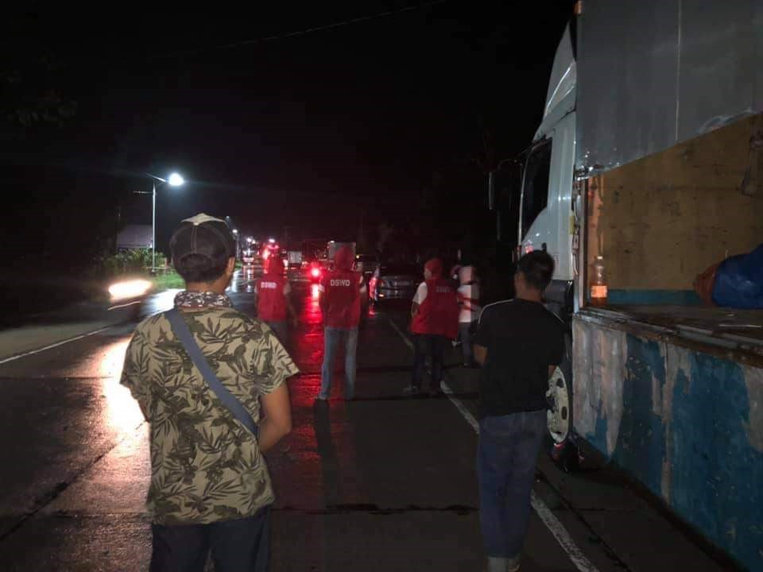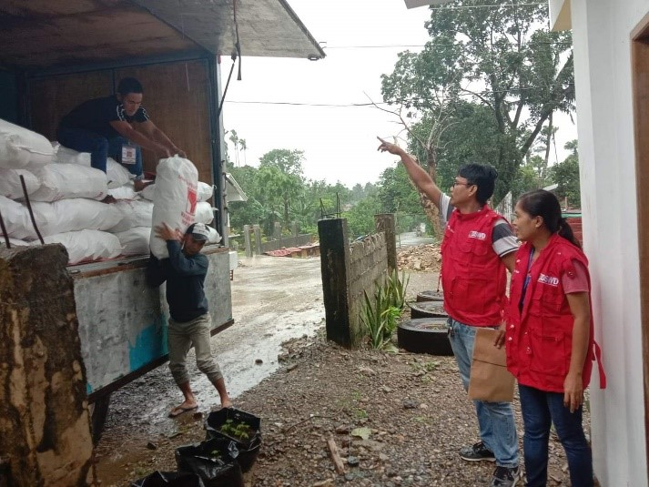

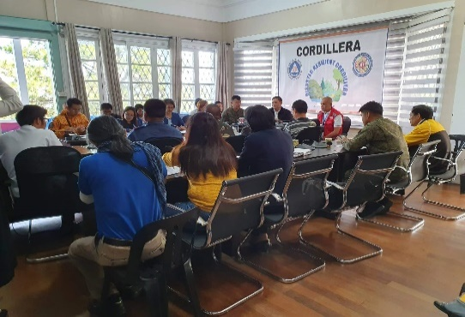

Cordillera Regional Disaster Risk Reduction Management Council (CRDDMC) Response Cluster Meeting with the member agencies

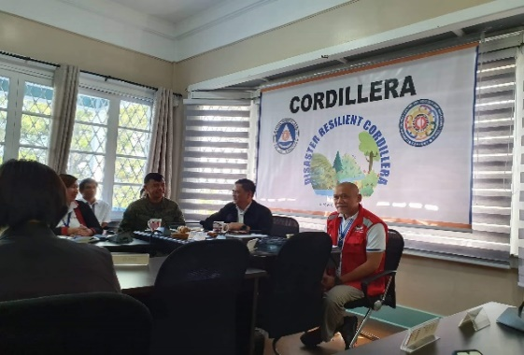

OIC-RD Leo L. Quintilla presiding the Response Cluster Meeting of CRDRRMC

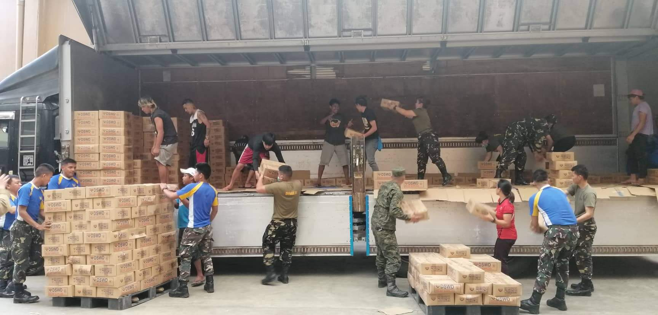The volunteers helped each other load the 7,000 family food packs to be delivered in the province of Apayao.

