DSWD DROMIC Terminal Report on the
Preparedness for Response on Tropical Storm “Sarah”
11 December 2019, 6PM

This is the final report on the Preparedness for Response on Tropical Storm “Sarah” which entered the Philippine Area of Responsibility (PAR) on 19 November 2019. Tropical Depression “Sarah” became a Tropical Storm (TS) on 20 November 2019 but did not make any landfall in the country. However, TS “Sarah” brought light to moderate with occasional heavy rains as it exited PAR on 23 November 2019.
Source: DOST-PAGASA
PREDICTIVE ANALYTICS FOR HUMANITARIAN RESPONSE
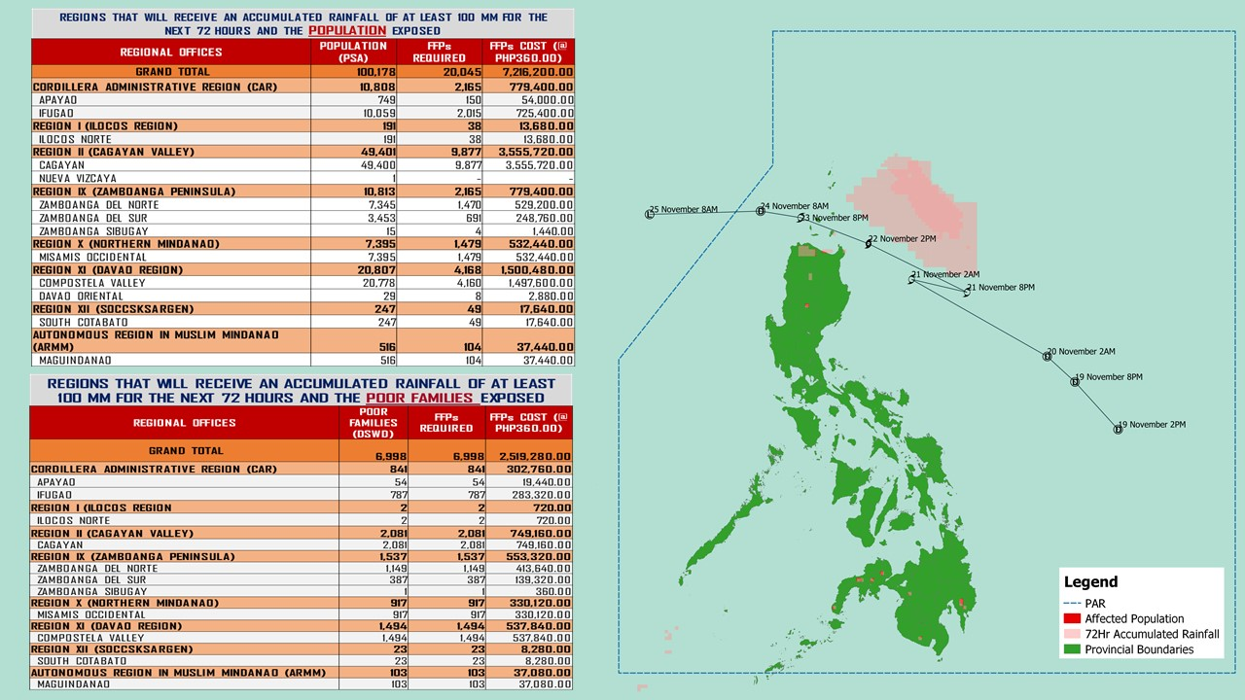

Source: DRMB-DROMIC GIS Specialists
Status of Prepositioned Resources: Stockpile and Standby Funds

The DSWD Central Office (CO), Field Offices (FOs), and National Resource Operations Center (NROC) have stockpiles and standby funds amounting to ₱1,953,138,881.84 with breakdown as follows (see Table 1):

- Standby Funds
A total of ₱1,199,492,141.37 standby funds in the CO and FOs. Of the said amount, ₱1,161,591,871.91 is the available Quick Response Fund (QRF) in the CO.

- Stockpiles
A total of 306,742 family food packs (FFPs) amounting to ₱118,964,395.38 and available food and non-food items (FNIs) amounting to ₱634,682,345.09.
 | STANDBY FUNDS | FAMILY FOOD PACKS |  | Other Food Items | Non Food Items | SUB-TOTAL (Food and NFIs) | Total STANDBY FUNDS & STOCKPILE
 |  | Quantity | Total Cost | Total Cost | Total Cost
TOTAL | 1,199,492,141.37 | 306,742 | 118,964,395.38 | 187,919,590.08 | 446,762,755.01 | 634,682,345.09 | 1,953,138,881.84
Central Office | 1,161,591,871.91 | - | - | - | - | - | 1,161,591,871.91
NRLMB - NROC | - | 51,593 | 22,107,302.48 | 36,455,018.55 | 238,222,574.31 | 274,677,592.86 | 296,784,895.34
NRLMB - VDRC | - | - | - | 7,365,040.00 | 4,090,050.00 | 11,455,090.00 | 11,455,090.00
I | 2,379,275.00 | 15,239 | 5,515,126.58 | 299,455.20 | 37,645,525.20 | 37,944,980.40 | 45,839,381.98
II | 3,564,703.35 | 21,639 | 7,642,384.62 | 639,602.00 | 9,372,145.35 | 10,011,747.35 | 21,218,835.32
III | 3,068,057.00 | 11,629 | 4,676,672.68 | 2,406,194.70 | 6,042,738.40 | 8,448,933.10 | 16,193,662.78
CALABARZON | 1,785,325.00 | 6,675 | 2,382,327.50 | 3,187,954.80 | 5,523,160.91 | 8,711,115.71 | 12,878,768.21
MIMAROPA | 3,046,722.58 | 31,474 | 13,156,132.00 | 898,761.00 | 10,663,131.29 | 11,561,892.29 | 27,764,746.87
V | 3,000,000.00 | 22,340 | 8,707,456.00 | 5,689,296.56 | 27,577,623.94 | 33,266,920.50 | 44,974,376.50
VI | 2,040,000.00 | 14,273 | 5,138,280.00 | 5,179,572.75 | 5,285,253.00 | 10,464,825.75 | 17,643,105.75
VII | 752,800.00 | 16,053 | 5,779,080.00 | 9,056,694.26 | 10,349,862.37 | 19,406,556.63 | 25,938,436.63
VIII | 1,203,735.00 | 18,108 | 6,837,222.14 | 2,195,592.06 | 20,937,915.08 | 23,133,507.14 | 31,174,464.28
IX | 3,001,888.85 | 16,396 | 5,902,560.00 | 2,076,520.00 | 15,472,334.14 | 17,548,854.14 | 26,453,302.99
X | 3,000,000.00 | 28,878 | 10,633,520.42 | 87,239,260.45 | 12,628,921.90 | 99,868,182.35 | 113,501,702.77
XI | 322,644.00 | 14,846 | 5,884,509.02 | 7,170,000.00 | 6,973,437.90 | 14,143,437.90 | 20,350,590.92
XII | 1,415,770.18 | 5,923 | 2,371,139.00 | 6,914,259.00 | 6,716,851.16 | 13,631,110.16 | 17,418,019.34
CARAGA | 3,000,000.00 | 15,238 | 5,751,611.40 | 1,884,232.10 | 1,772,370.46 | 3,656,602.56 | 12,408,213.96
NCR | 3,292,543.50 | 4,269 | 1,598,543.38 | 659,823.29 | 9,642,807.85 | 10,302,631.14 | 15,193,718.02
CAR | 3,026,805.00 | 12,169 | 4,880,528.16 | 8,602,313.36 | 17,846,051.75 | 26,448,365.11 | 34,355,698.27
*Quick Response Fund (QRF) as of 06 December 2019

Situational Reports

DSWD-FO I
DATE | SITUATIONS / ACTIONS UNDERTAKEN
11 December 2019 | - DSWD-FO I submitted their terminal report.

DSWD-FO MIMAROPA
DATE | SITUATIONS / ACTIONS UNDERTAKEN
11 December 2019 | - DSWD-FO MIMAROPA submitted their terminal report.

DSWD-FO VIII
DATE | SITUATIONS / ACTIONS UNDERTAKEN
11 December 2019 | - DSWD-FO VIII submitted their terminal report.

DSWD-FO CAR
DATE | SITUATIONS / ACTIONS UNDERTAKEN
11 December 2019 | - DSWD-FO CAR submitted their terminal report.

*****
The Disaster Response Operations Monitoring and Information Center (DROMIC) of the DSWD-DRMB continues to closely coordinate with DSWD-FO XI for any request of Technical Assistance and Resource Augmentation (TARA).

PREPARED BY:

MARIE JOYCE G. RAFANAN

JAN ERWIN ANDREW I. ONTANILLAS
Releasing Officer

