DSWD DROMIC Preparedness for Response Report
#1 on Tropical Storm “Ursula”
as of 24 December 2019, 4PM

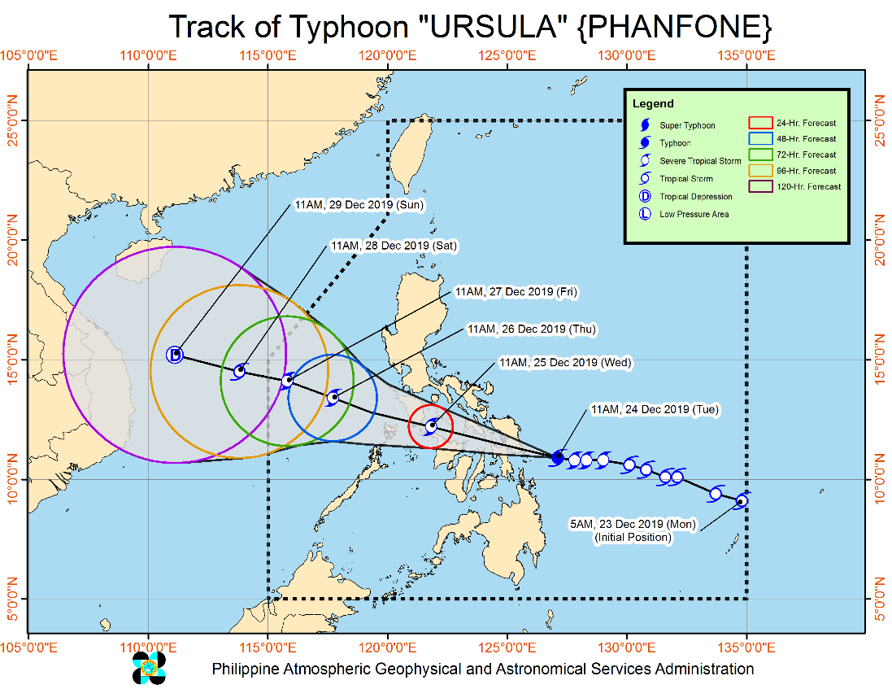
Situation Overview

"URSULA" INTENSIFIES INTO A TYPHOON AS IT ENDANGERS EASTERN VISAYAS.

- Heavy Rainfall Outlook
- Between today and tomorrow noon: Occasional to frequent heavy rains over Dinagat Islands, Siargao and Bucas Grande Islands, Eastern Visayas, Sorsogon, Masbate, northern and central Cebu, northern Negros Provinces, Aklan, Antique, Capiz, Iloilo, Guimaras and Romblon. Light to moderate with intermittent heavy rains over the rest of Bicol Region, Quezon, Marinduque, Oriental Mindoro, and the rest of Visayas and Surigao del Norte.
- Between tomorrow noon and late evening: Occasional to frequent heavy rains over Aklan, Antique, Capiz, Romblon, Marinduque, Oriental Mindoro, Occidental Mindoro, Batangas, and Calamian Islands. Light to moderate with intermittent heavy rains over Cuyo Islands, Negros Provinces, Iloilo, Guimaras, Aurora, and the rest of CALABARZON.
- Residents in these areas are advised to take appropriate measures to reduce the potential impact of flooding and rain-induced landslides, especially in areas identified to be highly to very highly susceptible to these hazards.
- Tropical Cyclone Winds:
- Moderate to strong winds to begin affecting Northeastern Mindanao and Eastern Visayas today; Bicol Region and portions of Central Visayas this afternoon or tonight; CALABARZON, and portions of MIMAROPA and Western Visayas tomorrow morning; Metro Manila, Bulacan, and Bataan tomorrow morning or afternoon. Medium to high-risk structures may experience light damage.
- Damaging gale to storm-force winds to begin affecting areas under Tropical Cyclone Wind Signal (TCWS) #2 in Eastern Visayas this afternoon; in Albay, Sorsogon, Masbate, Romblon, Aklan, Capiz and portions of Antique, Iloilo, and northern Cebu tonight. This may bring light to moderate damage to high-risk structures and at most light damage to medium-risk structures.
- Destructive typhoon force winds to begin affecting areas under TCWS #3 this afternoon. High-risk structures may experience heavy damage.
- Other Hazards and Warning Information:
- "URSULA" is forecast make to landfall over Borongan-Guiuan area b etween 4:00 PM to 6:00 PM today.
- Storm Surge of up to 2.0 meters may affect the several coastal areas of Eastern Samar, Northern Samar, and Leyte.
- Rough sea conditions will prevail starting today over the eastern seaboards of the country; this afternoon or tonight over the inland waters of Southern Luzon and Visayas; tomorrow afternoon over the western seaboards of Southern Luzon. Sea travel is risky over these areas.

At 1:00 PM today, the eye of Typhoon "URSULA" was located based on all available data including Guiuan Doppler Radar at 95 km East of Guiuan, Eastern Samar (11.0 °N, 126.6 °E )
Source: DOST-PAGASA Severe Weather Bulletin

PREDICTIVE ANALYTICS FOR HUMANITARIAN RESPONSE
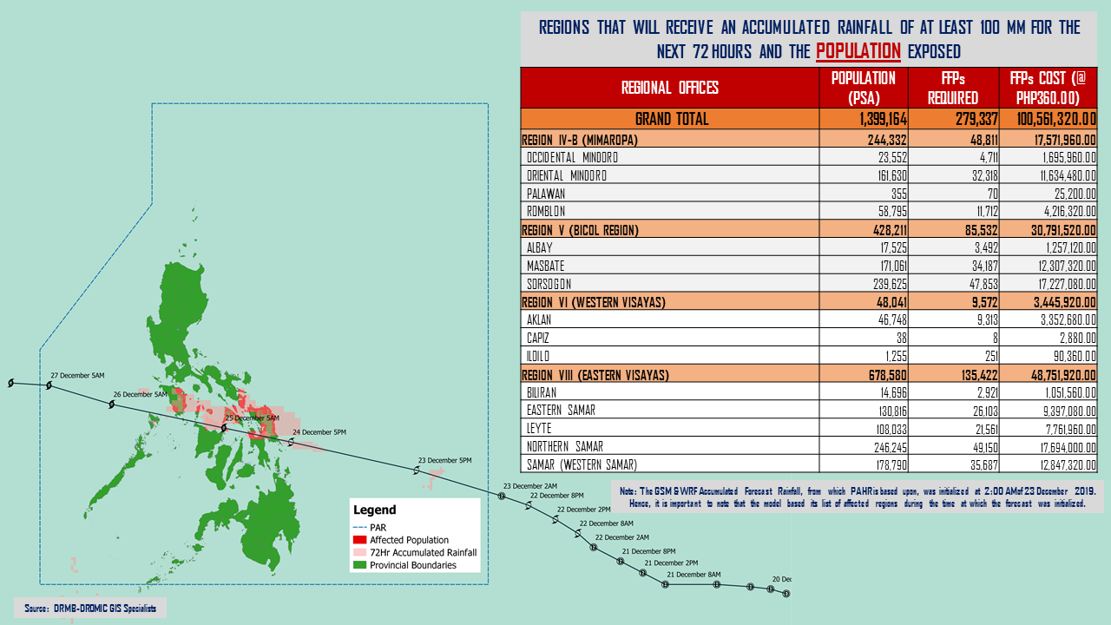

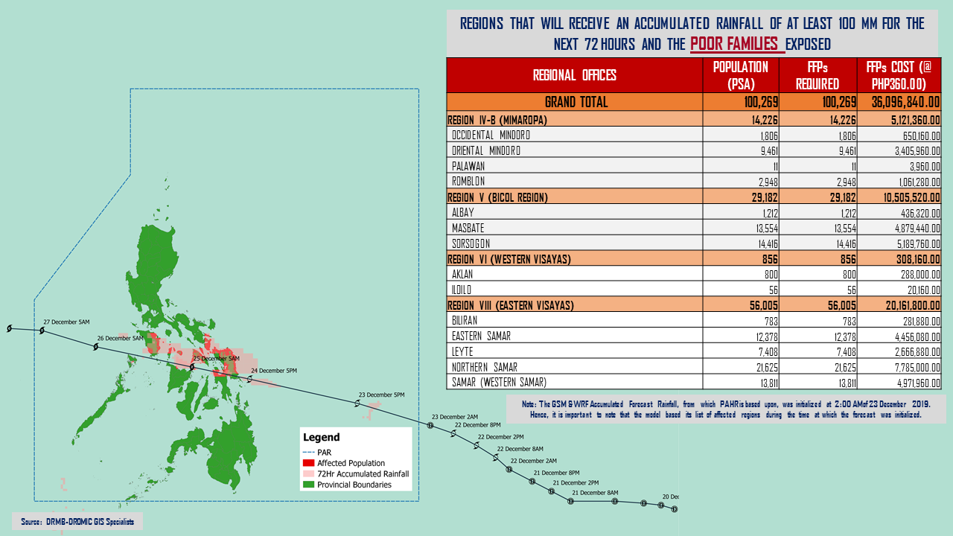

Status of Prepositioned Resources: Stockpile and Standby Funds

The DSWD Central Office (CO), Field Offices (FOs), and National Resource Operations Center (NROC) have stockpiles and standby funds amounting to ₱1,914,941,449.98 with breakdown as follows (see Table 1):

- Standby Funds
A total of ₱1,204,499,677.12 standby funds in the CO and FOs. Of the said amount, ₱1,161,591,871.91 is the available Quick Response Fund (QRF) in the CO.

- Stockpiles
A total of 259,975 family food packs (FFPs) amounting to ₱98,412,415.34 and available food and non-food items (FNIs) amounting to ₱612,029,357.52.

 | STANDBY FUNDS | FAMILY FOOD PACKS |  | Other Food Items | Non Food Items | SUB-TOTAL (Food and NFIs) | Total STANDBY FUNDS & STOCKPILE
 |  | Quantity | Total Cost | Total Cost | Total Cost
TOTAL | 1,204,499,677.12 | 259,975 | 98,412,415.34 | 179,977,803.95 | 432,051,553.57 | 612,029,357.52 | 1,914,941,449.98
Central Office | 1,161,591,871.91 | - | - | - | - | - | 1,161,591,871.91
NRLMB - NROC | - | 12,150 | 4,582,251.00 | 31,262,201.29 | 220,849,102.11 | 252,111,303.40 | 256,693,554.40
NRLMB - VDRC | - | 600 | 216,000.00 | 7,365,040.00 | 4,090,050.00 | 11,455,090.00 | 11,671,090.00
I | 2,379,275.00 | 14,984 | 5,423,326.58 | 299,455.20 | 37,645,525.20 | 37,944,980.40 | 45,747,581.98
II | 3,537,163.35 | 28,472 | 10,219,382.24 | 639,602.00 | 10,408,918.95 | 11,048,520.95 | 24,805,066.54
III | 3,068,057.00 | 12,604 | 5,044,384.18 | 2,406,194.70 | 6,022,018.40 | 8,428,213.10 | 16,540,654.28
CALABARZON | 3,000,000.00 | 5,763 | 2,078,967.02 | 3,168,773.20 | 5,523,160.91 | 8,691,934.11 | 13,770,901.13
MIMAROPA | 2,540,473.78 | 25,971 | 10,855,878.00 | 898,761.00 | 8,482,881.29 | 9,381,642.29 | 22,777,994.07
V | 3,000,000.00 | 22,815 | 8,681,904.88 | 6,331,723.96 | 31,404,289.94 | 37,736,013.90 | 49,417,918.78
VI | 3,000,000.00 | 16,666 | 5,999,760.00 | 6,209,765.75 | 5,285,253.00 | 11,495,018.75 | 20,494,778.75
VII | 3,000,800.00 | 14,349 | 5,165,640.00 | 8,230,869.59 | 10,349,862.37 | 18,580,731.96 | 26,747,171.96
VIII | 1,203,735.00 | 7,116 | 2,736,143.28 | 2,195,592.06 | 20,937,915.08 | 23,133,507.14 | 27,073,385.42
IX | 3,000,000.00 | 18,493 | 6,657,480.00 | 2,076,520.00 | 15,472,334.14 | 17,548,854.14 | 27,206,334.14
X | 3,000,000.00 | 26,430 | 9,732,923.64 | 87,239,260.45 | 12,628,921.90 | 99,868,182.35 | 112,601,105.99
XI | 3,000,644.00 | 8,170 | 3,238,342.90 | 7,170,000.00 | 6,973,437.90 | 14,143,437.90 | 20,382,424.80
XII | 3,000,770.18 | 15,715 | 6,297,731.00 | 3,337,676.00 | 6,716,851.16 | 10,054,527.16 | 19,353,028.34
CARAGA | 3,000,000.00 | 15,238 | 5,751,611.40 | 1,884,232.10 | 1,772,370.46 | 3,656,602.56 | 12,408,213.96
NCR | 176,886.00 | 4,158 | 1,558,162.92 | 659,823.29 | 10,573,477.85 | 11,233,301.14 | 12,968,350.06
CAR | 3,000,000.90 | 10,281 | 4,172,526.30 | 8,602,313.36 | 16,915,182.91 | 25,517,496.27 | 32,690,023.47
*Quick Response Fund (QRF) as of 23 December 2019

Situational Reports

DSWD-DRMB
DATE | SITUATIONS / ACTIONS UNDERTAKEN
24 December 2019 | - The Disaster Response Management Bureau (DRMB) is on BLUE alert status and is closely coordinating with the concerned field offices for significant disaster response updates  - All QRT members and emergency equipment are on standby and ready for deployment.

DSWD-MIMAROPA
DATE | SITUATIONS / ACTIONS UNDERTAKEN
24 December 2019 | - DSWD-FO MIMAROPA through the Disaster Response Management Division (DRMD) and Provincial Project Development Officers are alerted to monitor daily local weather condition and ensure provision of information to all concerned offices, divisions, sections, offices.  - Alerted all P/C/M Quick Response Team in five provinces of MIMAROPA to regularly monitor the situations in their areas.  - 24/7 On-call status of the R/P/C/M QRT together with special projects for the possible activation of Operation Center.  - Close coordination with the Office of Civil Defense (OCD) and RDRRMC MIMAROPA for any warning signal updates for monitoring purposes and response mechanism for areas that will be affected.  - Standby logistical equipment and workforce through coordination with SWADT Offices and concerned LGUs on the management of stranded passengers, if any, in ports and terminals.  - Information and Communication Technology Management Unit (ICTMU) is on standby status to ensure robust communication system.  - All members of Rapid Emergency Telecommunications Team are on on-call and standby status ready for deployment if needed.  - Ensured that the Rapid Emergency Telecommunications Equipment (GX Terminal, BGAN Terminals and Satellite Phones) are in good condition and ready for deployment to areas that will experience potential emergencies.  - Ensured that there is an on-call truck available for delivery of goods and equipment to areas that will be affected.

DSWD-FO V
DATE | SITUATIONS / ACTIONS UNDERTAKEN
24 December 2019 | - DSWD-FO V continuous to monitor weather updates and information.  - Resource Operation Section ensures the availability of family food packs and non-food items as need arises.  - DSWD-FO V QRTs were alerted and advised to be prepared for augmentation support needed from the field and/or 24/7 duty at the DRMD Operations Center.  - PAT and MAT members in the 6 provinces are on standby and were instructed to coordinate with the P/MDRRMOs for status reports and updates.

DSWD-FO VI
DATE | SITUATIONS / ACTIONS UNDERTAKEN
24 December 2019 | - DSWD-FO VI is on Blue Alert Status.  - On-going 24/7 duty Rota at RDRRMC Operation Center with DRMD Staff as personnel in-charge.  - On-going 24/7 duty Rota at DSWD Operation Center with DROMIC staff as personnel in-charge.  - ALL staff are on standby and on-call ready for augmentation.  - The Committee on Logistics, Transportation and Escort Services will work together with the regional drivers to transport food and non-food items if augmentation will be requested by the LGUs. The vehicles and drivers are on standby for augmentation and for the use of DSWD QRT.

DSWD-FO VII
DATE | SITUATIONS / ACTIONS UNDERTAKEN
24 December 2019 | - DSWD Regional QRT Team already activated starting with Team 2 to render duty in three shifts.  - The City and Municipal Action Team and SWAD Offices already requested to closely coordinate with their local counterparts and their respective LDRRMC. Field staff are requested to monitor AOR and provide reports and updates to the Regional DROMIC Focal.  - The Provincial/City/Municipal Quick Response Team is on standby alert and ready for mobilization for any assistance and augmentation support needed from the LGUs.  - The Regional Disaster Division is in close coordination with OCD-7 and other members of the RDRRMC for any response mobilization strategies.  - Warehouses in the three island provinces are on ready alert.

DSWD-FO VIII
DATE | SITUATIONS / ACTIONS UNDERTAKEN
24 December 2019 | - SWAD Teams and DRMD-PDOs assigned in the provinces are alerted and advised to closely coordinate with P/C/MSWDOs and/or P/C/MDRRMOs and immediately report any eventualities that may arise during the period.  - Quick Response Teams (QRT) and Disaster Response Management Division (DRMD) are alerted in case augmentation of workforce is needed.  - Disaster Response Information Management Section (DRIMS) is closely coordinating with SWADTs, QRTs and PDOs for any eventualities on the ground.  - Regional Resource Operations Section (RROS) are also alerted to ensure the readiness of dispatching the Food and Non-Food commodities whenever needed.

DSWD-FO Caraga
DATE | SITUATIONS / ACTIONS UNDERTAKEN
24 December 2019 | - DSWD-FO Caraga is on RED Alert Status.  - DSWD-FO Caraga has activated its Quick Response Teams in relation to the BLUE Alert Status to render 24-hour duty and monitor updates regarding the effects of TS “URSULA”.  - DSWD-FO Caraga is constantly coordinating with the LSWDOs and LDRRMOs for the provision of timely updates and information.

*****
The Disaster Response Operations Monitoring and Information Center (DROMIC) of the DSWD-DRMB is closely monitoring the effects of TS “Ursula” and is coordinating with the concerned DSWD Field Offices for any significant updates.

Prepared by:

MARIE JOYCE G. RAFANAN

RODEL V. CABADDU
Releasing Officer

