DSWD DROMIC Preparedness for Response Report
#1 on Typhoon "TISOY"
as of 28 November 2019, 7PM

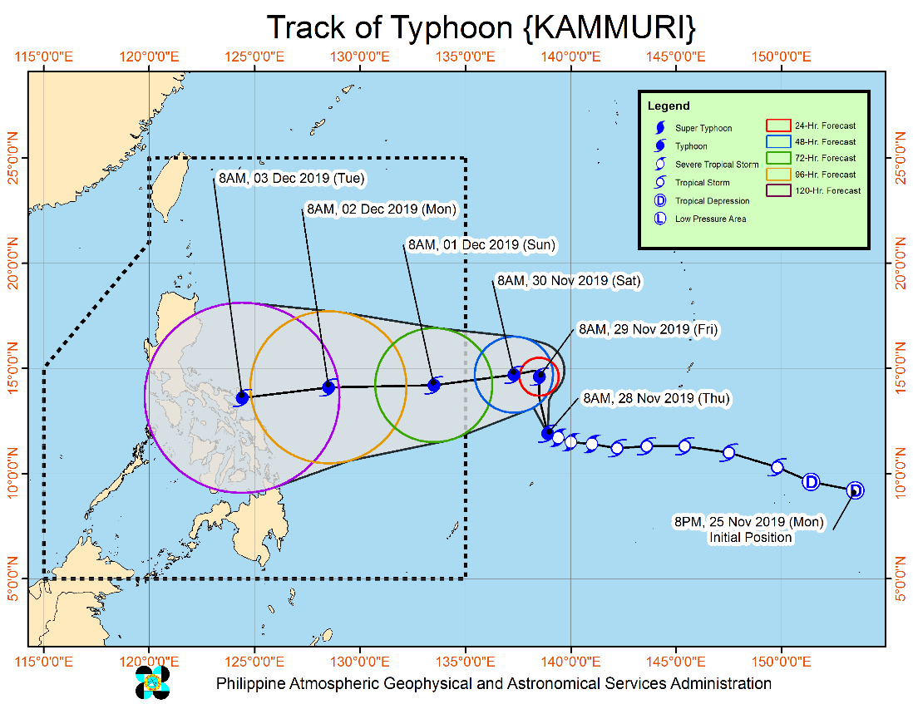
Situation Overview

The center of Typhoon "KAMMURI" was estimated based on all available data at 1,430 km East of Visayas (Outside PAR) (11.9°N,138.8°E). "KAMMURI" intensifies into a Typhoon as it slows down while moving west-northwestward. "KAMMURI" is forecast to enter the Philippine Area of Responsibility (PAR) between Saturday evening (30 November) and Sunday (01 December) morning and will be named "TISOY" as the 20th Philippine tropical cyclone for 2019. Tropical Cyclone Wind Signal #1 may be raised over the eastern portion of Bicol Region-Eastern Visayas area on Sunday. Disruption of maritime travel may be experienced in these areas. Steady intensification is likely throughout the forecast period. The outer rainbands of "KAMMURI" may bring scattered rains and thunderstorms over Bicol Region and Eastern Visayas on Monday (02 December).
Source: DOST-PAGASA Severe Weather Bulletin

PREDICTIVE ANALYTICS FOR HUMANITARIAN RESPONSE

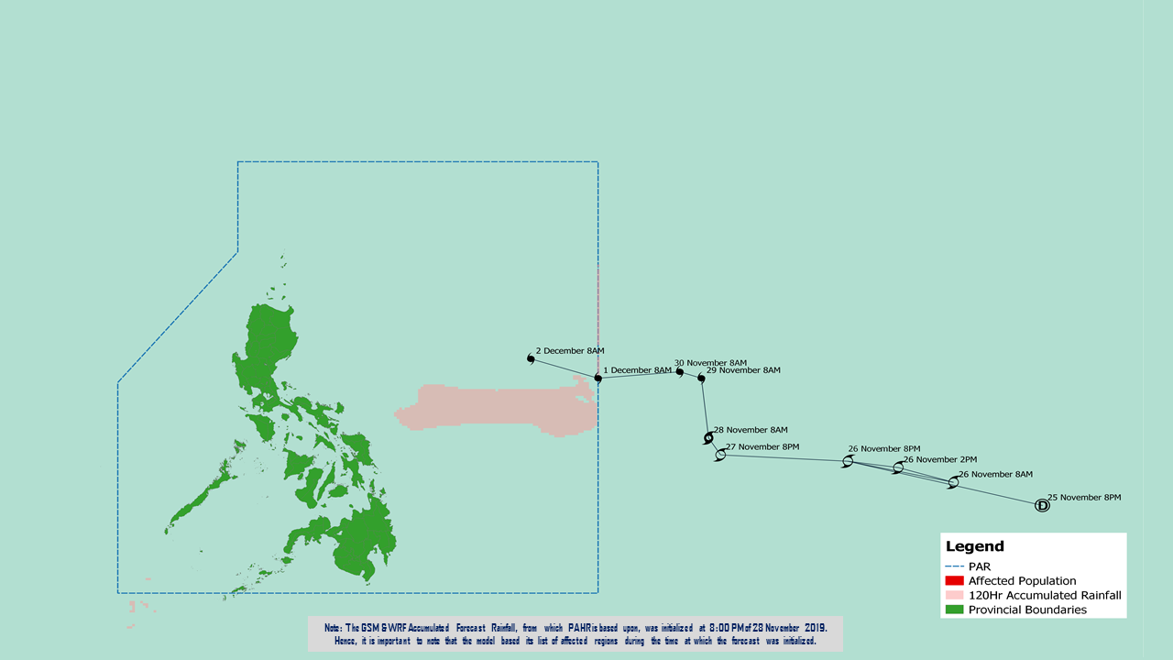

Prepared by: DRMB-DROMIC GIS Specialists
Status of Prepositioned Resources: Stockpile and Standby Funds

The DSWD Central Office (CO), Field Offices (FOs), and National Resource Operations Center (NROC) have stockpiles and standby funds amounting to ₱1,353,912,860.63 with breakdown as follows (see Table 1):

- Standby Funds
A total of ₱586,890,340.46 standby funds in the CO and FOs. Of the said amount, ₱548,990,071.00 is the available Quick Response Fund (QRF) in the CO.

- Stockpiles
A total of 299,489 family food packs (FFPs) amounting to ₱115,375,181.72 and available food and non-food items (FNIs) amounting to ₱651,647,338.45.

FIELD OFFICE | STANDBY FUNDS | FAMILY FOOD PACKS |  | Other Food Items | Non Food Items | SUB-TOTAL (Food and NFIs) | Total STANDBY FUNDS & STOCKPILE
 |  | Quantity | Total Cost | Total Cost | Total Cost
TOTAL | 586,890,340.46 | 299,489 | 115,375,181.72 | 198,892,269.76 | 452,755,068.69 | 651,647,338.45 | 1,353,912,860.63
Central Office | 548,990,071.00 | 0 | - | - | - | - | 548,990,071.00
NRLMB - NROC | - | 36,718 | 15,509,556.20 | 43,155,892.91 | 246,903,110.99 | 290,059,003.90 | 305,568,560.10
NRLMB - VDRC | - | 0 | - | 7,256,200.00 | 4,090,050.00 | 11,346,250.00 | 11,346,250.00
I | 2,379,275.00 | 14,303 | 5,178,166.58 | 299,455.20 | 37,645,525.20 | 37,944,980.40 | 45,502,421.98
II | 3,564,703.35 | 26,940 | 10,550,187.76 | 639,602.00 | 3,514,865.95 | 4,154,467.95 | 18,269,359.06
III | 3,068,057.00 | 12,629 | 5,053,812.68 | 2,420,969.70 | 6,042,738.40 | 8,463,708.10 | 16,585,577.78
CALABARZON | 1,785,325.00 | 6,405 | 2,264,433.70 | 3,187,954.80 | 5,523,160.91 | 8,711,115.71 | 12,760,874.41
MIMAROPA | 3,046,722.58 | 29,087 | 12,158,366.00 | 697,934.74 | 10,663,131.29 | 11,361,066.03 | 26,566,154.61
V | 3,000,000.00 | 23,140 | 9,024,600.00 | 5,689,296.56 | 27,591,623.94 | 33,280,920.50 | 45,305,520.50
VI | 2,040,000.00 | 13,828 | 4,978,080.00 | 3,840,535.67 | 5,285,253.00 | 9,125,788.67 | 16,143,868.67
VII | 752,800.00 | 12,565 | 4,523,400.00 | 11,682,706.50 | 11,950,331.27 | 23,633,037.77 | 28,909,237.77
VIII | 1,203,735.00 | 18,960 | 7,169,851.74 | 3,285,093.94 | 24,068,382.08 | 27,353,476.02 | 35,727,062.76
IX | 3,001,888.85 | 13,322 | 4,795,920.00 | 2,453,920.00 | 15,492,234.14 | 17,946,154.14 | 25,743,962.99
X | 3,000,000.00 | 17,823 | 6,498,552.00 | 97,334,812.23 | 13,481,175.80 | 110,815,988.03 | 120,314,540.03
XI | 322,644.00 | 33,481 | 12,100,033.40 | 3,875,600.00 | 5,285,389.50 | 9,160,989.50 | 21,583,666.90
XII | 1,415,770.18 | 5,923 | 2,371,139.00 | 6,482,259.00 | 5,918,551.16 | 12,400,810.16 | 16,187,719.34
CARAGA | 3,000,000.00 | 15,325 | 5,782,957.50 | 1,947,237.00 | 685,755.46 | 2,632,992.46 | 11,415,949.96
NCR | 3,292,543.50 | 6,346 | 2,378,666.64 | 982,611.51 | 10,538,332.60 | 11,520,944.11 | 17,192,154.25
CAR | 3,026,805.00 | 12,694 | 5,037,458.52 | 3,660,188.00 | 18,075,457.00 | 21,735,645.00 | 29,799,908.52
*Quick Response Fund (QRF) as of 28 November 2019

Situational Reports

DSWD-DRMB
DATE | SITUATIONS / ACTIONS UNDERTAKEN
28 November 2019 | - The Disaster Response Management Bureau (DRMB) is on BLUE alert status and is closely coordinating with the concerned field offices for significant disaster response updates  - All QRT members and emergency equipment are on standby and ready for deployment.

DSWD-FO MIMAROPA
DATE | SITUATIONS / ACTIONS UNDERTAKEN
28 November 2019 | - DSWD-FO MIMAROPA alerted all P/C/M QRT in five provinces of MIMAROPA to regularly monitor the situations in the area.  - DSWD-FO MIMAROPA is in close coordination with the Office of Civil Defense and RDDRMC MIMAROPA for any warning signal updates.  - All members of Rapid Emergency Telecommunications Team are on on-call and standby status ready for deployment if needed.  - DSWD-FO MIMAROPA ensured that the Rapid Emergency Telecommunications Equipment (GX Terminal, BGAN Terminals and Satellite Phones) are in good condition and ready for deployment to areas that will experience potential emergencies.  - DSWD-FO MIMAROPA ensured that there is an on-call truck available for delivery of goods and equipment to areas that will be affected.

DSWD-FO VIII
DATE | SITUATIONS / ACTIONS UNDERTAKEN
28 November 2019 | - DSWD-FO VIII Disaster Response Management Division -Disaster Response Information Management Section (DRMD-DRIMS) is monitoring the weather situation and is in close coordination with SWADTs, QRTs and PDOs for any eventualities on the ground.  - All Quick Response Team (QRT) members and DRMD staff are alerted in case augmentation is needed.  - Regional Resource Operation Section (RROS) is also alerted to ensure the readiness of dispatching the food and non-food commodities.

DSWD-FO CAR
DATE | SITUATIONS / ACTIONS UNDERTAKEN
28 November 2019 | - Quick Response Teams (QRT), Provincial Social Welfare and Development Teams (PSWADT), Municipal Action Teams (MAT) are on alert and on standby.  - Rapid Emergency Telecommunications Team (RETT) including the INMARSAT equipment are on standby.  - The Operations Center is on BLUE alert in accordance to the alert level status of Cordillera Regional Disaster Risk Reduction and Management Council (CRDRRMC).

*****
The Disaster Response Operations Monitoring and Information Center (DROMIC) of the DSWD-DRMB is closely monitoring the effects of TS Sarah and is coordinating with the concerned DSWD Field Offices for any significant updates.

Prepared by:

CLARRIE MAE A. CASTILLO
MARIEL B. FERRARIZ
DIANE C. PELEGRINO

RODEL V. CABADDU
Releasing Officer

