DSWD DROMIC Preparedness for Response Report
#4 on Typhoon "TISOY"
as of 02 December 2019, 6PM
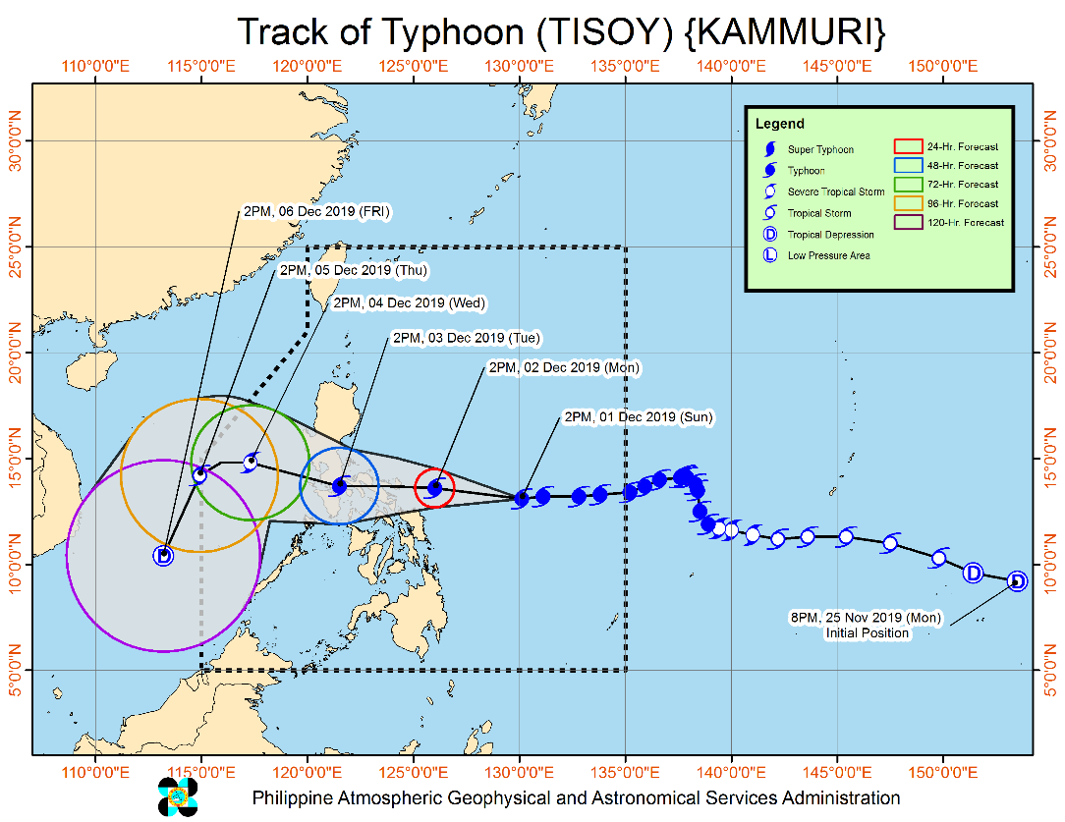
Situation Overview

Typhoon “Tisoy” increases its threat as it moves closer towards Northern Samar, Albay, Sorsogon area.

- Heavy rainfall outlook until this afternoon (02 Dec): Occasional heavy rains over Bicol Region, Samar Provinces and Biliran. Intermittent heavy rains over Northern Cebu, Northern Negros Island, Dinagat Islands, Siargao Island, and the rest of Eastern Visayas.
- Between this afternoon (02 Dec) and tomorrow noon (03 Dec): Frequent to continuous heavy to intense rains over Bicol Region, Northern Samar, Southern Quezon, and Marinduque. Occasional heavy rains over Romblon, Mindoro Provinces, Samar, Eastern Samar and the rest of CALABARZON. Intermittent heavy rains over Metro Manila, Central Luzon, eastern portions of Cagayan and Isabela, and the rest of Eastern Visayas.
- Between tomorrow noon (03 Dec) and Wednesday noon (04 Dec): Frequent to continuous heavy to intense rains over Central Luzon, Metro Manila, CALABARZON, Bicol Region, Mindoro Provinces, Marinduque, and Romblon. Intermittent to occasional heavy rains over Cordillera Administrative Region, Cagayan Valley, Pangasinan, Aklan, Capiz, and northern Antique.
- Residents in the aforementioned areas, especially those living in areas identified to be highly or very highly susceptible to flooding and rain-induced landslides, are advised to take appropriate actions, coordinate with local disaster risk reduction and management offices, and continue monitoring for updates, especially the Thunderstorm or Rainfall Advisories and Heavy Rainfall Warnings to be issued by PAGASA Regional Services Divisions.
- Possible Storm Surge height in surge prone areas: more than 3.0 meters over several coastal areas in Camarines Norte (Mercedes and Mandao), Camarines Sur (Cabusao, Bombon, Calabanga, Tinambac, and Sipocot), and Catanduanes (Bagamanoc, Baras, Bato, Viga, Panganiban and Gigmoto); 1 to 3 meters over several coastal areas in Quezon, Camarines Norte, Camarines Sur, Catanduanes, and Samar. For more information, refer to "Storm Surge Warning #3" issued at 11:00 AM today (02 Dec).
- Sea travel is risky over the seaboards of areas under TCWS, the seaboards of Northern Luzon, the western seaboard of Palawan, central seaboards of Visayas, and the northern and eastern seaboards of Mindanao due to prevailing or forecast rough sea conditions which may be perilous for maritime activities, especially for those using small seacrafts.
- Gusty conditions may also be experienced in areas in Northern Luzon that are not under any TCWS (especially in the coastal and mountainous zones) due to the Northeast Monsoon.
- "TISOY" is forecast to make landfall over Catanduanes, Albay or Sorsogon between tonight and tomorrow early morning.

At 1:00 PM today, the eye of Typhoon "TISOY" was located based on all available data including Virac Doppler Radar at 195 km East of Juban, Sorsogon (13.0 °N, 125.8 °E )

Source: DOST-PAGASA Severe Weather Bulletin
PREDICTIVE ANALYTICS FOR HUMANITARIAN RESPONSE
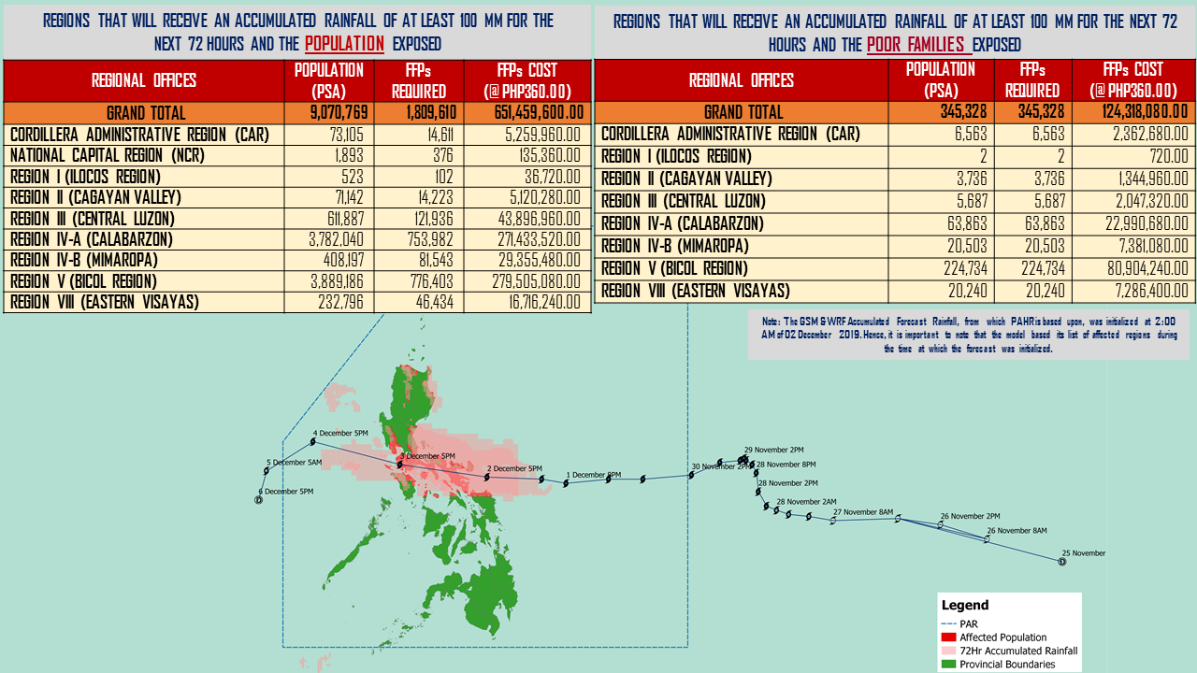

Status of Prepositioned Resources: Stockpile and Standby Funds

The DSWD Central Office (CO), Field Offices (FOs), and National Resource Operations Center (NROC) have stockpiles and standby funds amounting to ₱1,353,912,860.63 with breakdown as follows (see Table 1):

- Standby Funds
A total of ₱586,890,340.46 standby funds in the CO and FOs. Of the said amount, ₱548,990,071.00 is the available Quick Response Fund (QRF) in the CO.

- Stockpiles
A total of 299,489 family food packs (FFPs) amounting to ₱115,375,181.72 and available food and non-food items (FNIs) amounting to ₱651,647,338.45.
FIELD OFFICE | STANDBY FUNDS | FAMILY FOOD PACKS |  | Other Food Items | Non Food Items | SUB-TOTAL (Food and NFIs) | Total STANDBY FUNDS & STOCKPILE
 |  | Quantity | Total Cost | Total Cost | Total Cost
TOTAL | 586,890,340.46 | 299,489 | 115,375,181.72 | 198,892,269.76 | 452,755,068.69 | 651,647,338.45 | 1,353,912,860.63
Central Office | 548,990,071.00 | 0 | - | - | - | - | 548,990,071.00
NRLMB - NROC | - | 36,718 | 15,509,556.20 | 43,155,892.91 | 246,903,110.99 | 290,059,003.90 | 305,568,560.10
NRLMB - VDRC | - | 0 | - | 7,256,200.00 | 4,090,050.00 | 11,346,250.00 | 11,346,250.00
I | 2,379,275.00 | 14,303 | 5,178,166.58 | 299,455.20 | 37,645,525.20 | 37,944,980.40 | 45,502,421.98
II | 3,564,703.35 | 26,940 | 10,550,187.76 | 639,602.00 | 3,514,865.95 | 4,154,467.95 | 18,269,359.06
III | 3,068,057.00 | 12,629 | 5,053,812.68 | 2,420,969.70 | 6,042,738.40 | 8,463,708.10 | 16,585,577.78
CALABARZON | 1,785,325.00 | 6,405 | 2,264,433.70 | 3,187,954.80 | 5,523,160.91 | 8,711,115.71 | 12,760,874.41
MIMAROPA | 3,046,722.58 | 29,087 | 12,158,366.00 | 697,934.74 | 10,663,131.29 | 11,361,066.03 | 26,566,154.61
V | 3,000,000.00 | 23,140 | 9,024,600.00 | 5,689,296.56 | 27,591,623.94 | 33,280,920.50 | 45,305,520.50
VI | 2,040,000.00 | 13,828 | 4,978,080.00 | 3,840,535.67 | 5,285,253.00 | 9,125,788.67 | 16,143,868.67
VII | 752,800.00 | 12,565 | 4,523,400.00 | 11,682,706.50 | 11,950,331.27 | 23,633,037.77 | 28,909,237.77
VIII | 1,203,735.00 | 18,960 | 7,169,851.74 | 3,285,093.94 | 24,068,382.08 | 27,353,476.02 | 35,727,062.76
IX | 3,001,888.85 | 13,322 | 4,795,920.00 | 2,453,920.00 | 15,492,234.14 | 17,946,154.14 | 25,743,962.99
X | 3,000,000.00 | 17,823 | 6,498,552.00 | 97,334,812.23 | 13,481,175.80 | 110,815,988.03 | 120,314,540.03
XI | 322,644.00 | 33,481 | 12,100,033.40 | 3,875,600.00 | 5,285,389.50 | 9,160,989.50 | 21,583,666.90
XII | 1,415,770.18 | 5,923 | 2,371,139.00 | 6,482,259.00 | 5,918,551.16 | 12,400,810.16 | 16,187,719.34
CARAGA | 3,000,000.00 | 15,325 | 5,782,957.50 | 1,947,237.00 | 685,755.46 | 2,632,992.46 | 11,415,949.96
NCR | 3,292,543.50 | 6,346 | 2,378,666.64 | 982,611.51 | 10,538,332.60 | 11,520,944.11 | 17,192,154.25
CAR | 3,026,805.00 | 12,694 | 5,037,458.52 | 3,660,188.00 | 18,075,457.00 | 21,735,645.00 | 29,799,908.52
*Quick Response Fund (QRF) as of 28 November 2019

Situational Reports

DSWD-DRMB
DATE | SITUATIONS / ACTIONS UNDERTAKEN
02 December 2019 | - The Disaster Response Management Bureau (DRMB) is on BLUE alert status and is closely coordinating with the concerned field offices for significant disaster response updates  - All QRT members and emergency equipment are on standby and ready for deployment.

DSWD-FO NCR
DATE | SITUATIONS / ACTIONS UNDERTAKEN
29 November 2019 | - DSWD-FO NCR composed of organic staff from the Field Office and Centers and Residential Care Facilities (C/RCFs) were activated and on standby in response to any eventualities. The assignment of said staff is scheduled per day.  - The DSWD-NCR has established its EOC located at Room 109, FO-NCR, Sampaloc, Manila.

DSWD-FO I
DATE | SITUATIONS / ACTIONS UNDERTAKEN
29 November 2019 | - DSWD-FO I was closely monitoring the possible effects of Severe Tropical Storm “KAMMURI”, even outside PAR, and in close coordination with the Office of Civil Defense (OCD) Region I.  - Provincial Operations Offices (POOs) were in close coordination with the different Provincial/City/Municipal Disaster Risk Reduction and Management Councils (P/C/MDRRMCs) and Provincial/City/Municipal Social Welfare and Development Offices (P/C/MSWDOs) to monitor the adverse effects that might be brought by the weather disturbance.

DSWD-FO II
DATE | SITUATIONS / ACTIONS UNDERTAKEN
02 December 2019 | - DSWD-FO II Disaster Response Management Division ensures Relief Goods both Food and Non-Food Items (F/NFI) are ready and available at any given time.  - DSWD-FO II is in close coordination with Social Welfare and Development (SWAD) Teams, the Provincial/City/Municipal Disaster Risk Reduction and Management Council (P/C/MDRRMC) for adverse effects brought by this weather disturbance.  - DSWD-FO II ensures on-call and standby duty of the Regional DMRT for possible activation in the event Typhoon "Kammuri" accelerate its strength.

DSWD-FO CALABARZON
DATE | SITUATIONS / ACTIONS UNDERTAKEN
29 November 2019 | - DSWD-FO CALABARZON Emergency Operations Center was already activated to monitor the possible effects of TY Kammuri.  - DSWD-FO CALABARZON had constant communication with the Local Social Welfare and Development Offices (LSWDOs) with pre-disaster assessments being conducted.  - DSWD-FO CALABARZON was in close coordination with the Local Government Units (LGUs) with regards to the preparedness efforts undertaken in the Flood, Landslide and Storm Surge prone areas.  - DSWD-FO CALABARZON coordinated with SWAD Team Leaders and Provincial Action Team of the CALABARZON and advised them to monitor and coordinate with the LGUs to gather reports on the possible effects of Typhoon Kammuri.  - DSWD-FO CALABARZON had coordinated with the Administrative Division to ensure that the Disaster Response Vehicle and the six-wheeler wing van is readily available to transport personnel and goods to disaster-stricken areas should need arises.

DSWD-FO MIMAROPA
DATE | SITUATIONS / ACTIONS UNDERTAKEN
28 November 2019 | - DSWD-FO MIMAROPA alerted all P/C/M QRT in five provinces of MIMAROPA to regularly monitor the situations in the area.  - DSWD-FO MIMAROPA was in close coordination with the Office of Civil Defense and RDDRMC MIMAROPA for any warning signal updates.  - All members of Rapid Emergency Telecommunications Team are on on-call and standby status ready for deployment if needed.  - DSWD-FO MIMAROPA ensured that the Rapid Emergency Telecommunications Equipment (GX Terminal, BGAN Terminals and Satellite Phones) are in good condition and ready for deployment to areas that will experience potential emergencies.  - DSWD-FO MIMAROPA ensured that there is an on-call truck available for delivery of goods and equipment to areas that will be affected.

DSWD-FO V
DATE | SITUATIONS / ACTIONS UNDERTAKEN
02 December 2019 | - DSWD-FO V sent one (1) truck with 1,000 family food packs and 2,000 pieces of malong as prepositioned in Catanduanes.  - DSWD-FO V sent additional prepositioned goods at DPWH Tigaon, DPWH Baao, DPWH Sipocot, Camarines Sur and DPWH Daet, Camarines Norte.  - DSWD-FO V coordinated with the Office of the Presidential Adviser for Bicol Affairs (OPABA) for the use of DPWH trucks during the prepositioning of goods and relief augmentation.  - DSWD-FO V through the Resource Operation Section ensures the availability of family food packs and non-food items as need arises.  - DSWD FO V QRTs already activated.  - Provincial Action Team (PAT) and Municipal Action Team (MAT) members in the six (6) provinces are closely coordinating with the Provincial/Municipal Disaster Risk Reduction and Management Offices (P/MDRRMOs) for status reports and updates.  - DSWD-FO V coordinated with PAT/MAT for generation of data of the affected families/persons.  - DSWD-FO V is continuously monitoring the weather updates.  - A total of 5,054 families or 20,876 persons have pre-emptively evacuated in 142 Evacuation Centers in Camarines Norte, Camarines Sur and Masbate.  REGION / PROVINCE / MUNICIPALITY NUMBER OF EVACUATION CENTERS (ECs) NUMBER OF INSIDE ECs  Families Persons  NOW NOW NOW  REGION V 142 5,054 20,876  Albay 12 1,261 4,844  Guinobatan 11 1,211 4,619  Oas 1 50 225  Camarines Norte 6 1,000 3,574  Basud 2 47 152  Mercedes 1 57 241  Vinzons 3 896 3,181  Camarines Sur 93 1,657 6,994  Baao 22 93 462  Buhi 5 184 775  Calabanga 7 379 1,168  Caramoan 46 509 2,222  Del Gallego 2 50 255  Magarao 2 24 113  Minalabac 1 5 27  Sagñay 1 11 55  Tinambac 7 402 1,917  Catanduanes 29 1,061 5,172  Bagamanoc 4 63 365  Baras 4 242 1,190  Caramoran 1 30 150  Pandan 1 3 11  San Andres (Calolbon) 4 40 141  San Miguel 1 15 70  Virac (capital) 14 668 3,245  Masbate 1 59 222  Mandaon 1 59 222  Sorsogon 1 16 70  Magallanes 1 16 70

DSWD-FO VII
DATE | SITUATIONS / ACTIONS UNDERTAKEN
01 December 2019 | - Regional Disaster Risk Reduction and Management Council/Office of Civil Defense (RDRRMC/OCD-7) raised Alert Status Level to Red as TY Tisoy continuous to move closer to the landmass.  - City and Municipal Action Team and SWAD Offices already requested to closely coordinate with their local counterparts and their respective LDRRMC. Field staff requested to monitor AOR and provide reports and updates to the Regional DROMIC Focal.  - Regional and Provincial/City/Municipal Quick Response Team is on standby alert and ready for mobilization for any assistance and augmentation support needed from the LGUs.  - Warehouses in the three island provinces are on ready alert.  - DSWD-FO VII is in close coordination with OCD-7 and other members of the RDRRMC for any response mobilization strategies.  - DSWD-FO VII is continuously monitoring the latest weather updates, alerts and relevant information for widest dissemination to DSWD staff in the field.

DSWD-FO VIII
DATE | SITUATIONS / ACTIONS UNDERTAKEN
02 December 2019 | - DSWD-FO VIII Disaster Response Management Division-Disaster Response Information Management Section (DRMD-DRIMS) was monitoring the weather situation and is in close coordination with SWADTs, QRTs and PDOs for any eventualities on the ground.  - All Quick Response Team (QRT) members and DRMD staff were alerted in case augmentation is needed.  - Regional Resource Operation Section (RROS) was also alerted to ensure the readiness of dispatching the food and non-food commodities.  - There are 93 families or 251 individuals who were pre-emptively evacuated in and are currently accommodated in 3 evacuation centers in Jipapad, Eastern Samar and 14 families or 56 individuals pre-emptively evacuated and moved to their relatives and/or friends in Sogod, Southern Leyte.  REGION / PROVINCE / MUNICIPALITY NUMBER OF EVACUATION CENTERS (ECs) NUMBER OF INSIDE ECs NUMBER OF OUTSIDE ECs  Families Persons Families Persons  NOW NOW NOW NOW NOW  REGION VIII 3 93 251 14 56  Eastern Samar 3 93 251 - -  Jipapad 3 93 251 - -  Southern Leyte - - - 14 56  Sogod - - - 14 56

DSWD-FO CARAGA
DATE | SITUATIONS / ACTIONS UNDERTAKEN
02 December 2019 | - DSWD-FO CARAGA is continuously coordinating with LSWDOs and LDRRMOs for the provision of timely updates and information.

DSWD-FO CAR
DATE | SITUATIONS / ACTIONS UNDERTAKEN
01 December 2019 | - DSWD-FO CAR attended the Pre Disaster Risk Assessment and Response Cluster Meeting at Office of Civil Defense CAR.  - DSWD-FO CAR updated the Response Asset.
29 November 2019 | - The Operations Center is on BLUE alert status in accordance to the alert level status of Cordillera Regional Disaster Risk Reduction and Management Council (CRDRRMC).  - Quick Response Teams (QRT), Provincial Social Welfare and Development Teams (PSWADT), Municipal Action Teams (MAT) were on alert and on standby.  - Rapid Emergency Telecommunications Team (RETT) including the INMARSAT equipment were on standby.  - DSWD-FO CAR coordinated with the OCD regarding list of barangays with High and Moderate Landslide Susceptibility and barangays with Very High, High and Moderate Flood Susceptibility.  - DSWD-FO CAR Mapped the Landslide Susceptibility listed barangays from MGB through the OCD CAR.

*****
The Disaster Response Operations Monitoring and Information Center (DROMIC) of the DSWD-DRMB is closely monitoring the effects of Typhoon Tisoy and is coordinating with the concerned DSWD Field Offices for any significant updates.

Prepared by:

MARIEL B. FERRARIZ
DIANE C. PELEGRINO

RODEL V. CABADDU
Releasing Officer

