DSWD DROMIC Report #1 on the
Ms 6.9 Earthquake Incident in Matanao, Davao del Sur
as of 16 December 2019, 6PM

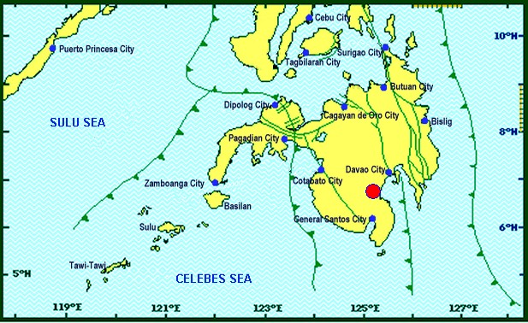

Situation Overview

On 15 December 2019 at 02:11 PM, a 6.9 magnitude earthquake jolted the municipality of Matanao, Devao del Sur (06.74°N, 125.20°E - 005 km N 72° W) with a tectonic origin and a depth of focus of 3 km.

Source: DOST-PHIVOLCS Earthquake Bulletin

- Status of Affected Families / Persons
A total of 1,951 families or 9,755 persons were affected by the earthquake incident in 12 barangays in Region XI (see Table 1).

Table 1. Number of Affected Families / Persons
REGION / PROVINCE / MUNICIPALITY |  | NUMBER OF AFFECTED
 |  | Barangays | Families | Persons
GRAND TOTAL |  | 12 | 1,951 | 9,755
REGION XI |  | 12 | 1,951 | 9,755
Davao del Sur |  | 12 | 1,951 | 9,755
 | Bansalan | 2 | 17 | 85
 | City of Digos (capital) | 9 | 1,896 | 9,480
 | Santa Cruz | 1 | 38 | 190
Note: Ongoing assessment and validation being conducted.
Source: DSWD-FO XI

- Status of Displaced Families / Persons
There are 1,913 families or 9,565 persons taking temporary shelter in 13 evacuation centers in Region XI (see Table 2).

Table 2. Number of Displaced Families / Persons Inside Evacuation Centers
REGION / PROVINCE / MUNICIPALITY |  | NUMBER OF EVACUATION CENTERS (ECs) |  | NUMBER OF DISPLACED
 |  |  |  | INSIDE ECs
 |  |  |  | Families |  | Persons (Actual)
 |  | CUM | NOW | CUM | NOW | CUM | NOW
GRAND TOTAL |  | 13 | 13 | 1,913 | 1,913 | 9,565 | 9,565
REGION XI |  | 13 | 13 | 1,913 | 1,913 | 9,565 | 9,565
Davao del Sur |  | 13 | 13 | 1,913 | 1,913 | 9,565 | 9,565
 | Bansalan | 3 | 3 | 17 | 17 | 85 | 85
 | City of Digos (capital) | 10 | 10 | 1,896 | 1,896 | 9,480 | 9,480
Note: Ongoing assessment and validation being conducted.
Source: DSWD-FO XI

- Assistance Provided
A total of ₱57,473.65 worth of assistance was provided by DSWD to the affected families (see Table 3).

Table 3. Cost of Assistance Provided to Affected Families / Persons
REGION / PROVINCE / MUNICIPALITY |  | COST OF ASSISTANCE
 |  | DSWD | LGU | NGOs | OTHERS | GRAND TOTAL
GRAND TOTAL |  | 57,473.65 | - | - | - | 57,473.65
REGION XI |  | 57,473.65 | - | - | - | 57,473.65
Davao del Sur |  | 57,473.65 | - | - | - | 57,473.65
 | City of Digos (capital) | 57,473.65 | - | - | - | 57,473.65
Source: DSWD-FO XI

DSWD DISASTER RESPONSE INFORMATION
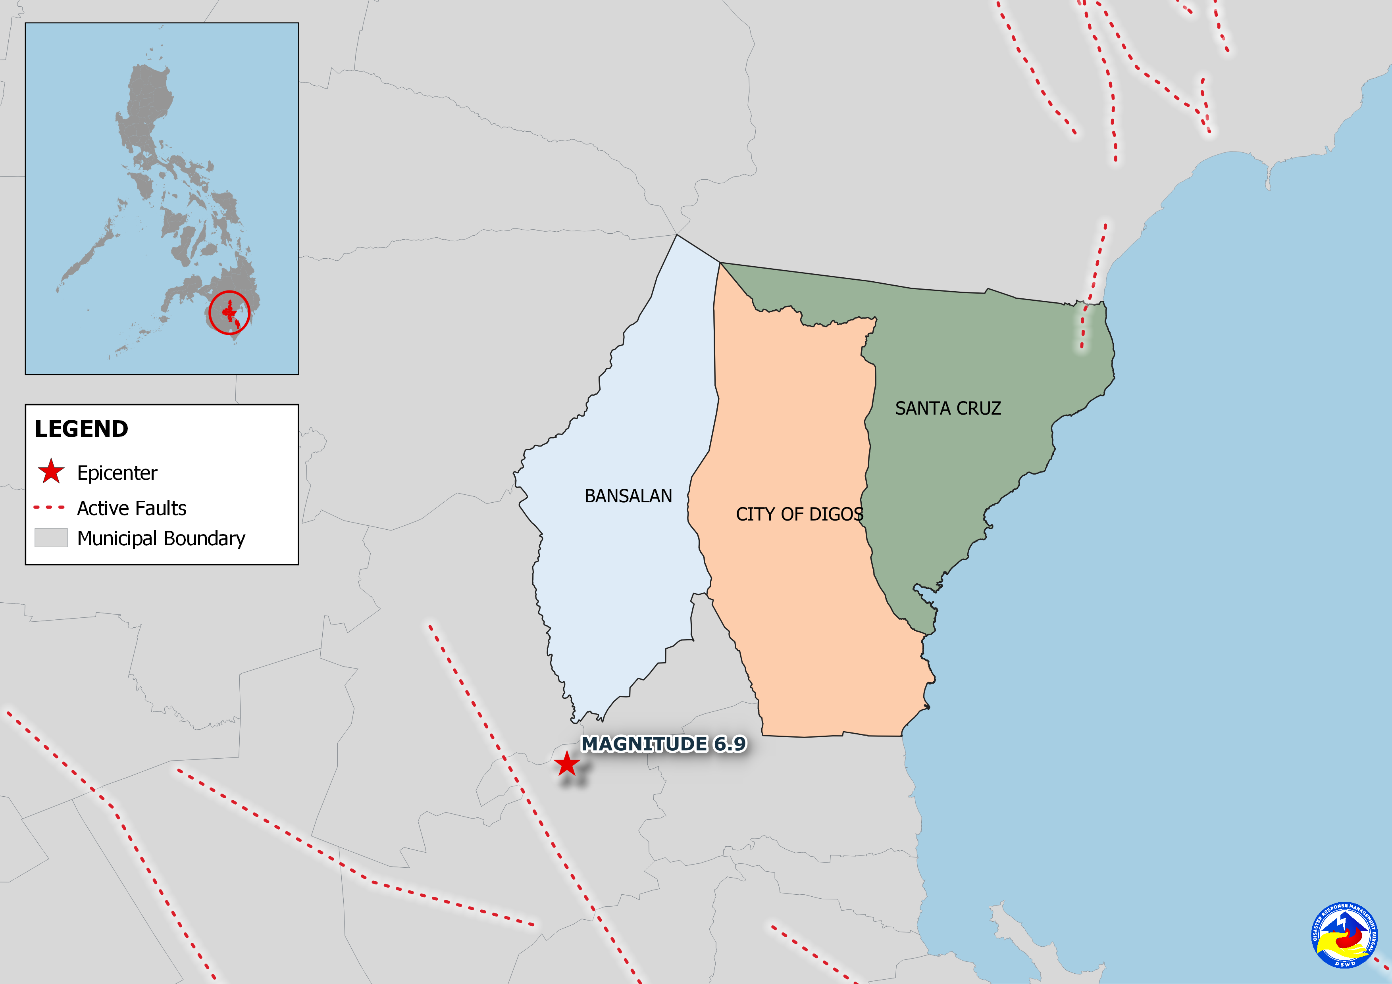

Situational Reports

DSWD-DRMB
DATE | SITUATIONS / ACTIONS UNDERTAKEN
16 December 2019 | - The Disaster Response Management Bureau (DRMB) is on BLUE alert status and is closely coordinating with the concerned Field Offices for significant disaster response updates.

DSWD-FO XI
DATE | SITUATIONS / ACTIONS UNDERTAKEN
16 December 2019 | - DSWD-FO XI is in close coordination with the concerned LGUs for any significant updates.

DSWD-FO XII
DATE | SITUATIONS / ACTIONS UNDERTAKEN
16 December 2019 | - DSWD-FO XII is closely monitoring and coordinating with the concerned LGUs for any possible resource augmentation.  - Four (4) vehicles are ready for utilization in case of response activation.  - All QRT members are on standby and ready for activation if there is a need for deployment.

*****
The Disaster Response Operations Monitoring and Information Center (DROMIC) of the DSWD-DRMB is closely coordinating with concerned DSWD Field Offices for any significant disaster response updates.

Prepared by:

MARIEL B. FERRARIZ

CLARRIE MAE A. CASTILLO
Releasing Officer

