DSWD DROMIC Report #15 on the
Ms 6.9 Earthquake Incident in Matanao, Davao del Sur
as of 03 January 2020, 6PM

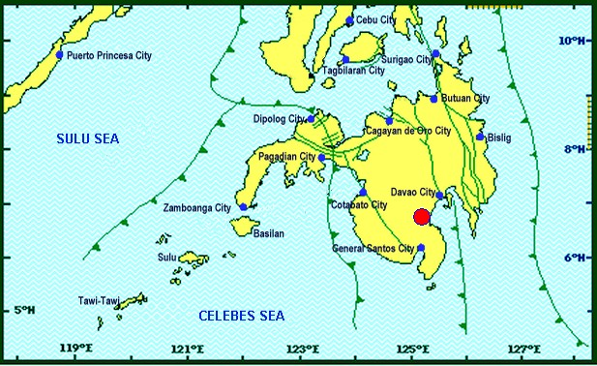
Situation Overview

On 15 December 2019 at 2:11 PM, a 6.9 magnitude earthquake jolted the municipality of Matanao, Davao del Sur (06.74°N, 125.20°E - 005 km N 72°W) with a tectonic origin and a depth of focus of 3 km.

Source: DOST-PHIVOLCS Earthquake Bulletin

- Status of Affected Families / Persons
A total of 86,547 families or 394,355 persons were affected by the earthquake incident in 218 barangays in Regions XI and XII (see Table 1).

Table 1. Number of Affected Families / Persons
REGION / PROVINCE / MUNICIPALITY |  | NUMBER OF AFFECTED
 |  | Barangays | Families | Persons
GRAND TOTAL |  | 218 | 86,547 | 394,355
REGION XI |  | 207 | 86,182 | 392,700
Davao del Sur |  | 207 | 86,182 | 392,700
 | Bansalan | 25 | 6,993 | 32,638
 | City of Digos (capital) | 13 | 3,120 | 15,575
 | Hagonoy | 21 | 9,223 | 32,254
 | Kiblawan | 30 | 13,938 | 67,626
 | Magsaysay | 22 | 15,939 | 75,596
 | Malalag | 15 | 10,937 | 54,685
 | Matanao | 33 | 14,477 | 59,587
 | Padada | 17 | 7,421 | 37,105
 | Santa Cruz | 6 | 661 | 3,499
 | Sulop | 25 | 3,473 | 14,135
REGION XII |  | 11 | 365 | 1,655
North Cotabato |  | 3 | 37 | 185
 | M'lang | 3 | 37 | 185
Sarangani |  | 5 | 175 | 705
 | Malungon | 5 | 175 | 705
Sultan Kudarat |  | 3 | 153 | 765
 | Columbio | 3 | 153 | 765
Note: The increase and decrease in the number of affected persons in Davao del Sur is based on the validated report submitted by DSWD-FO XI. Thus, ongoing assessment and validation being conducted.
Source: DSWD-FOs XI and XII

- Status of Displaced Families / Persons
- Inside Evacuation Centers
There are 10,244 families or 38,633 persons taking temporary shelter in 107 evacuation centers in Regions XI and XII (see Table 2).

Table 2. Number of Displaced Families / Persons Inside Evacuation Centers
REGION / PROVINCE / MUNICIPALITY |  | NUMBER OF EVACUATION CENTERS (ECs) |  | NUMBER OF DISPLACED
 |  |  |  | INSIDE ECs
 |  |  |  | Families |  | Persons
 |  | CUM | NOW | CUM | NOW | CUM | NOW
GRAND TOTAL |  | 109 | 107 | 12,008 | 10,244 | 50,562 | 38,633
REGION XI |  | 105 | 103 | 11,794 | 10,030 | 49,537 | 37,608
Davao del Sur |  | 105 | 103 | 11,794 | 10,030 | 49,537 | 37,608
 | Bansalan | 12 | 12 | 1,032 | 970 | 3,585 | 3,417
 | City of Digos (capital) | 15 | 14 | 3,416 | 3,027 | 16,720 | 11,889
 | Hagonoy | 5 | 4 | 701 | 441 | 2,302 | 1,671
 | Kiblawan | 41 | 41 | 1,975 | 1,847 | 7,842 | 7,427
 | Magsaysay | 11 | 11 | 1,511 | 1,510 | 5,674 | 5,670
 | Malalag | 4 | 4 | 469 | 435 | 1,883 | 1,408
 | Matanao | 16 | 16 | 2,654 | 1,768 | 11,371 | 6,016
 | Padada | 1 | 1 | 36 | 32 | 160 | 110
REGION XII |  | 4 | 4 | 214 | 214 | 1,025 | 1,025
Sarangani |  | 3 | 3 | 61 | 61 | 260 | 260
 | Malungon | 3 | 3 | 61 | 61 | 260 | 260
Sultan Kudarat |  | 1 | 1 | 153 | 153 | 765 | 765
 | Columbio | 1 | 1 | 153 | 153 | 765 | 765
Note: The increase and decrease in the number of affected persons in Davao del Sur is based on the validated report submitted by DSWD-FO XI. Thus, ongoing assessment and validation being conducted.
Source: DSWD-FOs XI and XII

- Outside Evacuation Centers
There are 23,321 families or 100,427 persons currently staying with their relatives and/or friends, or in open spaces (see Table 3).

Table 3. Number of Displaced Families / Persons Outside Evacuation Centers
REGION / PROVINCE / MUNICIPALITY |  | NUMBER OF DISPLACED
 |  | OUTSIDE ECs
 |  | Families |  | Persons
 |  | CUM | NOW | CUM | NOW
GRAND TOTAL |  | 23,475 | 23,321 | 100,951 | 100,427
REGION XI |  | 23,361 | 23,207 | 100,506 | 99,982
Davao del Sur |  | 23,361 | 23,207 | 100,506 | 99,982
 | Bansalan | 3,762 | 3,677 | 17,374 | 17,195
 | City of Digos (capital) | 119 | 119 | 595 | 595
 | Hagonoy | 8,642 | 8,642 | 30,376 | 30,376
 | Kiblawan | 1,984 | 1,984 | 9,330 | 9,330
 | Magsaysay | 247 | 247 | 1,235 | 1,235
 | Malalag | 7,486 | 7,417 | 37,430 | 37,085
 | Padada | 926 | 926 | 2,996 | 2,996
 | Santa Cruz | 195 | 195 | 1,170 | 1,170
REGION XII |  | 114 | 114 | 445 | 445
Sarangani |  | 114 | 114 | 445 | 445
 | Malungon | 114 | 114 | 445 | 445
Note: The increase and decrease in the number of affected persons in Davao del Sur is based on the validated report submitted by DSWD-FO XI. Thus, ongoing assessment and validation being conducted.
Source: DSWD-FOs XI and XII

- Damaged Houses
There are 38,985 damaged houses; of which, 6,960 are totally damaged and 32,025 are partially damaged (see Table 4).

Table 4. Number of Damaged Houses
REGION / PROVINCE / MUNICIPALITY |  | NO. OF DAMAGED HOUSES
 |  | Total | Totally | Partially
GRAND TOTAL |  | 38,985 | 6,960 | 32,025
REGION XI |  | 38,953 | 6,960 | 31,993
Davao del Sur |  | 38,953 | 6,960 | 31,993
 | Bansalan | 3,708 | 1,031 | 2,677
 | City of Digos (capital) | 119 | - | 119
 | Hagonoy | 8,866 | 775 | 8,091
 | Kiblawan | 4,142 | 523 | 3,619
 | Magsaysay | 7,774 | 2,530 | 5,244
 | Malalag | 2,430 | 111 | 2,319
 | Matanao | 4,950 | 1,380 | 3,570
 | Padada | 3,311 | 347 | 2,964
 | Santa Cruz | 195 | 1 | 194
 | Sulop | 3,458 | 262 | 3,196
REGION XII |  | 32 | - | 32
North Cotabato |  | 32 | - | 32
 | M'lang | 32 | - | 32
Note: The increase and decrease in the number of damaged houses in Davao del Sur is based on the validated report submitted by DSWD-FO XI. Thus, ongoing assessment and validation being conducted.
Source: DSWD-FOs XI and XII

- Assistance Provided
A total of ₱26,058,701.87 worth of assistance was provided by DSWD to the affected families (see Table 5).

Table 5. Cost of Assistance Provided to Affected Families / Persons
REGION / PROVINCE / MUNICIPALITY |  | COST OF ASSISTANCE
 |  | DSWD | LGU | NGOs | OTHERS | GRAND TOTAL
GRAND TOTAL |  | 26,058,701.87 | - | - | - | 26,058,701.87
REGION XI |  | 25,719,311.87 | - | - | - | 25,719,311.87
Davao del Sur |  | 25,719,311.87 | - | - | - | 25,719,311.87
 | Bansalan | 337,295.00 | - | - | - | 337,295.00
 | City of Digos (capital) | 6,288,903.93 | - | - | - | 6,288,903.93
 | Hagonoy | 4,031,294.44 | - | - | - | 4,031,294.44
 | Kiblawan | 2,889,297.20 | - | - | - | 2,889,297.20
 | Magsaysay | 1,466,569.00 | - | - | - | 1,466,569.00
 | Malalag | 3,211,755.88 | - | - | - | 3,211,755.88
 | Matanao | 2,093,514.00 | - | - | - | 2,093,514.00
 | Padada | 4,359,449.92 | - | - | - | 4,359,449.92
 | Sulop | 1,041,232.50 | - | - | - | 1,041,232.50
REGION XII |  | 339,390.00 | - | - | - | 339,390.00
Sultan Kudarat |  | 339,390.00 | - | - | - | 339,390.00
 | Columbio | 339,390.00 | - | - | - | 339,390.00

Source: DSWD-FOs XI and XII

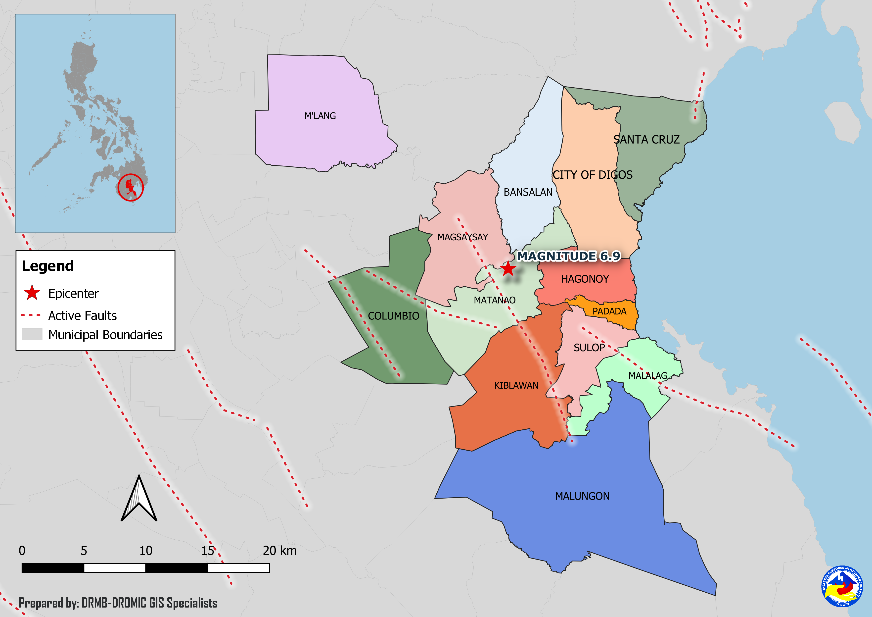
DSWD DISASTER RESPONSE INFORMATION

Situational Reports

DSWD-DRMB
DATE | SITUATIONS / ACTIONS UNDERTAKEN
03 January 2020 | - The Disaster Response Management Bureau (DRMB) is closely coordinating with the concerned Field Offices for significant disaster response updates.

DSWD-FO XI
DATE | SITUATIONS / ACTIONS UNDERTAKEN
03 January 2020 | - DSWD-FO XI distributed family food packs to the affected families in Malalag, Davao del Sur and its Crisis Intervention Unit (CIU) extended cash assistance to the affected families in Padada and Malalag.  - DSWD-FO XI provided ₱20,599,000.00 worth of cash assistance to the affected families.  - DSWD-FO XI is still on BLUE alert.
02 January 2020 | - DSWD-FO XI distributed family food packs to the affected families in Malalag, Davao del Sur.  - DSWD-FO XI closely coordinated with PSWDO/MSWDO for updates and reports relative to the earthquake incident.
31 December 2019 | - DSWD-FO XI provided ₱6,733,000.00 worth of cash assistance to the affected families.  - DSWD-FO XI through the Disaster Response Management Division (DRMD) visited the affected municipalities in Davao del Sur and checked the status of the evacuation centers established in the municipalities.  - DSWD-FO XI deployed new camp managers in all areas affected by the earthquake.  - The Municipal Coordinator assigned in the municipality of Kiblawan conducted validation of the camps that were reported by the BLGU to the MDRRMO.  - DSWD-FO XI conducted site visit at the Municipality of Padada, Davao del Sur and attended meeting with PLGU of Davao del Sur.  - Interfacing of camp managers to be assigned at different evacuation centers and camps in the affected municipalities and cities.  - DSWD-FO XI established satellite operations center and mobile storage at Brgy. Matti, Capitol, Digos City.

DSWD-FO XII
DATE | SITUATIONS / ACTIONS UNDERTAKEN
26 December 2019 | - DSWD-FO XII provided 24 family tents to affected families in Malungon, Sarangani.  - 135 families were given financial assistance worth ₱2,400.00 through DSWD Assistance to Individual in Crisis Situation.
19 December 2019 | - DSWD-FO XII provided 270 packs family food packs, 135 pieces of sleeping kits, 270 pieces of collapsible water, 135 pieces of kitchen kits for the affected families in Columbio, Sultan Kudarat.  - DSWD-FO XII provided 5 units of tent in Malungon, Sarangani.
17 December 2019 | - DSWD-FO XII released 20 additional tents to the Local Government Unit of Malungon.

*****
The Disaster Response Operations Monitoring and Information Center (DROMIC) of the DSWD-DRMB is closely coordinating with concerned DSWD Field Offices for any significant disaster response updates.

Prepared by:

CLARRIE MAE A. CASTILLO

MARC LEO L. BUTAC
Releasing Officer

