DSWD DROMIC Report #2 on Typhoon “URSULA”
as of 25 December 2019, 5PM

Situation Overview

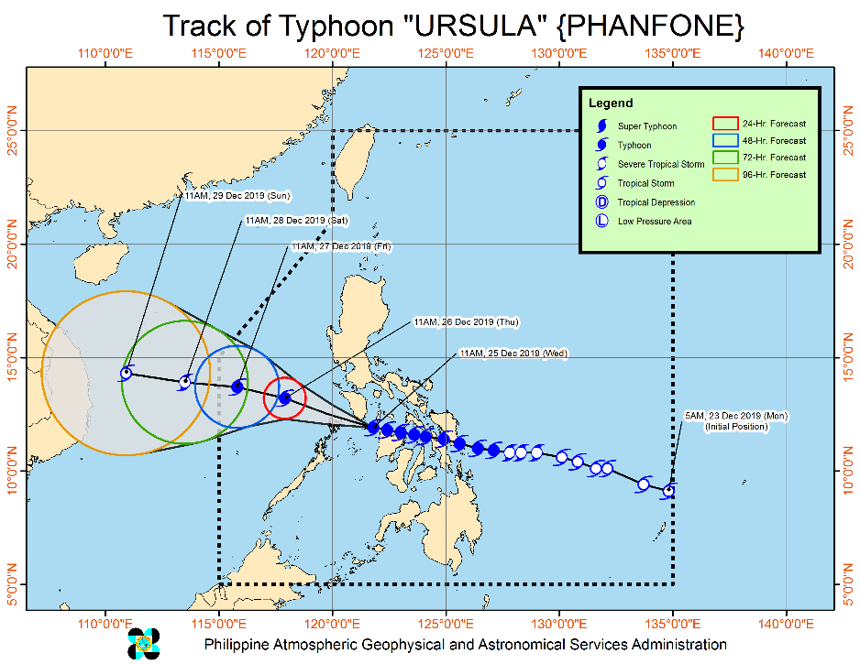
"URSULA" maintains its strength as it moves towards southern portion of Mindoro Provinces.

- The eyewall of Typhoon "URSULA" is bringing very destructive winds and intense rainfall over Caluya Islands. The southern portion of Mindoro Provinces will be affected by the eyewall in the coming hours. In case of the passage of the eye in some of the aforementioned areas, calm conditions will be experienced. However, as soon as the eye moves out of the area, violent conditions associated with the eyewall will resume.
- Tropical Cyclone Wind Signals are now lifted over Sorsogon and northern Cebu.

Heavy Rainfall Outlook
- Until tonight: Occasional to frequent heavy with intermittent intense rains over Aklan, Antique, Capiz, Romblon, Calamian Islands, Cuyo Islands, and Mindoro Provinces. Light to moderate rains with isolated heavy rainshowers during thunderstorms over Bicol Region, rest of Western Visayas, CALABARZON, Metro Manila, Marinduque, Aurora and the northern portion of mainland Palawan.
- Residents in these areas are advised to take appropriate measures to reduce the potential impact of flooding and rain-induced landslides, especially in areas identified to be highly to very highly susceptible to these hazards.

Onset of Tropical Cyclone Winds
- Moderate to strong winds to begin affecting Metro Manila and Bataan between this afternoon.
- Destructive typhoon-force winds to begin affecting Mindoro Provinces this afternoon; Calamian islands between this afternoon and evening.

Other Hazards and Warning Information
- Rough sea conditions will prevail over the seaboards of areas under TCWS, as well the seaboards of Aurora, and the northern and eastern seaboards of Mindanao. Sea travel remains risky over these areas.
- Storm surge of 1.0 to 2.0 meters may affect several coastal areas in southern Masbate, Aklan, Capiz, northern Antique, northeastern Iloilo, Romblon, Marinduque, and Mindoro Provinces, Calamian Islands and Cuyo Islands in the next 24 hours.
- Landfalls: Salcedo, Eastern Samar (4:45 PM yesterday); Tacloban City, Leyte (7:30 PM yesterday); Cabucgayan, Biliran (9:15 PM yesterday); Gigantes Islands, Carles, Iloilo (2:30 AM today), Ibajay, Aklan (8:40 AM today).

At 1:00 PM today, the eye of Typhoon "URSULA" was located based on all available data including Busuanga Doppler Radar at 70 km Southeast of San Jose, Occidental Mindoro (12.0°N, 121.5°E).

Source: DOST-PAGASA Severe Weather Bulletin

- Status of Affected Families / Persons
A total of 569 families or 2,351 persons are affected in 38 barangays in Regions VII and Caraga (see Table 1).

Table 1. Number of Affected Families / Persons
REGION / PROVINCE / MUNICIPALITY |  | NUMBER OF AFFECTED
 |  | Barangays | Families | Persons
GRAND TOTAL |  | 38 | 569 | 2,351
REGION VII |  | 17 | 232 | 1,000
Cebu |  | 17 | 232 | 1,000
 | City of Bogo | 1 | 19 | 73
 | Daanbantayan | 4 | 35 | 176
 | Dumanjug | 1 | 76 | 382
 | Poro | 6 | 36 | 159
 | Tudela | 5 | 66 | 210
CARAGA |  | 21 | 337 | 1,351
Dinagat Island |  | 19 | 307 | 1,228
 | Basilisa (Rizal) | 7 | 101 | 404
 | Libjo (Albor) | 3 | 31 | 124
 | San Jose (capital) | 7 | 166 | 664
 | Tubajon | 2 | 9 | 36
Surigao del Norte |  | 2 | 30 | 123
 | Pilar | 2 | 30 | 123
Note: Ongoing assessment and validation being conducted.
Source: DSWD-FOs VII and Caraga

- Status of Displaced Families / Persons
- Inside Evacuation Centers
There are 425 families or 1,654 persons taking temporary shelter in 31 evacuation centers in Regions VII and Caraga (see Table 2).

Table 2. Number of Displaced Families / Persons Inside Evacuation Centers
REGION / PROVINCE / MUNICIPALITY |  | NUMBER OF EVACUATION CENTERS (ECs) |  | NUMBER OF DISPLACED
 |  |  |  | INSIDE ECs
 |  |  |  | Families |  | Persons
 |  | CUM | NOW | CUM | NOW | CUM | NOW
GRAND TOTAL |  | 33 | 31 | 455 | 425 | 1,777 | 1,654
REGION VII |  | 10 | 10 | 118 | 118 | 426 | 426
Cebu |  | 10 | 10 | 118 | 118 | 426 | 426
 | City of Bogo | 1 | 1 | 19 | 19 | 73 | 73
 | Poro | 7 | 7 | 36 | 36 | 159 | 159
 | Tudela | 2 | 2 | 63 | 63 | 194 | 194
CARAGA |  | 23 | 21 | 337 | 307 | 1,351 | 1,228
Dinagat Island |  | 21 | 21 | 307 | 307 | 1,228 | 1,228
 | Basilisa (Rizal) | 10 | 10 | 101 | 101 | 404 | 404
 | Libjo (Albor) | 3 | 3 | 31 | 31 | 124 | 124
 | San Jose (capital) | 6 | 6 | 166 | 166 | 664 | 664
 | Tubajon | 2 | 2 | 9 | 9 | 36 | 36
Surigao del Norte |  | 2 | - | 30 | - | 123 | -
 | Pilar | 2 | - | 30 | - | 123 | -
Note: Ongoing assessment and validation being conducted.
Source: DSWD-FOs VII and Caraga

- Outside Evacuation Centers
There are 3 families or 16 persons currently staying with their relatives and/or friends (see Table 3).

Table 3. Number of Displaced Families / Persons Outside Evacuation Centers
REGION / PROVINCE / MUNICIPALITY |  | NUMBER OF DISPLACED
 |  | OUTSIDE ECs
 |  | Families |  | Persons
 |  | CUM | NOW | CUM | NOW
GRAND TOTAL |  | 3 | 3 | 16 | 16
REGION VII |  | 3 | 3 | 16 | 16
Cebu |  | 3 | 3 | 16 | 16
 | Tudela | 3 | 3 | 16 | 16
Note: Ongoing assessment and validation being conducted.
Source: DSWD-FO VII

Status of Prepositioned Resources: Stockpile and Standby Funds

The DSWD Central Office (CO), Field Offices (FOs), and National Resource Operations Center (NROC) have stockpiles and standby funds amounting to ₱1,914,941,449.98 with breakdown as follows (see Table 4):

- Standby Funds
A total of ₱1,204,499,677.12 standby funds available in the CO and FOs. Of the said amount, ₱1,161,591,871.91 is the available Quick Response Fund (QRF) in the CO.

- Stockpiles
A total of 259,975 family food packs (FFPs) amounting to ₱98,412,415.34 and available food and non-food items (FNIs) amounting to ₱612,029,357.52.

Table 4. Available Standby Funds and Stockpiles
 | STANDBY FUNDS | FAMILY FOOD PACKS |  | Other Food Items | Non Food Items | SUB-TOTAL (Food and NFIs) | Total STANDBY FUNDS & STOCKPILE
 |  | Quantity | Total Cost | Total Cost | Total Cost
TOTAL | 1,204,499,677.12 | 259,975 | 98,412,415.34 | 179,977,803.95 | 432,051,553.57 | 612,029,357.52 | 1,914,941,449.98
Central Office | 1,161,591,871.91 | - | - | - | - | - | 1,161,591,871.91
NRLMB - NROC | - | 12,150 | 4,582,251.00 | 31,262,201.29 | 220,849,102.11 | 252,111,303.40 | 256,693,554.40
NRLMB - VDRC | - | 600 | 216,000.00 | 7,365,040.00 | 4,090,050.00 | 11,455,090.00 | 11,671,090.00
I | 2,379,275.00 | 14,984 | 5,423,326.58 | 299,455.20 | 37,645,525.20 | 37,944,980.40 | 45,747,581.98
II | 3,537,163.35 | 28,472 | 10,219,382.24 | 639,602.00 | 10,408,918.95 | 11,048,520.95 | 24,805,066.54
III | 3,068,057.00 | 12,604 | 5,044,384.18 | 2,406,194.70 | 6,022,018.40 | 8,428,213.10 | 16,540,654.28
CALABARZON | 3,000,000.00 | 5,763 | 2,078,967.02 | 3,168,773.20 | 5,523,160.91 | 8,691,934.11 | 13,770,901.13
MIMAROPA | 2,540,473.78 | 25,971 | 10,855,878.00 | 898,761.00 | 8,482,881.29 | 9,381,642.29 | 22,777,994.07
V | 3,000,000.00 | 22,815 | 8,681,904.88 | 6,331,723.96 | 31,404,289.94 | 37,736,013.90 | 49,417,918.78
VI | 3,000,000.00 | 16,666 | 5,999,760.00 | 6,209,765.75 | 5,285,253.00 | 11,495,018.75 | 20,494,778.75
VII | 3,000,800.00 | 14,349 | 5,165,640.00 | 8,230,869.59 | 10,349,862.37 | 18,580,731.96 | 26,747,171.96
VIII | 1,203,735.00 | 7,116 | 2,736,143.28 | 2,195,592.06 | 20,937,915.08 | 23,133,507.14 | 27,073,385.42
IX | 3,000,000.00 | 18,493 | 6,657,480.00 | 2,076,520.00 | 15,472,334.14 | 17,548,854.14 | 27,206,334.14
X | 3,000,000.00 | 26,430 | 9,732,923.64 | 87,239,260.45 | 12,628,921.90 | 99,868,182.35 | 112,601,105.99
XI | 3,000,644.00 | 8,170 | 3,238,342.90 | 7,170,000.00 | 6,973,437.90 | 14,143,437.90 | 20,382,424.80
XII | 3,000,770.18 | 15,715 | 6,297,731.00 | 3,337,676.00 | 6,716,851.16 | 10,054,527.16 | 19,353,028.34
CARAGA | 3,000,000.00 | 15,238 | 5,751,611.40 | 1,884,232.10 | 1,772,370.46 | 3,656,602.56 | 12,408,213.96
NCR | 176,886.00 | 4,158 | 1,558,162.92 | 659,823.29 | 10,573,477.85 | 11,233,301.14 | 12,968,350.06
CAR | 3,000,000.90 | 10,281 | 4,172,526.30 | 8,602,313.36 | 16,915,182.91 | 25,517,496.27 | 32,690,023.47

Situational Reports

DSWD-DRMB
DATE | SITUATIONS / ACTIONS UNDERTAKEN
25 December 2019 | - The Disaster Response Management Bureau (DRMB) is on BLUE alert status and is closely coordinating with the concerned Field Offices for significant disaster response updates.  - All QRT members and emergency equipment are on standby and ready for deployment.

DSWD-FO MIMAROPA
DATE | SITUATIONS / ACTIONS UNDERTAKEN
25 December 2019 | - DSWD-FO MIMAROPA through its Disaster Response Management Division (DRMD) and Provincial Project Development Officers are alerted to monitor daily local weather condition and ensure provision of information to all concerned offices, divisions, sections, offices.  - Alerted all P/C/M Quick Response Team in five provinces of MIMAROPA to regularly monitor the situations in their areas.  - 24/7 on-call status of the R/P/C/M QRT together with special projects for the possible activation of Operation Center.  - Close coordination with the Office of Civil Defense (OCD) and RDRRMC MIMAROPA for any warning signal updates for monitoring purposes and response mechanism for areas that will be affected.  - Standby logistical equipment and workforce through coordination with SWADT Offices and concerned LGUs on the management of stranded passengers, in ports and terminals, if any.  - Information and Communication Technology Management Unit (ICTMU) is on standby status to ensure robust communication system.  - All members of Rapid Emergency Telecommunications Team are on-call and on standby status ready for deployment if needed.  - Ensured that the Rapid Emergency Telecommunications Equipment (GX Terminal, BGAN and satellite phones) are in good condition and ready for deployment to areas that will experience potential emergencies.  - Ensured that there is an on-call truck available for delivery of goods and equipment to areas that will be affected.  - A total of 137 families or 523 persons have pre-emptively evacuated in 4 Evacuation Centers in Oriental Mindoro.  REGION / PROVINCE / MUNICIPALITY NUMBER OF EVACUATION CENTERS (ECs) NUMBER OF DISPLACED  INSIDE ECs  Families Persons  NOW NOW NOW  MIMAROPA 4 137 523  Oriental Mindoro 4 137 523  Mansalay 3 100 369  Roxas 1 37 154

DSWD-FO V
DATE | SITUATIONS / ACTIONS UNDERTAKEN
25 December 2019 | - DSWD-FO V augmented 4,000 family food packs amounting to ₱1,508,560.00 to the province of Sorsogon.  - DSWD-FO V through the Disaster Response Management Division (DRMD) facilitated the provision of assistance to the affected individuals.  - DSWD-FO V coordinated with PAT/MAT for generation of data of the affected families/persons.  - DSWD-FO V through DRMD continuous to monitor weather updates and information.  - DSWD-FO V Resource Operation Section ensured the availability of family food packs and non-food items as need arises.  - PAT and MAT members in the 6 provinces are in close coordination with the P/MDRRMOs for status reports and updates.  - A total of 1,464 families or 5,382 persons have pre-emptively evacuated in 34 Evacuation Centers in Region V; 31 families or 130 individuals pre-emptively evacuated and moved to their relatives and/or friends in Albay and Masbate.  REGION / PROVINCE / MUNICIPALITY NUMBER OF EVACUATION CENTERS (ECs) NUMBER OF DISPLACED  INSIDE ECs OUTSIDE ECs  Families Persons Families Persons  NOW NOW NOW NOW NOW  REGION V 34 1,464 5,382 31 130  Albay 4 710 2,257 29 121  Guinobatan 3 676 2,128 - -  Libon 1 34 129 29 121  Masbate 18 533 2,164 2 9  Cataingan 2 26 109 2 9  Claveria - - - - -  Milagros 7 199 740 - -  Mobo 1 193 927 - -  Palanas 2 22 103 - -  Pio V. Corpuz (Limbuhan) 2 38 112 - -  Uson 4 55 173 - -  Sorsogon 12 221 961 - -  Irosin 12 221 961 - -

DSWD-FO VI
DATE | SITUATIONS / ACTIONS UNDERTAKEN
25 December 2019 | - DSWD-FO VI is on Blue alert status.  - On-going 24/7 duty at RDRRMC Operation Center with DRMD Staff as personnel in-charge.  - All staff are on standby and on-call ready for augmentation.  - The Committee on Logistics, Transportation and Escort Services will work together with the regional drivers to transport food and non-food items if augmentation will be requested by the LGUs. The vehicles and drivers are on standby for augmentation and for the use of DSWD QRT.

DSWD-FO VII
DATE | SITUATIONS / ACTIONS UNDERTAKEN
25 December 2019 | - DSWD-FO VII is on RED Alert Status.  - DSWD Regional QRT is activated.  - Continuous coordination with the LDRRMCs together with the DSWD city/municipal action teams for any incidents in the field is being done.  - Repacking of relief goods at the Regional Warehouses located in Labangon, Cebu City and in Tagbilaran City, Bohol is continuously being done.  - On-going distribution of DSWD relief items worth ₱243,915.00 to stranded passengers accommodated at the Cebu City Sports Complex. At least 483 families or close to 2,000 individuals from various city ports were offered temporary shelter by the city government due to trip cancellations since last night. Families received two malongs, two hand towels and a mat.  - Stranded passengers, who are staying inside the gym will be taken care of until the Philippine Coast Guard (PCG) allows sea travel to resume. City government will cover their food, toiletries and medicines while they stay in the gym

DSWD-FO VIII
DATE | SITUATIONS / ACTIONS UNDERTAKEN
25 December 2019 | - SWAD Teams are alerted and monitoring the situation on the ground.  - Quick Response Teams are alerted, advised to provide necessary support in Disaster Operations and instructed to be ready for possible augmentation of workforce on the ground as the need arise.  - The Disaster Response Management Division (DRMD) personnel is rendering duty at DSWD OpCen to strengthen monitoring during holidays.  - DRMD Project Development Officers (PDOs) assigned in the provinces, PATs and C/MATs are alerted, monitoring the situation in their areas of responsibility, and in close coordination with P/C/MSWDOs and P/C/MDRRMOs to gather data on pre-emptive evacuation.  - The Disaster Response Information Management Section (DRIMS) is monitoring the weather condition, consolidating the data on pre-emptive evacuation undertaken by the LGUs and in close coordination with SWADTs, QRTs and PDOs for any updates on the ground.  - Regional Resource Operation Section (RROS) is also alerted to ensure the readiness of dispatching the Food and Non-Food commodities whenever needed.  - There are 713 families or 2,785 individuals pre-emptively evacuated and currently being accommodated in 50 evacuation centers in Region VIII.  REGION / PROVINCE / MUNICIPALITY NUMBER OF EVACUATION CENTERS (ECs) NUMBER OF DISPLACED  INSIDE ECs  Families Persons  NOW NOW NOW  REGION VIII 50 713 2,785  Biliran 1 47 236  Naval (capital) 1 47 236  Eastern Samar 28 204 763  Sulat 2 71 182  Guiuan 26 133 581  Leyte 21 462 1,786  Babatngon 1 2 8  Palo 2 35 140  Tolosa 4 44 176  Barugo 7 102 376  Capoocan 1 1 4  Carigara 1 19 79  Dulag 2 200 800  Jaro 1 8 30  La Paz 1 49 166  Tunga 1 2 7

DSWD-FO Caraga
DATE | SITUATIONS / ACTIONS UNDERTAKEN
25 December 2019 | - DSWD-FO Caraga is on RED Alert Status.  - DSWD-FO Caraga is on 24-hour duty to monitor updates regarding the effects of Typhoon “URSULA” in the region.  - The Provincial QRT of Surigao del Norte is on 24-hour duty to monitor updates regarding the effects of Typhoon URSULA in the province.  - DSWD-FO Caraga is constantly coordinating with the LSWDOs and LDRRMOs for the provision of timely updates and information.

*****
The Disaster Response Operations Monitoring and Information Center (DROMIC) of the DSWD-DRMB is closely monitoring the effects of Typhoon Ursula and is coordinating with the concerned DSWD Field Offices for any significant updates.

Prepared by:

MARIE JOYCE G. RAFANAN

MARC LEO L. BUTAC
Releasing Officer

