DSWD DROMIC Report #27 on the
Ms 6.9 Earthquake Incident in Matanao, Davao del Sur
as of 22 January 2020, 6PM

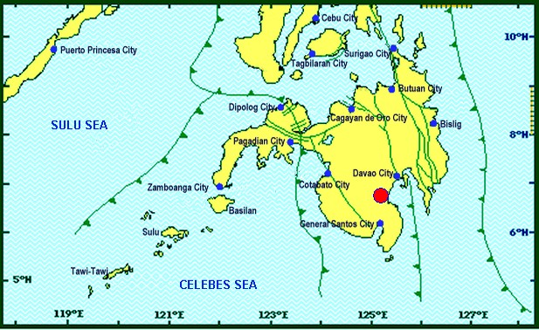
Situation Overview

On 15 December 2019 at 2:11 PM, a 6.9 magnitude earthquake jolted the municipality of Matanao, Davao del Sur (06.74°N, 125.20°E - 005 km N 72°W) with a tectonic origin and a depth of focus of 3 km.

Source: DOST-PHIVOLCS Earthquake Bulletin

- Status of Affected Families / Persons
A total of 87,093 families or 397,080 persons were affected by the earthquake incident in 230 barangays in Regions XI and XII (see Table 1).

Table 1. Number of Affected Families / Persons
REGION / PROVINCE / MUNICIPALITY |  | NUMBER OF AFFECTED
GRAND TOTAL |  | 230 | 87,093 | 397,080
REGION XI |  | 219 | 86,728 | 395,425
Davao del Sur |  | 219 | 86,728 | 395,425
 | Bansalan | 25 | 6,993 | 32,638
 | City of Digos (capital) | 25 | 3,666 | 18,300
 | Hagonoy | 21 | 9,223 | 32,254
 | Kiblawan | 30 | 13,938 | 67,626
 | Magsaysay | 22 | 15,939 | 75,596
 | Malalag | 15 | 10,937 | 54,685
 | Matanao | 33 | 14,477 | 59,587
 | Padada | 17 | 7,421 | 37,105
 | Santa Cruz | 6 | 661 | 3,499
 | Sulop | 25 | 3,473 | 14,135
REGION XII |  | 11 | 365 | 1,655
North Cotabato |  | 3 | 37 | 185
 | M'lang | 3 | 37 | 185
Sarangani |  | 5 | 175 | 705
 | Malungon | 5 | 175 | 705
Sultan Kudarat |  | 3 | 153 | 765
 | Columbio | 3 | 153 | 765
Note: The change in the number of affected persons in Davao del Sur is based on the validated report submitted by DSWD-FO XI. Thus, ongoing assessment and validation being conducted.
Source: DSWD-FOs XI and XII

- Status of Displaced Families / Persons
- Inside Evacuation Centers
There are 7,580 families or 28,840 persons taking temporary shelter in 72 evacuation centers in Region XI (see Table 2).

Table 2. Number of Displaced Families / Persons Inside Evacuation Centers
REGION / PROVINCE / MUNICIPALITY |  | NUMBER OF EVACUATION CENTERS (ECs) |  | NUMBER OF DISPLACED
 |  |  |  | INSIDE ECs
 |  |  |  | Families |  | Persons
 |  | CUM | NOW | CUM | NOW | CUM | NOW
GRAND TOTAL |  | 117 | 72 | 14,639 | 7,580 | 60,891 | 28,840
REGION XI |  | 113 | 72 | 14,425 | 7,580 | 59,866 | 28,840
Davao del Sur |  | 113 | 72 | 14,425 | 7,580 | 59,866 | 28,840
 | Bansalan | 12 | 12 | 1,032 | 811 | 3,585 | 2,895
 | City of Digos (capital) | 15 | 3 | 3,417 | 899 | 16,720 | 3,301
 | Hagonoy | 5 | 4 | 701 | 401 | 2,346 | 1,487
 | Kiblawan | 49 | 22 | 4,453 | 1,918 | 17,702 | 8,077
 | Magsaysay | 11 | 11 | 1,525 | 1,500 | 5,722 | 5,632
 | Malalag | 4 | 3 | 562 | 272 | 2,014 | 1,026
 | Matanao | 16 | 16 | 2,660 | 1,704 | 11,533 | 6,178
 | Padada | 1 | 1 | 75 | 75 | 244 | 244
REGION XII |  | 4 | - | 214 | - | 1,025 | -
Sarangani |  | 3 | - | 61 | - | 260 | -
 | Malungon | 3 | - | 61 | - | 260 | -
Sultan Kudarat |  | 1 | - | 153 | - | 765 | -
 | Columbio | 1 | - | 153 | - | 765 | -
Note: The change in the number of displaced persons in Davao del Sur is based on the validated report submitted by DSWD-FO XI. Thus, ongoing assessment and validation being conducted.
Source: DSWD-FOs XI and XII

- Outside Evacuation Centers
There are 23,672 families or 101,590 persons currently staying with their relatives and/or friends, or in open spaces (see Table 3).

Table 3. Number of Displaced Families / Persons Outside Evacuation Centers
REGION / PROVINCE / MUNICIPALITY |  | NUMBER OF DISPLACED
 |  | OUTSIDE ECs
 |  | Families |  | Persons
 |  | CUM | NOW | CUM | NOW
GRAND TOTAL |  | 23,940 | 23,672 | 102,559 | 101,590
REGION XI |  | 23,826 | 23,672 | 102,114 | 101,590
Davao del Sur |  | 23,826 | 23,672 | 102,114 | 101,590
 | Bansalan | 3,762 | 3,677 | 17,374 | 17,195
 | City of Digos (capital) | 119 | 119 | 595 | 595
 | Hagonoy | 8,642 | 8,642 | 30,376 | 30,376
 | Kiblawan | 2,449 | 2,449 | 10,938 | 10,938
 | Magsaysay | 247 | 247 | 1,235 | 1,235
 | Malalag | 7,486 | 7,417 | 37,430 | 37,085
 | Padada | 926 | 926 | 2,996 | 2,996
 | Santa Cruz | 195 | 195 | 1,170 | 1,170
REGION XII |  | 114 | - | 445 | -
Sarangani |  | 114 | - | 445 | -
 | Malungon | 114 | - | 445 | -
Note: The change in the number of displaced persons in Davao del Sur is based on the validated report submitted by DSWD-FO XI. Thus, ongoing assessment and validation being conducted.
Source: DSWD-FOs XI and XII

- Damaged Houses
There are 47,635 damaged houses; of which, 8,386 are totally damaged and 39,367 are partially damaged (see Table 4).

Table 4. Number of Damaged Houses
REGION / PROVINCE / MUNICIPALITY |  | NO. OF DAMAGED HOUSES
 |  | Total | Totally | Partially
GRAND TOTAL |  | 47,635 | 8,386 | 39,367
REGION XI |  | 47,603 | 8,386 | 39,335
Davao del Sur |  | 47,603 | 8,386 | 39,335
 | Bansalan | 5,729 | 1,936 | 3,793
 | City of Digos (capital) | 1,237 | 289 | 948
 | Hagonoy | 8,866 | 775 | 8,091
 | Kiblawan | 4,142 | 523 | 3,619
 | Magsaysay | 7,774 | 2,530 | 5,244
 | Malalag | 2,430 | 111 | 2,319
 | Matanao | 10,461 | 1,612 | 8,967
 | Padada | 3,311 | 347 | 2,964
 | Santa Cruz | 195 | 1 | 194
 | Sulop | 3,458 | 262 | 3,196
REGION XII |  | 32 | - | 32
North Cotabato |  | 32 | - | 32
 | M'lang | 32 | - | 32
Note: The change in the number of damaged houses in Davao del Sur is based on the validated report submitted by DSWD-FO XI. Thus, ongoing assessment and validation being conducted.
Source: DSWD-FOs XI and XII

- Assistance Provided
A total of ₱38,212,640.97 worth of assistance was provided by DSWD to the affected families (see Table 5).

Table 5. Cost of Assistance Provided to Affected Families / Persons
REGION / PROVINCE / MUNICIPALITY |  | COST OF ASSISTANCE
 |  | DSWD | LGU | NGOs | OTHERS | GRAND TOTAL
GRAND TOTAL |  | 38,212,640.97 | - | - | - | 38,212,640.97
REGION XI |  | 37,873,250.97 | - | - | - | 37,873,250.97
Davao del Sur |  | 37,873,250.97 | - | - | - | 37,873,250.97
 | Bansalan | 1,522,757.50 | - | - | - | 1,522,757.50
 | City of Digos (capital) | 11,532,658.46 | - | - | - | 11,532,658.46
 | Hagonoy | 6,045,646.78 | - | - | - | 6,045,646.78
 | Kiblawan | 2,894,277.20 | - | - | - | 2,894,277.20
 | Magsaysay | 3,349,326.50 | - | - | - | 3,349,326.50
 | Malalag | 4,882,974.77 | - | - | - | 4,882,974.77
 | Matanao | 2,244,927.34 | - | - | - | 2,244,927.34
 | Padada | 4,359,449.92 | - | - | - | 4,359,449.92
 | Sulop | 1,041,232.50 | - | - | - | 1,041,232.50
REGION XII |  | 339,390.00 | - | - | - | 339,390.00
Sultan Kudarat |  | 339,390.00 | - | - | - | 339,390.00
 | Columbio | 339,390.00 | - | - | - | 339,390.00
Source: DSWD-FOs XI and XII

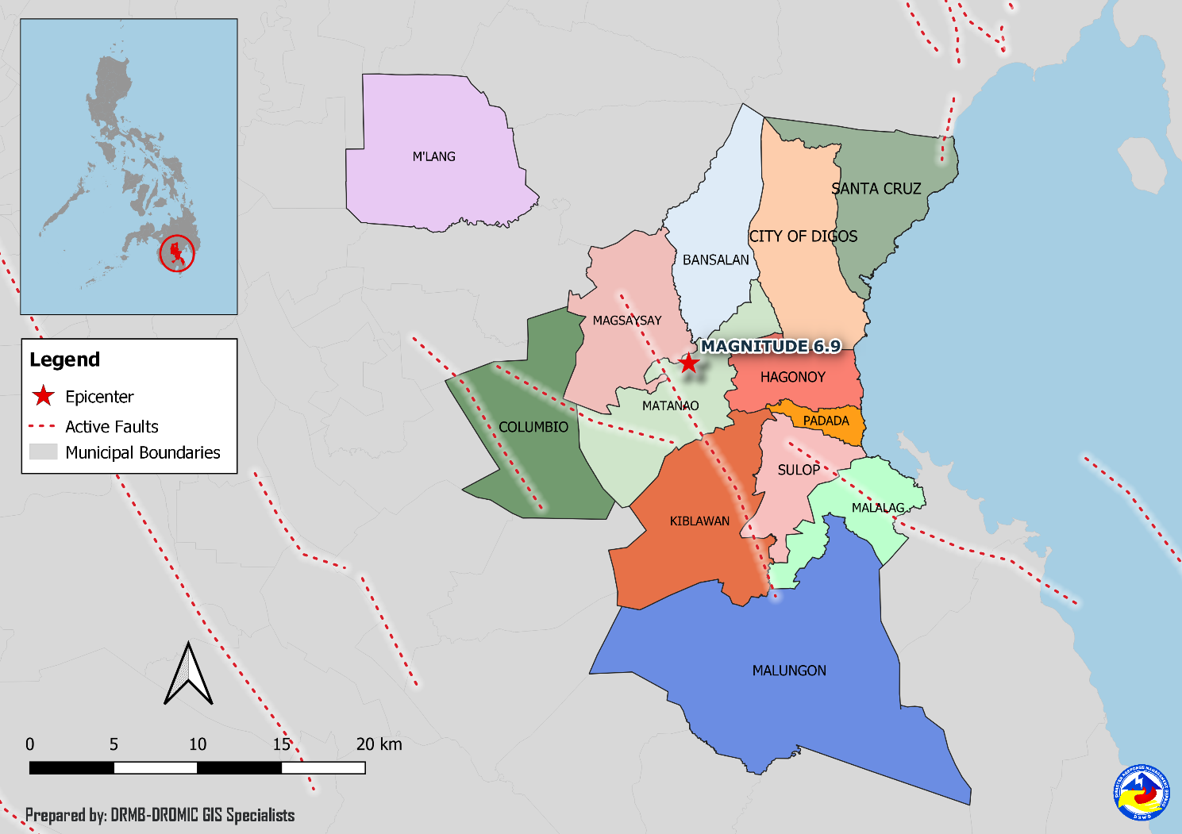
DSWD DISASTER RESPONSE INFORMATION

Situational Reports

DSWD-DRMB
DATE | SITUATIONS / ACTIONS UNDERTAKEN
22 January 2020 | - The Disaster Response Management Bureau (DRMB) is closely coordinating with the concerned Field Offices for significant disaster response updates.

DSWD-FO XI
DATE | SITUATIONS / ACTIONS UNDERTAKEN
- January 2020 | - DSWD-FO XI is still on BLUE alert status.  - Orientation and deployment of ten (10) Camp Managers in areas affected, (2) two camp managers in each municipalities to include Bansalan, Magsaysay, Kiblawan, Malalag, Padada, Digos City,Matanao, and Hagonoy.
- January 2020 | - The Response Cluster conducted a meeting with major hit municipalities in Davao del Sur wherein the OCD laid down the Communication Plan for these municipalities. The ComPlan is intended to provide the IDPs with the correct information regarding evacuation centers and the implications related to prolonged stay inside these ECs. Schedules for the Communication Plan are slated to commence on the 3rd week of January.
07 January 2020 | - DSWD-FO XI conducted orientation and deployment of ten (10) Camp Managers in areas affected; two (2) camp managers each municipality to include Malalag, Padada, Digos City, Matanao, Hagonoy.  - OCD XI has prepositioned of goods (non-food items) located at DSWD-Mobile Storage Unit near Davao del Sur Coliseum, Digos City to wit; 129 pieces of camping tents, 546 sets of Tent, 999 box hygiene kits as of January 06, 2020.  - DSWD-FO XI Delivered/provided the Food Items to the ff. municipalities to wit; MATANAO; 332 FFPs and 332 Hygiene kit (OCD XI) PADADA; 2 Laminated sacks and 1 set Tent (OCD XI)
05 January 2020 | - DSWD-FO XI through the Disaster Response Management Division (DRMD) distributed family food packs to the affected families in Malalag, Davao del Sur and attended consultation meeting with LGU of Kiblawan Davao del Sur.  - The Crisis Intervention Unit (CIU) simultaneously extended cash assistance to the affected families in Padada and Malalag, Davao del Sur.
03 January 2020 | - DSWD-FO XI distributed family food packs to the affected families in Malalag, Davao del Sur and its Crisis Intervention Unit (CIU) extended cash assistance to the affected families in Padada and Malalag.  - DSWD-FO XI provided ₱20,599,000.00 worth of cash assistance to the affected families.
02 January 2020 | - DSWD-FO XI distributed family food packs to the affected families in Malalag, Davao del Sur.  - DSWD-FO XI closely coordinated with PSWDO/MSWDO for updates and reports relative to the earthquake incident.

DSWD-FO XII
DATE | SITUATIONS / ACTIONS UNDERTAKEN
09 January 2020 | - DSWD-FO XII submitted their terminal report.
26 December 2019 | - DSWD-FO XII provided 24 family tents to affected families in Malungon, Sarangani.  - 135 families were given financial assistance worth ₱2,400.00 through DSWD Assistance to Individual in Crisis Situation.
19 December 2019 | - DSWD-FO XII provided 270 packs family food packs, 135 pieces of sleeping kits, 270 pieces of collapsible water, 135 pieces of kitchen kits for the affected families in Columbio, Sultan Kudarat.  - DSWD-FO XII provided 5 units of tent in Malungon, Sarangani.
17 December 2019 | - DSWD-FO XII released 20 additional tents to the Local Government Unit of Malungon.

*****
The Disaster Response Operations Monitoring and Information Center (DROMIC) of the DSWD-DRMB is closely coordinating with concerned DSWD Field Offices for any significant disaster response updates.

Prepared by:

MARIE JOYCE G. RAFANAN

RODEL V. CABADDU
Releasing Officer

