DSWD DROMIC Report #3 on the
Ms 6.9 Earthquake Incident in Matanao, Davao del Sur
as of 18 December 2019, 6PM

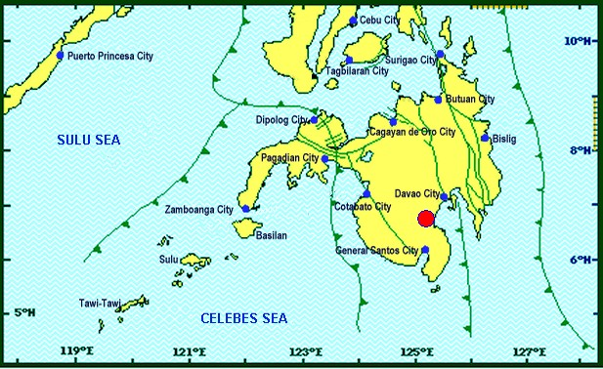

Situation Overview

On 15 December 2019 at 02:11 PM, a 6.9 magnitude earthquake jolted the municipality of Matanao, Devao del Sur (06.74°N, 125.20°E - 005 km N 72° W) with a tectonic origin and a depth of focus of 3 km.

Source: DOST-PHIVOLCS Earthquake Bulletin
- Status of Affected Families / Persons
A total of 29,592 families or 124,221 persons were affected by the earthquake incident in 105 barangays in Region XI (see Table 1).

Table 1. Number of Affected Families / Persons
REGION / PROVINCE / MUNICIPALITY |  | NUMBER OF AFFECTED
 |  | Barangays | Families | Persons
GRAND TOTAL |  | 105 | 29,592 | 124,221
REGION XI |  | 105 | 29,592 | 124,221
Davao del Sur |  | 105 | 29,592 | 124,221
 | Bansalan | 2 | 17 | 85
 | City of Digos (capital) | 10 | 2,249 | 11,245
 | Hagonoy | 15 | 2,706 | 10,072
 | Kiblawan | 11 | 2,898 | 12,426
 | Malalag | 3 | 134 | 670
 | Matanao | 32 | 13,819 | 50,878
 | Padada | 17 | 7,421 | 37,105
 | Santa Cruz | 1 | 38 | 190
 | Sulop | 14 | 310 | 1,550
Note: Ongoing assessment and validation being conducted.
Source: DSWD-FO XI
- Status of Displaced Families / Persons
- Inside Evacuation Centers
There are 3,076 families or 14,993 persons taking temporary shelter in 24 evacuation centers in Region XI (see Table 2).

Table 2. Number of Displaced Families / Persons Inside Evacuation Centers
REGION / PROVINCE / MUNICIPALITY |  | NUMBER OF EVACUATION CENTERS (ECs) |  | NUMBER OF DISPLACED
 |  |  |  | INSIDE ECs
 |  |  |  | Families |  | Persons
 |  | CUM | NOW | CUM | NOW | CUM | NOW
GRAND TOTAL |  | 24 | 24 | 3,076 | 3,076 | 14,993 | 14,993
REGION XI |  | 24 | 24 | 3,076 | 3,076 | 14,993 | 14,993
Davao del Sur |  | 24 | 24 | 3,076 | 3,076 | 14,993 | 14,993
 | Bansalan | 3 | 3 | 17 | 17 | 85 | 85
 | City of Digos (capital) | 12 | 12 | 2,249 | 2,249 | 11,245 | 11,245
 | Hagonoy | 4 | 4 | 272 | 272 | 1,227 | 1,227
 | Kiblawan | 3 | 3 | 326 | 326 | 1,630 | 1,630
 | Matanao | 1 | 1 | 176 | 176 | 646 | 646
 | Padada | 1 | 1 | 36 | 36 | 160 | 160
Note: Ongoing assessment and validation being conducted.
Source: DSWD-FO XI
- Outside Evacuation Centers
There are 4,379 families or 18,051 persons currently staying with their relatives and/or friends, or in open spaces (see Table 3).

Table 3. Number of Displaced Families / Persons Outside Evacuation Centers
REGION / PROVINCE / MUNICIPALITY |  | NUMBER OF DISPLACED
 |  | OUTSIDE ECs
 |  | Families |  | Persons
 |  | CUM | NOW | CUM | NOW
GRAND TOTAL |  | 4,379 | 4,379 | 18,051 | 18,051
REGION XI |  | 4,379 | 4,379 | 18,051 | 18,051
Davao del Sur |  | 4,379 | 4,379 | 18,051 | 18,051
 | Hagonoy | 2,395 | 2,395 | 8,721 | 8,721
 | Kiblawan | 1,984 | 1,984 | 9,330 | 9,330
Note: Ongoing assessment and validation being conducted.
Source: DSWD-FO XI
- Damaged Houses
There are 14,021 damaged houses; of which, 2,760 are totally damaged and
11,261 are partially damaged (see Table 4).

Table 4. Number of Damaged Houses
REGION / PROVINCE / MUNICIPALITY |  | NO. OF DAMAGED HOUSES
 |  | Total | Totally | Partially
GRAND TOTAL |  | 14,021 | 2,760 | 11,261
REGION XI |  | 14,021 | 2,760 | 11,261
Davao del Sur |  | 14,021 | 2,760 | 11,261
 | Hagonoy | 5,760 | 1,033 | 4,727
 | Matanao | 4,950 | 1,380 | 3,570
 | Padada | 3,311 | 347 | 2,964
Note: Ongoing assessment and validation being conducted.
Source: DSWD-FO XI
- Assistance Provided
A total of ₱3,119,126.76 worth of assistance was provided by DSWD to the affected families (see Table 5).

Table 5. Cost of Assistance Provided to Affected Families / Persons
REGION / PROVINCE / MUNICIPALITY |  | COST OF ASSISTANCE
 |  | DSWD | LGU | NGOs | OTHERS | GRAND TOTAL
GRAND TOTAL |  | 3,119,126.76 | - | - | - | 3,119,126.76
REGION XI |  | 3,119,126.76 | - | - | - | 3,119,126.76
Davao del Sur |  | 3,119,126.76 | - | - | - | 3,119,126.76
 | Bansalan | 563,000.00 | - | - | - | 563,000.00
 | City of Digos (capital) | 632,762.26 | - | - | - | 632,762.26
 | Hagonoy | 421,270.00 | - | - | - | 421,270.00
 | Matanao | 910,724.50 | - | - | - | 910,724.50
 | Padada | 591,370.00 | - | - | - | 591,370.00
Source: DSWD-FO XI

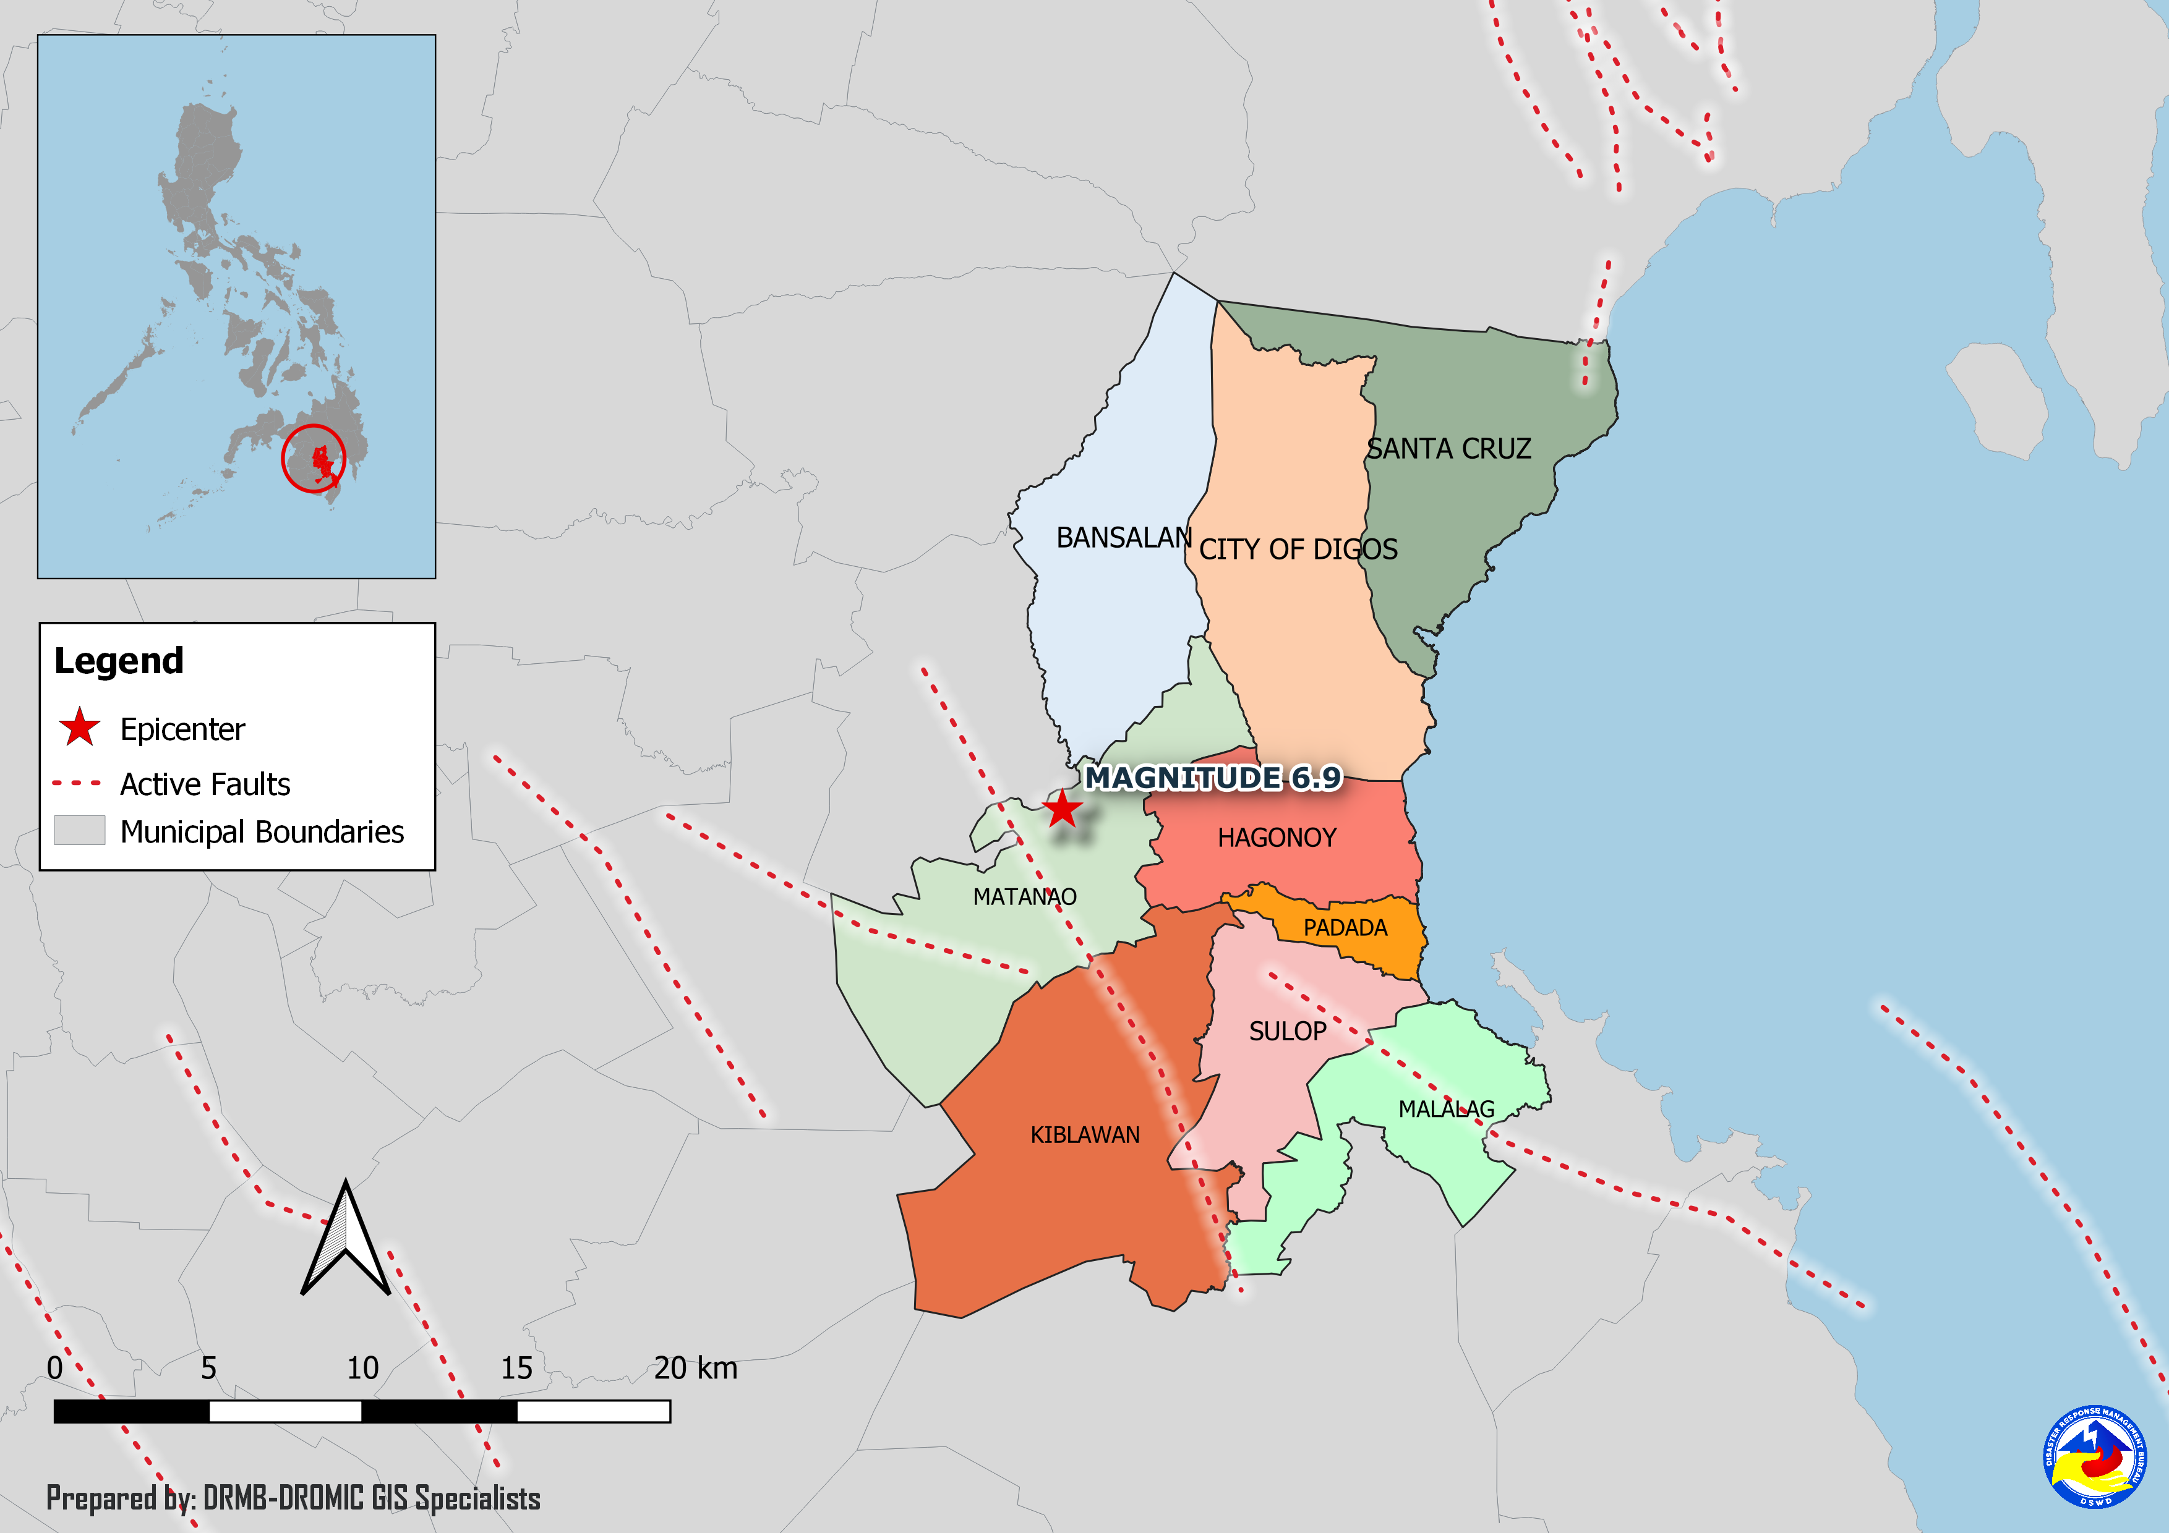
DSWD DISASTER RESPONSE INFORMATION

Situational Reports

DSWD-DRMB
DATE | SITUATIONS / ACTIONS UNDERTAKEN
18 December 2019 | - The Disaster Response Management Bureau (DRMB) is on BLUE alert status and is closely coordinating with the concerned Field Offices for significant disaster response updates.

DSWD-FO XI
DATE | SITUATIONS / ACTIONS UNDERTAKEN
17 December 2019 | - DSWD-FO XI is in close coordination with the concerned LGUs for any significant updates.  - DSWD-FO XI provided food assistance and non-food assistance to the affected families in the Municipalities of Bansalan and City of Digos.  - On-going validation and assessment of the affected families.

DSWD-FO XII
DATE | SITUATIONS / ACTIONS UNDERTAKEN
17 December 2019 | - DSWD-FO XII released 20 additional tents to the Local Government Unit of Malungon.  - On-going validation in different Municipalities in North Cotabato and other areas in Region XII in close coordination with concerned LGU’s and offices.
16 December 2019 | - DSWD-FO XII is closely monitoring and coordinating with the concerned LGUs for any possible resource augmentation.  - Four (4) vehicles are ready for utilization in case of response activation.  - All QRT members are on standby and ready for activation if there is a need for deployment.

*****
The Disaster Response Operations Monitoring and Information Center (DROMIC) of the DSWD-DRMB is closely coordinating with concerned DSWD Field Offices for any significant disaster response updates.

Prepared by:

MARIEL B. FERRARIZ

CLARRIE MAE A. CASTILLO
Releasing Officer

