DSWD DROMIC Report #31 on Typhoon “URSULA”
as of 31 January 2020, 6PM

Situation Overview

“PHANFONE” entered the Philippine Area of Responsibility (PAR) on 23 December 2019 and was named “Ursula” as the 21st Philippine tropical cyclone for 2019. On 24 December 2019, “Ursula” intensified into a typhoon as it moved toward Eastern Visayas; hence, also affecting Northeastern Mindanao, Bicol Region, Central Visayas, CALABARZON, MIMAROPA and Western Visayas. On 28 December 2019, “Ursula” weakened into a Tropical Storm (TS) and exited PAR.
Source: DOST-PAGASA

- Status of Affected Families / Persons
A total of 795,449 families or 3,296,877 persons are affected in 3,099 barangays in Regions MIMAROPA, VI, VII, VIII and CARAGA (see Table 1).

Table 1. Number of Affected Families / Persons
REGION / PROVINCE / MUNICIPALITY |  | NUMBER OF AFFECTED
 |  | Barangays | Families | Persons
GRAND TOTAL |  | 3,099 | 795,449 | 3,296,877
MIMAROPA |  | 132 | 31,636 | 155,317
Marinduque |  | - | 3 | 7
 | Gasan | - | 3 | 7
Occidental Mindoro |  | 27 | 23,658 | 119,037
 | Calintaan | 6 | 2,384 | 11,885
 | Looc | 3 | 15 | 37
 | Magsaysay | 10 | 5,078 | 25,409
 | Rizal | 2 | 2,752 | 13,803
 | San Jose | 6 | 13,429 | 67,903
Oriental Mindoro |  | 74 | 4,020 | 19,214
 | Baco | 11 | 262 | 1,320
 | Bansud | 3 | 109 | 469
 | Bongabong | 1 | 144 | 669
 | Bulalacao (San Pedro) | 15 | 2,462 | 12,226
 | City of Calapan (capital) | 3 | 85 | 250
 | Gloria | 8 | 168 | 642
 | Mansalay | 8 | 454 | 1,826
 | Pinamalayan | 5 | 65 | 244
 | Puerto Galera | 3 | 68 | 311
 | Roxas | 8 | 160 | 1,080
 | Socorro | 5 | 29 | 117
 | Victoria | 4 | 14 | 60
Romblon |  | 31 | 3,955 | 17,059
 | Alcantara | - | 131 | 655
 | Cajidiocan | 5 | 220 | 785
 | Calatrava | - | 1 | 5
 | Concepcion | 2 | 63 | 207
 | Corcuera | 1 | 36 | 120
 | Ferrol | 6 | 233 | 662
 | Looc | 5 | 283 | 99
 | Odiongan | - | 45 | 225
 | Romblon (capital) | 1 | 20 | 102
 | San Agustin | 6 | 92 | 340
 | San Andres | - | 6 | 30
 | San Jose | - | 856 | 4,280
 | Santa Fe | - | 1,825 | 9,125
 | Santa Maria (Imelda) | 5 | 144 | 424
REGION VI |  | 1,009 | 351,128 | 1,491,876
Aklan |  | 312 | 122,641 | 510,342
 | Altavas | 14 | 6,680 | 25,626
 | Balete | 10 | 7,049 | 24,706
 | Banga | 30 | 9,250 | 39,362
 | Batan | 20 | 6,557 | 24,410
 | Kalibo (capital) | 16 | 16,036 | 73,623
 | Libacao | 12 | 165 | 712
 | Madalag | 25 | 1,385 | 4,848
 | New Washington | 16 | 10,323 | 51,615
 | Buruanga | 15 | 4,038 | 21,251
 | Ibajay | 35 | 10,068 | 50,110
 | Lezo | 12 | 4,773 | 16,963
 | Makato | 18 | 7,804 | 30,053
 | Malay | 17 | 7,130 | 30,397
 | Malinao | 20 | 4,502 | 16,262
 | Nabas | 20 | 10,144 | 40,090
 | Numancia | 17 | 11,814 | 38,924
 | Tangalan | 15 | 4,923 | 21,390
Antique |  | 81 | 18,398 | 81,642
 | Caluya | 18 | 5,383 | 25,849
 | Libertad | 19 | 4,163 | 19,690
 | Pandan | 34 | 8,147 | 32,345
 | Sebaste | 10 | 705 | 3,758
Capiz |  | 383 | 140,220 | 625,921
 | Cuartero | 21 | 1,393 | 6,965
 | Dao | 20 | 1,715 | 8,011
 | Dumalag | 19 | 8,098 | 39,393
 | Dumarao | 33 | 11,975 | 46,157
 | Ivisan | 15 | 7,415 | 37,075
 | Ma-ayon | 32 | 9,139 | 38,416
 | Mambusao | 25 | 4,245 | 20,163
 | Panay | 42 | 13,601 | 68,005
 | Panitan | 26 | 4,965 | 19,989
 | Pilar | 24 | 13,103 | 56,799
 | Pontevedra | 26 | 8,951 | 32,224
 | President Roxas | 22 | 8,569 | 42,835
 | Roxas City (capital) | 47 | 33,556 | 168,580
 | Sapi-an | 10 | 4,734 | 7,904
 | Sigma | 21 | 8,761 | 33,405
Iloilo |  | 233 | 69,869 | 273,971
 | Ajuy | 34 | 15,906 | 57,978
 | Balasan | 23 | 9,654 | 35,616
 | Banate | 5 | 85 | 351
 | Batad | 24 | 5,649 | 22,539
 | Carles | 33 | 18,477 | 77,671
 | Concepcion | 14 | 381 | 1,476
 | Estancia | 19 | 7,865 | 39,325
 | City of Passi | 3 | 98 | 392
 | San Dionisio | 29 | 3,818 | 10,932
 | San Enrique | 2 | 88 | 440
 | San Rafael | 6 | 17 | 81
 | Sara | 41 | 7,831 | 27,170
REGION VII |  | 100 | 26,287 | 131,435
Cebu |  | 100 | 26,287 | 131,435
 | Bantayan | 20 | 127 | 635
 | City of Bogo | 9 | 32 | 160
 | Daanbantayan | 20 | 14,781 | 73,905
 | Madridejos | 14 | 1,869 | 9,345
 | Medellin | 19 | 6,653 | 33,265
 | San Remigio | 5 | 13 | 65
 | Santa Fe | 10 | 2,809 | 14,045
 | Tabogon | 3 | 3 | 15
REGION VIII |  | 1,837 | 386,061 | 1,516,898
Biliran |  | 145 | 32,111 | 118,852
 | Almeria | 13 | 4,474 | 17,852
 | Kawayan | 20 | 2,353 | 10,257
 | Naval (capital) | 52 | 7,335 | 20,213
 | Biliran | 11 | 3,571 | 4,853
 | Cabucgayan | 13 | 5,141 | 21,708
 | Caibiran | 17 | 5,388 | 26,500
 | Culaba | 17 | 3,249 | 15,069
 | Maripipi | 2 | 600 | 2,400
Eastern Samar |  | 333 | 60,716 | 230,861
 | City of Borongan (capital) | 38 | 2,285 | 9,140
 | Can-Avid | 28 | 47 | 191
 | San Julian | 16 | 4,134 | 16,536
 | Sulat | 9 | 305 | 1,127
 | Balangiga | 13 | 4,148 | 16,276
 | Balangkayan | 15 | 2,986 | 11,370
 | General MacArthur | 30 | 4,038 | 10,414
 | Giporlos | 18 | 4,140 | 13,652
 | Guiuan | 50 | 13,800 | 55,200
 | Hernani | 13 | 2,670 | 10,680
 | Lawaan | 2 | 2,921 | 11,684
 | Llorente | 33 | 6,137 | 22,504
 | Mercedes | 2 | 2,389 | 9,556
 | Quinapondan | 25 | 4,644 | 18,576
 | Salcedo | 41 | 6,072 | 23,955
Leyte |  | 906 | 194,615 | 772,162
 | Alangalang | 54 | 5,019 | 11,680
 | Babatngon | 25 | 7,023 | 21,069
 | Palo | 33 | 19,289 | 79,563
 | San Miguel | 21 | 5,573 | 22,291
 | Santa Fe | 16 | 4,572 | 18,288
 | Tacloban City (capital) | 117 | 25,176 | 119,918
 | Tanauan | 54 | 8,407 | 13,098
 | Tolosa | 15 | 5,524 | 27,620
 | Barugo | 37 | 8,632 | 34,932
 | Capoocan | 21 | 6,705 | 21,599
 | Carigara | 49 | 12,080 | 54,083
 | Dagami | 65 | 3,293 | 15,194
 | Dulag | 45 | 13,722 | 51,591
 | Jaro | 42 | 3,680 | 14,720
 | La Paz | 10 | 4,980 | 20,775
 | MacArthur | 31 | 632 | 3,000
 | Mayorga | 16 | 71 | 311
 | Pastrana | 29 | 3,872 | 16,375
 | Tabontabon | 16 | 3,410 | 12,484
 | Tunga | 8 | 2,446 | 9,784
 | Calubian | 53 | 7,799 | 29,059
 | Leyte | 30 | 6,142 | 30,457
 | San Isidro | 19 | 9,245 | 36,980
 | Tabango | 11 | 8,496 | 36,542
 | Villaba | 35 | 12,990 | 51,960
 | Albuera | 1 | 731 | 3,642
 | Isabel | 2 | 25 | 106
 | Kananga | 1 | 963 | 3,852
 | Matag-ob | 21 | 142 | 457
 | Ormoc City | 15 | 2,740 | 6,575
 | Palompon | 3 | 589 | 2,356
 | Abuyog | 1 | 38 | 170
 | Bato | 1 | 164 | 506
 | City of Baybay | 3 | 228 | 556
 | Hilongos | 5 | 11 | 44
 | Javier (Bugho) | 1 | 206 | 525
Western Samar |  | 453 | 98,619 | 395,023
 | Almagro | 23 | 725 | 2,559
 | Pagsanghan | 1 | 1 | 4
 | Santa Margarita | 2 | 34 | 127
 | Santo Nino | 4 | 465 | 1,378
 | Tagapul-an | 13 | 250 | 1,307
 | Tarangnan | 1 | 218 | 872
 | Basey | 51 | 17,894 | 64,493
 | Calbiga | 41 | 6,626 | 22,201
 | City of Catbalogan (capital) | 56 | 30,736 | 122,572
 | Daram | 58 | 8,319 | 39,609
 | Jiabong | 34 | 4,126 | 16,009
 | Marabut | 9 | 2,065 | 8,260
 | Motiong | 1 | 34 | 136
 | Paranas (Wright) | 18 | 424 | 1,900
 | Pinabacdao | 24 | 4,925 | 18,904
 | San Sebastian | 14 | 2,309 | 9,766
 | Santa Rita | 38 | 11,384 | 49,213
 | Talalora | 2 | 2,306 | 9,224
 | Villareal | 38 | 2,944 | 15,153
 | Zumarraga | 25 | 2,834 | 11,336
CARAGA |  | 21 | 337 | 1,351
Dinagat Island |  | 19 | 307 | 1,228
 | Basilisa (Rizal) | 7 | 101 | 404
 | Libjo (Albor) | 3 | 31 | 124
 | San Jose (capital) | 7 | 166 | 664
 | Tubajon | 2 | 9 | 36
Surigao del Norte |  | 2 | 30 | 123
 | Pilar | 2 | 30 | 123
Note: The decrease in the number of affected persons is based on the validated report submitted by DSWD Field Offices. Ongoing assessment and validation are continuously being conducted in other regions.
Source: DSWD-FOs MIMAROPA, VI, VII, VIII and Caraga
- Status of Displaced Families / Persons
- Inside Evacuation Centers
There are 1 family or 3 persons taking temporary shelter in 1 evacuation center in Region VI (see Table 2).

Table 2. Number of Displaced Families / Persons Inside Evacuation Centers
REGION / PROVINCE / MUNICIPALITY |  | NUMBER OF EVACUATION CENTERS (ECs) |  | NUMBER OF DISPLACED
 |  |  |  | INSIDE ECs
 |  |  |  | Families |  | Persons
 |  | CUM | NOW | CUM | NOW | CUM | NOW
GRAND TOTAL |  | 1,604 | 1 | 47,576 | 1 | 198,399 | 3
MIMAROPA |  | 225 | - | 6,409 | - | 29,370 | -
Occidental Mindoro |  | 41 | - | 1,696 | - | 7,870 | -
 | Calintaan | 11 | - | 207 | - | 791 | -
 | Looc | 3 | - | 15 | - | 37 | -
 | Magsaysay | 15 | - | 823 | - | 4,030 | -
 | Rizal | 5 | - | 114 | - | 450 | -
 | San Jose | 7 | - | 537 | - | 2,562 | -
Oriental Mindoro |  | 131 | - | 3,950 | - | 18,810 | -
 | Baco | 12 | - | 262 | - | 1,320 | -
 | Bansud | 6 | - | 109 | - | 469 | -
 | Bongabong | 1 | - | 144 | - | 669 | -
 | Bulalacao (San Pedro) | 61 | - | 2,401 | - | 11,933 | -
 | City of Calapan (capital) | 3 | - | 85 | - | 250 | -
 | Gloria | 8 | - | 168 | - | 642 | -
 | Mansalay | 8 | - | 454 | - | 1,826 | -
 | Pinamalayan | 7 | - | 61 | - | 224 | -
 | Puerto Galera | 5 | - | 68 | - | 311 | -
 | Roxas | 11 | - | 155 | - | 989 | -
 | Socorro | 5 | - | 29 | - | 117 | -
 | Victoria | 4 | - | 14 | - | 60 | -
Romblon |  | 53 | - | 763 | - | 2,690 | -
 | Cajidiocan | 11 | - | 220 | - | 785 | -
 | Concepcion | 2 | - | 49 | - | 158 | -
 | Corcuera | 4 | - | 36 | - | 120 | -
 | Ferrol | 6 | - | 205 | - | 662 | -
 | Looc | 5 | - | 26 | - | 99 | -
 | Romblon (capital) | 1 | - | 20 | - | 102 | -
 | San Agustin | 12 | - | 91 | - | 340 | -
 | Santa Maria (Imelda) | 12 | - | 116 | - | 424 | -
REGION VI |  | 684 | 1 | 11,990 | 1 | 51,522 | 3
Aklan |  | 235 | - | 4,047 | - | 17,211 | -
 | Altavas | 16 | - | 93 | - | 403 | -
 | Banga | 6 | - | 12 | - | 58 | -
 | Batan | 8 | - | 243 | - | 1,199 | -
 | Kalibo (capital) | 16 | - | 93 | - | 451 | -
 | Libacao | 12 | - | 66 | - | 317 | -
 | Madalag | 17 | - | 216 | - | 882 | -
 | New Washington | 20 | - | 423 | - | 2,115 | -
 | Ibajay | 19 | - | 216 | - | 1,105 | -
 | Lezo | 16 | - | 69 | - | 263 | -
 | Malay | 7 | - | 177 | - | 603 | -
 | Malinao | 34 | - | 167 | - | 560 | -
 | Nabas | 28 | - | 845 | - | 3,396 | -
 | Numancia | 17 | - | 1,275 | - | 5,232 | -
 | Tangalan | 19 | - | 152 | - | 627 | -
Antique |  | 29 | - | 311 | - | 1,320 | -
 | Libertad | 20 | - | 196 | - | 676 | -
 | Sebaste | 9 | - | 115 | - | 644 | -
Capiz |  | 278 | - | 5,285 | - | 24,359 | -
 | Cuartero | 2 | - | 18 | - | 65 | -
 | Dao | 11 | - | 66 | - | 254 | -
 | Dumalag | 7 | - | 54 | - | 185 | -
 | Dumarao | 33 | - | 725 | - | 3,256 | -
 | Ivisan | 21 | - | 458 | - | 2,103 | -
 | Ma-ayon | 9 | - | 333 | - | 1,389 | -
 | Mambusao | 38 | - | 366 | - | 1,417 | -
 | Panay | 34 | - | 1,081 | - | 5,123 | -
 | Panitan | 5 | - | 112 | - | 577 | -
 | Pilar | 43 | - | 625 | - | 3,125 | -
 | Pontevedra | 11 | - | 272 | - | 1,015 | -
 | Roxas City (capital) | 47 | - | 968 | - | 4,884 | -
 | Sapi-an | 11 | - | 154 | - | 770 | -
 | Sigma | 6 | - | 53 | - | 196 | -
Iloilo |  | 142 | 1 | 2,347 | 1 | 8,632 | 3
 | Ajuy | 8 | - | 57 | - | 229 | -
 | Balasan | 70 | - | 1,046 | - | 4,001 | -
 | Batad | 22 | 1 | 382 | 1 | 1,314 | 3
 | Concepcion | 1 | - | 9 | - | 29 | -
 | Estancia | 3 | - | 79 | - | 307 | -
 | City of Passi | 3 | - | 98 | - | 392 | -
 | San Dionisio | 21 | - | 639 | - | 2,179 | -
 | San Enrique | 2 | - | 20 | - | 100 | -
 | San Rafael | 6 | - | 17 | - | 81 | -
REGION VIII |  | 672 | - | 28,840 | - | 116,156 | -
Biliran |  | 8 | - | 2,818 | - | 9,190 | -
 | Almeria | 1 | - | 88 | - | 157 | -
 | Kawayan | 1 | - | 832 | - | 3,096 | -
 | Naval (capital) | 1 | - | 116 | - | 569 | -
 | Biliran | 1 | - | 168 | - | 562 | -
 | Cabucgayan | 1 | - | 435 | - | 962 | -
 | Caibiran | 1 | - | 555 | - | 1,661 | -
 | Culaba | 1 | - | 120 | - | 505 | -
 | Maripipi | 1 | - | 504 | - | 1,678 | -
Eastern Samar |  | 74 | - | 1,097 | - | 4,397 | -
 | Can-Avid | 6 | - | 47 | - | 191 | -
 | San Julian | 9 | - | 219 | - | 950 | -
 | Balangkayan | 13 | - | 290 | - | 1,065 | -
 | Giporlos | 1 | - | 228 | - | 912 | -
 | Guiuan | 26 | - | 133 | - | 581 | -
 | Salcedo | 19 | - | 180 | - | 698 | -
Leyte |  | 311 | - | 12,951 | - | 50,034 | -
 | Babatngon | 22 | - | 100 | - | 400 | -
 | Palo | 37 | - | 2,001 | - | 7,350 | -
 | San Miguel | 21 | - | 528 | - | 829 | -
 | Tacloban City (capital) | 13 | - | 934 | - | 4,145 | -
 | Tolosa | 15 | - | 817 | - | 3,268 | -
 | Barugo | 7 | - | 102 | - | 376 | -
 | Capoocan | 1 | - | 1 | - | 4 | -
 | Carigara | 5 | - | 152 | - | 680 | -
 | Dagami | 1 | - | 493 | - | 1,972 | -
 | Dulag | 27 | - | 889 | - | 3,540 | -
 | Jaro | 7 | - | 1,277 | - | 3,882 | -
 | La Paz | 10 | - | 202 | - | 730 | -
 | MacArthur | 7 | - | 642 | - | 2,568 | -
 | Pastrana | 9 | - | 174 | - | 662 | -
 | Tabontabon | 16 | - | 337 | - | 1,350 | -
 | Tunga | 8 | - | 393 | - | 1,572 | -
 | Calubian | 21 | - | 147 | - | 744 | -
 | Leyte | 30 | - | 998 | - | 4,233 | -
 | San Isidro | 6 | - | 394 | - | 2,020 | -
 | Tabango | 19 | - | 422 | - | 1,608 | -
 | Isabel | 2 | - | 25 | - | 106 | -
 | Kananga | 4 | - | 963 | - | 3,852 | -
 | Ormoc City | 21 | - | 684 | - | 3,039 | -
 | Palompon | 2 | - | 276 | - | 1,104 | -
Western Samar |  | 279 | - | 11,974 | - | 52,535 | -
 | Santa Margarita | 4 | - | 34 | - | 127 | -
 | Santo Nino | 10 | - | 25 | - | 75 | -
 | Tagapul-an | 14 | - | 144 | - | 519 | -
 | Basey | 83 | - | 3,671 | - | 16,383 | -
 | Calbiga | 30 | - | 1,782 | - | 7,128 | -
 | Daram | 58 | - | 2,911 | - | 14,556 | -
 | Jiabong | 34 | - | 1,070 | - | 4,546 | -
 | Paranas (Wright) | 8 | - | 424 | - | 1,900 | -
 | Pinabacdao | 14 | - | 668 | - | 2,634 | -
 | San Sebastian | 14 | - | 700 | - | 2,604 | -
 | Santa Rita | 2 | - | 63 | - | 161 | -
 | Zumarraga | 8 | - | 482 | - | 1,902 | -
CARAGA |  | 23 | - | 337 | - | 1,351 | -
Dinagat Island |  | 21 | - | 307 | - | 1,228 | -
 | Basilisa (Rizal) | 10 | - | 101 | - | 404 | -
 | Libjo (Albor) | 3 | - | 31 | - | 124 | -
 | San Jose (capital) | 6 | - | 166 | - | 664 | -
 | Tubajon | 2 | - | 9 | - | 36 | -
Surigao del Norte |  | 2 | - | 30 | - | 123 | -
 | Pilar | 2 | - | 30 | - | 123 | -
Note: Ongoing assessment and validation are continuously being conducted.

Source: DSWD-FOs MIMAROPA, VI, VIII and Caraga

- Outside Evacuation Centers
There are 5,285 families or 26,422 persons currently staying with their relatives and/or friends (see Table 3).

Table 3. Number of Displaced Families / Persons Outside Evacuation Centers
REGION / PROVINCE / MUNICIPALITY |  | NUMBER OF DISPLACED
 |  | OUTSIDE ECs
 |  | Families |  | Persons
 |  | CUM | NOW | CUM | NOW
GRAND TOTAL |  | 71,335 | 5,285 | 295,248 | 26,422
MIMAROPA |  | 579 | - | 2,498 | -
Marinduque |  | 3 | - | 7 | -
 | Gasan | 3 | - | 7 | -
Occidental Mindoro |  | 492 | - | 2,038 | -
 | Calintaan | 322 | - | 1,331 | -
 | Magsaysay | 86 | - | 364 | -
 | Rizal | 84 | - | 343 | -
Oriental Mindoro |  | 70 | - | 404 | -
 | Bulalacao (San Pedro) | 61 | - | 293 | -
 | Pinamalayan | 4 | - | 20 | -
 | Roxas | 5 | - | 91 | -
Romblon |  | 14 | - | 49 | -
 | Concepcion | 14 | - | 49 | -
REGION VI |  | 43,863 | 23 | 180,598 | 112
Aklan |  | 7,026 | - | 30,614 | -
 | Altavas | 624 | - | 2,637 | -
 | Batan | 395 | - | 1,702 | -
 | Kalibo (capital) | 1,072 | - | 5,355 | -
 | Libacao | 99 | - | 395 | -
 | New Washington | 767 | - | 3,835 | -
 | Ibajay | 385 | - | 1,975 | -
 | Lezo | 455 | - | 1,729 | -
 | Malay | 980 | - | 3,749 | -
 | Malinao | 347 | - | 1,208 | -
 | Nabas | 1,383 | - | 6,082 | -
 | Tangalan | 519 | - | 1,947 | -
Antique |  | 1,113 | - | 4,877 | -
 | Libertad | 434 | - | 1,599 | -
 | Sebaste | 679 | - | 3,278 | -
Capiz |  | 25,257 | 23 | 106,120 | 112
 | Cuartero | 46 | - | 213 | -
 | Dao | 506 | - | 1,987 | -
 | Dumalag | 159 | - | 603 | -
 | Dumarao | 37 | - | 150 | -
 | Ivisan | 113 | - | 565 | -
 | Ma-ayon | 158 | - | 635 | -
 | Mambusao | 14 | - | 75 | -
 | Panay | 1,006 | - | 5,115 | -
 | Panitan | 4,853 | - | 19,412 | -
 | Pilar | 584 | - | 2,920 | -
 | Pontevedra | 8,951 | - | 32,112 | -
 | Roxas City (capital) | 6,823 | 21 | 34,115 | 105
 | Sapi-an | 1,482 | - | 6,135 | -
 | Sigma | 525 | 2 | 2,083 | 7
Iloilo |  | 10,467 | - | 38,987 | -
 | Balasan | 765 | - | 3,265 | -
 | Banate | 85 | - | 351 | -
 | Batad | 1,235 | - | 6,119 | -
 | San Dionisio | 483 | - | 1,742 | -
 | San Enrique | 68 | - | 340 | -
 | Sara | 7,831 | - | 27,170 | -
REGION VII |  | 5,262 | 5,262 | 26,310 | 26,310
Cebu |  | 5,262 | 5,262 | 26,310 | 26,310
 | Bantayan | 62 | 62 | 310 | 310
 | City of Bogo | 6 | 6 | 30 | 30
 | Daanbantayan | 4,803 | 4,803 | 24,015 | 24,015
 | Madridejos | 96 | 96 | 480 | 480
 | Medellin | 111 | 111 | 555 | 555
 | San Remigio | 7 | 7 | 35 | 35
 | Santa Fe | 176 | 176 | 880 | 880
 | Tabogon | 1 | 1 | 5 | 5
REGION VIII |  | 21,631 | - | 85,842 | -
Biliran |  | 85 | - | 402 | -
 | Culaba | 85 | - | 402 | -
Eastern Samar |  | 3,513 | - | 13,441 | -
 | City of Borongan (capital) | 347 | - | 1,388 | -
 | Balangiga | 1,728 | - | 6,912 | -
 | Balangkayan | 1,438 | - | 5,141 | -
Leyte |  | 9,106 | - | 34,403 | -
 | Alangalang | 3,464 | - | 11,680 | -
 | Santa Fe | 98 | - | 392 | -
 | Tacloban City (capital) | 1,251 | - | 5,161 | -
 | Villaba | 4,057 | - | 16,228 | -
 | Albuera | 131 | - | 524 | -
 | Ormoc City | 105 | - | 418 | -
Western Samar |  | 8,927 | - | 37,596 | -
 | Santo Nino | 15 | - | 60 | -
 | Daram | 3,623 | - | 17,208 | -
 | Jiabong | 3,353 | - | 11,776 | -
 | San Sebastian | 1,619 | - | 7,162 | -
 | Santa Rita | 317 | - | 1,390 | -
Note: Ongoing assessment and validation are continuously being conducted.
Source: DSWD-FOs MIMAROPA, VI, VII and VIII

- Damaged Houses
There are 527,199 damaged houses; of which, 59,471 are totally damaged and 467,728 are partially damaged (see Table 4).

Table 4. Number of Damaged Houses
REGION / PROVINCE / MUNICIPALITY |  | NO. OF DAMAGED HOUSES
 |  | Total | Totally | Partially
GRAND TOTAL |  | 527,199 | 59,471 | 467,728
MIMAROPA |  | 3,216 | 810 | 2,406
Oriental Mindoro |  | 38 | 5 | 33
 | Puerto Galera | 13 | - | 13
 | Roxas | 25 | 5 | 20
Romblon |  | 3,178 | 805 | 2,373
 | Alcantara | 131 | 24 | 107
 | Calatrava | 1 | - | 1
 | Ferrol | 28 | 3 | 25
 | Looc | 257 | 22 | 235
 | Odiongan | 45 | - | 45
 | San Agustin | 1 | - | 1
 | San Andres | 6 | 3 | 3
 | San Jose | 856 | 565 | 291
 | Santa Fe | 1,825 | 180 | 1,645
 | Santa Maria (Imelda) | 28 | 8 | 20
REGION VI |  | 243,846 | 34,370 | 209,476
Aklan |  | 115,423 | 9,884 | 105,539
 | Altavas | 5,729 | 472 | 5,257
 | Balete | 7,049 | 130 | 6,919
 | Banga | 9,807 | 813 | 8,994
 | Batan | 5,983 | 297 | 5,686
 | Kalibo (capital) | 16,036 | 1,167 | 14,869
 | Libacao | 146 | 9 | 137
 | Madalag | 953 | 42 | 911
 | New Washington | 10,552 | 1,419 | 9,133
 | Buruanga | 4,648 | 487 | 4,161
 | Ibajay | 10,263 | 944 | 9,319
 | Lezo | 3,722 | 285 | 3,437
 | Makato | 6,334 | 361 | 5,973
 | Malay | 7,130 | 793 | 6,337
 | Malinao | 4,601 | 166 | 4,435
 | Nabas | 8,783 | 986 | 7,797
 | Numancia | 8,761 | 1,170 | 7,591
 | Tangalan | 4,926 | 343 | 4,583
Antique |  | 16,179 | 5,115 | 11,064
 | Caluya | 5,453 | 4,014 | 1,439
 | Libertad | 3,736 | 454 | 3,282
 | Pandan | 6,189 | 539 | 5,650
 | Sebaste | 801 | 108 | 693
Capiz |  | 82,659 | 14,257 | 68,402
 | Cuartero | 370 | 23 | 347
 | Dao | 209 | 9 | 200
 | Dumalag | 29 | - | 29
 | Dumarao | 7 | - | 7
 | Ivisan | 6,823 | 346 | 6,477
 | Ma-ayon | 3,063 | 177 | 2,886
 | Mambusao | 2,966 | 98 | 2,868
 | Panay | 11,359 | 2,220 | 9,139
 | Panitan | 453 | 34 | 419
 | Pilar | 11,952 | 1,669 | 10,283
 | Pontevedra | 1,282 | 656 | 626
 | President Roxas | 2,183 | 318 | 1,865
 | Roxas City (capital) | 33,556 | 7,791 | 25,765
 | Sapi-an | 4,734 | 860 | 3,874
 | Sigma | 3,673 | 56 | 3,617
Iloilo |  | 29,585 | 5,114 | 24,471
 | Ajuy | 32 | 27 | 5
 | Balasan | 9,242 | 3,164 | 6,078
 | Batad | 4,203 | 370 | 3,833
 | Carles | 5,562 | 1,362 | 4,200
 | San Dionisio | 2,698 | 136 | 2,562
 | San Rafael | 17 | 1 | 16
 | Sara | 7,831 | 54 | 7,777
REGION VII |  | 26,287 | 5,262 | 21,025
Cebu |  | 26,287 | 5,262 | 21,025
 | Bantayan | 127 | 62 | 65
 | City of Bogo | 32 | 6 | 26
 | Daanbantayan | 14,781 | 4,803 | 9,978
 | Madridejos | 1,869 | 96 | 1,773
 | Medellin | 6,653 | 111 | 6,542
 | San Remigio | 13 | 7 | 6
 | Santa Fe | 2,809 | 176 | 2,633
 | Tabogon | 3 | 1 | 2
REGION VIII |  | 253,850 | 19,029 | 234,821
Biliran |  | 27,277 | 3,013 | 24,264
 | Almeria | 2,371 | 238 | 2,133
 | Kawayan | 2,353 | 410 | 1,943
 | Naval (capital) | 7,355 | 674 | 6,681
 | Biliran | 3,571 | 227 | 3,344
 | Cabucgayan | 3,168 | 207 | 2,961
 | Caibiran | 4,228 | 509 | 3,719
 | Culaba | 1,231 | 148 | 1,083
 | Maripipi | 3,000 | 600 | 2,400
Eastern Samar |  | 47,173 | 5,025 | 42,148
 | City of Borongan (capital) | 2,285 | 27 | 2,258
 | San Julian | 84 | 3 | 81
 | Balangiga | 3,352 | 118 | 3,234
 | Balangkayan | 2,655 | 190 | 2,465
 | General MacArthur | 3,447 | 288 | 3,159
 | Giporlos | 3,640 | 415 | 3,225
 | Guiuan | 12,046 | 1,981 | 10,065
 | Hernani | 2,183 | 149 | 2,034
 | Lawaan | 2,921 | 101 | 2,820
 | Llorente | 5,189 | 429 | 4,760
 | Mercedes | 1,767 | 517 | 1,250
 | Quinapondan | 3,903 | 492 | 3,411
 | Salcedo | 3,701 | 315 | 3,386
Leyte |  | 131,732 | 7,060 | 124,672
 | Alangalang | 5,019 | 569 | 4,450
 | Babatngon | 6,911 | 419 | 6,492
 | Palo | 6,572 | 197 | 6,375
 | San Miguel | 2,795 | 80 | 2,715
 | Santa Fe | 3,120 | 675 | 2,445
 | Tacloban City (capital) | 24,247 | 990 | 23,257
 | Tanauan | 8,407 | 568 | 7,839
 | Tolosa | 5,458 | 152 | 5,306
 | Barugo | 2,648 | 76 | 2,572
 | Capoocan | 6,018 | 420 | 5,598
 | Carigara | 5,943 | 177 | 5,766
 | Dagami | 2,250 | 10 | 2,240
 | Dulag | 1,119 | 18 | 1,101
 | Jaro | 4,375 | 67 | 4,308
 | La Paz | 3 | - | 3
 | MacArthur | 1 | 1 | -
 | Mayorga | 1 | 1 | -
 | Pastrana | 3,873 | 140 | 3,733
 | Tabontabon | 2,616 | 35 | 2,581
 | Tunga | 1,506 | 50 | 1,456
 | Calubian | 7,572 | 317 | 7,255
 | Leyte | 6,118 | 315 | 5,803
 | San Isidro | 5,860 | 454 | 5,406
 | Tabango | 8,496 | 467 | 8,029
 | Villaba | 6,692 | 626 | 6,066
 | Albuera | 600 | 23 | 577
 | Isabel | 5 | 1 | 4
 | Matag-ob | 142 | 26 | 116
 | Ormoc City | 2,740 | 151 | 2,589
 | Palompon | 589 | 32 | 557
 | City of Baybay | 25 | 3 | 22
 | Hilongos | 11 | - | 11
Western Samar |  | 47,668 | 3,931 | 43,737
 | Almagro | 297 | 8 | 289
 | Pagsanghan | 1 | 1 | -
 | Santo Nino | 305 | 37 | 268
 | Tagapul-an | 15 | 1 | 14
 | Tarangnan | 218 | 29 | 189
 | Basey | 12,956 | 860 | 12,096
 | Calbiga | 1,530 | 33 | 1,497
 | City of Catbalogan (capital) | 723 | 15 | 708
 | Daram | 6,080 | 1,124 | 4,956
 | Jiabong | 5 | - | 5
 | Marabut | 2,065 | 98 | 1,967
 | Motiong | 34 | - | 34
 | Paranas (Wright) | 146 | - | 146
 | Pinabacdao | 3,871 | 227 | 3,644
 | San Sebastian | 525 | 12 | 513
 | Santa Rita | 9,746 | 1,019 | 8,727
 | Talalora | 2,014 | 132 | 1,882
 | Villareal | 4,303 | 242 | 4,061
 | Zumarraga | 2,834 | 93 | 2,741
N ote: Ongoing assessment and validation are continuously being conducted in other regions.

Source: DSWD-FOs MIMAROPA, VI, VII and VIII
- Assistance Provided
A total of ₱119,812,013.64 worth of assistance was provided to the affected families; of which, ₱ 76,865,282.84 was provided by DSWD; ₱30,554,396.26 from LGUs; ₱780,286.00 and ₱11,612,048.54 from other private sectors (see Table 5).

Table 5. Cost of Assistance Provided to Affected Families / Persons
REGION / PROVINCE / MUNICIPALITY |  | COST OF ASSISTANCE
 |  | DSWD | LGU | NGOs | OTHERS | GRAND TOTAL
GRAND TOTAL |  | 76,865,282.84 | 30,554,396.26 | 780,286.00 | 11,612,048.54 | 119,812,013.64
MIMAROPA |  | 2,570,100.00 | 4,911,250.00 | - | 11,612,048.54 | 19,093,398.54
Oriental Mindoro |  | 1,350,000.00 | 353,500.00 | - | 4,666,630.12 | 6,370,130.12
REGION VI |  | 44,791,800.00 | 4,921,702.00 | 780,286.00 | - | 50,493,788.00
Aklan |  | 16,405,920.00 | 510,800.00 | 14,786.00 | - | 16,931,506.00
 | Altavas | 360,000.00 | - | - | - | 360,000.00
 | Balete | 1,350,000.00 | - | - | - | 1,350,000.00
 | Banga | 929,880.00 | - | - | - | 929,880.00
 | Batan | 900,000.00 | 8,300.00 | - | - | 908,300.00
 | Kalibo (capital) | 1,440,000.00 | - | - | - | 1,440,000.00
 | Libacao | 59,400.00 | - | - | - | 59,400.00
 | Madalag | 354,600.00 | 502,500.00 | 14,786.00 | - | 871,886.00
 | New Washington | 1,260,000.00 | - | - | - | 1,260,000.00
 | Buruanga | 419,760.00 | - | - | - | 419,760.00
 | Ibajay | 2,263,680.00 | - | - | - | 2,263,680.00
 | Lezo | 612,000.00 | - | - | - | 612,000.00
 | Makato | 733,680.00 | - | - | - | 733,680.00
 | Malay | 2,122,200.00 | - | - | - | 2,122,200.00
 | Malinao | 630,000.00 | - | - | - | 630,000.00
 | Nabas | 960,480.00 | - | - | - | 960,480.00
 | Numancia | 1,038,240.00 | - | - | - | 1,038,240.00
 | Tangalan | 972,000.00 | - | - | - | 972,000.00
Antique |  | 4,662,000.00 | 660,300.00 | 765,500.00 | - | 6,087,800.00
 | Caluya | 1,080,000.00 | - | - | - | 1,080,000.00
 | Libertad | 1,134,000.00 | 660,300.00 | 765,500.00 | - | 2,559,800.00
 | Pandan | 2,160,000.00 | - | - | - | 2,160,000.00
 | Sebaste | 288,000.00 | - | - | - | 288,000.00
Capiz |  | 12,629,680.00 | 3,525,902.00 | - | - | 16,155,582.00
 | Cuartero | 72,000.00 | - | - | - | 72,000.00
 | Dao | 108,000.00 | 40,000.00 | - | - | 148,000.00
 | Dumalag | - | 1,206,602.00 | - | - | 1,206,602.00
 | Dumarao | 180,000.00 | 36,000.00 | - | - | 216,000.00
 | Ivisan | 396,000.00 | - | - | - | 396,000.00
 | Ma-ayon | 972,000.00 | - | - | - | 972,000.00
 | Mambusao | 848,000.00 | 138,600.00 | - | - | 986,600.00
 | Panay | 1,548,000.00 | - | - | - | 1,548,000.00
 | Panitan | 572,760.00 | 298,700.00 | - | - | 871,460.00
 | Pilar | 1,440,000.00 | - | - | - | 1,440,000.00
 | Pontevedra | 2,565,120.00 | - | - | - | 2,565,120.00
 | President Roxas | 1,102,520.00 | - | - | - | 1,102,520.00
 | Roxas City (capital) | 2,096,640.00 | - | - | - | 2,096,640.00
 | Sapi-an | 273,600.00 | 76,000.00 | - | - | 349,600.00
 | Sigma | 455,040.00 | 1,730,000.00 | - | - | 2,185,040.00
Iloilo |  | 11,094,200.00 | 224,700.00 | - | - | 11,318,900.00
 | Ajuy | 720,000.00 | - | - | - | 720,000.00
 | Balasan | 2,907,920.00 | - | - | - | 2,907,920.00
 | Batad | 970,000.00 | - | - | - | 970,000.00
 | Carles | 2,580,000.00 | - | - | - | 2,580,000.00
 | San Dionisio | 1,058,040.00 | - | - | - | 1,058,040.00
 | Sara | 498,240.00 | 224,700.00 | - | - | 722,940.00
REGION VII |  | 10,234,080.00 | - | - | - | 10,234,080.00
Cebu |  | 10,234,080.00 | - | - | - | 10,234,080.00
 | City of Bogo | 988,200.00 | - | - | - | 988,200.00
 | Daanbantayan | 3,851,640.00 | - | - | - | 3,851,640.00
 | Medellin | 2,451,600.00 | - | - | - | 2,451,600.00
 | Santa Fe | 2,942,640.00 | - | - | - | 2,942,640.00
REGION VIII |  | 19,269,302.84 | 20,721,444.26 | - | - | 39,990,747.10
Biliran |  | 2,187,882.24 | 10,947,814.84 | - | - | 13,135,697.08
 | Almeria | 88,325.60 | 88,325.60 | - | - | 176,651.20
 | Kawayan | 547,237.20 | 6,368,531.36 | - | - | 6,915,768.56
 | Naval (capital) | 278,627.12 | 46,571.68 | - | - | 325,198.80
 | Biliran | 139,991.60 | 88,325.60 | - | - | 228,317.20
 | Cabucgayan | 181,224.36 | 88,325.60 | - | - | 269,549.96
 | Caibiran | 750,578.92 | 1,555,735.00 | - | - | 2,306,313.92
 | Culaba | 178,003.04 | 2,462,000.00 | - | - | 2,640,003.04
 | Maripipi | 23,894.40 | 250,000.00 | - | - | 273,894.40
Eastern Samar |  | 4,617,020.00 | 1,389,489.48 | - | - | 6,006,509.48
 | Balangiga | 602,220.00 | - | - | - | 602,220.00
 | Balangkayan | - | 693,757.44 | - | - | 693,757.44
 | Giporlos | 401,480.00 | 91,537.44 | - | - | 493,017.44
 | Guiuan | 802,960.00 | - | - | - | 802,960.00
 | Lawaan | 602,220.00 | - | - | - | 602,220.00
 | Mercedes | 802,960.00 | - | - | - | 802,960.00
 | Quinapondan | 602,220.00 | 160,559.20 | - | - | 762,779.20
 | Salcedo | 802,960.00 | 443,635.40 | - | - | 1,246,595.40
Leyte |  | 9,654,040.60 | 6,411,267.22 | - | - | 16,065,307.82
 | Alangalang | 553,030.00 | - | - | - | 553,030.00
 | Babatngon | 188,695.60 | 1,295,192.80 | - | - | 1,483,888.40
 | Palo | 401,480.00 | - | - | - | 401,480.00
 | San Miguel | 401,480.00 | - | - | - | 401,480.00
 | Santa Fe | 602,220.00 | - | - | - | 602,220.00
 | Tacloban City (capital) | 802,960.00 | 3,164,142.36 | - | - | 3,967,102.36
 | Tolosa | 954,510.00 | 180,000.00 | - | - | 1,134,510.00
 | Barugo | 401,480.00 | - | - | - | 401,480.00
 | Capoocan | 954,510.00 | - | - | - | 954,510.00
 | Carigara | 954,510.00 | - | - | - | 954,510.00
 | Dagami | 802,960.00 | 197,929.64 | - | - | 1,000,889.64
 | La Paz | - | 19,672.52 | - | - | 19,672.52
 | Pastrana | 401,480.00 | - | - | - | 401,480.00
 | Calubian | 553,030.00 | - | - | - | 553,030.00
 | San Isidro | 802,960.00 | - | - | - | 802,960.00
 | Tabango | 401,480.00 | 527,856.00 | - | - | 929,336.00
 | Villaba | 477,255.00 | - | - | - | 477,255.00
 | Albuera | - | 34,750.00 | - | - | 34,750.00
 | Ormoc City | - | 713,831.44 | - | - | 713,831.44
 | City of Baybay | - | 20,142.30 | - | - | 20,142.30
Western Samar |  | 2,810,360.00 | 1,972,872.72 | - | - | 4,783,232.72
 | Basey | 802,960.00 | 1,473,833.08 | - | - | 2,276,793.08
 | Calbiga | 401,480.00 | 218,003.64 | - | - | 619,483.64
 | Daram | 802,960.00 | - | - | - | 802,960.00
 | Pinabacdao | 401,480.00 | - | - | - | 401,480.00
 | San Sebastian | - | 281,036.00 | - | - | 281,036.00
 | Villareal | 401,480.00 | - | - | - | 401,480.00

Source: DSWD-FOs MIMAROPA, VI, VII and VIII
Situational Reports

DSWD-DRMB
DATE | SITUATIONS / ACTIONS UNDERTAKEN
31 January 2020 | - The Disaster Response Management Bureau (DRMB) is closely coordinating with the concerned Field Offices for significant disaster response updates.

DSWD-FO MIMAROPA
DATE | SITUATIONS / ACTIONS UNDERTAKEN
30 December 2019 | - DSWD-FO MIMAROPA through SWADT has already provided augmentation support through relief distribution to the Municipality of Bulalacao in Oriental Mindoro, and Municipalities of Calintaan, Magsaysay and San Jose in Occidental Mindoro.  - DSWD-FO MIMAROPA conducted thorough validation on the affected families and individuals.  - DSWD-FO MIMAROPA through SWADT Offices monitored the existing evacuation centers to know other needs and services that might be needed by the affected families.  - DSWD-FO MIMAROPA coordinated with affected LGUs and other concerned agencies on the condition and situation of displaced families/individuals.  - With ongoing replenishment of goods to ensure availability of goods to support the immediate needs of the affected families/individuals.  - DSWD-FO MIMAROPA-Disaster Response Management Division deployed staff to attend Disaster Response Cluster Meeting at Office of Civil Defense, Batangas City.  - A total of 662 families or 2,868 persons have pre-emptively evacuated in 29 Evacuation Centers in MIMAROPA; 21 families or 84 individuals pre-emptively evacuated and moved to their relatives and/or friends in Marinduque and Romblon.

DSWD-FO V
DATE | SITUATIONS / ACTIONS UNDERTAKEN
29 December 2019 | - DSWD-FO V submitted their terminal report.  - A total of 2,368 families or 8,511 persons have pre-emptively evacuated in 62 Evacuation Centers in Region V; 42 families or 176 individuals pre-emptively evacuated and moved to their relatives and/or friends in Albay and Masbate. The needs of the 74 families or 307 persons who are still inside the Evacuation Centers shall be continuously monitored and managed by LGUs.  - DSWD-FO V augmented 4,000 family food packs amounting to ₱1,508,560.00 to the province of Sorsogon.  - DSWD-FO V through the Disaster Response Management Division (DRMD) facilitated the provision of assistance to the affected individuals.  - DSWD-FO V coordinated with PAT/MAT for generation of data of the affected families/persons.  - DSWD-FO V through DRMD continuous to monitor weather updates and information.  - DSWD-FO V Resource Operation Section ensured the availability of family food packs and non-food items as need arises.  - PAT and MAT members in the 6 provinces are in close coordination with the P/MDRRMOs for status reports and updates.

DSWD-FO VI
DATE | SITUATIONS / ACTIONS UNDERTAKEN
31 January 2020 | - Ongoing repacking of relief goods at the regional warehouse at Mambog, Oton, Roxas City, Capiz, San Jose, Antique and ABL Sports Complex Cultural Center Kalibo, Aklan.  - Delivery of relief goods to Balete, Kalibo and New Washington, Aklan.

DSWD-FO VII
DATE | SITUATIONS / ACTIONS UNDERTAKEN
23 January 2020 | - Continuous repacking of goods at the Regional Warehouse with the help of volunteers from the various sectors. Total food packs on stock is – 25,663. Volunteers are continuously being mobilized to help in the repacking in order to respond to requests from Ursula-hit towns in the Cebu province.  - Continuous coordination with affected LGUs together with the Cebu Provincial government for the status/updates of their on-going validation and damage assessment report.
21 January 2020 | - Continuous repacking of goods at the Regional Warehouse with the help of volunteers from the various sectors. Total food packs on stock is – 24,663. Volunteers are continuously being mobilized to help in the repacking in order to respond to requests from Ursula-hit towns in the Cebu province.  - Continuous coordination with affected LGUs together with the Cebu Provincial government for the status/updates of their on-going validation and damage assessment report.
08 January 2020 | - Other LGU requests includes: Madridejos (11,500) and additional (4,310) from Medellin which will be picked up at the warehouse tomorrow. On-going dispatching/hauling of goods by the Provincial government in coordination with the Philippine Coast Guard for the relief goods which will be delivered to Sta. Fe. Total request is 8,174 FFPs. At the moment, only 2,000 FFPs or P720,000.00 worth of assistance was released.  - A total of 10,104 families or 50,168 persons have pre-emptively evacuated in 32 Evacuation Centers in Region VII.  - A total of 17,470 houses were damaged in Cebu; of which, 5,342 were totally damaged and 12,128 were partially damaged. On-going assessment and validation are still being conducted.  - DSWD-FO VII has provided a total of ₱3,829,422.50 worth of assistance to the affected families or individuals; of which, ₱105,222.50 were given to the strandees sheltered at the Cebu City Sports Complex, ₱1,836,000.00 to Daanbantayan, ₱988,200.00 to Bogo City, and ₱900,000.00 to Medellin.  - State of Calamity is declared in Daanbantayan, Medellin, Madridejos, Sta.Fe and Bantayan, Cebu.

DSWD-FO VIII
DATE | SITUATIONS / ACTIONS UNDERTAKEN
- January 2020 | - A total of seventy-nine (79) local government units were able to submit disaster reports. These are the municipalities which were plotted within the radius of the eyewall of Typhoon “Ursula”.
- January 2020 | - Thirty-six (36) local government units were provided FFPs which distribution to affected families is being handled and managed by the DRMD staff, and P/C/MAT of the disaster-stricken municipality.  - Disaster Response Information Management Section (DRIMS) is currently in charge of curating disaster reports, analyzing and consolidating the data submitted by the LGUs and DRMD-PDOs.  - Regional Resource Operation Section (RROS) has ongoing releasing of FFPs to different local government units. While, arrival of FFPs from various regional offices of the department is being monitored to ensure allocations would be prepared in accordance with the available commodities.
11 January 2020 | - SWAD Teams and DRMD PDOs closely coordinated with P/C/MSWDOs and P/C/MDRRMOs to gather data on affected families.  - Quick Response Teams provided support in Disaster Operations and instructed to be ready for possible augmentation of workforce on the ground for the relief operations.  - Disaster Response Management Division (DRMD) personnel rendered duty at DSWD OpCen and RDRRMC OpCen.  - A total of 2,748 families or 11,242 persons have pre-emptively evacuated in 115 Evacuation Centers in Region VIII

DSWD-FO Caraga
DATE | SITUATIONS / ACTIONS UNDERTAKEN
29 December 2019 | - DSWD-FO Caraga submitted their terminal report.

*****
The Disaster Response Operations Monitoring and Information Center (DROMIC) of the DSWD-DRMB is closely coordinating with the concerned DSWD Field Offices for any significant updates.

Prepared by:

DIANE C. PELEGRINO

CLARRIE MAE A. CASTILLO
Releasing Officer

PHOTO DOCUMENTATION

DSWD-FO VIII
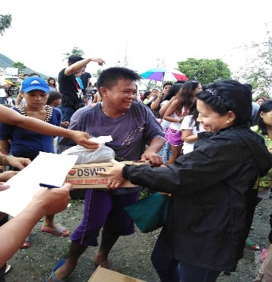
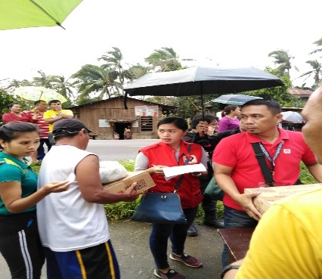
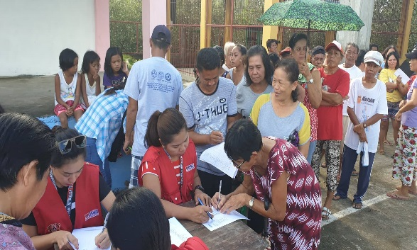
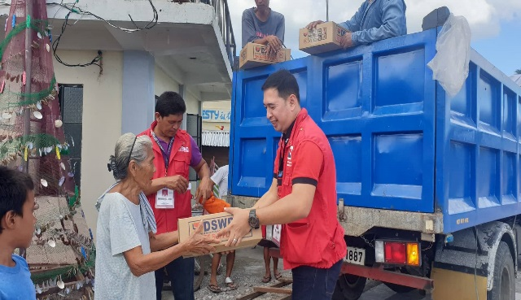
Distribution of F/NFIs in Babatngon, Leyte last December 26, 2019 (Credit to Honeylou Mora)
Distribution of FFPs in Barugo, Leyte last December 28, 2019 (Credit to Juel Ramos)
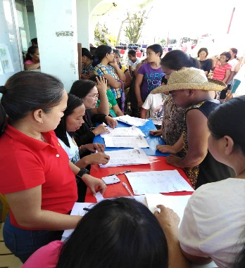
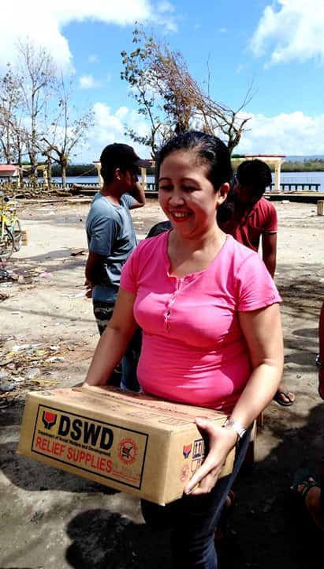
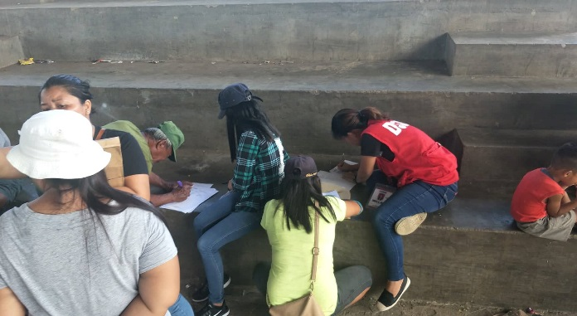
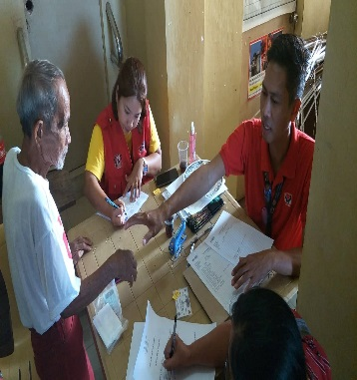
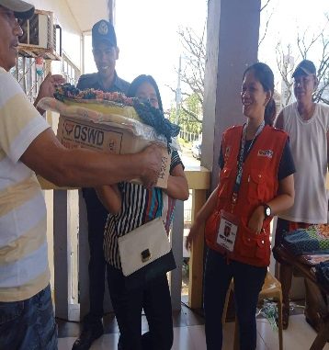
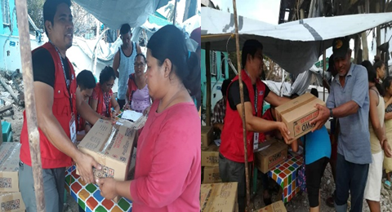
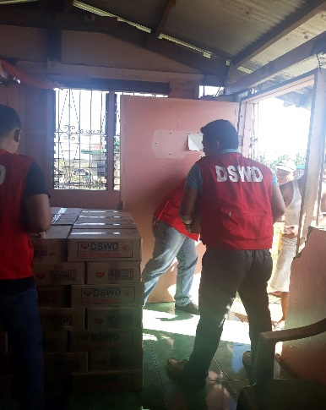
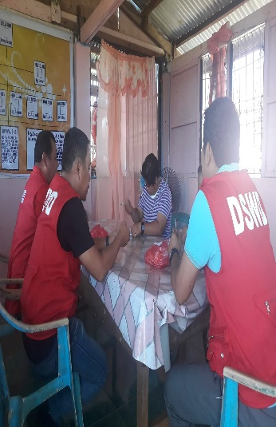
Distribution of FFPs in Basey, Samar last December 31, 2019 (Credit to Honeylou Mora)
Distribution of F/NFIs in Culaba, Biliran last December 30, 2019 (Credit to Virdyl Benito)
Distribution of F/NFIs in Caibiran, Biliran last December 30, 2019 (Credit to Virdyl Benito)
Distribution of FFPs in Salcedo, Eastern Samar last December 31, 2019 (Credit to Joseph Dela Peña)
Distribution of FFPs in Salcedo, Eastern Samar last December 29, 2019 (Credit to Joseph Dela Peña)
Distribution of FFPs in Dagami, Leyte last December 30, 2019 (Credit to Juel Ramos)
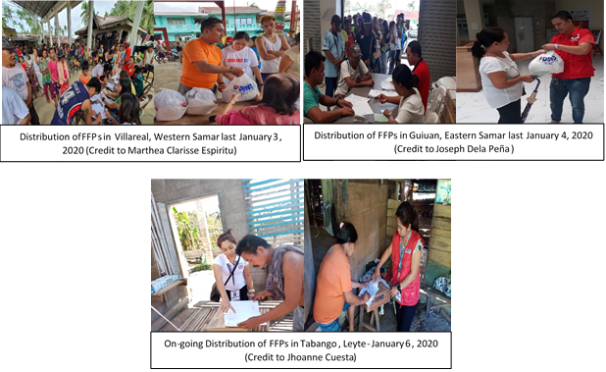
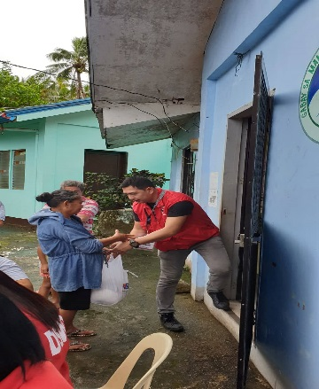
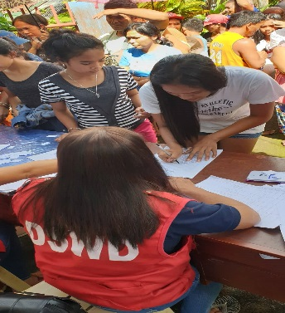
Distribution of FFPs in Capoocan, Leyte last January 3, 2020 (Credit to Juel Ramos)
Distribution of F/NFIs in Tacloban City last January 2, 2020 (Credit to Juel Ramos)

