DSWD DROMIC Report #34 on the
Ms 6.9 Earthquake Incident in Matanao, Davao del Sur
as of 03 February 2020, 6PM

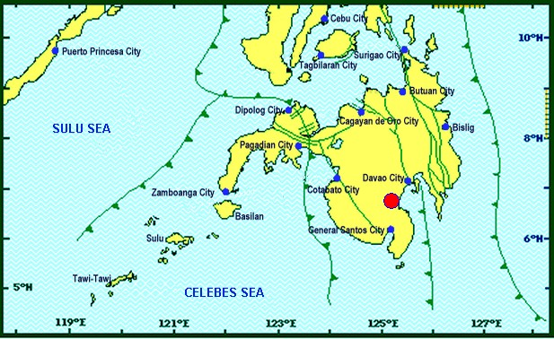
Situation Overview

On 15 December 2019 at 2:11 PM, a 6.9 magnitude earthquake jolted the municipality of Matanao, Davao del Sur (06.74°N, 125.20°E - 005 km N 72°W) with a tectonic origin and a depth of focus of 3 km.

Source: DOST-PHIVOLCS Earthquake Bulletin

- Status of Affected Families / Persons
A total of 87,094 families or 397,080 persons were affected by the earthquake incident in 230 barangays in Regions XI and XII (see Table 1).

Table 1. Number of Affected Families / Persons
REGION / PROVINCE / MUNICIPALITY |  | NUMBER OF AFFECTED
 |  | Barangays | Families | Persons
GRAND TOTAL |  | 230 | 87,094 | 397,080
REGION XI |  | 219 | 86,729 | 395,425
Davao del Sur |  | 219 | 86,729 | 395,425
 | Bansalan | 25 | 6,993 | 32,638
 | City of Digos (capital) | 25 | 3,666 | 18,300
 | Hagonoy | 21 | 9,223 | 32,254
 | Kiblawan | 30 | 13,938 | 67,626
 | Magsaysay | 22 | 15,940 | 75,596
 | Malalag | 15 | 10,937 | 54,685
 | Matanao | 33 | 14,477 | 59,587
 | Padada | 17 | 7,421 | 37,105
 | Santa Cruz | 6 | 661 | 3,499
 | Sulop | 25 | 3,473 | 14,135
REGION XII |  | 11 | 365 | 1,655
North Cotabato |  | 3 | 37 | 185
 | M'lang | 3 | 37 | 185
Sarangani |  | 5 | 175 | 705
 | Malungon | 5 | 175 | 705
Sultan Kudarat |  | 3 | 153 | 765
 | Columbio | 3 | 153 | 765
Note: The change in the number of affected persons in Davao del Sur is based on the validated report submitted by DSWD-FO XI. Thus, ongoing assessment and validation being conducted.
Source: DSWD-FOs XI and XII

- Status of Displaced Families / Persons
- Inside Evacuation Centers
There are 5,598 families or 20,530 persons taking temporary shelter in 60 evacuation centers in Region XI (see Table 2).

Table 2. Number of Displaced Families / Persons Inside Evacuation Centers
REGION / PROVINCE / MUNICIPALITY |  | NUMBER OF EVACUATION CENTERS (ECs) |  | NUMBER OF DISPLACED
 |  |  |  | INSIDE ECs
 |  |  |  | Families |  | Persons
 |  | CUM | NOW | CUM | NOW | CUM | NOW
GRAND TOTAL |  | 117 | 60 | 14,112 | 5,598 | 58,443 | 20,530
REGION XI |  | 113 | 60 | 13,898 | 5,598 | 57,418 | 20,530
Davao del Sur |  | 113 | 60 | 13,898 | 5,598 | 57,418 | 20,530
 | Bansalan | 12 | 12 | 1,032 | 657 | 3,585 | 2,313
 | City of Digos (capital) | 15 | 3 | 3,041 | 620 | 14,915 | 2,232
 | Hagonoy | 5 | 3 | 701 | 247 | 2,346 | 936
 | Kiblawan | 49 | 14 | 4,301 | 912 | 17,056 | 3,312
 | Magsaysay | 11 | 10 | 1,526 | 1,445 | 5,722 | 5,422
 | Malalag | 4 | 3 | 562 | 264 | 2,017 | 938
 | Matanao | 16 | 14 | 2,660 | 1,378 | 11,533 | 5,133
 | Padada | 1 | 1 | 75 | 75 | 244 | 244
REGION XII |  | 4 | - | 214 | - | 1,025 | -
Sarangani |  | 3 | - | 61 | - | 260 | -
 | Malungon | 3 | - | 61 | - | 260 | -
Sultan Kudarat |  | 1 | - | 153 | - | 765 | -
 | Columbio | 1 | - | 153 | - | 765 | -
Note: The change in the number of displaced persons in Davao del Sur is based on the validated report submitted by DSWD-FO XI. Thus, ongoing assessment and validation being conducted.
Source: DSWD-FOs XI and XII

- Outside Evacuation Centers
There are 25,272 families or 107,227 persons currently staying with their relatives and/or friends, or in open spaces (see Table 3).

Table 3. Number of Displaced Families / Persons Outside Evacuation Centers
REGION / PROVINCE / MUNICIPALITY |  | NUMBER OF DISPLACED
 |  | OUTSIDE ECs
 |  | Families |  | Persons
 |  | CUM | NOW | CUM | NOW
GRAND TOTAL |  | 25,565 | 25,272 | 108,573 | 107,227
REGION XI |  | 25,451 | 25,272 | 108,128 | 107,227
Davao del Sur |  | 25,451 | 25,272 | 108,128 | 107,227
 | Bansalan | 3,762 | 3,677 | 17,374 | 17,195
 | City of Digos (capital) | 495 | 470 | 2,400 | 2,023
 | Hagonoy | 8,642 | 8,642 | 30,376 | 30,376
 | Kiblawan | 2,758 | 2,758 | 12,137 | 12,137
 | Magsaysay | 247 | 247 | 1,235 | 1,235
 | Malalag | 7,486 | 7,417 | 37,430 | 37,085
 | Matanao | 940 | 940 | 3,010 | 3,010
 | Padada | 926 | 926 | 2,996 | 2,996
 | Santa Cruz | 195 | 195 | 1,170 | 1,170
REGION XII |  | 114 | - | 445 | -
Sarangani |  | 114 | - | 445 | -
 | Malungon | 114 | - | 445 | -
Note: The change in the number of displaced persons in Davao del Sur is based on the validated report submitted by DSWD-FO XI. Thus, ongoing assessment and validation being conducted.
Source: DSWD-FOs XI and XII

- Damaged Houses
There are 47,635 damaged houses; of which, 8,386 are totally damaged and 39,367 are partially damaged (see Table 4).

Table 4. Number of Damaged Houses
REGION / PROVINCE / MUNICIPALITY |  | NO. OF DAMAGED HOUSES
 |  | Total | Totally | Partially
GRAND TOTAL |  | 47,635 | 8,386 | 39,367
REGION XI |  | 47,603 | 8,386 | 39,335
Davao del Sur |  | 47,603 | 8,386 | 39,335
 | Bansalan | 5,729 | 1,936 | 3,793
 | City of Digos (capital) | 1,237 | 289 | 948
 | Hagonoy | 8,866 | 775 | 8,091
 | Kiblawan | 4,142 | 523 | 3,619
 | Magsaysay | 7,774 | 2,530 | 5,244
 | Malalag | 2,430 | 111 | 2,319
 | Matanao | 10,461 | 1,612 | 8,967
 | Padada | 3,311 | 347 | 2,964
 | Santa Cruz | 195 | 1 | 194
 | Sulop | 3,458 | 262 | 3,196
REGION XII |  | 32 | - | 32
North Cotabato |  | 32 | - | 32
 | M'lang | 32 | - | 32
Note: The change in the number of damaged houses in Davao del Sur is based on the validated report submitted by DSWD-FO XI. Thus, ongoing assessment and validation being conducted.
Source: DSWD-FOs XI and XII

- Assistance Provided
A total of ₱42,889,806.97 worth of assistance was provided by DSWD to the affected families (see Table 5).

Table 5. Cost of Assistance Provided to Affected Families / Persons
REGION / PROVINCE / MUNICIPALITY |  | COST OF ASSISTANCE
 |  | DSWD | LGU | NGOs | OTHERS | GRAND TOTAL
GRAND TOTAL |  | 42,889,806.97 | - | - | - | 42,889,806.97
REGION XI |  | 42,550,416.97 | - | - | - | 42,550,416.97
Davao del Sur |  | 42,550,416.97 | - | - | - | 42,550,416.97
 | Bansalan | 1,522,757.50 | - | - | - | 1,522,757.50
 | City of Digos (capital) | 11,532,658.46 | - | - | - | 11,532,658.46
 | Hagonoy | 6,045,646.78 | - | - | - | 6,045,646.78
 | Kiblawan | 5,450,863.70 | - | - | - | 5,450,863.70
 | Magsaysay | 3,349,326.50 | - | - | - | 3,349,326.50
 | Malalag | 5,477,529.77 | - | - | - | 5,477,529.77
 | Matanao | 3,691,677.84 | - | - | - | 3,691,677.84
 | Padada | 4,438,723.92 | - | - | - | 4,438,723.92
 | Sulop | 1,041,232.50 | - | - | - | 1,041,232.50
REGION XII |  | 339,390.00 | - | - | - | 339,390.00
Sultan Kudarat |  | 339,390.00 | - | - | - | 339,390.00
 | Columbio | 339,390.00 | - | - | - | 339,390.00
Source: DSWD-FOs XI and XII

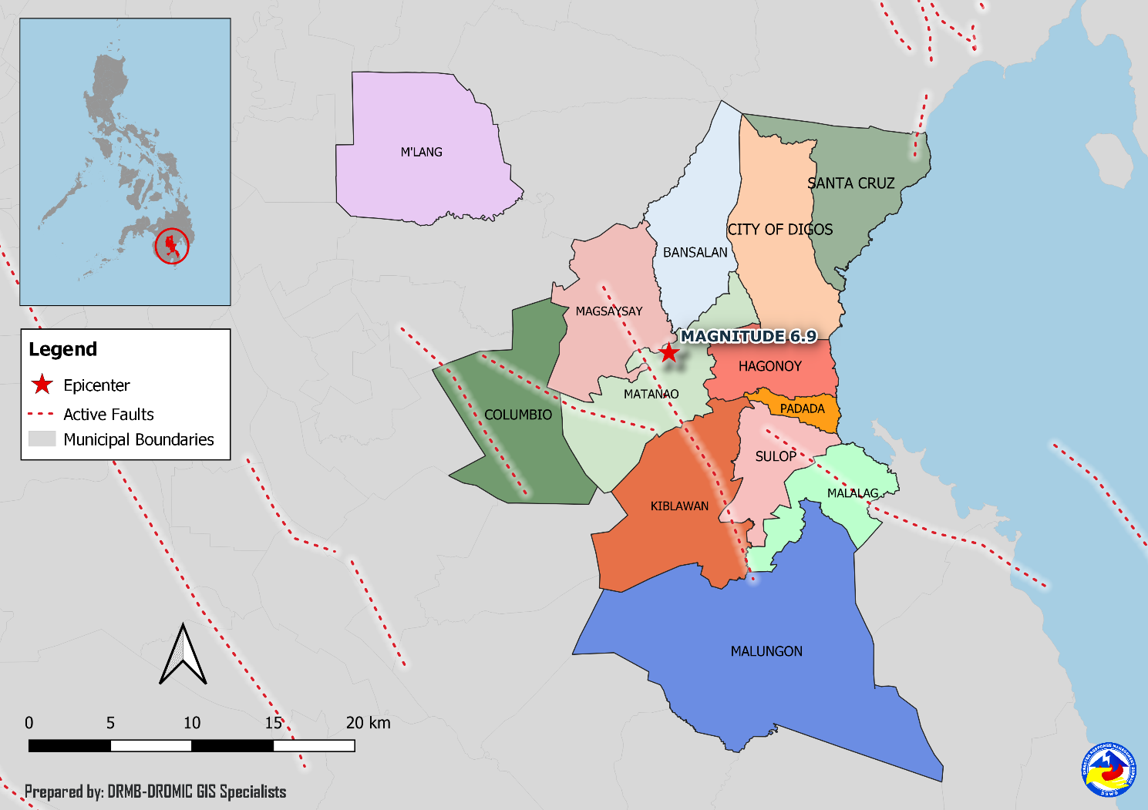
DSWD DISASTER RESPONSE INFORMATION

Situational Reports

DSWD-DRMB
DATE | SITUATIONS / ACTIONS UNDERTAKEN
03 February 2020 | - The Disaster Response Management Bureau (DRMB) is closely coordinating with the concerned Field Offices for significant disaster response updates.

DSWD-FO XI
DATE | SITUATIONS / ACTIONS UNDERTAKEN
25 January 2020 | - Seven (7) camp managers were oriented and deployed to seven (7) affected municipalities for augmentation including three (3) support staff assigned in the Mobile Storage Hub.
07 January 2020 | - OCD XI has prepositioned of goods (non-food items) located at DSWD-Mobile Storage Unit near Davao del Sur Coliseum, Digos City to wit; 129 pieces of camping tents, 546 sets of Tent, 999 box hygiene kits as of January 06, 2020.  - DSWD-FO XI Delivered/provided the Food Items to the ff. municipalities to wit; MATANAO; 332 FFPs and 332 Hygiene kit (OCD XI) PADADA; 2 Laminated sacks and 1 set Tent (OCD XI)
03 January 2020 | - DSWD-FO XI distributed family food packs to the affected families in Malalag, Davao del Sur and its Crisis Intervention Unit (CIU) extended cash assistance to the affected families in Padada and Malalag.  - DSWD-FO XI provided ₱20,599,000.00 worth of cash assistance to the affected families.
02 January 2020 | - DSWD-FO XI distributed family food packs to the affected families in Malalag, Davao del Sur.

DSWD-FO XII
DATE | SITUATIONS / ACTIONS UNDERTAKEN
09 January 2020 | - DSWD-FO XII submitted their terminal report.
26 December 2019 | - DSWD-FO XII provided 24 family tents to affected families in Malungon, Sarangani.  - 135 families were given financial assistance worth ₱2,400.00 through DSWD Assistance to Individual in Crisis Situation.
19 December 2019 | - DSWD-FO XII provided 270 packs family food packs, 135 pieces of sleeping kits, 270 pieces of collapsible water, 135 pieces of kitchen kits for the affected families in Columbio, Sultan Kudarat.  - DSWD-FO XII provided 5 units of tent in Malungon, Sarangani.
17 December 2019 | - DSWD-FO XII released 20 additional tents to the Local Government Unit of Malungon.

*****
The Disaster Response Operations Monitoring and Information Center (DROMIC) of the DSWD-DRMB is closely coordinating with concerned DSWD Field Offices for any significant disaster response updates.

Prepared by:

MARIE JOYCE G. RAFANAN

RODEL V. CABADDU
Releasing Officer

