DSWD DROMIC Terminal Report on the
Fire Incident in Brgy. Lawaan III, Talisay City, Cebu
09 July 2020, 6PM

This is the final report on the fire incident that occurred in Upper Cadicay, Brgy. Lawaan III, Talisay City, Cebu on 09 December 2019.
Source: DSWD-FO VII

SUMMARY

- Status of Affected Families / Persons
A total of 49 families or 214 were affected in Brgy. Lawaan III, Talisay City, Cebu (see Table 1).

Table 1. Number of Affected Families / Persons
REGION / PROVINCE / MUNICIPALITY |  | NUMBER OF AFFECTED
 |  | Barangays | Families | Persons
GRAND TOTAL |  | 1 | 49 | 214
REGION VII |  | 1 | 49 | 214
Cebu |  | 1 | 49 | 214
 | City of Talisay | 1 | 49 | 214
Source: DSWD-FO VII

- Status of Displaced Families / Persons
49 families or 214 persons took temporary shelter in tents set up near the site of the fire (see Table 2).

Table 2. Number of Displaced Families / Persons Outside Evacuation Center
REGION / PROVINCE / MUNICIPALITY |  | OUTSIDE ECs
 |  | Families |  | Persons
 |  | CUM | NOW | CUM | NOW
GRAND TOTAL |  | 49 | - | 214 | -
REGION VII |  | 49 | - | 214 | -
Cebu |  | 49 | - | 214 | -
 | City of Talisay | 49 | - | 214 | -
Source: DSWD-FO VII

- Damaged Houses
There were 49 damaged houses; of which, 48 were totally damaged and 1 was partially damaged (see Table 3).

Table 3. Number of Damaged Houses
REGION / PROVINCE / MUNICIPALITY |  | NO. OF DAMAGED HOUSES
 |  | Total | Totally | Partially
GRAND TOTAL |  | 49 | 48 | 1
REGION VII |  | 49 | 48 | 1
Cebu |  | 49 | 48 | 1
 | City of Talisay | 49 | 48 | 1
Source: DSWD-FO VII

- Assistance Provided
A total of ₱726,619.04 worth of assistance was provided to the affected families; of which, ₱236,619.04 was provided by DSWD and ₱490,000.00 from LGU (see Table 4).
Table 4. Cost of Assistance Provided to Affected Families / Persons
REGION / PROVINCE / MUNICIPALITY |  | TOTAL COST OF ASSISTANCE
 |  | DSWD | LGU | NGOs | OTHERS | GRAND TOTAL
GRAND TOTAL |  | 236,619.04 | 490,000.00 | - | - | 726,619.04
REGION VII |  | 236,619.04 | 490,000.00 | - | - | 726,619.04
Cebu |  | 236,619.04 | 490,000.00 | - | - | 726,619.04
 | City of Talisay | 236,619.04 | 490,000.00 | - | - | 726,619.04
Source: DSWD-FO VII

SITUATIONAL REPORT

DSWD-FO VII
DATE | SITUATIONS / ACTIONS UNDERTAKEN
06 July 2020 | - DSWD-FO VII submitted their terminal report.  - DSWD-FO VII provided family food packs, hygiene kits, dining kits, sleeping kits, family clothing kits, and ready-to-eat goods to the affected families.  - The local government unit of Talisay City provided ₱10,000.00 worth of financial assistance to each affected family. Dry goods such as sleeping mats, blankets, water jugs, pails, dippers, kitchen utensils and food meals were also provided.

*****
The Disaster Response Operations Monitoring and Information Center (DROMIC) of the DSWD-DRMB continues to closely coordinate with DSWD-FO VII for any request of Technical Assistance and Resource Augmentation (TARA).

Prepared by:

MARIE JOYCE G. RAFANAN

MARC LEO L. BUTAC
Releasing Officer

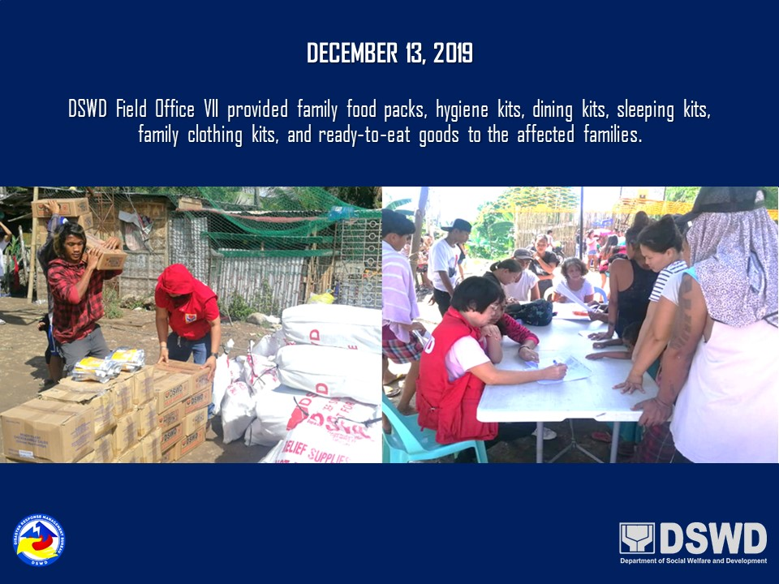
PHOTO DOCUMENTATION

