DSWD DROMIC Report #2
on the Taal Volcano Phreatic Eruption
as of 13 January 2020, 6PM

Situation Overview

At 5:30 PM 12 January 2020, the Philippine Institute of Volcanology and Seismology (PHIVOLCS) has raised alert level 4 over Taal Volcano, indicating that hazardous eruption is possible within hours to days. In its 7:30 PM advisory, the agency reiterated total evacuation of Taal Volcano Island and additional evacuation of areas at high-risk to pyroclastic density currents and volcanic tsunami within a 14-kilometer radius from the main crater. PHIVOLCS warned that areas in the general north of Taal Volcano to stay alert against effects of heavy and prolonged ash fall.

Source: PHIVOLCS (Philippine Institute of Volcanology and Seismology)

- Status of Affected Families / Persons
A total of 4,960 families or 21,937 persons were affected by the phreatic eruption in Region CALABARZON (see Table 1).

Table 1. Number of Affected Families / Persons
REGION / PROVINCE / MUNICIPALITY |  | NUMBER OF AFFECTED
 |  | Barangays | Families | Persons
GRAND TOTAL |  | - | 4,960 | 21,937
CALABARZON |  | - | 4,960 | 21,937
Batangas |  | - | 4,386 | 19,003
 | Agoncillo | - | 73 | 387
 | Alitagtag | - | 27 | 136
 | Balayan | - | 30 | 135
 | Bauan | - | 785 | 3,750
 | Cuenca | - | 42 | 216
 | Laurel | - | 457 | 2,281
 | Lemery | - | 348 | 1,585
 | Lipa City | - | 196 | 726
 | Malvar | - | 528 | 2,342
 | Mataas Na Kahoy | - | 93 | 439
 | Nasugbu | - | 40 | 176
 | San Luis | - | 29 | 161
 | San Nicolas | - | 10 | 95
 | Santa Teresita | - | 220 | 970
 | Santo Tomas | - | 474 | 2,148
 | Taal | - | 209 | 1,001
 | Talisay | - | 325 | 1,455
 | City of Tanauan | - | 500 | 1,000
Cavite |  | - | 574 | 2,934
 | Alfonso | - | 272 | 1,533
 | Tagaytay City | - | 302 | 1,401
Note: Ongoing assessment and validation are continuously being conducted in the number of barangays.
*Affected municipalities
**Host LGUs which catered the displaced families or persons from the affected municipalities
Source: DSWD-FO CALABARZON

- Status of Displaced Families / Persons Inside Evacuation Centers
There are 4,960 families or 21,937 persons taking temporary shelter in 78 evacuation centers in Region CALABARZON (see Table 2).

Table 2. Number of Displaced Families / Persons Inside Evacuation Centers
REGION / PROVINCE / MUNICIPALITY |  | NUMBER OF EVACUATION CENTERS (ECs) |  | NUMBER OF DISPLACED
 |  |  |  | INSIDE ECs
 |  |  |  | Families |  | Persons
 |  | CUM | NOW | CUM | NOW | CUM | NOW
GRAND TOTAL |  | 78 | 78 | 4,960 | 4,960 | 21,937 | 21,937
CALABARZON |  | 78 | 78 | 4,960 | 4,960 | 21,937 | 21,937
Batangas |  | 52 | 52 | 4,386 | 4,386 | 19,003 | 19,003
 | Agoncillo | 1 | 1 | 73 | 73 | 387 | 387
 | Alitagtag | 1 | 1 | 27 | 27 | 136 | 136
 | Balayan | 1 | 1 | 30 | 30 | 135 | 135
 | Bauan | 5 | 5 | 785 | 785 | 3,750 | 3,750
 | Cuenca | 1 | 1 | 42 | 42 | 216 | 216
 | Laurel | 4 | 4 | 457 | 457 | 2,281 | 2,281
 | Lemery | 4 | 4 | 348 | 348 | 1,585 | 1,585
 | Lipa City | 4 | 4 | 196 | 196 | 726 | 726
 | Malvar | 4 | 4 | 528 | 528 | 2,342 | 2,342
 | Mataas Na Kahoy | 4 | 4 | 93 | 93 | 439 | 439
 | Nasugbu | 1 | 1 | 40 | 40 | 176 | 176
 | San Luis | 1 | 1 | 29 | 29 | 161 | 161
 | San Nicolas | 2 | 2 | 10 | 10 | 95 | 95
 | Santa Teresita | 4 | 4 | 220 | 220 | 970 | 970
 | Santo Tomas | 5 | 5 | 474 | 474 | 2,148 | 2,148
 | Taal | 2 | 2 | 209 | 209 | 1,001 | 1,001
 | Talisay | 7 | 7 | 325 | 325 | 1,455 | 1,455
 | City of Tanauan | 1 | 1 | 500 | 500 | 1,000 | 1,000
Cavite |  | 26 | 26 | 574 | 574 | 2,934 | 2,934
 | Alfonso | 8 | 8 | 272 | 272 | 1,533 | 1,533
 | Tagaytay City | 18 | 18 | 302 | 302 | 1,401 | 1,401
Note: Ongoing assessment and validation are continuously being conducted in the region.
Source: DSWD-FO CALABARZON

- Assistance Provided
A total of ₱339,426.00 worth of assistance was provided by DSWD to the affected families (see Table 3).

Table 3. Cost of Assistance Provided to Affected Families / Persons
REGION / PROVINCE / MUNICIPALITY |  | COST OF ASSISTANCE
 |  | DSWD | LGU | NGOs | OTHERS | GRAND TOTAL
GRAND TOTAL |  | 339,426.00 | - | - | - | 339,426.00
CALABARZON |  | 339,426.00 | - | - | - | 339,426.00
Batangas |  | 339,426.00 | - | - | - | 339,426.00
 | Laurel | 339,426.00 | - | - | - | 339,426.00
Note: Ongoing assessment and validation are continuously being conducted in the region.
Source: DSWD-FO CALABARZON

Status of Prepositioned Resources: Stockpile and Standby Funds

The DSWD Central Office (CO), Field Offices (FOs), and National Resource Operations Center (NROC) have stockpiles and standby funds amounting to ₱1,028,135,584.56 with breakdown as follows (see Table 1):

- Standby Funds
A total of ₱361,431,736.99 standby funds in the CO and FOs. Of the said amount, ₱326,441,312.28 is the available Quick Response Fund (QRF) in the CO.

- Stockpiles
A total of 188,594 Family Food Packs (FFPs) amounting to ₱71,886,774.85 and available Food and Non-food Items (FNIs) amounting to ₱594,817,072.72.

 | STANDBY FUNDS | FAMILY FOOD PACKS |  | Other Food Items | Non Food Items | SUB-TOTAL (Food and NFIs) | Total STANDBY FUNDS & STOCKPILE
 |  | Quantity | Total Cost | Total Cost | Total Cost
TOTAL | 361,431,736.99 | 188,594 | 71,886,774.85 | 173,984,603.15 | 420,832,469.57 | 594,817,072.72 | 1,028,135,584.56
Central Office | 326,441,312.28 | - | - | - | - | - | 326,441,312.28
NRLMB - NROC | - | 1,750 | 659,995.00 | 23,655,750.79 | 213,593,172.11 | 237,248,922.90 | 237,908,917.90
NRLMB - VDRC | - | 9,800 | 3,528,000.00 | 7,365,040.00 | 4,090,050.00 | 11,455,090.00 | 14,983,090.00
I | 2,379,275.00 | 12,013 | 3,937,966.58 | 299,455.20 | 37,645,525.20 | 37,944,980.40 | 44,262,221.98
II | 2,650,779.35 | 15,313 | 5,740,055.66 | 639,602.00 | 7,486,716.95 | 8,126,318.95 | 16,517,153.96
III | 29,157.00 | 9,390 | 3,832,256.22 | 2,406,194.70 | 5,791,876.40 | 8,198,071.10 | 12,059,484.32
CALABARZON | 3,000,000.00 | 5,763 | 2,078,967.02 | 3,168,773.20 | 5,523,160.91 | 8,691,934.11 | 13,770,901.13
MIMAROPA | 2,240,983.78 | 26,721 | 12,024,450.00 | 898,761.00 | 7,348,871.29 | 8,247,632.29 | 22,513,066.07
V | 3,000,000.00 | 8,854 | 2,800,559.56 | 6,214,062.16 | 31,727,489.94 | 37,941,552.10 | 43,742,111.66
VI | 0.00 | 6,857 | 2,468,520.00 | 7,119,877.25 | 5,285,253.00 | 12,405,130.25 | 14,873,650.25
VII | 511,193.50 | 14,349 | 5,165,640.00 | 8,230,869.59 | 10,349,862.37 | 18,580,731.96 | 24,257,565.46
VIII | 3,000,735.00 | 3,946 | 1,492,710.38 | 3,016,392.06 | 20,937,915.08 | 23,954,307.14 | 28,447,752.52
IX | 3,000,000.00 | 13,152 | 4,734,720.00 | 2,076,520.00 | 15,472,334.14 | 17,548,854.14 | 25,283,574.14
X | 3,000,000.00 | 15,985 | 5,801,323.64 | 87,239,260.45 | 12,628,921.90 | 99,868,182.35 | 108,669,505.99
XI | 3,000,644.00 | 13,841 | 5,486,157.17 | 7,170,000.00 | 6,973,437.90 | 14,143,437.90 | 22,630,239.07
XII | 3,000,770.18 | 14,583 | 5,843,799.00 | 3,337,676.00 | 6,716,851.16 | 10,054,527.16 | 18,899,096.34
CARAGA | 3,000,000.00 | 5,238 | 1,911,011.40 | 1,884,232.10 | 1,772,370.46 | 3,656,602.56 | 8,567,613.96
NCR | 176,886.00 | 4,158 | 1,558,162.92 | 659,823.29 | 10,573,477.85 | 11,233,301.14 | 12,968,350.06
CAR | 3,000,000.90 | 6,881 | 2,822,480.30 | 8,602,313.36 | 16,915,182.91 | 25,517,496.27 | 31,339,977.47
*Quick Response Fund (QRF) as of 10 January 2020

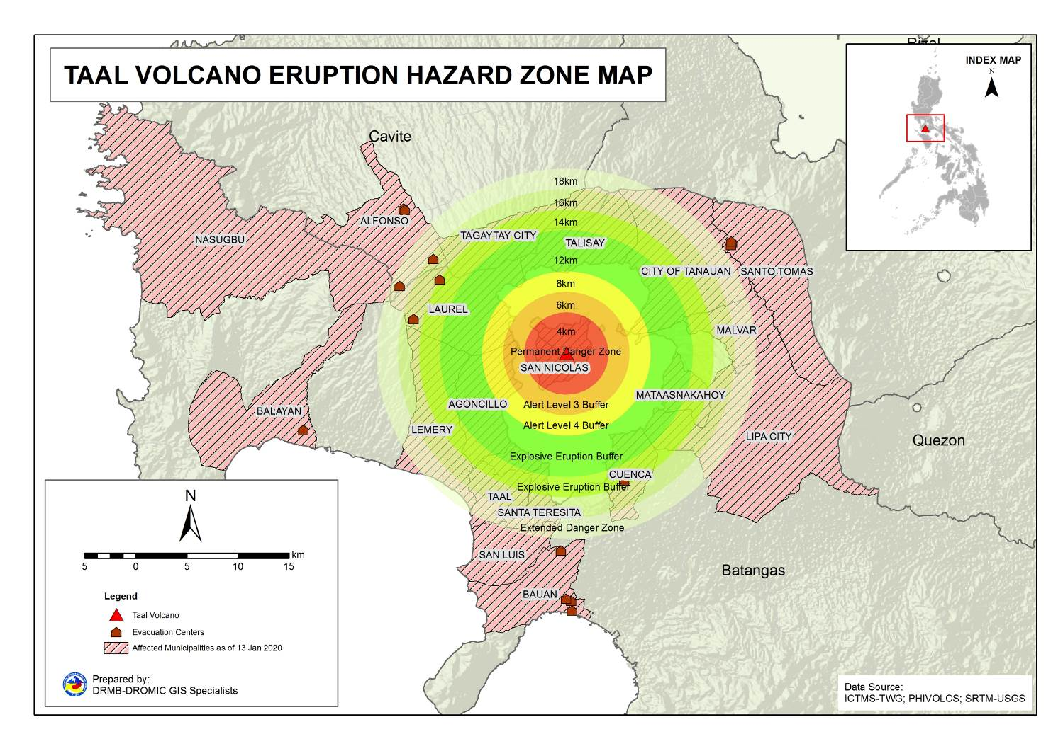
DSWD DISASTER RESPONSE INFORMATION
Note: Ongoing assessment and validation are continuously being conducted in the location of Evacuation Centers.

Situational Reports

DSWD-DRMB
DATE | SITUATIONS / ACTIONS UNDERTAKEN
- January 2020 | - The Disaster Response Management Bureau (DRMB) is on RED Alert Status and is closely coordinating with DSWD-FO CALABARZON for significant disaster response updates.  - Assistant Secretary for Disaster Response Management Group (DRMG) Rodolfo “Rudy” Encabo joined DSWD Secretary Bautista in Tagaytay Convention Center to attend the cabinet meeting relative to the Taal Volcano Phreatic Eruption Operations.  - All QRTs are on standby and ready for deployment.  - McDonalds House of Charity through Asec. Rhea Peñaflor donated meals for the disaster response duty teams.

DSWD-FO CALABARZON
DATE | SITUATIONS / ACTIONS UNDERTAKEN
- January 2020, 6PM | - DSWD-FO CALABARZON is on RED Alert Status.  - DSWD-FO CALABARZON provided 900 family food packs to the affected families in Laurel, Batangas.  - DSWD-FO CALABARZON is closely coordinating with RDRRMC IV-As response agencies, and Local Government Units (LGUs) on the effects of the volcanic eruption.  - The DRMD advised the LSWDOs to closely monitor and oversee the overall conduct of the operations in their respective areas in coordination with their Local Disaster Risk Reduction and Management Offices.  - Continuous coordination with the SWAD Team Leaders and Provincial Action Team of the Region and advised them to monitor and check with the LGUs to gather any reports on the effects of the eruption.  - Coordinated with LSWDOs and LDRRMOs outside the Permanent Danger Zone and instructed them to be on standby alert and prepare their respective evacuation centers, and family food packs should need arises.  - Coordinated with RDRRMC IV-A Operation Center for updates on the status of the members of the Response Cluster of the region.  - Continuous monitoring of the ongoing volcanic activity thru news reports and social media.  - RDANA Teams of Regional and Provincial Quick Response Teams have conducted assessment in the affected areas with existing IDPs.  - The Assistant Regional Director for Operations (ARDO) presided the response clusters meeting held on January 12, 2019.  - The Assistant Regional Director for Administration (ARDA) joined the team from the RDRRMC IV-A for the aerial assessment.  - Coordinated with FOs NCR, III, IV-B and V for the augmentation of FFPs and NFIs in the affected areas.
- January 2020, 8AM | - DSWD-FO CALABARZON has a total of 5,763 family food packs available in their GMA warehouse amounting to ₱2,078,967.02 while a total of 210,583 raw materials/unpacked goods amounting to ₱5,247,740.22 is also available for repacking, Non-Food Items amounting to ₱6,321,176.71 is available for augmentation and Standby Fund amounting to ₱ 5,268,000.00 that they can be utilized to augment the response operation.  - The Regional and Provincial Quick Response Teams are placed on heightened alert status and members from the Regional QRTs render disaster duty in DSWD FO IV-A Emergency Operations Center and in RDRRMC Emergency Operations Center.  - DSWD-FO CALABARZON advised the Local Social Welfare and Development Offices (LSWDOs) of CALABAR Region to activate their respective CCCM, IDP Protection and Food and Non-Food Clusters.  - DSWD-FO CALABARZON provided technical assistance to LGUs with opened evacuation centers on Camp Coordination and Camp Management.  - DSWD-FO CALABARZON advised the LGUs of CALABAR Region to remain vigilant and ensure prompt delivery of services when needed.  - DSWD-FO CALABARZON rendered duty in the RDRRMC CALABARZON EOC.  - DSWD-FO CALABARZON requested the Provincial Quick Response Teams and Municipal Action Teams to closely coordinate with their respective LDRRMCs. Field staff also requested to monitor their respective AOR and provide significant updates to the Emergency Operations Center.  - DSWD-FO CALABARZON ARD for Operations attended the Emergency Meeting at the RDRRMC Operations Center.

*****
The Disaster Response Operations Monitoring and Information Center (DROMIC) of the DSWD-DRMB is closely coordinating with DSWD Field Office CALABARZON for any significant disaster response updates.

Prepared by:

MARIE JOYCE G. RAFANAN

RODEL V. CABADDU
Releasing Officer

PHOTO DOCUMENTATION

FFP AND NFI DISTRIBUTION IN PUP GYM, STO. TOMAS BATANGAS
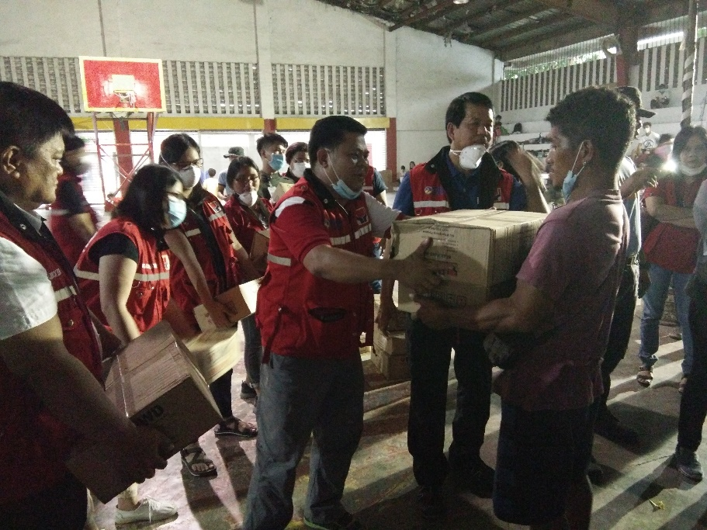

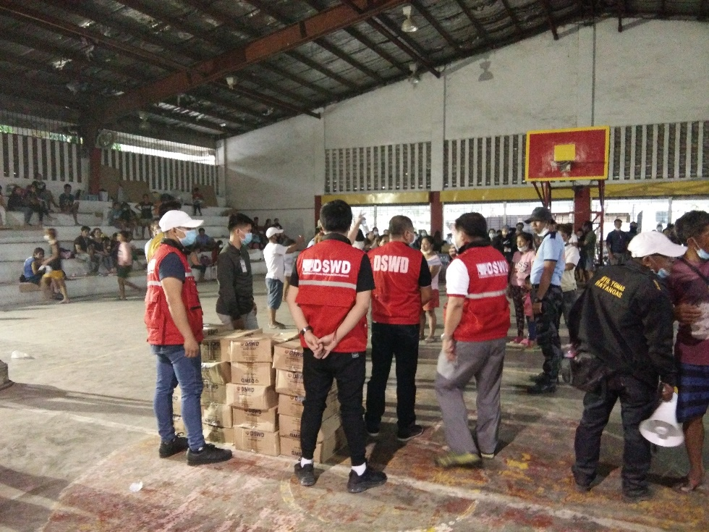
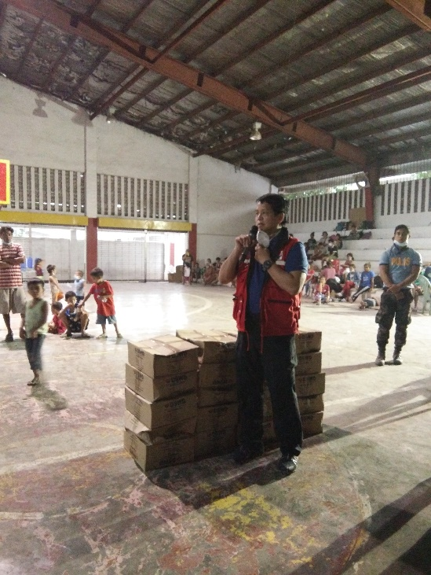

FFP AND NFI DISTRIBUTION TO 141 FAMILIES IN
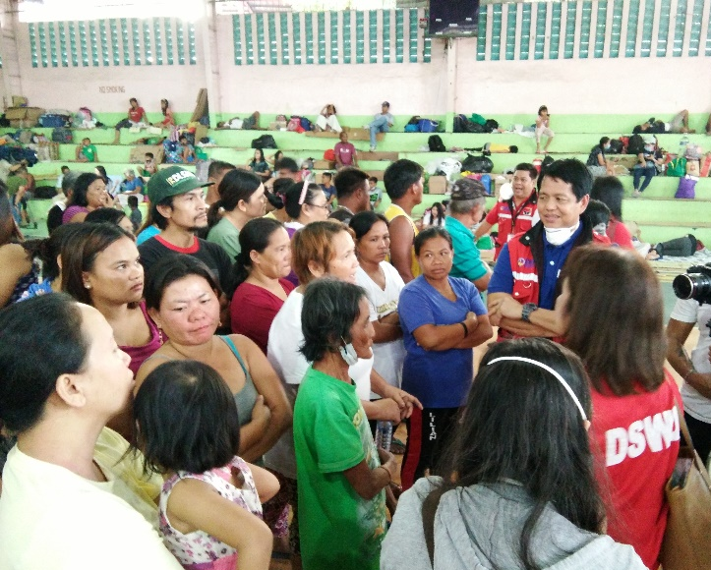
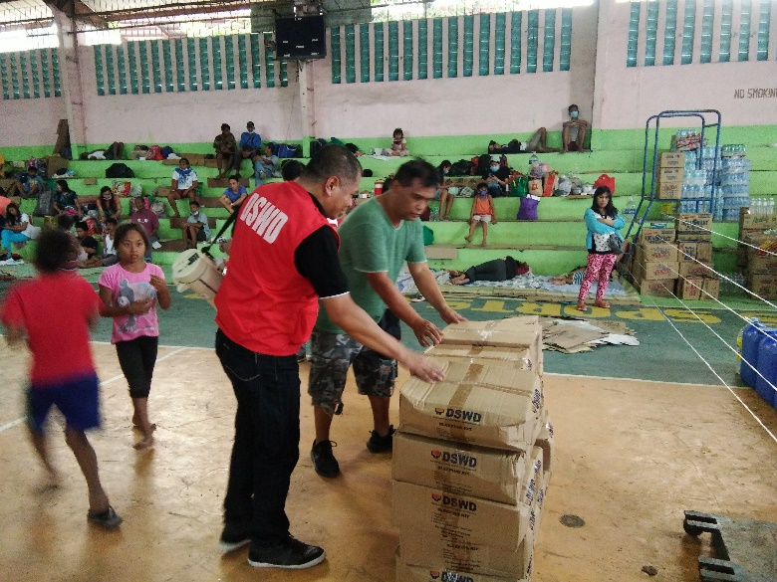
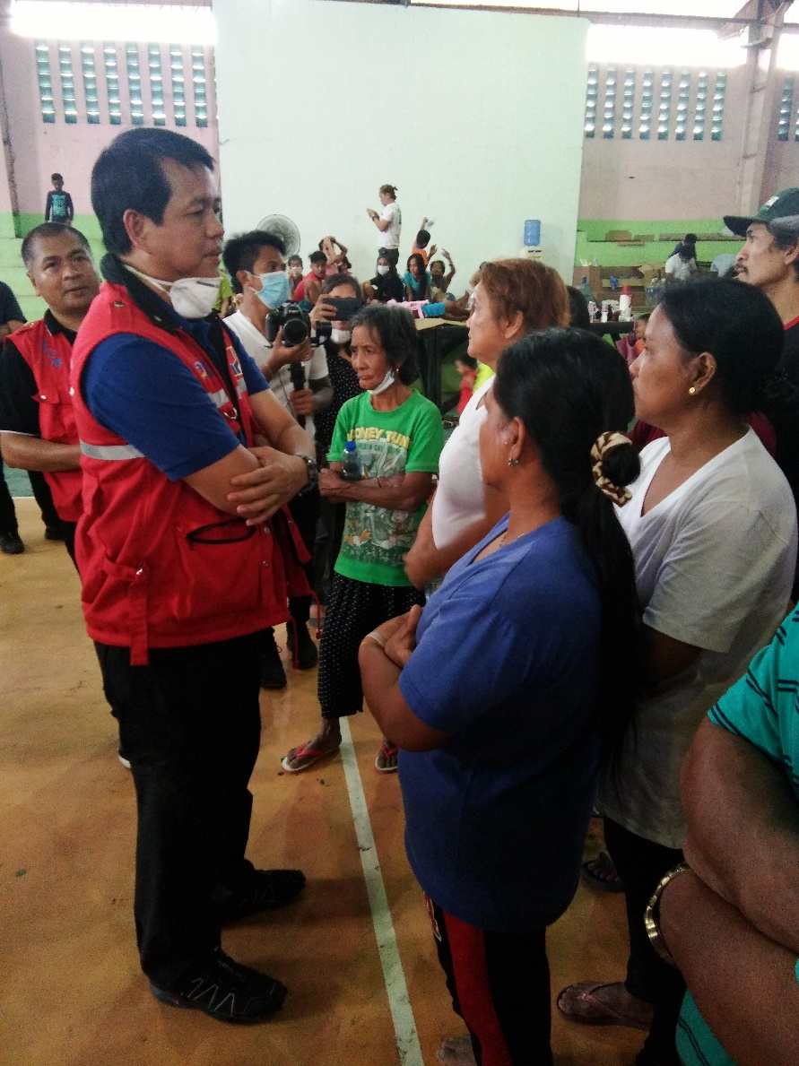
STO. TOMAS GYM, BATANGAS

