DSWD DROMIC Report #1 on the Fire Incident
in Brgy. Bagong Silang, Puerto Princesa City, Palawan
as of 25 April 2020, 6PM

SUMMARY

On 23 April 2020 at around 9:15 AM, a fire incident occurred in Brgy. Bagong Silang, Puerto Princesa City, Palawan.
Source: DSWD-FO MIMAROPA

- Status of Affected Families / Persons
A total of 95 families or 390 persons were affected by the fire incident in Brgy. Bagong Silang, Puerto Princesa City, Palawan (see Table 1).

Table 1. Number of Affected Families / Persons
REGION / PROVINCE / MUNICIPALITY |  | NUMBER OF AFFECTED
 |  | Barangays | Families | Persons
GRAND TOTAL |  | 1 | 95 | 390
REGION MIMAROPA |  | 1 | 95 | 390
Palawan |  | 1 | 95 | 390
 | Puerto Princesa City (Capital) | 1 | 95 | 390
Note: Ongoing assessment and validation being conducted
Source: DSWD-FO MIMAROPA

- Status of Displaced Families / Persons
a. Inside Evacuation Centers
There are 54 Families or 250 Persons currently staying in Pilot Elementary School in Brgy. Bagong Silang, Puerto Princesa City, Palawan (see Table 2).

Table 2. Displaced Families / Persons Inside Evacuation Centers
REGION / PROVINCE / MUNICIPALITY |  | NUMBER OF EVACUATION CENTERS (ECs) |  | INSIDE ECs
 |  |  |  | Families |  | Persons
 |  | CUM | NOW | CUM | NOW | CUM | NOW
GRAND TOTAL |  | 1 | 1 | 54 | 54 | 250 | 250
REGION MIMAROPA |  | 1 | 1 | 54 | 54 | 250 | 250
Palawan |  | 1 | 1 | 54 | 54 | 250 | 250
 | Puerto Princesa City (Capital) | 1 | 1 | 54 | 54 | 250 | 250
Note: Ongoing assessment and validation being conducted
Source: DSWD-FO MIMAROPA
b. Outside Evacuation Centers
There are 41 families or 140 persons temporarily staying with their relatives and/or friends. (see Table 3)

Table 3. Displaced Families / Persons Outside Evacuation Center
REGION / PROVINCE / MUNICIPALITY |  | OUTSIDE ECs
 |  | Families |  | Persons
 |  | CUM | NOW | CUM | NOW
GRAND TOTAL |  | 41 | 41 | 140 | 140
REGION MIMAROPA |  | 41 | 41 | 140 | 140
Palawan |  | 41 | 41 | 140 | 140
 | Puerto Princesa City (Capital) | 41 | 41 | 140 | 140
Note: Ongoing assessment and validation being conducted.
Source: DSWD-FO MIMAROPA
IV. Assistance Provided
A total of ₱85,200.00 worth of assistance was provided by DSWD to the affected families (see Table 4).

Table 4. Cost of Assistance Provided to Affected Families / Persons
REGION / PROVINCE / MUNICIPALITY |  | TOTAL COST OF ASSISTANCE
 |  | DSWD | LGU | NGOs | OTHERS | GRAND TOTAL
GRAND TOTAL |  | 85,200.00 | - | - | - | 85,200.00
REGION MIMAROPA |  | 85,200.00 | - | - | - | 85,200.00
Palawan |  | 85,200.00 | - | - | - | 85,200.00
 | Puerto Princesa City (Capital) | 85,200.00 | - | - | - | 85,200.00
Note: Ongoing assessment and validation being conducted.
Source: DSWD-FO MIMAROPA

SITUATIONAL REPORT

DSWD-DRMB
DATE | SITUATIONS / ACTIONS UNDERTAKEN
25 April 2020 | - The Disaster Response Operations Monitoring and Information Center (DROMIC) of the DSWD-DRMB is closely coordinating with DSWD-Field Office MIMAROPA for significant reports on the status of affected families, assistance, and relief efforts.

DSWD-FO MIMAROPA
DATE | SITUATIONS / ACTIONS UNDERTAKEN
25 April 2019 | - DSWD-FO MIMAROPA provided 71 family food packs and 71 sleeping kits to the affected families amounting to ₱85,200.00.  - Disaster Response Management Division (DRMD) is closely coordinating with the SWADT Office Palawan and concerned LGU to assist the affected families and thoroughly assess their needs.

*****
The Disaster Response Operations Monitoring and Information Center (DROMIC) of the DSWD-DRMB is closely coordinating with DSWD-FO MIMAROPA for any significant disaster response updates.

Prepared by:

MARIEL B. FERRARIZ

RODEL V. CABADDU
Releasing Officer

PHOTO DOCUMENTATION
The Philippine Navy rescuing the affected residents of Purok Lapu-lapu, Brggy Bagong Silang Puerto Princesa City, Palawan

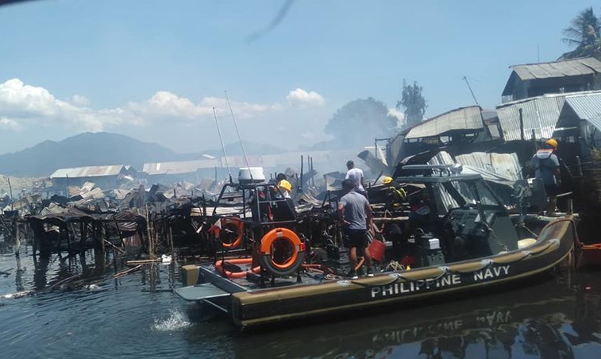

Relief distribution of the DSWD through SWADT Office Palawan to the displaced families of the fire incident in Pilot Elementary School

