DSWD DROMIC Report #3 on the
Fire Incident in Brgy. Bagong Silang, Puerto Princesa, Palawan
as of 28 April 2020, 6PM

SUMMARY

On 23 April 2020 at 9:15AM, a fire incident occurred at Brgy. Bagong Silang, Puerto Princesa, Palawan. The fire was declared under control around 10:40AM. The cause of fire is under investigation.

Source: DSWD-FO MIMAROPA

- Status of Affected Families / Persons
A total of 110 families or 368 persons were affected by the fire incident in Brgy. Bagong Silang, Puerto Princesa, Palawan (see Table 1).

Table 1. Number of Affected Families / Persons
REGION / PROVINCE / MUNICIPALITY |  | NUMBER OF AFFECTED
 |  | Barangays | Families | Persons
GRAND TOTAL |  | 1 | 110 | 368
REGION MIMAROPA |  | 1 | 110 | 368
Palawan |  | 1 | 110 | 368
 | Puerto Princesa City (Capital) | 1 | 110 | 368
Note: The decrease in the number of affected persons is due to the ongoing assessment and validation being conducted
Source: DSWD-FO MIMAROPA

- Status of Displaced Families
  - Inside Evacuation Centers
There are 103 families or 344 persons who are currently staying inside Pilot Elementary School, Palawan. (see Table 2).

Table 2. Displaced Families / Persons Inside Evacuation Center
REGION / PROVINCE / MUNICIPALITY | NUMBER OF EVACUATION CENTERS (ECs) |  | INSIDE ECs
 |  |  | Families |  | Persons
 | CUM | NOW | CUM | NOW | CUM | NOW
GRAND TOTAL | 1 | 1 | 103 | 103 | 344 | 344
MIMAROPA | 1 | 1 | 103 | 103 | 344 | 344
Palawan | 1 | 1 | 103 | 103 | 344 | 344
Note: Ongoing assessment and validation being conducted.
Source: DSWD-FO MIMAROPA

  - Outside Evacuation Centers
There are 7 families or 24 persons who stayed with their relatives and/or friends (see Table 3).

Table 3. Displaced Families / Persons Outside Evacuation Center
REGION / PROVINCE / MUNICIPALITY | OUTSIDE ECs
 | Families |  | Persons
 | CUM | NOW | CUM | NOW
GRAND TOTAL | 7 | 7 | 24 | 24
MIMAROPA | 7 | 7 | 24 | 24
Palawan | 7 | 7 | 24 | 24
Note: The decrease in the number of displaced families and persons is due to the ongoing assessment and validation being conducted.
Source: DSWD-FO MIMAROPA
- Damaged Houses
A total of 110 houses were damaged; of which, 108 were totally damaged and 2 were partially damaged by the fire (see Table 4).

Table 4. Number of Damaged Houses
REGION / PROVINCE / MUNICIPALITY | NO. OF DAMAGED HOUSES
 | Total | Totally | Partially
GRAND TOTAL | 110 | 108 | 2
MIMAROPA | 110 | 108 | 2
Palawan | 110 | 108 | 2
Note: The decrease in the number of partially damaged houses is due to the ongoing assessment and validation being conducted.
Source: DSWD- FO MIMAROPA

- Assistance Provided
A total of ₱85,200 worth of assistance was provided to the affected family and individuals by DSWD (see Table 5).

Table 5. Cost of Assistance Provided to Affected Families / Persons
REGION / PROVINCE / MUNICIPALITY |  | TOTAL COST OF ASSISTANCE
 |  | DSWD | LGU | NGOs | OTHERS | GRAND TOTAL
GRAND TOTAL |  | 85,200 | - | - | - | 85,200
MIMAROPA |  | 85,200 | - | - | - | 85,200
 | Palawan | 85,200 | - | - | - | 85,200
Note: Ongoing assessment and validation being conducted.
Source: DSWD-FO MIMAROPA

SITUATIONAL REPORT
DSWD-DRMB
DATE | SITUATIONS / ACTIONS UNDERTAKEN
28 April 2020 | - The Disaster Response Operations Monitoring and Information Center (DROMIC) of the DSWD-DRMB is closely coordinating with DSWD-FO MIMAROPA for significant reports on the status of affected families, assistance, and relief efforts.

DSWD-FO MIMAROPA
DATE | SITUATIONS / ACTIONS UNDERTAKEN
- April 2020 | - DSWD-FO MIMAROPA provided 71 family food packs and 71 sleeping kits amounting to ₱85,200 to the affected families.  - DSWD-FO MIMAROPA through AICS provided financial assistance amounting to ₱520,000.00 to the affected families.  - DSWD-FO MIMAROPA through SWADT Palawan is in coordination with the City Social Welfare and Development Office, supported by the Municipal Action Team (MAT) of DSWD, to conduct validation and assessment on the damaged houses and affected families.  - DSWD-FO MIMAROPA is continuously coordinating with SWADT Palawan and concerned LGU to assist the affected families and thoroughly assess their other needs.

*****
The Disaster Response Operations Monitoring and Information Center (DROMIC) of the DSWD-DRMB is closely coordinating with DSWD-FO MIMAROPA for any significant disaster response updates.

Prepared by:

MARIEL B. FERRARIZ

LESLIE R. JAWILI
Releasing Officer

PHOTO DOCUMENTATION

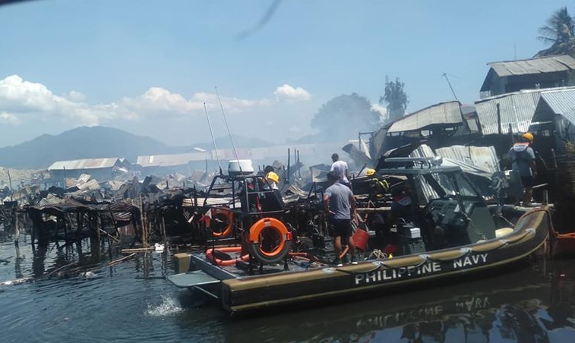
The Philippine Navy rescuing the affected residents of Purok Lapu-lapu, Brggy Bagong Silang Puerto Princesa City, Palawan
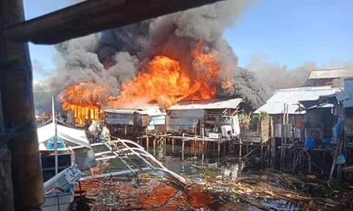
The raging fire destroying the houses in coastal areas of Bagong Silang
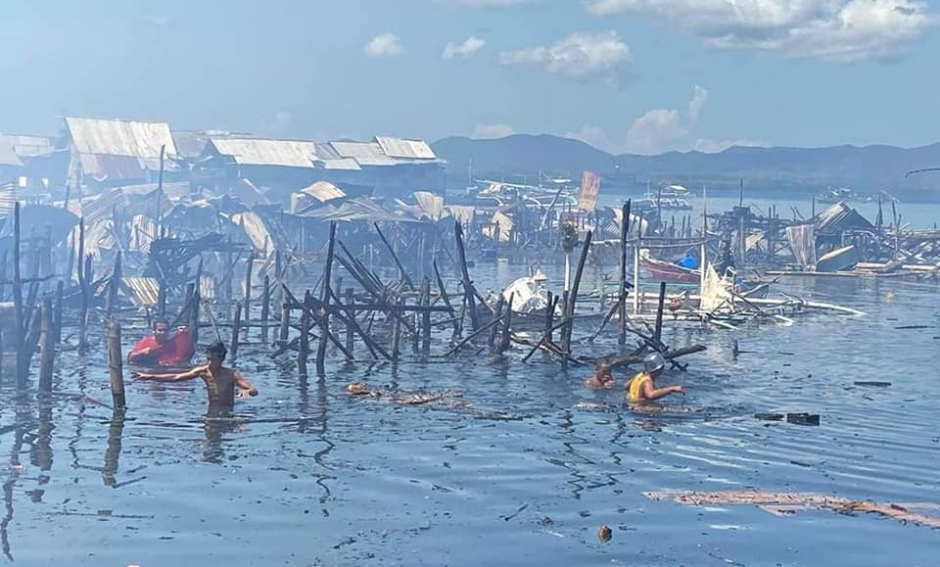
Aftermath of the fire incident in Bagong Silang, PPC, Palawan

Relief distribution of the DSWD through SWADT Office Palawan to the displaced families of the fire incident in Pilot Elementary School
The practice of physical distancing during the relief distribution to the affected families housed in Pilot Elementary School

