DSWD DROMIC Report #7 on the
Fire Incident in Brgy. Bagong Silang, Puerto Princesa, Palawan
as of 12 May 2020, 6AM

SUMMARY

On 23 April 2020 at 9:15AM, a fire incident occurred at Brgy. Bagong Silang, Puerto Princesa, Palawan. The fire was declared under control around 10:40AM. The cause of fire is under investigation.

Source: DSWD-FO MIMAROPA

- Status of Affected Families / Persons
A total of 110 families or 370 persons were affected by the fire incident in Brgy. Bagong Silang, Puerto Princesa, Palawan (see Table 1).

Table 1. Number of Affected Families / Persons
REGION / PROVINCE / MUNICIPALITY |  | NUMBER OF AFFECTED
 |  | Barangays | Families | Persons
GRAND TOTAL |  | 1 | 110 | 370
REGION MIMAROPA |  | 1 | 110 | 370
Palawan |  | 1 | 110 | 370
 | Puerto Princesa City (Capital) | 1 | 110 | 370
Note: Ongoing assessment and validation being conducted.
Source: DSWD-FO MIMAROPA
- Status of Displaced Families
  - Inside Evacuation Centers
There are 75 families or 267 persons who are currently staying inside Pilot Elementary School, Palawan. (see Table 2).

Table 2. Displaced Families / Persons Inside Evacuation Center
REGION / PROVINCE / MUNICIPALITY | NUMBER OF EVACUATION CENTERS (ECs) |  | INSIDE ECs
 |  |  | Families |  | Persons
 | CUM | NOW | CUM | NOW | CUM | NOW
GRAND TOTAL | 1 | 1 | 103 | 75 | 344 | 267
MIMAROPA | 1 | 1 | 103 | 75 | 344 | 267
Palawan | 1 | 1 | 103 | 75 | 344 | 267
Note: Ongoing assessment and validation being conducted.
Source: DSWD-FO MIMAROPA

  - Outside Evacuation Centers
There were 7 families or 26 persons who took temporary shelter with their relatives and/or friends (see Table 3).

Table 3. Displaced Families / Persons Outside Evacuation Center
REGION / PROVINCE / MUNICIPALITY |  | OUTSIDE ECs
 |  | Families |  | Persons
 |  | CUM | NOW | CUM | NOW
GRAND TOTAL |  | 7 | - | 26 | -
REGION MIMAROPA |  | 7 | - | 26 | -
Palawan |  | 7 | - | 26 | -
 | Puerto Princesa City (Capital) | 7 | - | 26 | -
Note: The decrease in the number of displaced families and persons is due to the ongoing assessment and validation being conducted.
Source: DSWD-FO MIMAROPA
- Damaged Houses
A total of 110 houses were damaged; of which, 108 were totally damaged and 2 were partially damaged by the fire (see Table 4).

Table 4. Number of Damaged Houses
REGION / PROVINCE / MUNICIPALITY | NO. OF DAMAGED HOUSES
 | Total | Totally | Partially
GRAND TOTAL | 110 | 108 | 2
MIMAROPA | 110 | 108 | 2
Palawan | 110 | 108 | 2
Note: The decrease in the number of partially damaged houses is due to the ongoing assessment and validation being conducted.
Source: DSWD- FO MIMAROPA

- Assistance Provided
A total of ₱1,102,955.00 worth of assistance was provided to the affected family and individuals; of which, ₱127,200.00 was provided by DSWD, ₱150,000.00 from LGUs and ₱825,755.00 from NGOs (see Table 5).

Table 5. Cost of Assistance Provided to Affected Families / Persons
REGION / PROVINCE / MUNICIPALITY |  | TOTAL COST OF ASSISTANCE
 |  | DSWD | LGU | NGOs | OTHERS | GRAND TOTAL
GRAND TOTAL |  | 127,200.00 | 150,000.00 | 825,755.00 | - | 1,102,955.00
REGION MIMAROPA |  | 127,200.00 | 150,000.00 | 825,755.00 | - | 1,102,955.00
Palawan |  | 127,200.00 | 150,000.00 | 825,755.00 | - | 1,102,955.00
 | Puerto Princesa City (Capital) | 127,200.00 | 150,000.00 | 825,755.00 | - | 1,102,955.00
Note: Ongoing assessment and validation being conducted.
Source: DSWD-FO MIMAROPA

SITUATIONAL REPORT
DSWD-DRMB
DATE | SITUATIONS / ACTIONS UNDERTAKEN
11 May 2020 | - The Disaster Response Operations Monitoring and Information Center (DROMIC) of the DSWD-DRMB is closely coordinating with DSWD-FO MIMAROPA for significant reports on the status of affected families, assistance, and relief efforts.

DSWD-FO MIMAROPA
DATE | SITUATIONS / ACTIONS UNDERTAKEN
11 May 2020 | - DSWD-FO MIMAROPA provided 106 family food packs and 106 sleeping kits amounting to ₱127,200.00 to the affected families.  - DSWD-FO MIMAROPA through AICS provided financial assistance amounting to ₱535,000.00 to the affected families.  - In compliance with the Enhanced Community Quarantine and Social Distancing, the Barangay transfer the Forty-Nine families who opted to stay in their relatives back to the evacuation center for easy access to basic services.  - DSWD-FO MIMAROPA DRMD through SWADT Office Palawan in coordination with the City Social Welfare and Development Office, supported by the City Action Team (CAT) of DSWD continuously assessing other needs of the affected families.

*****
The Disaster Response Operations Monitoring and Information Center (DROMIC) of the DSWD-DRMB is closely coordinating with DSWD-FO MIMAROPA for any significant disaster response updates.

Prepared by:

JEM ERIC F. FAMORCAN

RODEL V. CABADDU
Releasing Officer

PHOTO DOCUMENTATION

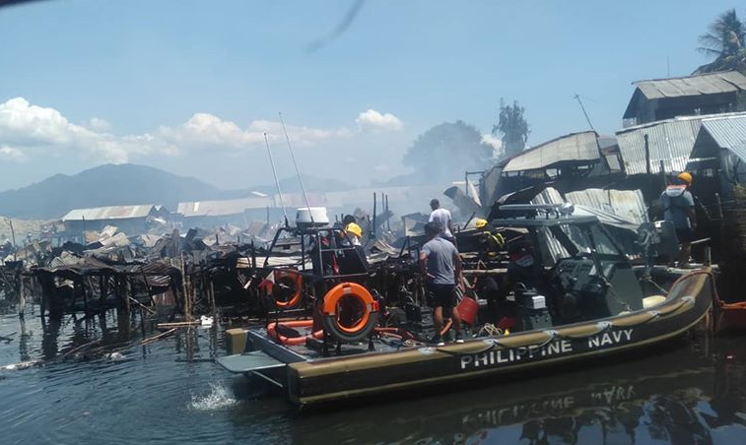
The Philippine Navy rescuing the affected residents of Purok Lapu-lapu, Brggy Bagong Silang Puerto Princesa City, Palawan
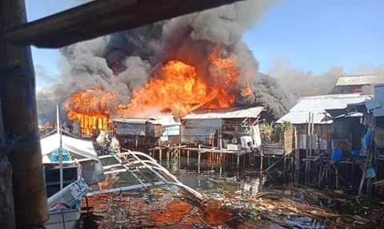
The raging fire destroying the houses in coastal areas of Bagong Silang
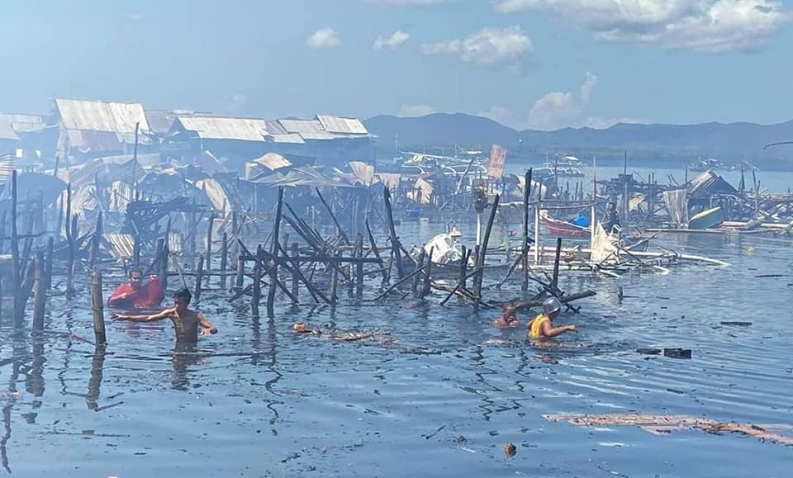
Aftermath of the fire incident in Bagong Silang, PPC, Palawan

Relief distribution of the DSWD through SWADT Office Palawan to the displaced families of the fire incident in Pilot Elementary School
The practice of physical distancing during the relief distribution to the affected families housed in Pilot Elementary School

