DSWD DROMIC Terminal Report on the Fire Incident in Brgy. Bagong Silang, Puerto Princesa, Palawan
21 October 2020, 4PM

SUMMARY

This is the final report on the fire incident that occurred in Brgy. Bagong Silang, Puerto Princesa, Palawan on 23 April 2020 at around 9:15AM and was declared under control at around 10:40AM.
Source: DSWD-FO MIMAROPA

- Status of Affected Families / Persons
A total of 110 families or 370 persons were affected by the fire incident in Brgy. Bagong Silang, Puerto Princesa, Palawan (see Table 1).

Table 1. Number of Affected Families / Persons
REGION / PROVINCE / MUNICIPALITY |  | NUMBER OF AFFECTED
 |  | Barangays | Families | Persons
GRAND TOTAL |  | 1 | 110 | 370
REGION MIMAROPA |  | 1 | 110 | 370
Palawan |  | 1 | 110 | 370
 | Puerto Princesa City (Capital) | 1 | 110 | 370
Source: DSWD-FO MIMAROPA
- Status of Displaced Families
  - Inside Evacuation Centers
A total of 103 families or 344 persons took temporary shelter inside Pilot Elementary School, Palawan (see Table 2).

Table 2. Displaced Families / Persons Inside Evacuation Center
REGION / PROVINCE / MUNICIPALITY | NUMBER OF EVACUATION CENTERS (ECs) |  | INSIDE ECs
 |  |  | Families |  | Persons
 | CUM | NOW | CUM | NOW | CUM | NOW
GRAND TOTAL | 1 | - | 103 | - | 344 | -
MIMAROPA | 1 | - | 103 | - | 344 | -
Palawan | 1 | - | 103 | - | 344 | -
Source: DSWD-FO MIMAROPA

  - Outside Evacuation Centers
There were 7 families or 26 persons who took temporary shelter with their relatives and/or friends (see Table 3).

Table 3. Displaced Families / Persons Outside Evacuation Center
REGION / PROVINCE / MUNICIPALITY |  | OUTSIDE ECs
 |  | Families |  | Persons
 |  | CUM | NOW | CUM | NOW
GRAND TOTAL |  | 7 | - | 26 | -
REGION MIMAROPA |  | 7 | - | 26 | -
Palawan |  | 7 | - | 26 | -
 | Puerto Princesa City (Capital) | 7 | - | 26 | -

Source: DSWD-FO MIMAROPA
- Damaged Houses
A total of 110 houses were damaged; of which, 108 were totally damaged and 2 were partially damaged by the fire (see Table 4).

Table 4. Number of Damaged Houses
REGION / PROVINCE / MUNICIPALITY | NO. OF DAMAGED HOUSES
 | Total | Totally | Partially
GRAND TOTAL | 110 | 108 | 2
MIMAROPA | 110 | 108 | 2
Palawan | 110 | 108 | 2
Source: DSWD- FO MIMAROPA

- Assistance Provided
A total of ₱2,512,955.00 worth of assistance was provided to the affected family and individuals; of which, ₱127,200.00 was provided by DSWD, ₱1,560,000.00 from LGUs and ₱825,755.00 from NGOs (see Table 5).

Table 5. Cost of Assistance Provided to Affected Families / Persons
REGION / PROVINCE / MUNICIPALITY |  | TOTAL COST OF ASSISTANCE
 |  | DSWD | LGU | NGOs | OTHERS | GRAND TOTAL
GRAND TOTAL |  | 127,200.00 | 1,560,000.00 | 825,755.00 | - | 2,512,955.00
REGION MIMAROPA |  | 127,200.00 | 1,560,000.00 | 825,755.00 | - | 2,512,955.00
Palawan |  | 127,200.00 | 1,560,000.00 | 825,755.00 | - | 2,512,955.00
 | Puerto Princesa City (Capital) | 127,200.00 | 1,560,000.00 | 825,755.00 | - | 2,512,955.00
Source: DSWD-FO MIMAROPA

SITUATIONAL REPORT
DSWD-FO MIMAROPA
DATE | SITUATIONS / ACTIONS UNDERTAKEN
21 October 2020 | - DSWD-FO MIMAROPA submitted their terminal report  - DSWD-FO MIMAROPA provided 106 family food packs and 106 sleeping kits amounting to ₱127,200.00 to the affected families.  - DSWD-FO MIMAROPA through AICS provided financial assistance amounting to ₱535,000.00 to the affected families.

*****
The Disaster Response Operations Monitoring and Information Center (DROMIC) of the DSWD-DRMB continues to closely coordinate with DSWD-FO MIMAROPA for any request of Technical Assistance and Resource Augmentation (TARA).

Prepared by:

MARIEL B. FERRARIZ

CLARRIE MAE A. CASTILLO
Releasing Officer

PHOTO DOCUMENTATION

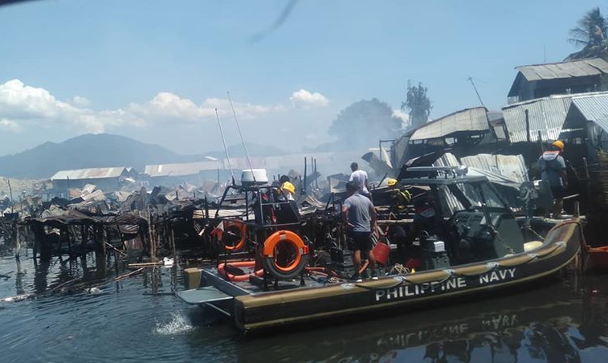
The Philippine Navy rescuing the affected residents of Purok Lapu-lapu, Brggy Bagong Silang Puerto Princesa City, Palawan
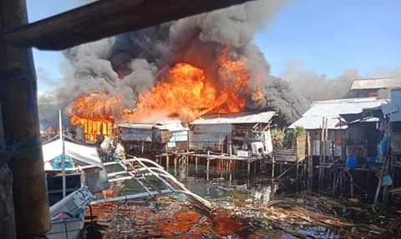
The raging fire destroying the houses in coastal areas of Bagong Silang
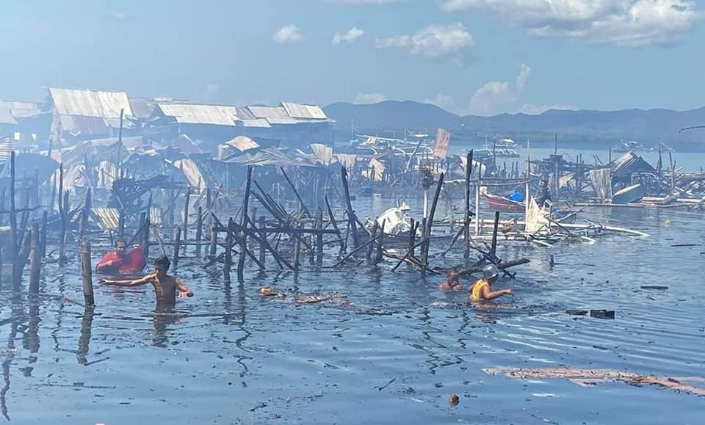
Aftermath of the fire incident in Bagong Silang, PPC, Palawan

Relief distribution of the DSWD through SWADT Office Palawan to the displaced families of the fire incident in Pilot Elementary School
The practice of physical distancing during the relief distribution to the affected families housed in Pilot Elementary School

