DSWD DROMIC Preparedness for Response Report #1
on Tropical Depression “Ambo”
as of 11 May 2020, 6PM

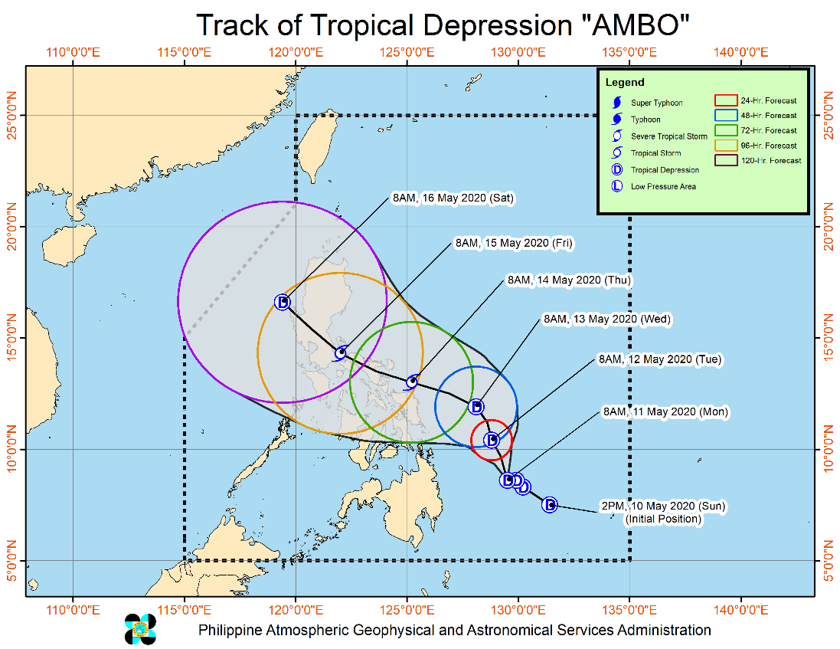
Situation Overview

At 11:00 AM, 11 May 2020, “AMBO” SLIGHTLY INTENSIFIES WHILE MOVING SLOWLY WESTWARD OVER THE PHILIPPINE SEA.

- In the next 24 hours, the trough of TD AMBO will bring scattered light to moderate with isolated heavy rains during thunderstorms over Mindanao. Residents in these areas are advised to continue monitoring for updates, especially the local rainfall or thunderstorm advisories and heavy rainfall warnings of PAGASA Regional Services Division (PRSD).
- Moderate to rough seas will be experienced on the eastern seaboards of Eastern Visayas, Caraga, Davao Oriental, and Davao Occidental. Fisherfolks and those with small seacrafts are advised not venture out on these areas.
- The raising of Tropical Cyclone Wind Signal in any locality of the country remains less likely in the next 24 hours.

Source: DOST-PAGASA Severe Weather Bulletin

At 10:00 AM today, the center of Tropical Depression "AMBO" was estimated based on all available data at 340 km East of Hinatuan, Surigao del Sur (08.6 °N, 129.4 °E)

PREDICTIVE ANALYTICS FOR HUMANITARIAN RESPONSE
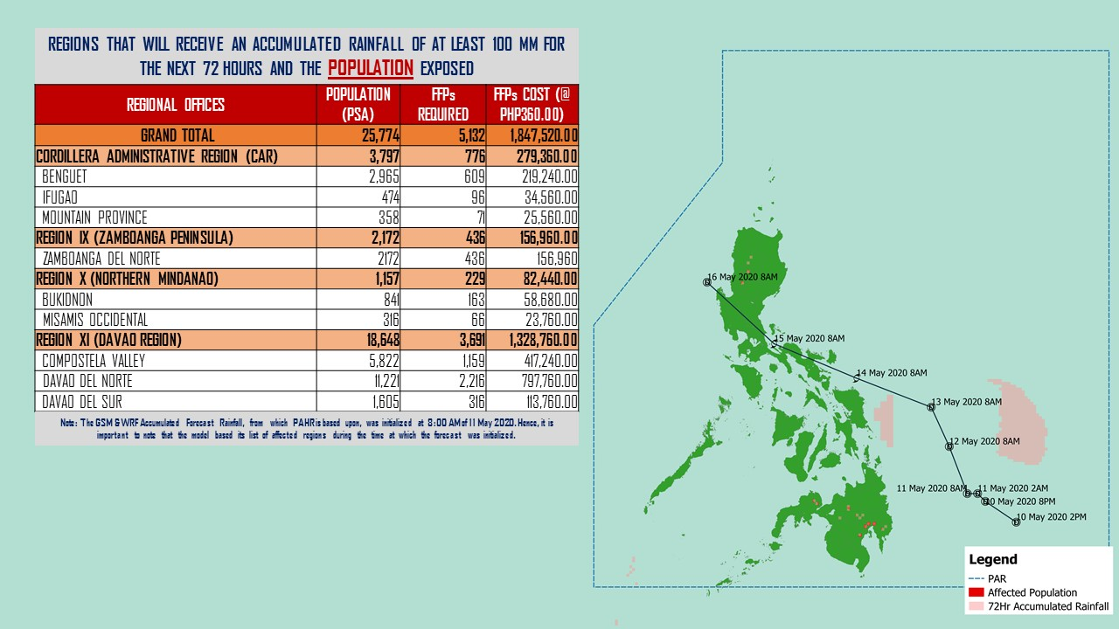
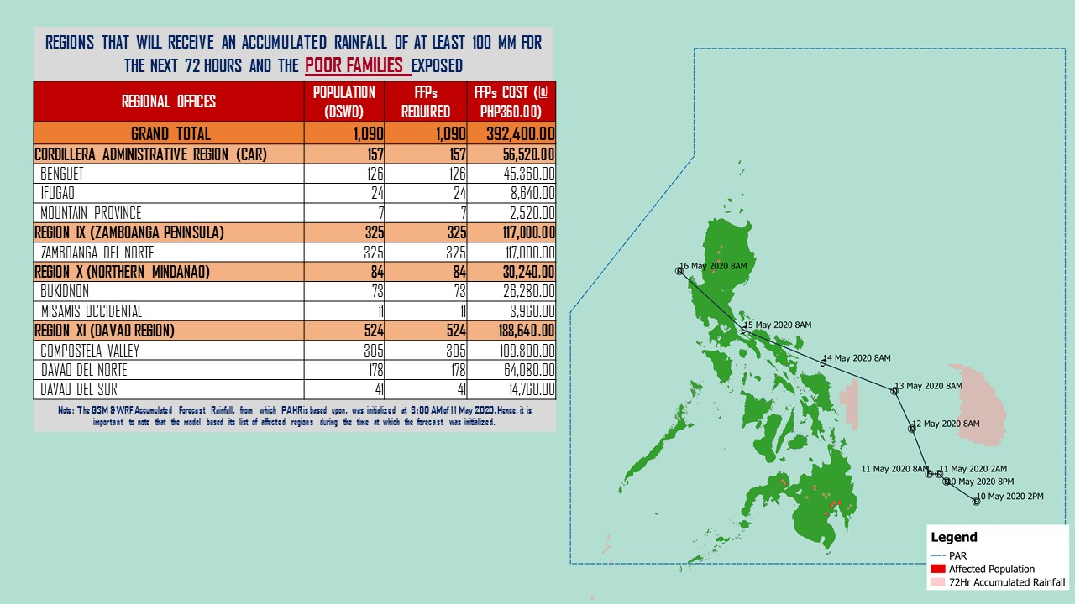

Source: DRMB-DROMIC GIS Specialists
Status of Prepositioned Resources: Stockpile and Standby Funds
The DSWD Central Office (CO), Field Offices (FOs), and National Resource Operations Center (NROC) have stockpiles and standby funds amounting to ₱1,204,703,654.41 with breakdown as follows (see Table 1):

- Standby Funds
A total of ₱244,927,720.96 standby funds in the CO and FOs. Of the said amount, ₱199,914,543.93 is the available Quick Response Fund (QRF) in the CO.

- Stockpiles
A total of 412,238 family food packs (FFPs) amounting to ₱179,569,503.06, other food items amounting to ₱286,170,636.01 and non-food items (FNIs) amounting to ₱494,035,794.38 are available.

Table 1. Available Standby Funds and Stockpiles
Region / Office | Standby Funds | FAMILY FOOD PACKS |  | Other Food Items | Non-Food Relief Items | Total Standby Funds & Stockpile
 |  | Quantity | Total Cost
 | 244,927,720.96 | 412,238 | 179,569,503.06 | 286,170,636.01 | 494,035,794.38 | 1,204,703,654.41
Central Office | 199,914,543.93 |  |  |  |  | 199,914,543.93
NRLMB - NROC | 0.00 | 77,565 | 35,281,430.00 | 58,442,881.92 | 273,405,234.98 | 367,129,546.90
NRLMB - VDRC | 0.00 | 47,609 | 22,409,556.30 | 15,343,865.24 | 8,740,010.50 | 46,493,432.04
I | 3,000,000.00 | 21,751 | 9,491,914.14 | 1,666,630.00 | 39,617,593.15 | 53,776,137.29
II | 2,700,138.89 | 25,377 | 9,584,907.00 | 12,757,129.10 | 5,510,398.95 | 30,552,573.94
III | 926,720.64 | 1,489 | 806,427.51 | 5,108,276.00 | 5,510,398.95 | 12,351,823.10
CALABARZON | 3,000,000.00 | 5,614 | 2,111,318.00 | 7,901,624.00 | 5,100,261.58 | 18,113,203.58
MIMAROPA | 3,069,989.19 | 14,617 | 6,577,650.00 | 4,313,203.00 | 5,464,805.75 | 19,425,647.94
V | 3,001,050.00 | 3,918 | 1,477,113.82 | 5,734,678.09 | 30,224,861.91 | 40,437,703.82
VI | 3,000,851.68 | 19,148 | 8,973,390.00 | 48,660,483.77 | 6,853,499.39 | 67,488,224.84
VII | 3,000,015.14 | 50,397 | 20,072,313.06 | 36,630,841.07 | 74,048.00 | 59,777,217.27
VIII | 3,001,454.16 | 4,814 | 2,643,222.98 | 1,593,189.54 | 19,362,680.38 | 26,600,547.06
IX | 3,000,000.00 | 30,361 | 15,589,638.00 | 8,782,570.00 | 14,357,924.59 | 41,730,132.59
X | 3,106,997.00 | 46,991 | 18,698,198.79 | 37,791,044.43 | 19,741,365.19 | 79,337,605.41
XI | 3,000,000.00 | 16,712 | 6,185,946.80 | 6,724,958.90 | 23,839,069.26 | 39,749,974.96
XII | 3,000,701.68 | 3,937 | 1,775,587.00 | 10,289,125.49 | 12,876,448.72 | 27,941,862.89
CARAGA | 3,000,000.00 | 15,279 | 5,550,167.70 | 10,935,422.52 | 3,258,445.70 | 22,744,035.92
NCR | 2,200,300.00 | 1,440 | 635,500.80 | 1,789,491.78 | 9,799,152.16 | 14,424,444.74
CAR | 3,004,958.65 | 25,219 | 11,705,221.16 | 11,705,221.16 | 10,299,595.22 | 36,714,996.19
Note: The Inventory Summary is as of 10 May 2020, 6PM.
Source: DRMB and NRLMB

Situational Reports

DSWD-DRMB
DATE | SITUATIONS / ACTIONS UNDERTAKEN
11 May 2020 | - The Disaster Response Management Bureau (DRMB) is on BLUE alert status and is closely coordinating with the concerned field offices for significant disaster response updates  - All QRT members and emergency equipment are on standby and ready for deployment.  - DRMB participated in the Online Pre-Disaster Risk Assessment Meeting on Tropical Depression “AMBO” on 11 May 2020 with other response cluster member agencies. Further meetings shall be conducted on the implementation of COVID-19 protocols during the response efforts on TD “Ambo”.

DSWD-FO CALABARZON
DATE | SITUATIONS / ACTIONS UNDERTAKEN
11 May 2020 | - DSWD-FO CALABARZON is in coordination with the National Food Authority (NFA) to facilitate the hauling of NFA Rice for the production of relief good in preparation to any untoward incidents.  - DSWD-FO CALABARZON Emergency Operations Center is already activated to monitor the possible effects of TD “Ambo”.  - DSWD-FO CALABARZON Disaster Response Management Division (DRMD) is in constant communication with the Local Social Welfare and Development Offices (LSWDOs) with pre-disaster assessments being conducted.  - DRMD conducted close coordination with the Local Government Units (LGUs) with regards to the preparedness efforts undertaken in the Flood, Landslide and Storm Surge prone areas.  - DRMD coordinated with SWAD Team Leaders and Provincial Action Team of the CALABARZON and advised them to monitor and coordinate with the LGUs to gather reports on the possible effects of TD “Ambo”.  - DRMD coordinated with LSWDOs and LDRRMOs and instructed them to be on standby alert and prepare their respective evacuation centers, and family food packs should need arises.  - DRMD coordinated with the RDRRMC IV-A OpCen for updates on the preparedness level of the members of the Response Cluster of the region.  - DSWD-FO CALABARZON informed the member agencies of the response cluster to be on-stand-by alert and be ready for mobilization.

DSWD-FO MIMAROPA
DATE | SITUATIONS / ACTIONS UNDERTAKEN
11 May 2020 | - DSWD-FO MIMAROPA Disaster Response Management Division and Provincial Project Development Officers are alerted to monitor daily local weather condition and ensure provision of information to all concerned offices, divisions, sections, offices.  - Alerted all P/C/M Quick Response Team in five provinces of MIMAROPA to regularly monitor the situations in their areas.  - 24/7 On-call status of the R/P/C/M QRT together with special projects for the possible activation of Operation Center.  - DSWD-MIMAROPA is in close coordination with the Office of Civil Defense (OCD) and RDRRMC MIMAROPA for any warning signal updates for monitoring purposes and response mechanism for areas that will be affected.  - Standby logistical equipment and workforce through coordination with SWADT Offices and concerned LGUs on the management of stranded passengers, if any, in ports and terminals.  - Information and Communication Technology Management Unit (ICTMU) is on standby status to ensure robust communication system.  - All members of Rapid Emergency Telecommunications Team are on on-call and standby status ready for deployment if needed.  - DSWD-MIMAROPA ensures that the Rapid Emergency Telecommunications Equipment (GX Terminal, BGAN Terminals and Satellite Phones) are in good condition and ready for deployment to areas that will experience potential emergencies.  - DSWD-MIMAROPA ensures that there is an on-call truck available for delivery of goods and equipment to areas that will be affected

DSWD-FO V
DATE | SITUATIONS / ACTIONS UNDERTAKEN
11 May 2020 | - DSWD-FO V is in close coordination with LGUs for food ration requirement.  - DSWD-FO V DRMD Disaster Response Management Division (DRMD) continuous to monitor weather updates and information.  - The Resource Operation Section ensures the availability of family food packs and non-food items as need arises.  - DSWD-FO V QRTs are activated.  - PAT and MAT members in the 6 provinces are activated and instructed to coordinate with the P/MDRRMOs, C/MSWDOs for TD Ambo reports.

DSWD-FO XI
DATE | SITUATIONS / ACTIONS UNDERTAKEN
11 May 2020 | - DSWD-FO XI activated the field office and RPMO’s (SWADTs, PATs, MATs, CATs) Quick Response Team as On-Call duty.  - DSWD-FO XI is in close coordination with all SWADOs and PSWDOs/CSWDO/MSWDOs for monitoring of the situation in the different parts of Davao Region. Personnel in the warehouse are also on alert to ensure the readiness to dispatch relief goods (food and non-food items) at any given time.  - Availability of Disaster Wing Van, vehicles and drivers in the event of relief operation.  - DSWD-FO XI is in close coordination with the Office of Civil Defense (OCD) XI for logistical support monitoring.  - DSWD-FO XI is in close coordination with the staff rendering skeletal duty in the DRMD Office and City/Municipal Action.

DSWD-FO Caraga
DATE | SITUATIONS / ACTIONS UNDERTAKEN
11 May 2020 | - DSWD-FO Caraga attended the PDRA/ERP Meeting through teleconferencing with the Caraga RDRRMC Member agencies to discuss the preparedness and response measures regarding the tropical depression.

*****
The Disaster Response Operations Monitoring and Information Center (DROMIC) of the DSWD-DRMB is closely monitoring the effects of TD “Ambo” and is coordinating with the concerned DSWD Field Offices for any significant updates.

Prepared by:

MARIE JOYCE G. RAFANAN

RODEL V. CABADDU
Releasing Officer

